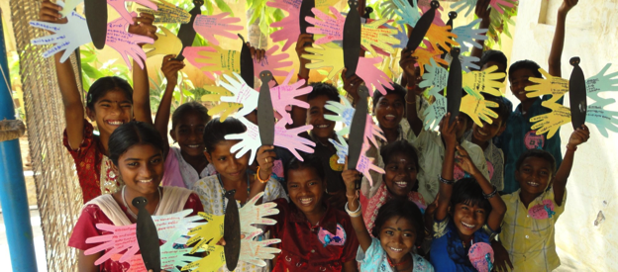
Buds of Christ exists to empower orphan children affected by HIV and AIDS from the most disadvantaged communities. We believe that unless children are empowered towards survival and development, protection and participation their wellbeing is not complete. Thus we work with a mission with children “to love, listen, learn and lead orphans children affected by HIV and AIDS to live life positively and with dignity and be children of hope and courage to their peers and to their community”

Why we focus around Namakkal District
Namakkal district is one of the HIV high burdened districts in India. This district is categorized as “A” by National AIDS Control Organisation (NACO) in India, which means that the HIV severity is high in this district. Currently over 13000 people living with HIV are enrolled with the government hospital for HIV treatment, of which around 600 are children living with HIV.

What services we extend for orphaned children affected by HIV and AIDS?
We chose to serve at Tiruchengode taluk in Namakkal district which is 40 kms away from the district headquarters and had no care and support services for rural orphaned children. Our approach is to keep the orphan children within their extended families in the community and provide the essential support and empowerment programs.

Our key service areas are categorized into H.E.A.L (Health, Education, Advocacy and Leadership)

HEALTH
The objective is to ensure good health including nutrition to children living with HIV and their caregivers primarily widow mothers. Major services provided under health are
- Monthly Health monitoring Home Visits
- Fortnightly support group meetings for children and adolescents living with HIV
- Emergency medical care support
- Periodic nutritional support for most deserving

EDUCATION
The objective is to ensure that orphan children are empowered to graduate in their area of interest and contribute back to the society. Key services provided are
- Tuition fees
- Educational support with a special focus on orphan girls
- Annual school educational kit support (School bags, stationaries, notebooks and guides)
- Life Skills and Value Education programs

ADVOCACY
The objective is to ensure that children’ rights are ensured at family, community and among Govt stakeholders. Key programs are
- Awareness programs for higher secondary school going children
- Linkage with Govt programs and services within the district administration
- Advocate for violation of child rights with stakeholders (ex. Child marriage, Child labour)

LEADERSHIP
The objective is to equip young people reached through the services to emerge as future leaders for Buds of Christ to serve their peers. Key programs are
- Annual Buds N Colors Leadership Camp
- Monthly Leadership Seminars
- Exposure to leaders from various social and developmental sectors

Legal Status of Buds of Christ
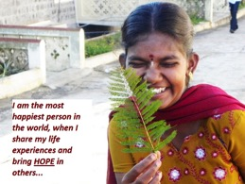
Buds of Christ is legally registered organisation under Indian Charitable Trust Act. We are also registered for 12 A and 80 G exemption with Income Tax Department. Buds of Christ is registered under FCRA, Ministry of home affairs. Buds of Christ is member of the Child Rights International Network, Guidestar India and Credibility Alliance India.

Contact Us
Buds of Christ Charitable Trust
164, Kootapalli Housing Board Colony
Tiruchengode 637 214 Namakkal District
jpaul@budsofchrist.org
www.budsofchrist.org

