Congo Children Trust in Lubumbashi
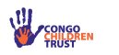
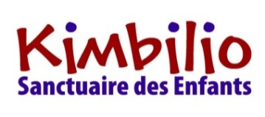
The Congo Children Trust’s project, Kimbilio, supports street children in Lubumbashi, Democratic Republic of Congo. Our aim is to improve the lives of vulnerable street children, reuniting them with their families where possible, and helping them build a future with hope. Kimbilio now runs four street child centres across the city, reaching out to over 100 children per month.
Many children end up on the streets due to family disputes, divorce and remarriage; witchcraft accusations; poverty; or family illness. Our reintegration model focuses on understanding each child on an individual level, gaining their trust, and gradually re-building bridges with their families.
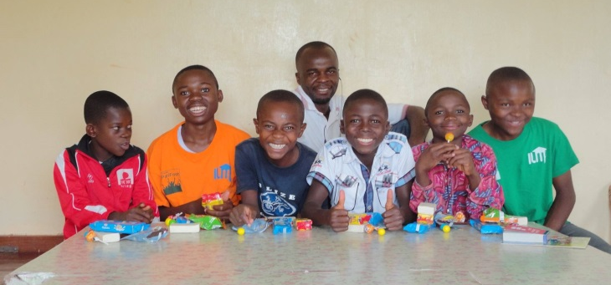
Our centres, Centre Kimbilio; Kimbilio Boys and Kimbilio Girls Transit; and Maison Kimbilio offer holistic care for Lubumbashi’s street children. A dedicated team of Congolese staff lead the project on a day-to-day basis, overseen by three part-time, UK-based staff and an experienced board of Trustees.
Centre Kimbilio (CK) is our first point of contact with children living on Lubumbashi’s streets. Running three times a week, this vital outreach centre offers street children a safe and accessible place to unwind, whilst caring for their immediate needs. The children are offered breakfast and lunch, with the opportunity to wash their clothes, shower, and engage in team building activities. Children also have access to healthcare.
Kimbilio’s positive reputation within the local community means that CK is often the first port of call for parents who are looking for their child. In other cases, children may have travelled hundreds of kilometres from their family home, or their family situation may be more challenging. In these more complex and costly situations, the child may be welcomed to Kimbilio Transit.
Kimbilio Transit (KT) cares for up to twelve boys and ten girls, ideally for up to four months. During this period, we build trust with the children, and work towards re-establishing links with their families.
Our social worker visits families to understand their viewpoint, and will assess whether this is a positive environment for a child to return. During a second visit, we may offer a sack of flour or to pay for the child’s school enrolment and fees for a term, to incentivise poorer families to welcome back their child. Reintegration only occurs if everyone is content, and we carry out a third, follow up visit to ensure the family’s welfare.
Where children are unable to return home, we welcome them to Maison Kimbilio (MK). Here we currently care for twenty boys and girls, in two separate houses, surrounded by countryside and our football pitch and basketball court. All children attend a local school too. MK’s homely feel offers an ideal, rural environment for the children to overcome their time on the streets and achieve a brighter future.
Our target is to reunite at least 16 children with their families this year, across all four centres.
“I want to tell people that we are not witches, thieves or street dogs. We are children, just like all the other children & all we need is love.”

