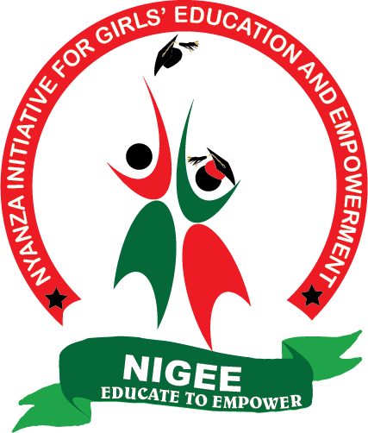

NIGEE PROJECT REPORT

SUBMITTED NOVEMBER, 2021

REALISATION OF A DREAM!
NIGEE has always had a dream to set up a Girls’ Empowerment Centre to be a one-stop shop for all girl-empowerment activities, i.e. to house a vocational training centre; an employment bureau, a bridging/transition centre, an early childhood education centre and a rescue centre.

The vocational training centre and the early childhood education centre sections are functional. We are offering courses on hairdressing, beauty therapy, fashion and design and basic computer skills. Girls who have children below school-going are allowed to come with them at the centre, where the children are cared for while their mothers are at school. In addition, the children are offered nutritious porridge at no extra cost – thanks to donations from Global giving.

We continue to fundraise to ensure the other components of the Girls’ Empowerment Centre come to fulfilment.

To the Global giving team and all our donors, thank you so much for immensely contributing towards the realisation of our dream.

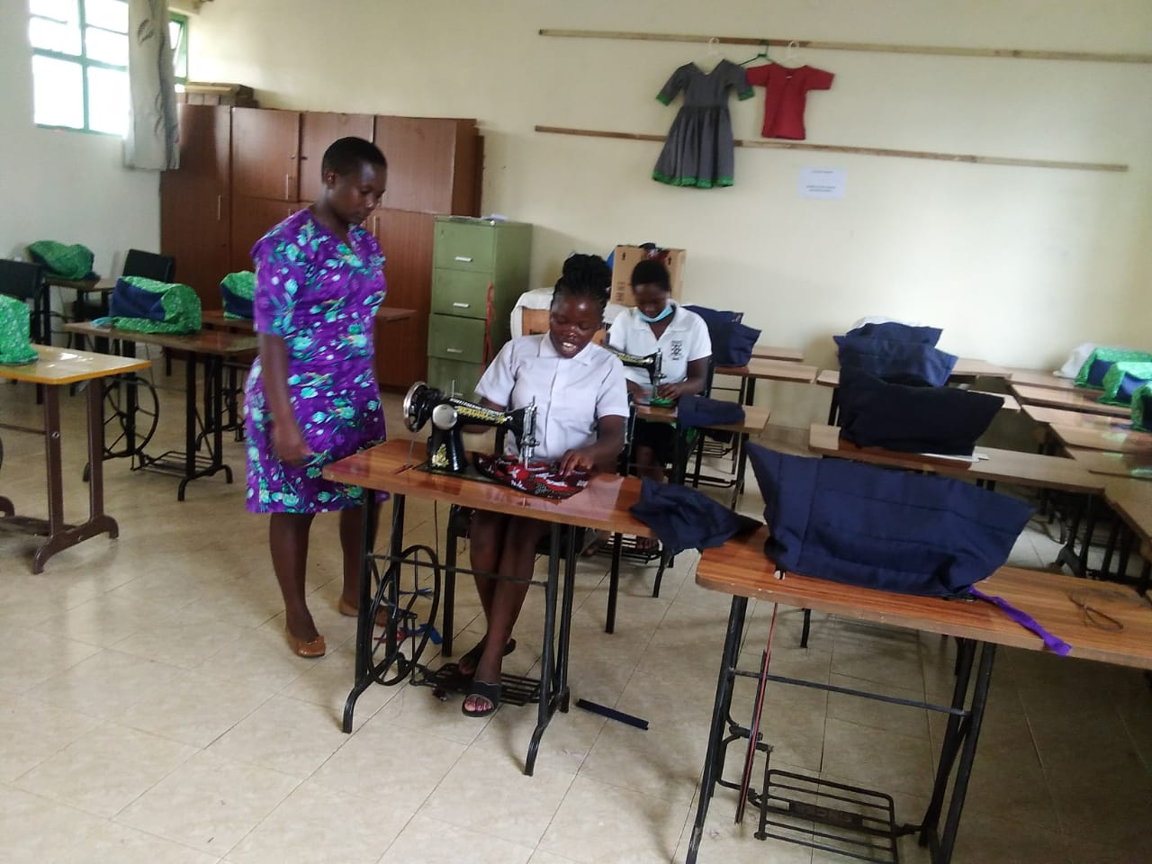
Fashion and design class in progress.

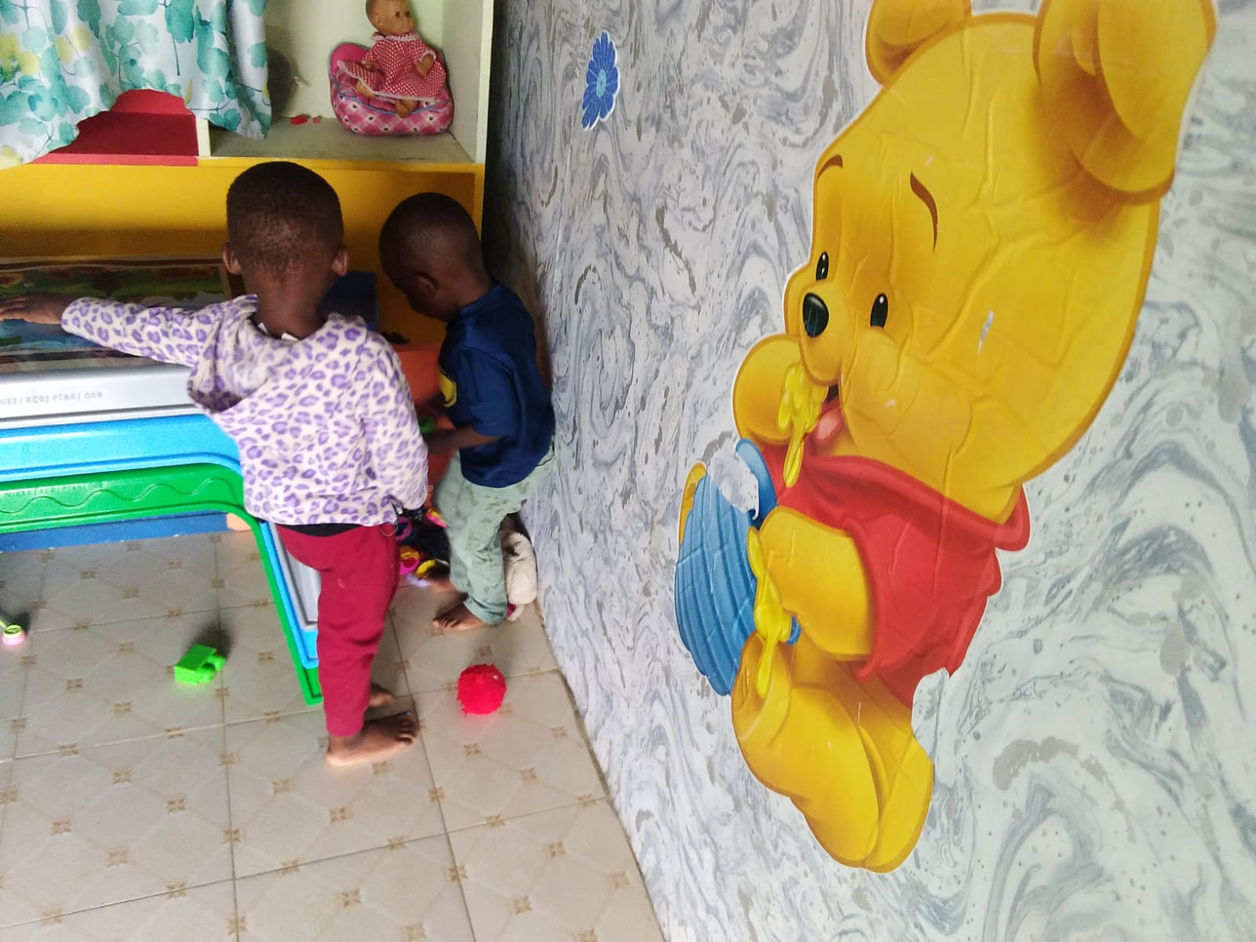
The day care centre.

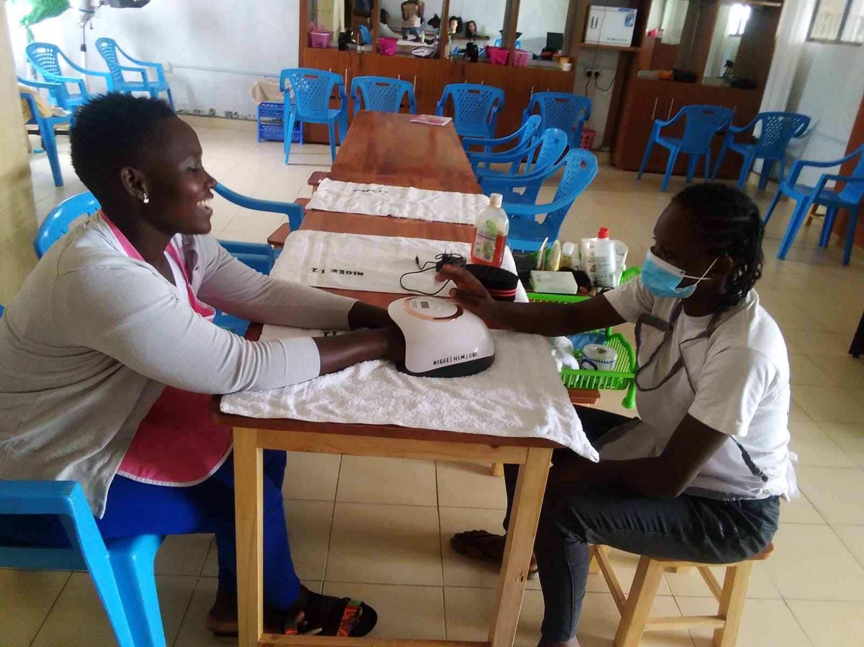
Beauty therapy class in progress.

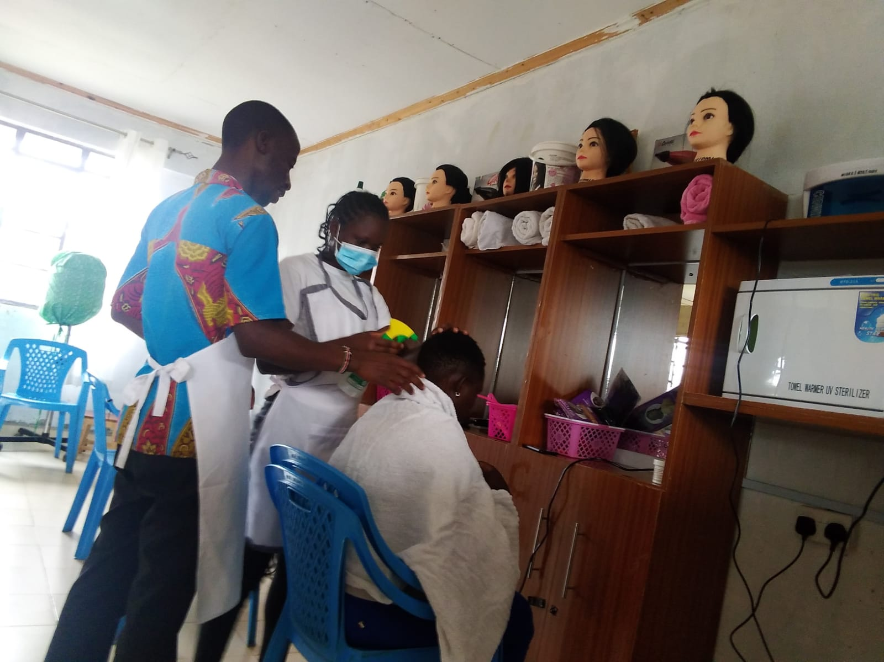
Hairdressing class in progress

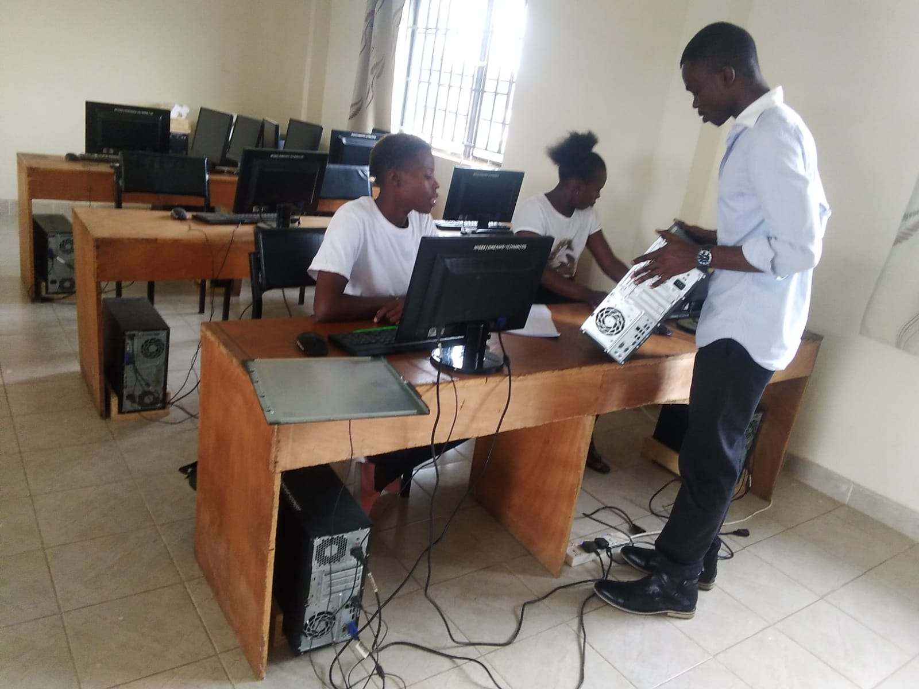
Basic computer skills class in progress.

