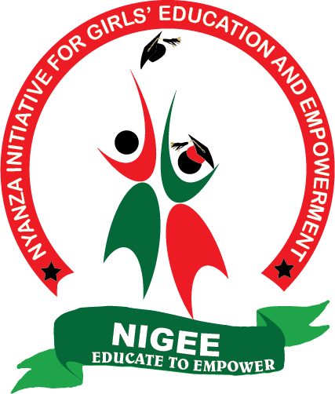

NIGEE PROJECT REPORT

AUGUST – OCTOBER 2020

RESCUE FGM CAMP
The Kuria community practice Female Genital Mutilation (FGM) annually, mostly between November - December. The specific time are decided by the clan elders. This year the practice started on 28th September and is still going on.
Whereas the community considers FGM as a rite of passage that makes girls more disciplined and better wives while at the same time elevating the girls’ parents in the society, its harmful effects include severe pain, ulceration of the genital area, increased risk of infections and HIV transmission, complications during child birth or haemorrhage that may lead to death. FGM is one of the leading causes of school dropouts, child marriage and teen pregnancies in Kuria community.

This year, the situation has been particularly dire for girls, as was reported in one of the leading television stations [https://www.youtube.com/watch?v=nZ91aES1ghc]. As a direct result of COVI-19, safe spaces ordinarily provided by schools are closed. Some girls under go FGM as a precursor to marriage as re-opening of schools is not certain. Due to the economic downturn, some parents force their girls to undergo FGM to get cash handouts.

NIGEE’s intervention
NIGEE partnered with two like-minded CSOs in Kuria, Msichana Kuria and Zinduka Kenya to hold an FGM rescue camp from October 2020. The camp is to recue and shelter girls from being forced to undergo FGM. As at 9th November, the camp has 39 rescued girls, who will be at the camp until the FGM period ends.
- Those who run away from home for fear of being forced to undergo FGM.
- Those rescued by police officers, area chiefs and other stakeholders.
- Those from single-parent(mother) homes. Kuria community is a patriarchal community where women’s voices don’t count. Girls from single-parent homes are usually forced to undergo FGM, without their mother’s consent.
- Those who have undergone FGM have had complications and hence their parents arrested. The camp acts as a safe space where the girls are sheltered as their cases are being heard and determined.
The three organisations are contributing materially to facilitate the camp. NIGEE’s contribution is part of the Global Giving microgrant won in July 2020.
The girls we have rescued are of the following categories

At the camp, there are mentorship sessions (where girls are taught on human rights and life skills), storytelling sessions (giving girls the opportunity to learn from each other’s experiences) and outdoor activities like football.
The camp has been visited by stakeholders from the Ant-FGM Board and officials from the Ministry of Gender, National Government. The stakeholders mentored the girls, encouraged them and assured them of their security when they return home when the FGM period ends.

The camp is expected to end in November, upon which time we will engage the girls’ parents and local stakeholders/child protection units to safely reintegrate the girls back to their community and their families.

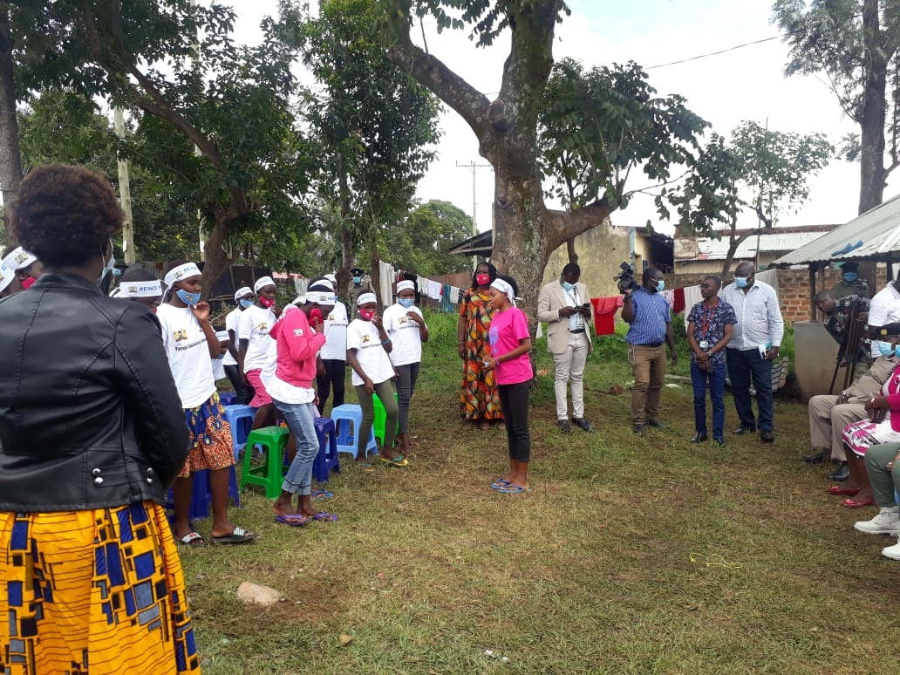

A girl doing a presentation during the visit by the stakeholders from the National Government an Anti-FGM Bord.

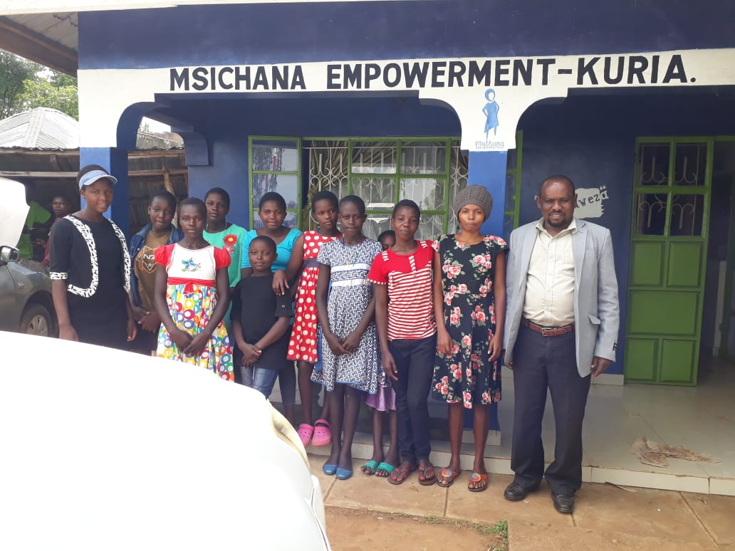

Girsl from Kuria East sub county, with the sib county Children’s Officer.

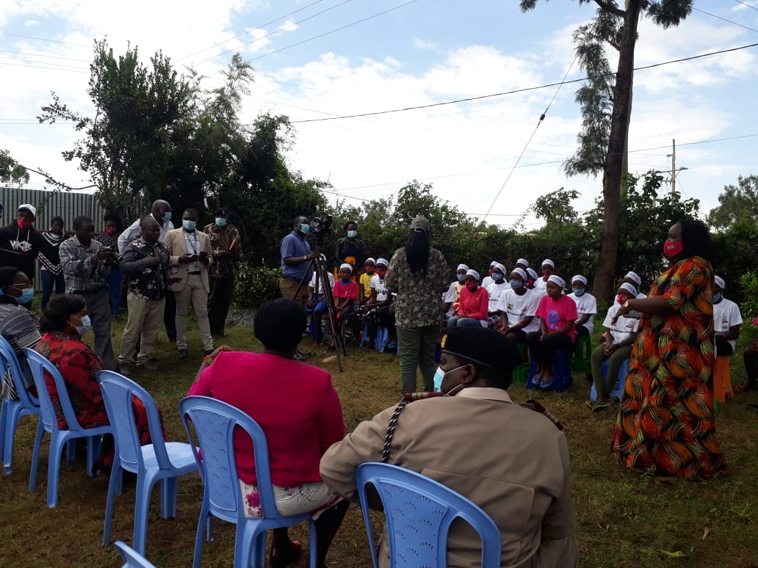

Hon Rachel Shebesh the Chief Administrative secretary (Public service and Gender), Mrs. Bernadette Luloju, CEO Anti-FGM Board, Mrs. Pamela Odhiambo, Migori County Women Representative among other stakeholders during the visit by the National Government and Anti-FGM Board officials.

