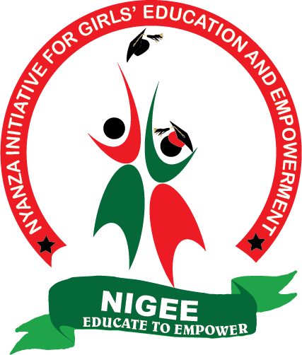

NIGEE PROJECT REPORT

SUBMITTED MARCH, 2021

LITTLE BY LITTLE
Little by little, with every donation from well-wishers and the global giving family, our Girls’ Empowerment Centre made another tremendous effort towards its completion. We have channelled most of the donations from the global giving platform in the 6-7 last months in putting rails at the centre. The rails make the first floor of the building safe for use by the girls and their children where applicable.

Further, in doing this, we are a step closer to opening the vocational training centre. In fact, we have started the process by sending out adverts for the various trainers of hairdressing and beauty therapy, dress making and design and computer studies. We hope to make the centre fully operational by June 2021.

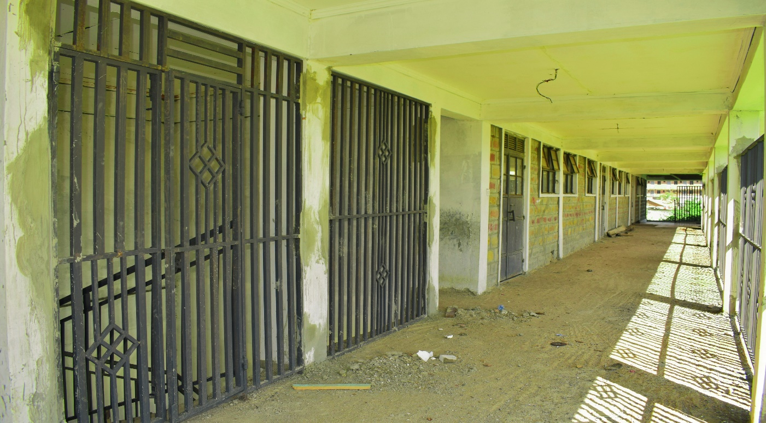
Rails on the centre’s first floor.
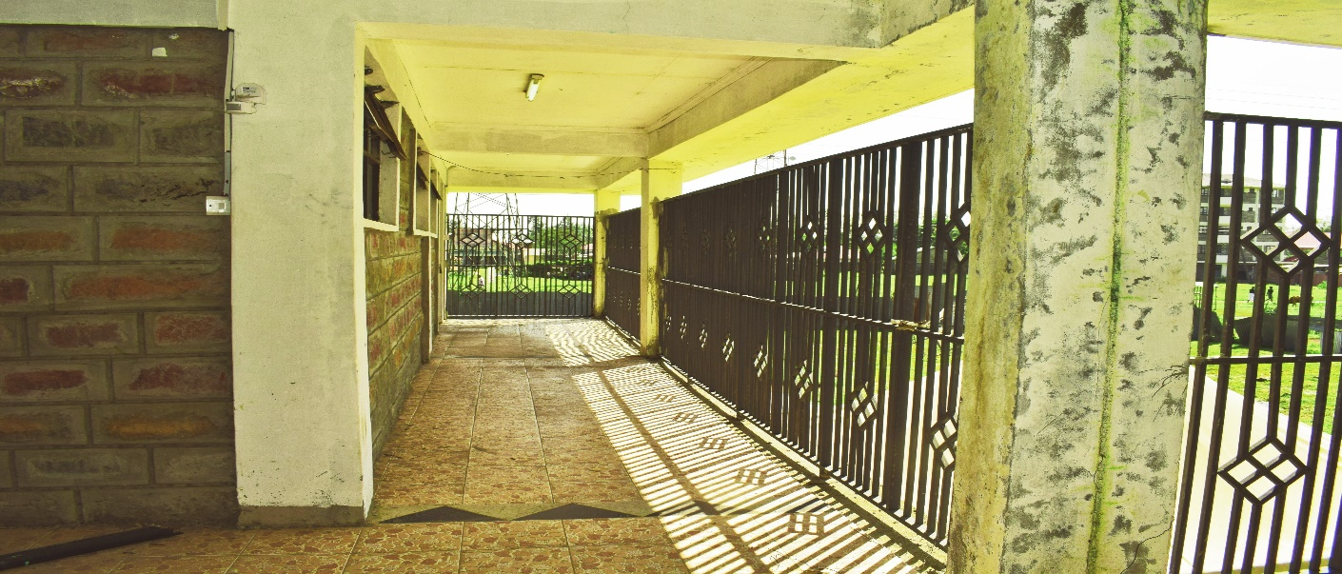
Rails on the first floor
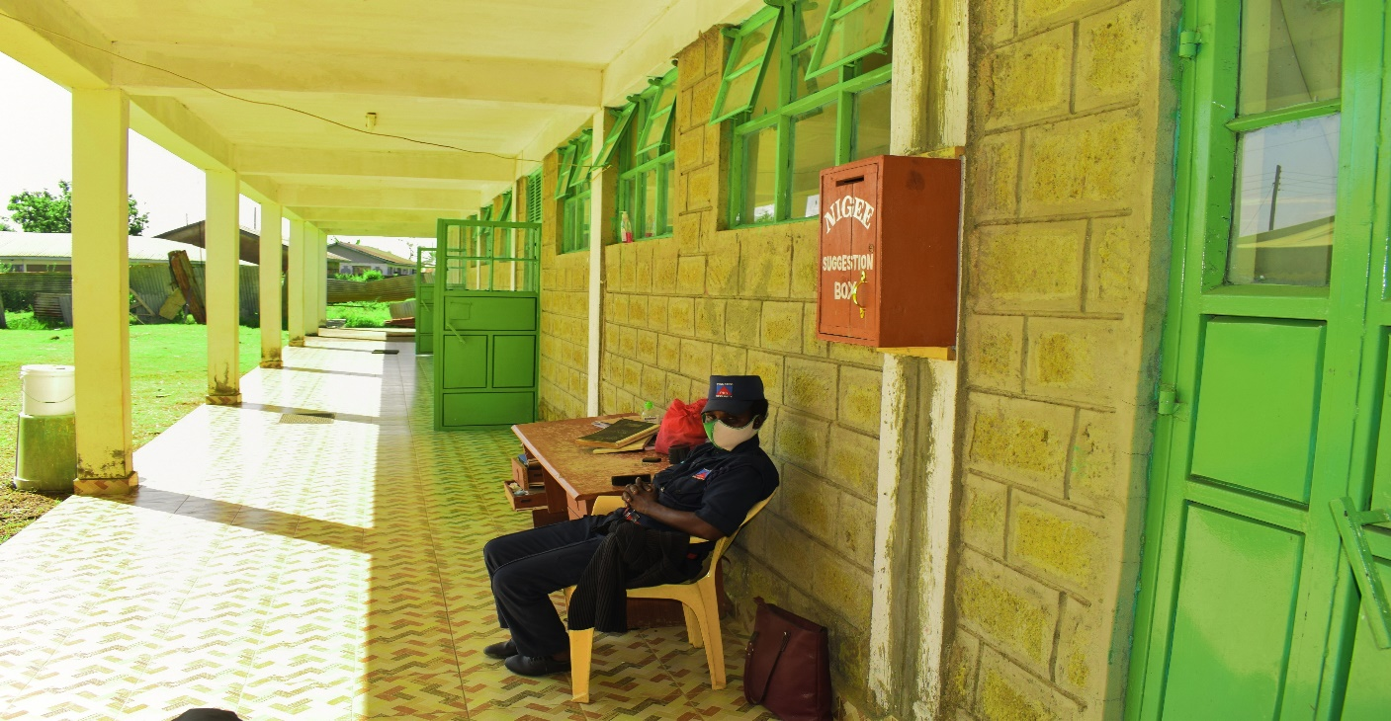
How the ground floor is now

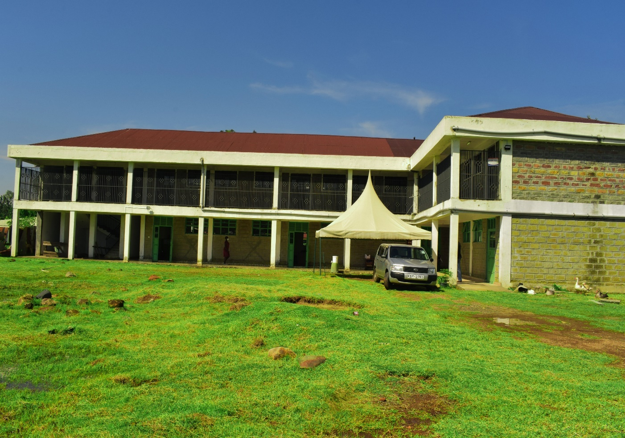
Front view of the whole centre

