NIGEE PROJECT REPORT

SUBMITTED MARCH, 2022

SECURITY!
The journey to the desired dream of the Girls’ Empowerment Centre (GEC)is on track. In this quarter, we channelled part of the global giving donations to repairing the GEC’s fence. Whereas the fence is still made of iron sheets, the current fence is way better, not only demarcating the centre’s boundary but also securing the students at the vocational skills training centre and the children at the day care centre. In addition to the gate we fence, we installed a steel gate to limit access.

We will continue to fundraise to complete the GEC and erect a perimeter wall fence burglar proofed with razor wire and steel gate.

To the Global giving team and all our donors, thank you so much – this gratitude is from all our beneficiaries.

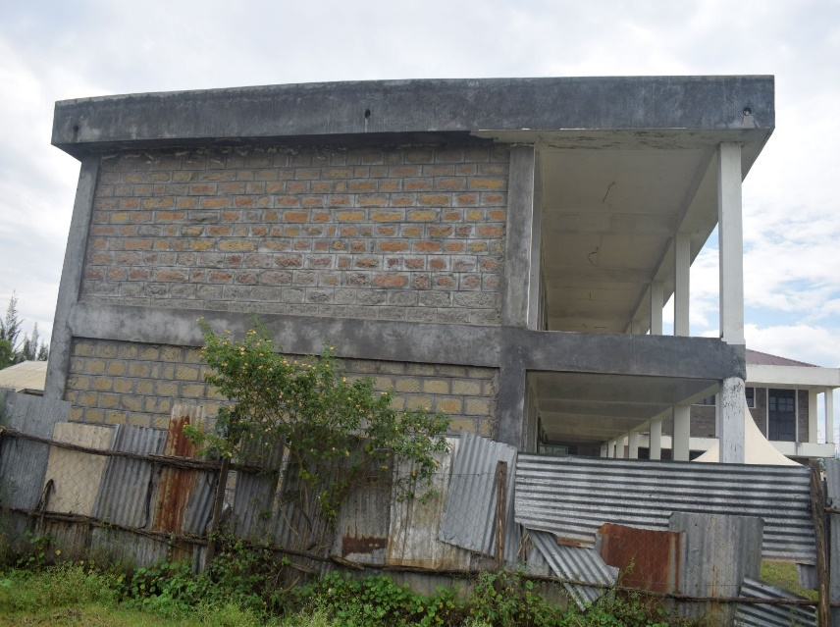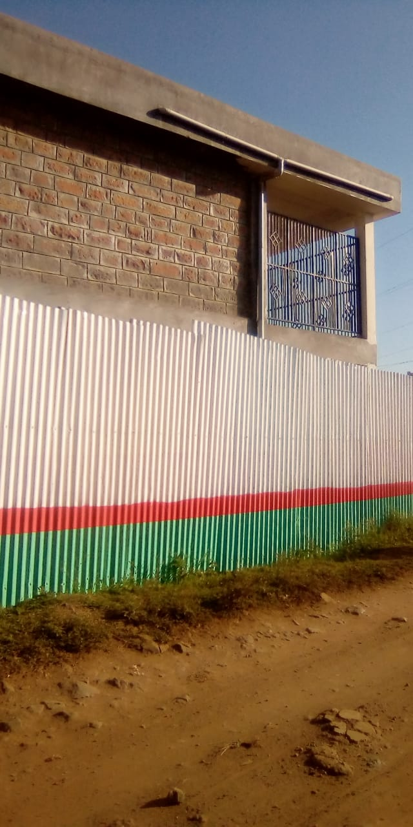
Older fence from the side. Better fence now in place

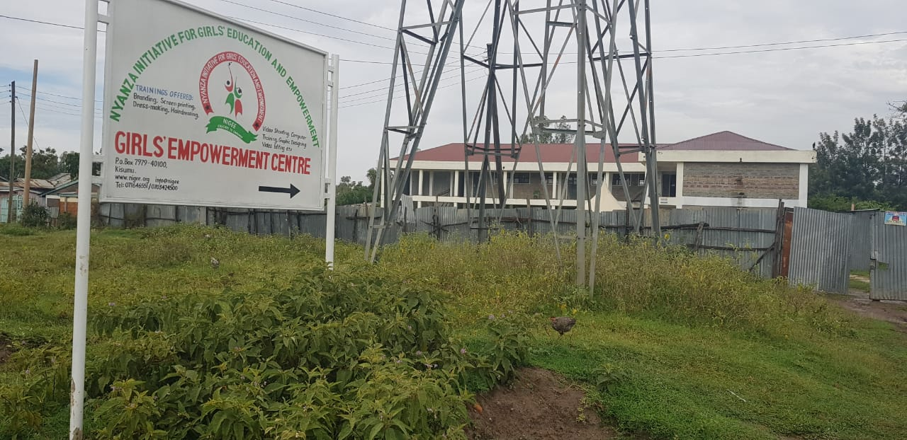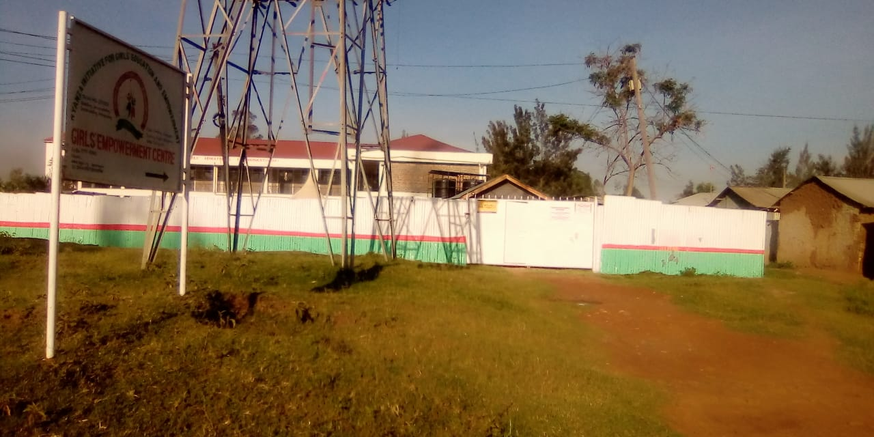
Older fence from the front. A picture from almost the same spot, better fence

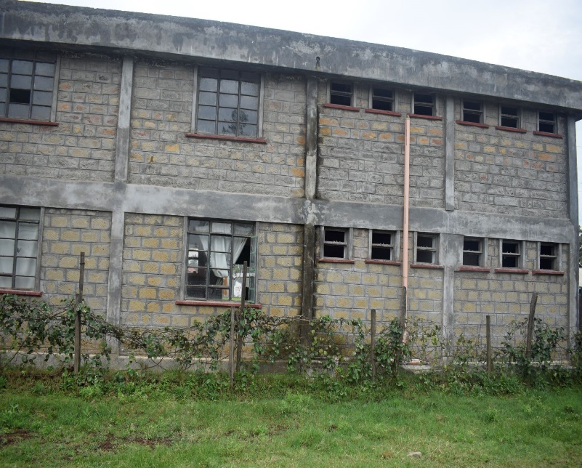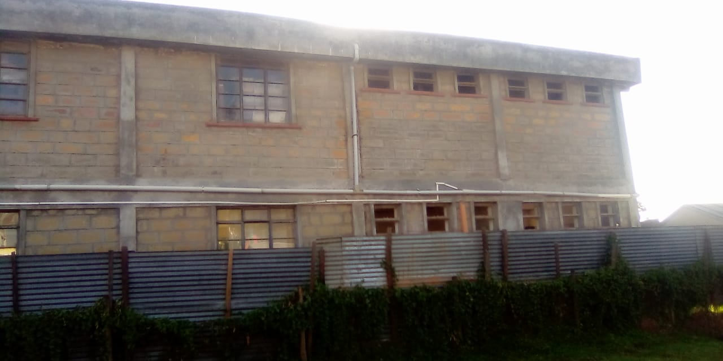
Older fence from the back The current fence in place.

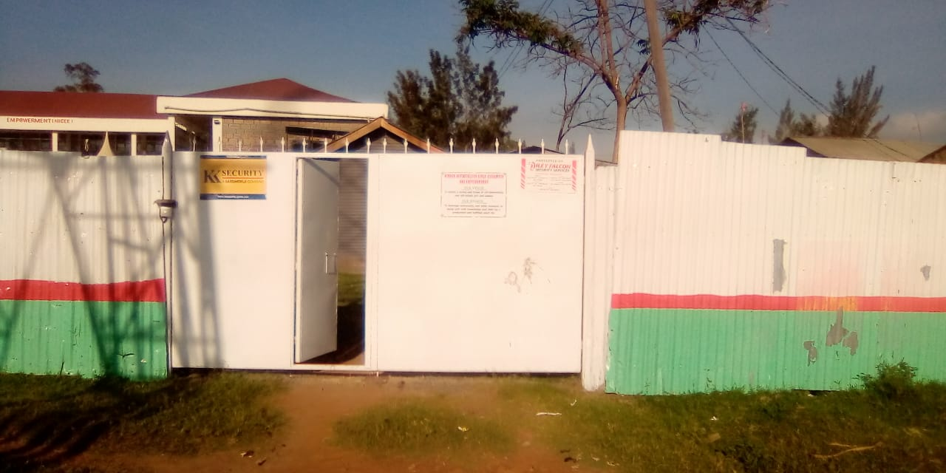
A view of the entrance to the centre.

