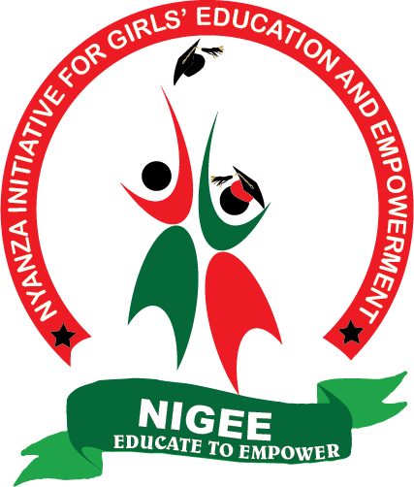

NIGEE PROJECT REPORT

SUBMITTED JULY, 2021

THE SUCESSES
The NIGEE dream is to see girls complete their education, recognising that education is the pillar for girls’ empowerment, thereby improving the girls’ chances of living fulfilled adult lives. Further, education is a bridge to other rights, as it gives girls and young women choices and the power to decide over their own lives and bodies. In addition, access to quality education is one of the greatest pathways to lift individuals and communities out of poverty. It equips historically marginalized groups with the opportunity to transform exclusionary systems.

Since 2013, NIGEE has returned to school to school 484 girls who dropped out of school due to teenage pregnancy, FGM, child marriage or abject poverty. Some of the girls are now pursuing courses such as civil engineering, law, medical laboratory and health records, education, social work and community development while others are managing their small scale businesses.

It is in pursuit of this dream that the Girls’ Empowerment Centre was birthed. The centre is now 75% complete, thanks to, among others, the global giving crowdsourcing platform.

Below is a video collection of some of our beneficiaries’ stories, a testament that NIGEE’s dream is slowly but surely coming to pass, and this is thanks to its partners, including the global giving platform, whose generosity is key to the success of NIGEE and realisation of the dream.

Thank you again for supporting this project- you have made a tremendous impact in our community!”
