Annual Report of Salaam Baalak Trust (April 2021 to March 2022)

Vulnerable Children Reached and Supported
SBT provided various facilities and services to children in need of care and protection through its long-term and short-term residential centres described below:
Name of Centre | Catering to Boys or Girls | Brief Overview
Aasra | Boys | Aasra was the first shelter home started by SBT. With a capacity of 50 it caters to boys between 5 to 18 years. It is located in Najafgarh, New Delhi.
ApnaGhar | Boys | It is a short stay centre, where 30 children come stay short duration and then they are either restored or placed in a long stay home. The centre is located in Multani Dhanda Paharganj, Delhi
DMRC | Boys | DMRC Children’s Home was established as part of Delhi Metro Rail Corporation’s corporate social responsibility. The home houses 125 boys from the age of five to below 18 years. It is located near Tis Hazari Court, Delhi
Old Delhi Railway Station (ODRS) Open Shelter | Boys | ODRS is an open centre catering to 30 boys. It is a short stay centre, where children come for a short duration and then they are either restored or placed in a long stay home.
Arushi | Girls | Arushi was first girls’ shelter home under SBT. It is an initiative to offer 24 hour shelter to 50 girls between the ages of five years to 18 years living on the streets. The centre is located in Gurgaon.
Udaan-Rose | Girls | Udaan-Rose Home was initiated with the support of Give 2 Asia in March 2010. It started with eight girls and currently shelters 60 girls at a time. This home is located in Kamla Nagar, New Delhi

Note: all these residential centres are registered as child care institutions under the Juvenile Justice (Care and Protection of Children) Act, 2015.

Numbers of vulnerable children reached and supported (April 2021 to March 2022)

Area of work | Udaan | Aarushi | Apna Ghar | ODRS | Uday | DMRC | Aasra
No of Beneficiaries | 336 | 89 | 214 | 562 | 269 | 365 | 52
Restored/ Transferred/rehabilitation | 144 | 30 | 115 | 255 | 196 | 159 | 4
Vocational Training | 6 | 8 | 1 | 1 | 0 | 10 | 2
Job Placement | 1 | 2 | 1 | 0 | 0 | 7 | 0
Medical Support  (In house Check- up) | 206 children (647 checkups | 45 children (200 checkups) | 153 children (1173 checkups) | 165 children (364 checkups) | 136 children (1174 checkups) | 238 children (924 checkups) | 52 children (1937 checkups)
Non Formal Education (NFE) | 153 | 52 | 152 | 283 | 178 | 167 | 10
Formal and higher studies | 42+10 | 28+1 | 55 | 8 | 8 | 54+1 | 39
National Institute of Open Schooling (NIOS) | 10 | 8 | 2 | 0 | 0 | 07 | 1
Mental Health Support (Psycho social support) | 164 | 80 | 24 | 150 | 101 | 277 | 40
A total of 1887 children were reached and supported by SBT through these residential centres in this period.
Efforts are made to provide education, health care, good nutrition and involve children in a wide-range of developmental activities through these centres of SBT.

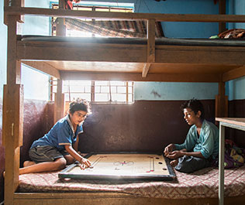
Sleeping arrangement and indoor games children play

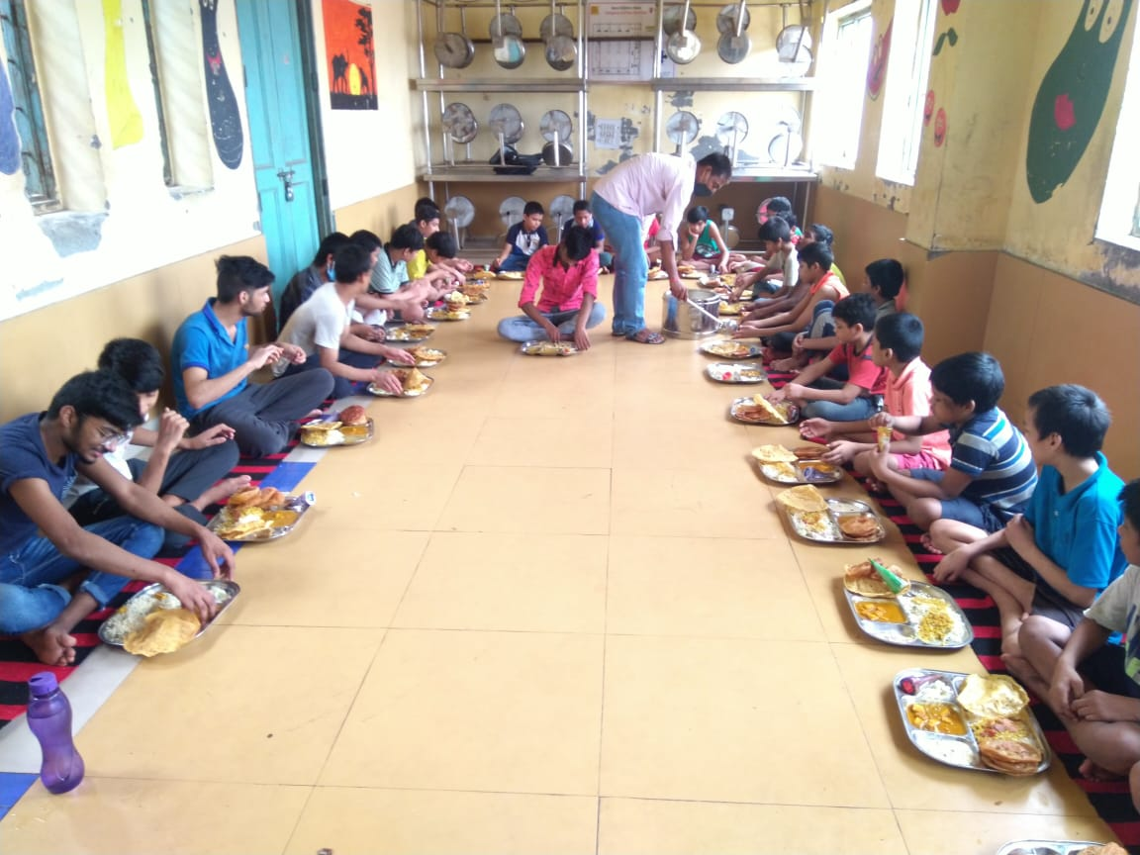
Food time

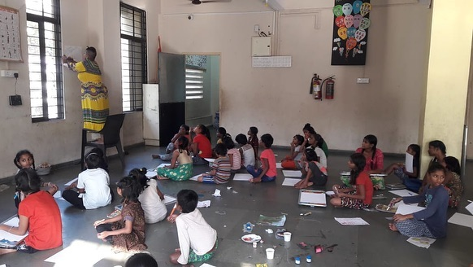
Educational session in a centre

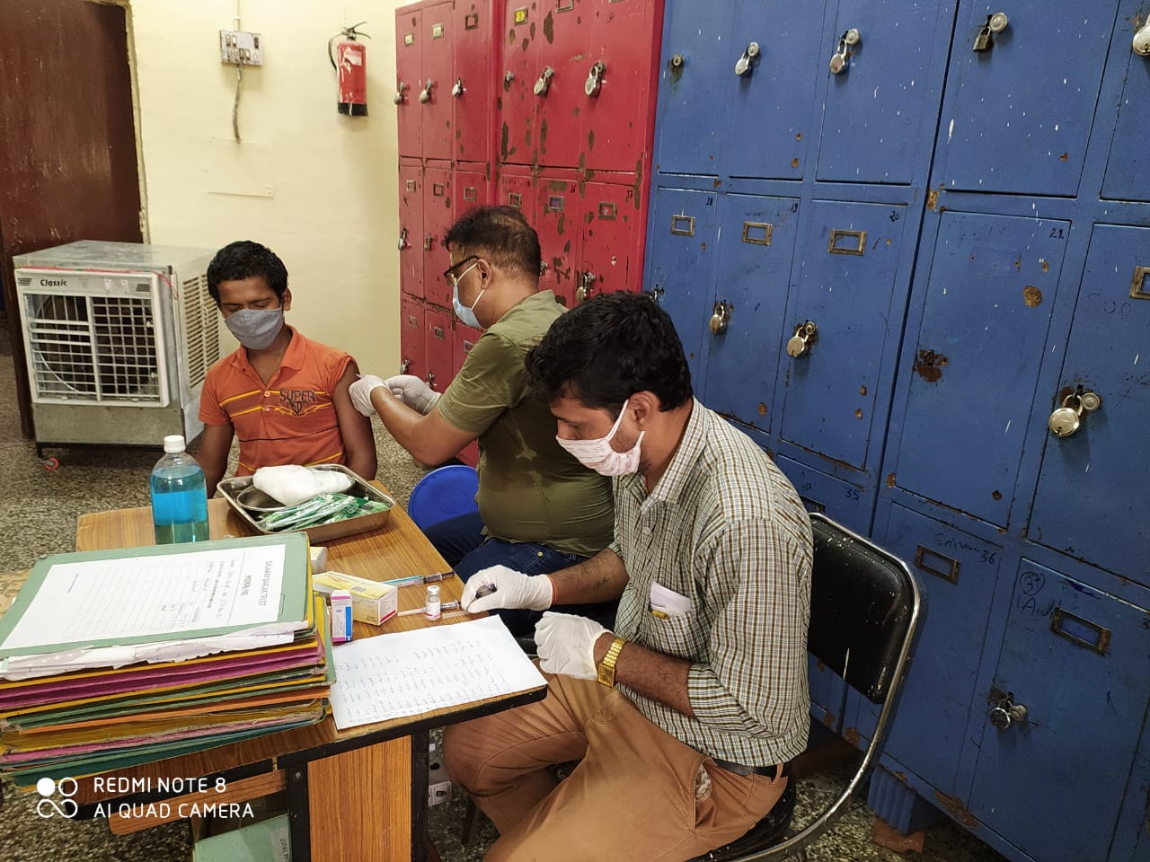
Regular health check up

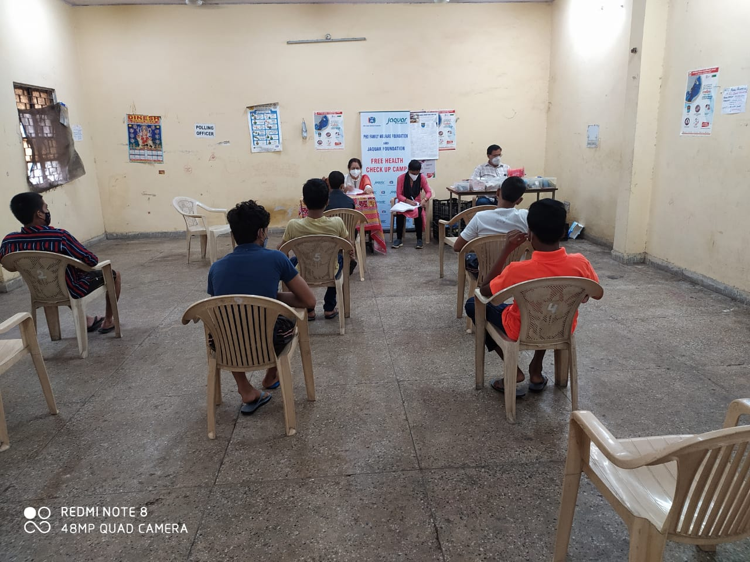
Health camp

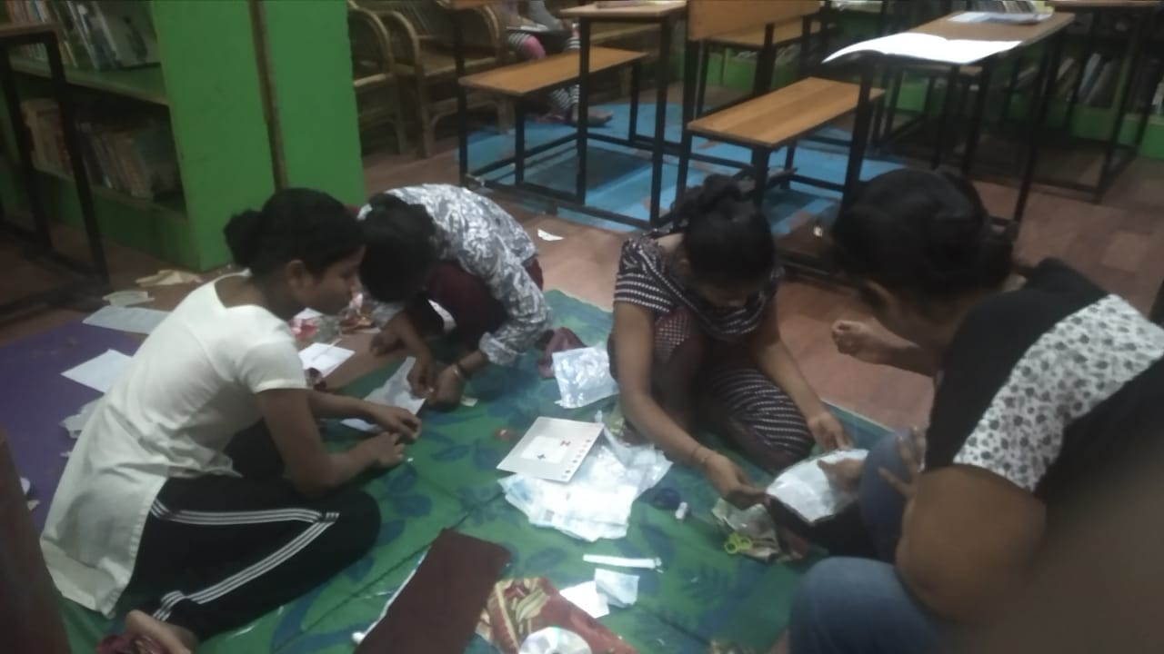
Vocational training session

Stories of Change

- Girl grows out of extreme family hardships and ready to fly the skies

Komal (name changed) is now a 19 year old girl, intelligent, smart and full of potential!

Five years ago, Komal (a child) was brought to SBT through another NGO. Komal’s father had passed away few years back and her mother had to deal with severe health issues. Komal’s younger sibling too suffered from major health issues. Due to the vulnerable situation, Komal was placed in a long-term care home for girls run by SBT.

Komal was given a comfortable environment so that she could settle in. Initially, she was enrolled in Non Formal Education and was provided mental health support. After a while she wasenrolled in formal education in Anantam Public School and later she was enrolled in Aarsha Public School.

Recently Komal completed her 12th standard and in interested to pursue an Air Hostess training at Frankfinn institute. She is an active child and loves to participate in all the activities of the centre. She has the capability to perform well.

SBT is committed to support Komal in completing her graduation and to undertake the Air Hostess training.

- Boy with special needs learns to cope with the world

Tridev (name changed) is a 6 year old boy with intellectual disability (including problem with speech), living in Aasra home for boys run by SBT. The boy is living in the centre with the support of caretakers round the clock.

Tridev was found on the street in Tilak Nagar area of Delhi by the police. Since the boy could not communicate due to his disability, he was produced before the district Child Welfare Committee (CWC). There was no trace of Tridev’s family. Soon the CWC ordered the child to be placed in a children’s home run by SBT.

After sometime in the children’s home, Tridev fell ill and the medical checks found that he had a stone in his gall bladder. He was admitted to Deen Dayal Upadhay Hospital where he underwent a surgery. Further medical interventions revealed that the boy suffers from mild intellectual disability. He has a poor eye contact and unable to respond to social interactions. His language is not present but he can express need non-verbally (pointing and gesture). Fine motor skills are present but he has poor grip to hold objects.
Despite the challenges, there has been significant change in the overall situation of Tridev due to the efforts of all the staff of SBT. Today Tridev is able to sit in a group and play with others. He also engages in individual activities. Efforts are on to see that he is able to speak few words and communicate better with gestures. Tridev would be involved in speech therapy and special education soon.
Tridev is cognitively very sound. He understands human emotions and feelings. Even though he finds it hard to empathise, he understands the repercussions of his behavior on the outside world. He is a jovial boy and enjoys being around people he is comfortable with. He has a sense of possession as well. He likes to dress up and engages in some age appropriate activities. Tridev doesn't harm others and has an affinity to animals and is gentle with them. Tridev’s biggest strength is that his weaknesses are due to his past events and a result of his conditioned mind rather than innate, which leaves tremendous room for change and improvement.

