Narrative Report
Sr. No | Items | Details
1 | Name of the Organization  (with address): | Salaam Baalak Trust (SBT)  D.D.A. Community Centre, 2nd Floor, ChandiwaliGali, PaharGanj,  New Delhi - 110055
2 | Name of the Project | Extending Psychological Support to Street and Working Children
3 | Location of the Project | The project is targeting children in Delhi and NCR.
4 | Broad Objective: | The key objectives of the project are to:  - To extend psychological support to children rescued from the streets and ensure their emotional and mental well-being  - To provide adequate support to children with learning and developmental challenges by enrolling them to special schools and enrolling them in professional institutions for therapeutic treatment
6
7 | Beneficiaries | The target beneficiaries of the project are children living in the residential centres of SBT
8 | Activities conducted  against Activities  Proposed | In the reporting period of the project, following key activities have been conducted by the project team.  - Referral Sessions: Thesesessions are being conducted with the children who need regular counselling and face psychological difficulties and clinical symptoms.The appointed mental health team member conducts detailed clinical assessments and if specific problems are found then the case is discussed in the core group meeting for a clear diagnosis. Following this management plansare made and discussed with the concerned staff members. These plansarebeing implemented by the combined efforts of the team comprising of a psychiatrist, psychologist and social workers.  - Psycho Social Counselling: The sessions are being conducted for children through informal discussions and problem solving. The issues currently being addressed during these sessions include, behavioural issues, anger and aggression management, sex and sexuality, emotional issues, drug abuse, relationship issues, academics, religion, belief systems, anxiety over a career decision among others.  - Group Sessionshave been regularly organised to address psycho social issues. These session have been conducted in groupsofeight to 10 children. The sessions are mostly arts based to provide a non-threatening environment to children and enable them to share their problems and solve these through collaborative learning. These sessions have been instrumental in helping children heal at their own pace.  - Enrolling Children with Special needs in Specialized Institutions: The children with learning disabilities have been enrolledin institutions likePrabhat Resource Centre and Orkids School for special educationand St. Stephens hospital for speech therapy.  - Extending In-House Academic and Psychological Support: The teachers and social workers at the centre are providing academic and psychological support children with learning disabilities and they are regularly monitoring their progress as well.  - Child Development Units (CDUs): The units provide children with neuro-developmental difficulties, a safe, nurturing environment and aim at early screening of mental health problems followed by carefully planned interventions. These were set up in September 2015. At present the CDU is covering eight boys with Autism Spectrum andattention deficit hyperactive Disorder.
9 | Challenges | The key challenge pertaining to child development unit has been the need for a multidisciplinary trained team as the children with special needs require different therapies viz.,speech therapy, and occupational therapy, sensory integration therapy etc. The team is making efforts to increase and enhance its human resource base does despite fund constraints.
10 | Lesson Learnt from the initiatives | The mental health team has made efforts to liaison with some institutes who work with special needs children and to understand their structure of working in limited funds and services with a perspective to learn and adopt some good practices in our systems.
11 | Impact of programme in the proposed area | Increased frequency of group therapy and other focussed sessions provided to the children in residential centres has resulted in deeperinsightson difficulties and strengths of children which the team has been able to leverage to instil confidence among children of residential homes. Thereby empowering them.
12 | Achievements | Child development unit is functioning smoothly and recently the team has successfully managed to capacitate and rehabilitate a 18 year boy with a genetic anomaly.
13 | Project related  Success Stories, Case  Studies, &  Photographs | Success Story  Anu*is a 10 year old girl who came to S.B.T’s girls residential centre through child welfare committee. She seemed to be disoriented and failed to give any information about her whereabouts. She had frequent episodes of seizures and exhibited other clinical symptoms such as irritable mood, hyperactivity, impulsivity.She could not make friends as she had language difficulty ad also would get agitated on menial issues.  The counsellor used play way methods to build a rapport with the girl and did a detailed mental status examination which indicated that she had significant global developmental delays. Her case was referred to a Psychiatrist and some medications were prescribed to reduce her hyperactivity and seizures. Regular counselling by the in house counsellor resulted inAnu gaining better control over her gross motor skills and there has been an improvement in her peer interaction. Now, she often maintains eye contact and has learnt a few Hindi sentences also.  She will be soon starting her sessions in a private institute called Children First and would work towards bringing a positive change in her overall development.  (*Name Changed  Note: Photographs of different activities conducted by the project team with children have been enclosed below)
14 | Press Coverage on the Project (if any) | NA
15 | Any special activity undertaken by Charity  Partner | NA

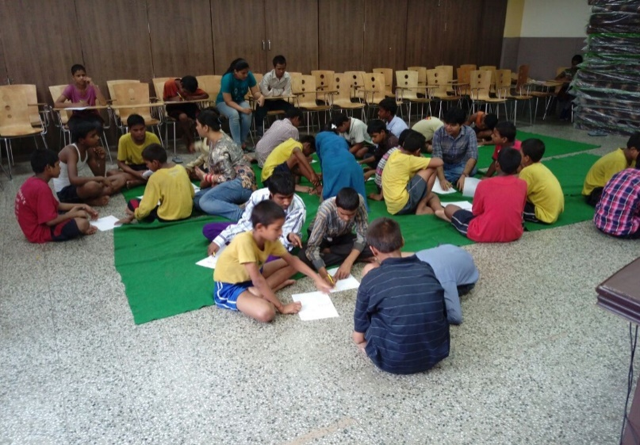
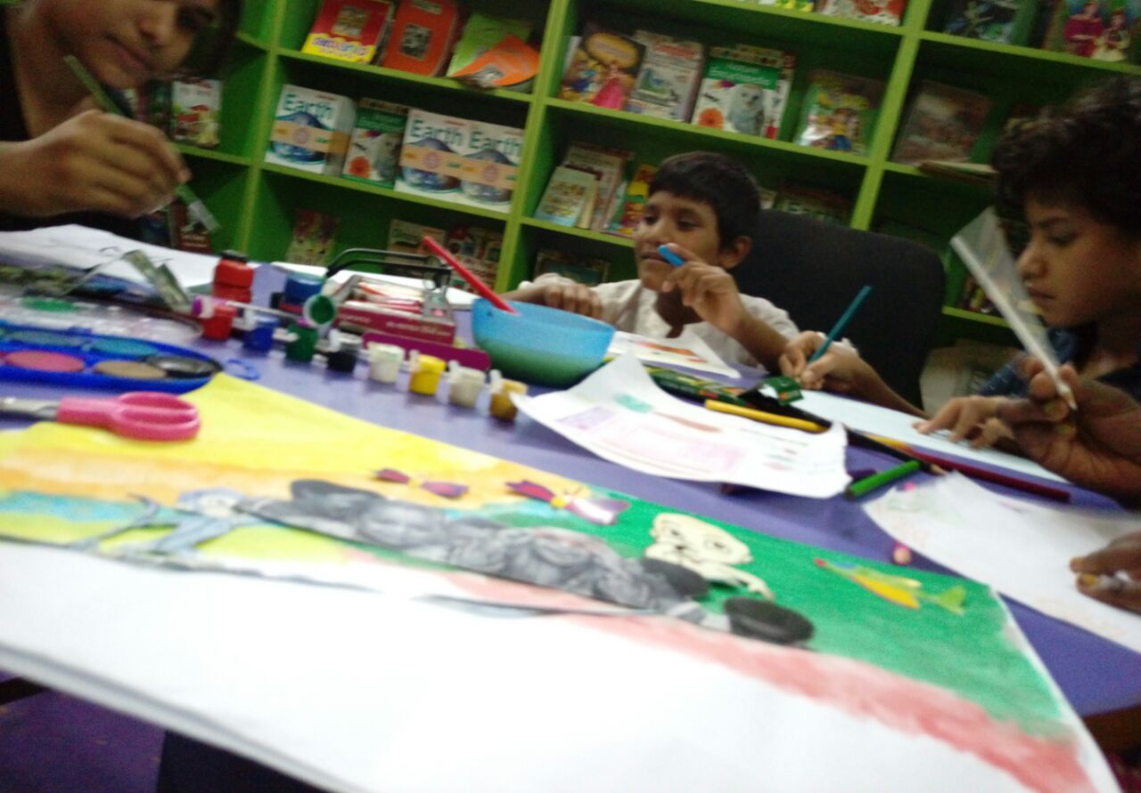
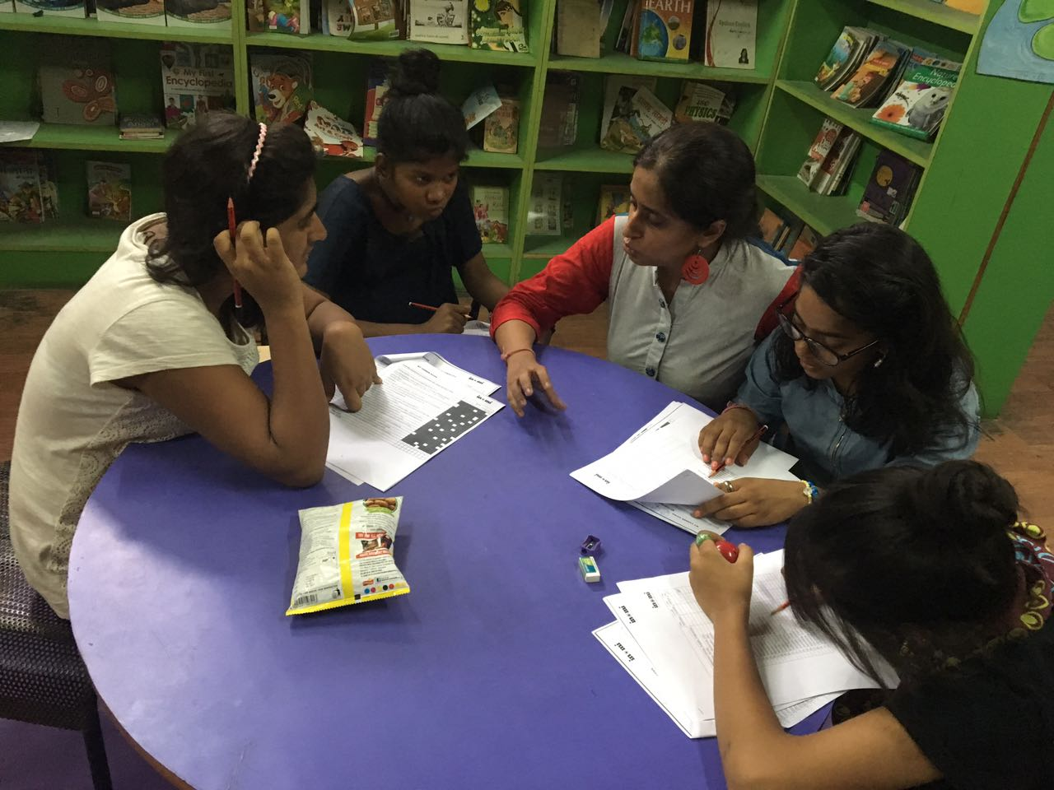
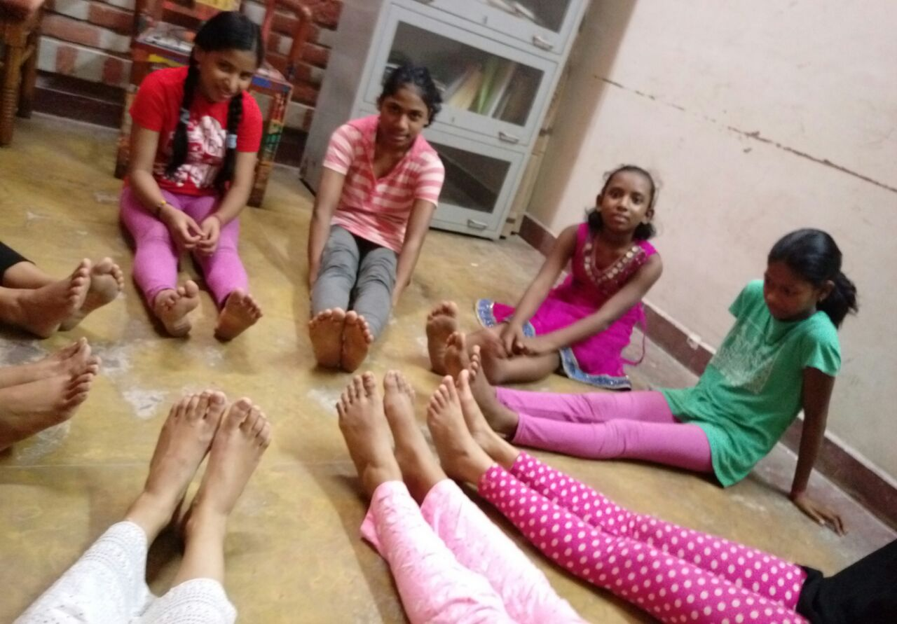
Visual Overview of Activities

