Progress Report

Residential Programmes 2016

Salaam Baalak Trust

Submitted by: Salaam Baalak Trust

Contents

Introduction 3
Brief Overview of Different Centres 3
Activities and Progress Update 4
Future Plan 5

Introduction
Street children are deprived of protective environment of family. Article 20 of United Nations Convention on the Rights of the Child recognizes the right of such children who cannot be looked after by their own family to special care. The Government of India also accorded serious attention to provide protective environment of children in need of care including street children through enactment of the Juvenile Justice (Care and Protection of Children) Act, 2000 and subsequent amendments to the Act. The Act in its Section 37 provides for establishment of shelter homes for children in need of care and protection. Significance of shelter homes and residential centres for street children is immense, given the exploitative, violent and hostile situations they face in cities. Shelter homes or residential centres act as safety nets protecting street children from sexual abuse and exploitation, physical violence and child labour.

SBT Residential Centres are Unique
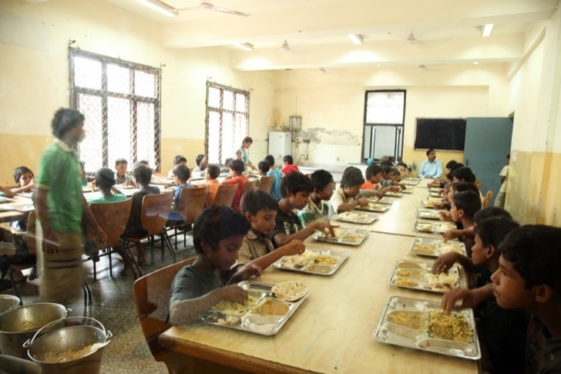
Unlike orphanages, shelter homes and other child care institutions, full-care and short stay residential homes provide an enabling environment to children to realize their potential to the fullest. An attempt is made to educate and help children develop intellectually at these centres. However, children who are not inclined towards academics are not pushed towards a definite career path. Children are provided opportunities to develop their hidden talents and skills. They are encouraged to pursue dance, puppetry, acting, painting and photography as well.

Brief Overview of Different Centers

Centre | Catering to Boys or Girls | Brief Overview
Aasra shelter home | Boys | Aasra was the first shelter home started by SBT. With a capacity of 50 it caters to boys of five to 18 years. The home was set up under the JJ Act, 2000.
Apna Ghar open shelter | Boys | It is an Open shelter, where children come stay short duration and then they are either restored or posted in a long stay home. The home was set under the JJ Act, 2000.
DMRC children’s home | Boys | DMRC Children’s Home was established as part of Delhi Metro Rail Corporation’s corporate social responsibility. The home houses 100 boys from the age of five to below 18 years.
Old Delhi Railway Station (ODRS) Open Shelter | Boys | ODRS is an open shelter catering to boys. It is an Open shelter, where children come stay short duration and then they are either restored or posted in a long stay home. The home was set under the JJ Act, 2000.
Arushi shelter home | Girls | Arushi was first girls’ shelter home under SBT. It is an initiative to offer 24 hour shelter to girls between the ages of five years to 18 years living on the streets.
Udaan shelter home | Girls | Udaan was initiated with the support of Give 2 Asia in March 2010. It started with eight girls and currently shelters more than 70 girls at a time.

Activities and Progress Update
Understanding the importance of ensuring a safe environment for children, SBT runs full-care residential homes for girls and boys who live on streets. Aasra, Apna Ghar, Old Delhi Railway Station Open Shelter (ODRS OS) DMRC Children Home are home for boys; Udaan Home and Arushi are shelter homes for girls. Besides serving the prime purpose of providing a ‘safe living space’ to children, residential homes offer a comprehensive package of services including food, education, medical care, mental health and psychological support. Children’s admission in the centres is ascertained after they are duly presented in CWCs as per the provisions of the JJ Act, 2000. Identifying the unique background and needs of the child, individual care plans are drawn for each child in these centres. Regular academic, psychological and medical assessments of the children are done to provide individualised education and health facilities. Full-time mental health professional and medical coordinator are appointed in the centre to provide psychological support, counselling and facilitate medical check-ups and treatment of children, respectively. The continuum of care and protection services provided at the residential centres have been depicted in the Figure below.

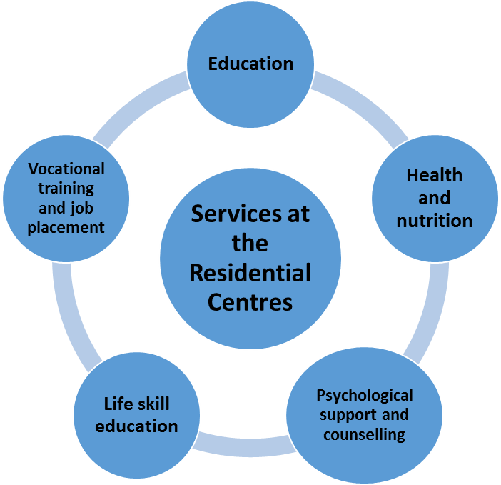

A snapshot of different residential centres, services provided by them and outreach in From April 2015-March 2016 has been presented in the Table below.
 | Apnaghar | ODRS OS | DMRC | Arushi | Aasra | Udaan | Total
Total Outreach
Total Outreach | 253 | 759 | 927 | 149 | 859 | 69 | 3016
Restoration | 22 | 218 | 690 | 82 | 663 | 02 | 1677
Education and Skill Development
Formal Education | 13 | 13 | 54 | 34 | 00 | 56 | 170
Non-formal Education | 134 | 312 | 650 | 90 | 441 | 04 | 1631
Open Schooling | 07 | 03 | 17 | 13 | 00 | 06 | 46
Vocational Training | 26 | 09 | 74 | 08 | 00 | 05 | 122
Health and Medical Facilities
Medical Check ups | 393 times/107 children | 915 times/150 children | 1405 times/927 children | 605 times/149 children | 1577 times /428 children | 1094 times/69 children | 5989 times/1830 children
De-Addiction | 00 | 30 | 02 | 00 | 03 | 00 | 35

Future Plan
SBT team plans to improve the existing quality of services through increased networks, better opportunities and staff capacity building. The team is making concerted efforts to reach more number of children in the coming year.

