SBT ANNUAL TOUR REPORT
2015-16

Submitted to:
Select City Walk

Introduction
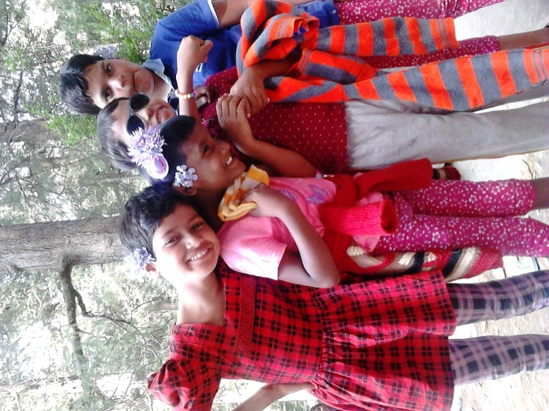
Most of the children living and working on the streets are exposed to multiple forms of exploitation and abuses having detrimental impact on their physical and psychological development.To enable these children lead a normal and healthy life, it is essential to help them overcome the pain and psychological trauma of living on the streets. This realisation in the early stages of evolution of SBT, motivated the founding members to use theatre and out station tours to form rapport with street children and help them catharsis to move on and start their lives afresh.

In the year 2015-16,the girls from Arushi were taken to a trip to Manali, Himachal Pradesh. The five day trip (June 19-25) to the picturesque hill station was both a refreshing and enriching experience for girls. In the bounty of nature, not only the girls but staff members accompanying them forgot about their mundane routine life and rediscovered themselves. A total of 38 girls and five staff members went from Arushi.

Activities
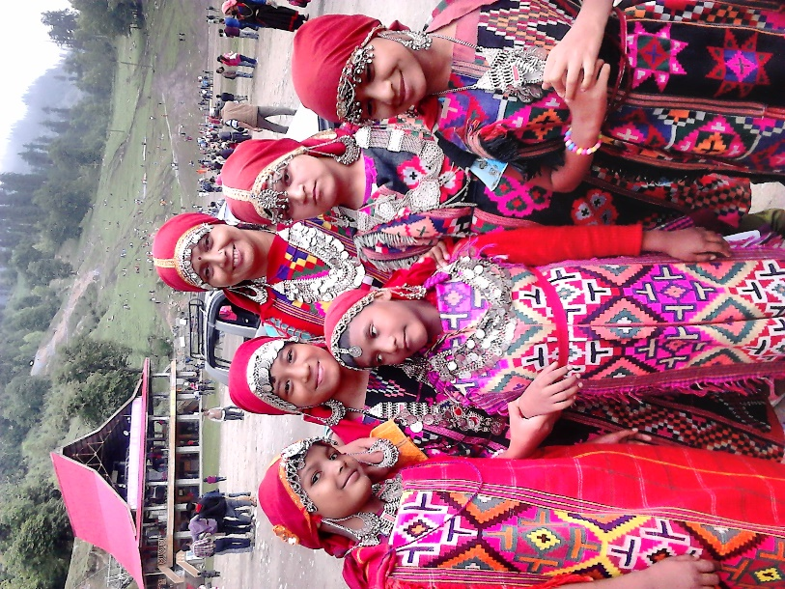
The girls left Delhi around noon on June 19. The hours spent travelling were long but interesting with short tea, snacks and girls interacting and bonding with each other. The girls reached the hotel ‘Mountainvilla’ in Manali (Nehru Kund) at 8 a.m. on the morning of June 20. The girls settled down in the accommodation and to give an official start to the activities envisaged during the trip.
- Exploring Manali: The girls began the day in Manali with a walk in the army cantonment area and explored the local places in Manali around their hotel.
- Indoor Games: During the evening, the girls danced, played badminton, ludo and chatted their heart out forming new friendships and rekindling the new ones.
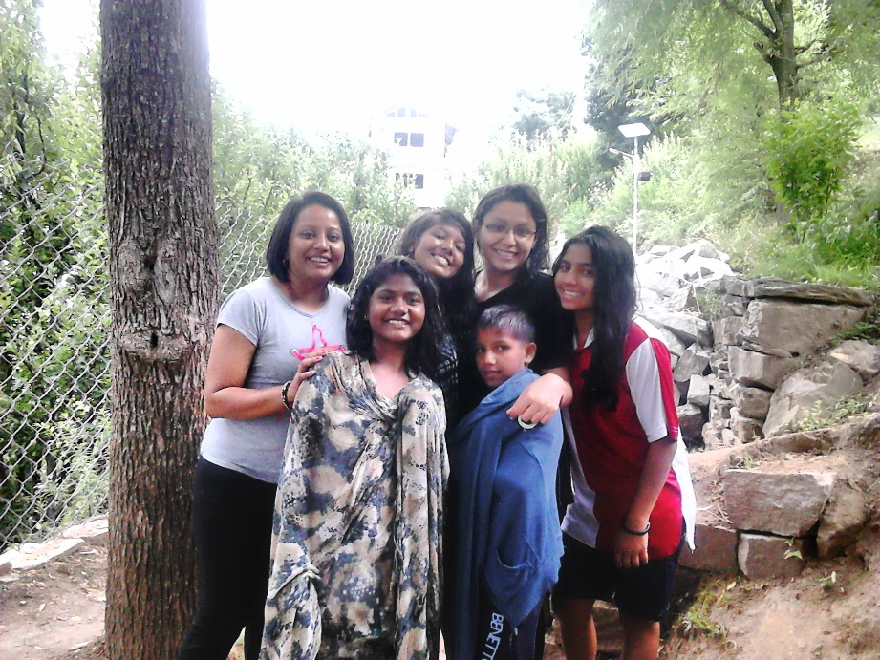
- Tourist Attractions: As part of the trip the girls visited the famous Jogni Falls. The water at Jogni was ice-cold and the girls splashed themselves wet. The only concern was that most of the girls had not brought an extra set of clothes with them and it was already raining, with there being a high possibility of the girls falling sick by the time they reached their hotel. So, they took take another break on the way and sipped some tea to keep themselves warm.
The girls also visited Solang Valley and enjoyed the indescribable beauty and lovely weather of the valley. Through cable car rides the girls were able to get a breath-taking top view of the valley. Some girls donned the ‘pahadi’ dresses and got their pictures clicked. Another worth-seeing spot visited by the girls was Roerich Art Museum and Gallery. The girls walked a distance of 3 km to see the gallery. They admired Mr. Roerich’s novel ideas and exquisite works of art. The girls also visited theHadimba and Vashishta Temple.

- Shopping: Each one of the girls was given Rs. 100 to spend at their leisure with each staff member having been put in charge of 9-10 girls for enable girls to shop. The girls headed off to the Mall Road, to shop and explore the place a little more.
- Educative Sessions with Girls: The staff also conducted educative sessions with the girls. The sessions centred on the historical importance of Himachal Pradesh and how tours and trips helped in fostering values of self-reliance and cooperating with others. A drawing competition was organised for the younger children.

Outcomes
The tour comprising an ideal mix of enriched learning and fun and frolic and paved the way for all-round development of children. The successful outcomes of the tour were:
- It improved and enhanced learning among students about the place visited, importance of conserving nature and world around them.
- Latent talent development and skill enhancement of children as children were provided with opportunities to showcase their drawing and painting skills and gained confidence to share their views in a group of people.
- Active participation in these visits further led to improvement in overall life pattern of children, through reduction of stress and negative emotions; using untapped mental and physical energy and strengthening the feelings of team building and team spirit among them.

Ministry of Women and Child Development, Government of India. (2007). Study on Child Abuse: India 2007.
Salaam Baalak Trust. (2014). Where the Mind is Without Fear, 1988-2013.

