Report November 2023

Overview
A total of 51 children are currently benefiting from this support In the month of November 2023

Educational Programs
All 51 children at the Aasra Home for Boys have been actively enrolled in formal or non-formal education programs. Out of these, 38 children are attending formal schools, 11 are engaged in non-formal education, and 2 are enrolled in the National Institute of Open Schooling (NIOS).
Education
Total | 51
Formal Education | 38
Non-Formal Education | 11
NIOS | 02

Special Events and Celebrations
- The children joyfully celebrated Children's Day on November 14, engaging in various activities.
- Birthdays of the children were celebrated to bring joy and create memorable moments.
- The District Child Protection Unit (DCPU) visited the center for a Management Committee meeting.
- A Diwali party was organized by the staff, and the festival was celebrated with great enthusiasm among the children.
- Regular volunteer engagement: One volunteer dedicatedly contributes to the center every Wednesday.
- Children actively participated in a session organized by Katha NGO.
- Notably, one child was transferred to another state, Uttar Pradesh.
- 31 children had the opportunity to watch an annual play, providing them with cultural exposure.
- A staff meeting was conducted, fostering communication and collaboration among the team members.
- Fifteen children had the privilege of attending a Diwali party hosted by JLL, further enhancing their festive experience.

Health and Well-being
- All children at the center received MMR vaccinations, ensuring their health and protection against preventable diseases.

Pictures
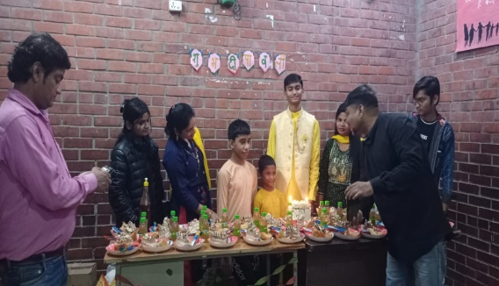
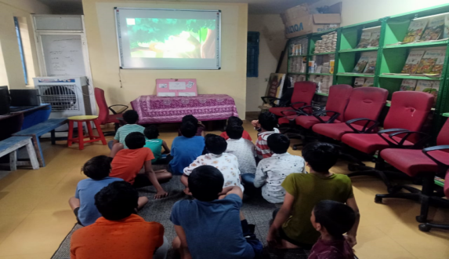
children birthday celebration Children attending katha Ngo session

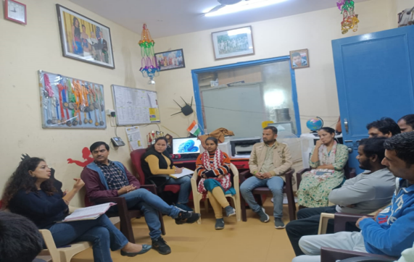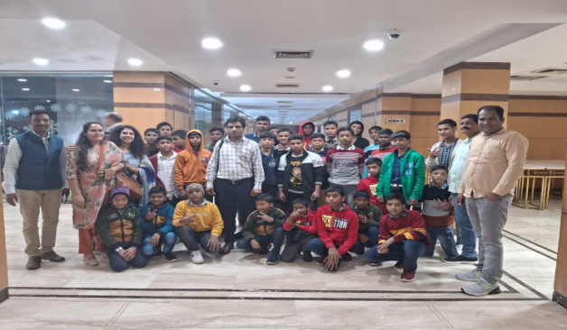
Staff Meeting SBT Annual play
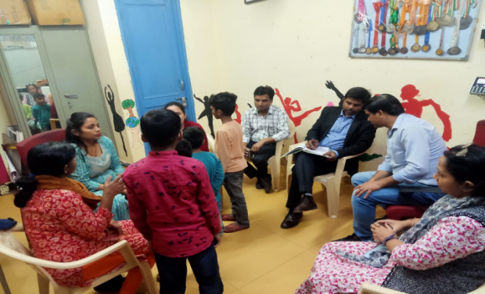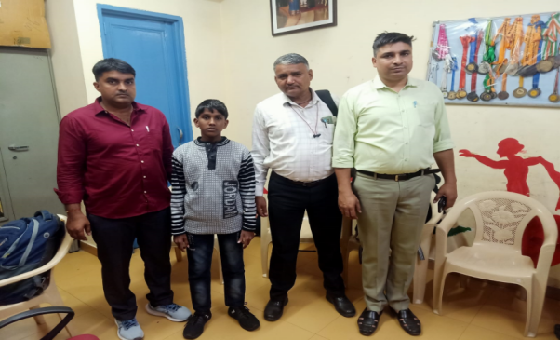

Management committee meeting one child transferred UP

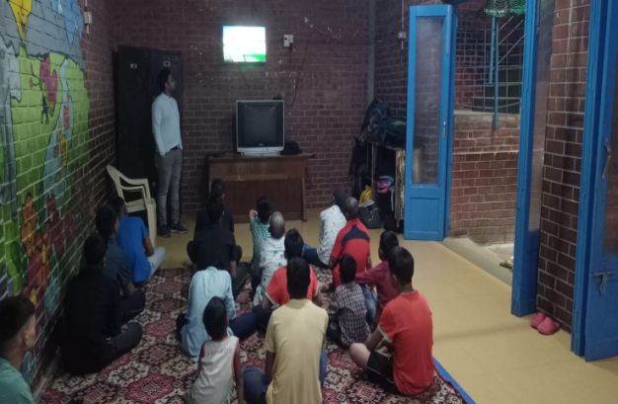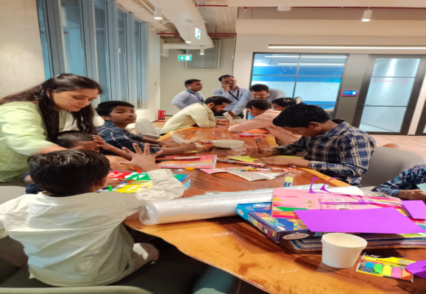
volunteer took session on importance of historical places.

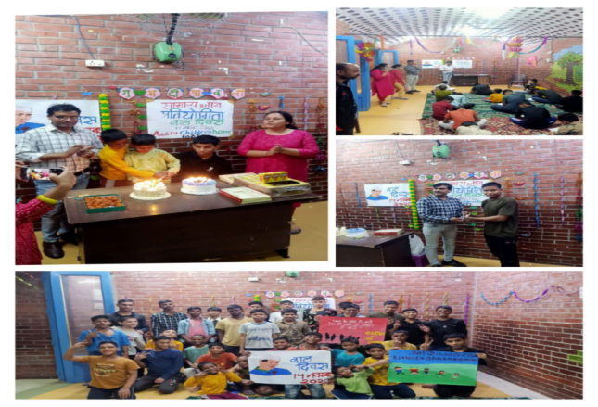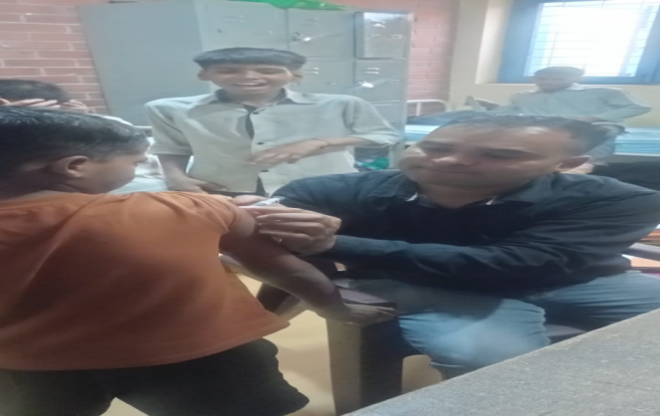
Childrens day celebration MMR vaccination camp

The month of November showcased a range of activities and events at the Aasra Home for Boys, reflecting the commitment of donors in providing not only essential support but also creating a nurturing and vibrant environment for the children's holistic development. The engagement of staff, volunteers, and external organizations demonstrates a collective effort towards the well-being and growth of the children

Thank you for your continued support.

Sincerely,
Salaam Baalak Trust
