Tools For Empowerment

Empowering entrepreneurs worldwide with tools for success “My tools are precious to me. I didn’t get to go to school as a child. But now with the income I’ll make from carpentry I can give my two children the education I never had.” These are the words of Mathias Sibanda. As a graduate of ASAP’s Tinovaka Training Center in Zimbabwe, Mathias received a certificate and complete set of carpentry tools.
It is impossible to imagine how life-changing owning your own tools can be in the developing world. Year in and year out, eager vocational school graduates, diploma in-hand, enthusiastically seek non-existent employment - a too often demoralizing and demotivating pursuit. To help promising youth succeed, ASAP’s new Tools For Empowerment (TFE) project will provide quality tool kits to entrepreneurs around the world. Working in partnership with The Salesian Missions Don Bosco Training Centers, ASAP will empower deserving entrepreneurs who have just graduated, with quality tool kits – applying newly acquired skills to earn a living. These basic tool kits, will help to transform lives from perpetual poverty to productivity, as graduates become contributing members of their community.
Donated tools, new and used, will be refurbished as needed and tool kits created for a myriad of crafts - bicycle repair, metalcraft, sewing, carpentry, building and blacksmithing, to name a few. Working together, with our corporate partners, donors and volunteers, ASAP looks forward to launching this new program in Haiti, and will empower entrepreneurs with the tools to make a living, improving life for families all over the world.
ASAP Partnership with Salesian Missions of Don Bosco
Tools For Empowerment in Haiti
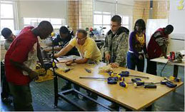
Nowhere in the western world are the needs as great as in Haiti today; where over 40% of the population is unemployed and 80% live in poverty. ASAP has teamed up with The Salesian Missions of Don Bosco Timkatec Vocational Training School in Haiti to provide badly needed tool kits for young graduates of their training center. These tools can mean the difference between poverty and productivity.
Timkatec graduates will receive tools from ASAP
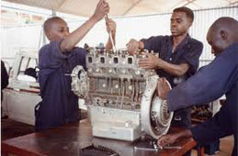

Owning tools helps graduates secure employment
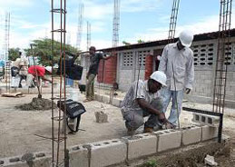

The SMDB Timkatec Vocational School in Haiti was hard hit by the January 12, 2010 earthquake, losing over 100 students. The country is slowly rebuilding from the disaster that killed over 230,000 and destroyed a million homes. Hardworking graduates from Timkatec are now equipped with the skills needed to help rebuild their devastated country. With ASAP’s Tools For Empowerment, they will have the means to get the job done.

Tools kick start success for entrepreneurs
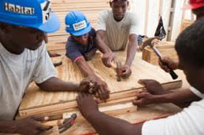

Father Joseph Simon of Timkatec Quote: "It is fundamental to show children that one loves them and really wants to help them. The rest goes automatically. It is also a work of justice towards these children whose physical, intellectual and moral development is jeopardized by a life without affection, without guidance, without constraint, without obligation. The street cannot educate in any way."


ASAP will provide tools to benefit children around the world through The Salesian Missions of Don Bosco. The Salesian Missions work to teach young people various trades that will help them find decent jobs and become self-sufficient, contributing members of society. Founded in 1815, St. John "Don" Bosco dedicated his life to the education of poor and disadvantaged young people. Originally established as the Society of St. Francis of Sales, today the Salesian Missions of Don Bosco provide vocational training and education in over 130 countries, touching the lives of millions of children and families where the need is greatest.

