Moringa to support Kenyan farmers’ health and wealth quarterly report Dec. 2015 Pictures
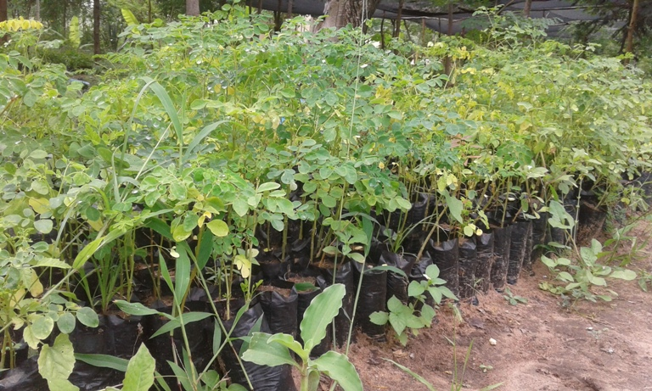
Moringa seedlings in the tree nursery

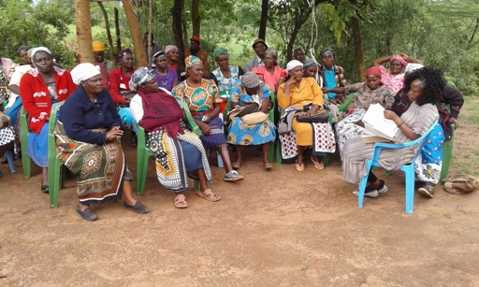
Farmers meeting/training

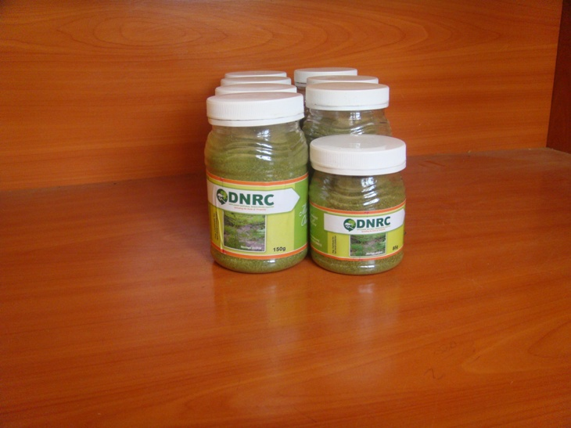
Sample of packaged moringa powder

