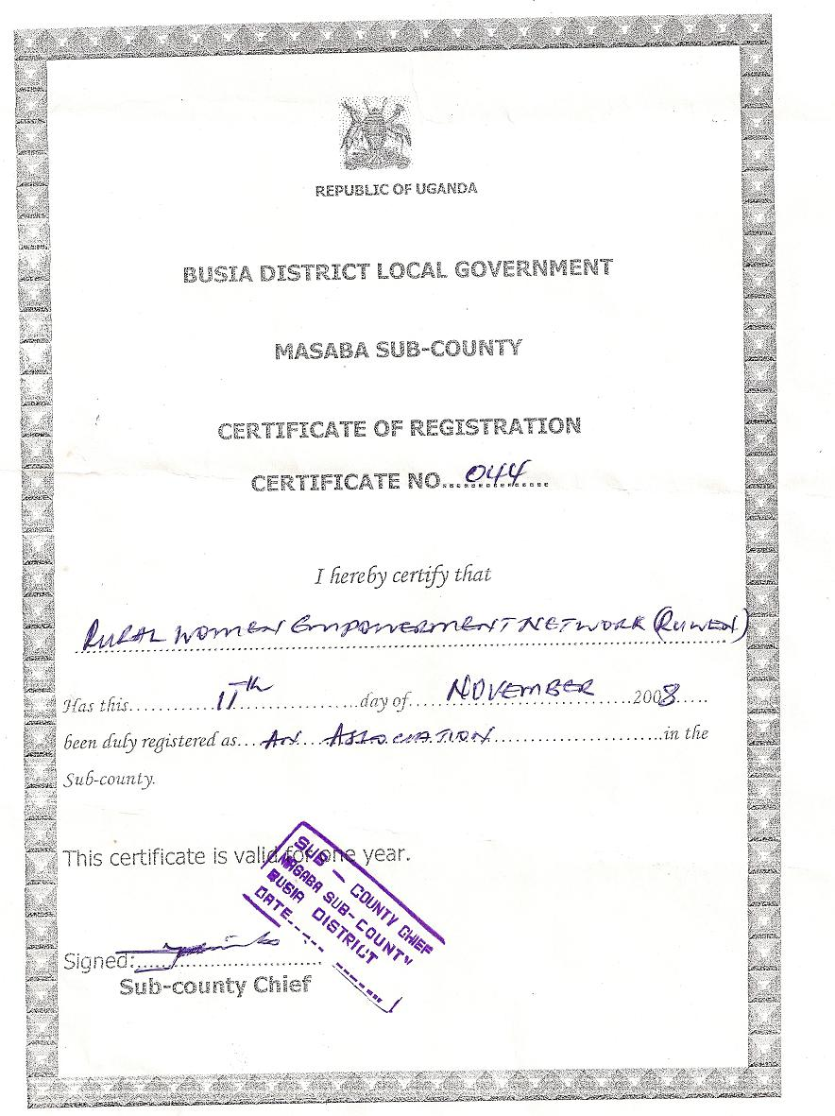

RURAL WOMEN EMPOWERMENT NETWORK (RUWEN)

BUGET ACTIVITIES’ WORKPLAN 2009 – 2010
 | ACTIVITY | ITEM REQUIRED | QTY | COST PER ITEM | PERIOD | TOTAL COST IN SHS
1 | Organization of the office | Stationary:  Pens (bic)  Files (box)  Record books  Cash books  Vote books  Writing pads  Office glue puncher  Pins masking tapes stapler  Furniture  Side board  Benches  Chairs  Communication:  Office phone | 2  10  10  1  1  10  1  2  4  3  1 | 15,000  4,000  4,000  6,000  6,000  3,000  250,000  15,000  20,000  2,0000 | 1 year  1 year | 30,000  40,000  40,000  6,000  30,000  90,000  500,000  60,000  60,000  200,000
 | Sub total |  |  |  |  | 1,170,000
2 | Sensitization and recruitment  of TOT 20 members | Meetings:  Stationary  1 ream dup. papers  Transport:  To and from meeting place  Meals:  Lunch | 4  4  4 | 9,000  500,000  500,000 | 1 year | 36,000  500,000  500,000
 | Sub total |  |  |  |  | 1,036,000
3 | Training of TOTS in HIV/AIDS long term survival skills / nutrition in the community | Meeting:  Meeting of Executive members  Lunch  TOTS  Transport  Trainees  Stationary:  Flip charts  Markers  Masking tapes  Exercise books (96 pages)  Manila cards  Pens  Seeds:  Gallic  Sukuma  Tomatoes  Onions  Egg plants  G. nuts  Meals:  Trainees / TOTS  Breakfast  Tea break  Lunch  Evening tea | 6 pple  6  6  35  5  20 dozens  5 rolls  4 dozens  20  ½ Pkt  20 Kgs  35 tins  35 tins  12 tins  12 tins  70  41  41  41  41 | 4,000  10,000  5,000  15,000  5,000  5,000  6,000  600  7,500  8,000  8,500  15,000  8,500  8,000  3,000  2,500  2,500  2,500  2,500 | 1 day  1 day  5 days  5 days | 36,000  60,000  1,225,000  75,000  254,000  25,000  24,000  12,000  75,00  160,000  325,000  525,000  93,000  96,000  210,000  325,000  325,000  96,000  325,000
 | Sub total |  |  |  |  | 3,364,500
4 | Advanced training of TOTS from other areas in long term survival skills | Budadiri, Kitgum, Kwapa  Stationary preparation  Meeting:  Lunch  Transport  Stationary:  Flip charts  Marker pens  Pens  Exercise books (96 pages)  Masking tapes  Manila cards  Meals:  Breakfast TOTS/Trainees  Evening tea  Tea break  Lunch  Supper  Transport refund:  Kitgum  Budadiri  Kwapa  TOTS  Visitors  Mosquito nets  Other essentials:  Basins  Jerricans  Mats  Accommodation  Courses centre Mattresses | 2  2  10  20  1  10 dozens  5  20  123  123  123  123  123  35  35  35  9  4  123  20  10  20  41 | 4,000  30,000  4,800  5,000  700  2,500  2,500  2,500  4,000  4,000  70,000  50,000  30,000  100,000  2,000,000  10,000  5,000  8,000  6,000  60,000 | 2 days  6 days  6 days  6 days  6 days  7 days  3 weeks | 72,000  520,000  480,000  25,000  14,000  1,845,000  1,845,000  1,845,000  2,952,000  3,444,000  2,450,000  1,250,000  1,050,000  900,000  2,000,000  1,230,000  100,000  80,000  120,000  1,500,000  2,460,000
 | Sub total |  |  |  |  | 25,722,000
5 | Capacity building food security nutrition | Organising committee meeting  Lunch for TOTS  Transport for TOTS  Resource person ( Agricultural officer)  Land hiring  Training beneficiaries (20)  Stationary:  Flip charts  Exercise books  Pens  Seeds:  Maize  Beans  G. nuts  Simsim  Potato leaves  Cassava stems  Meals:  Break tea  Lunch  Evening tea  Monitoring  Spraying  sprayers | 7  7  1  4 acres  2  3 dozens  30  100 Kgs  100 Kgs  50 Kgs  50 Kgs  10 sacks  10 sacks  27  27  27  2 seasons  2  4 | 4,000  10,000  50,000  500,000  15,000  6,000  4,000  5,000  2,500  3,000  2,500  8,000  10,000  2,500  4,000  2,500  200,000  100,000  5,000 | 1 day  1 year  1 year | 28,000  70,000  50,000  1,000,000  30,000  18,000  12,000  500,000  250,000  150,000  125,000  800,000  100,000  675,000  108,000  675,000  400,000  200,000  200,000
 | Sub total |  |  |  |  | 5,771,000
6 | OVC school age going youths | Enrolling children of school age  Stationary:  Exercise books (96 pages)  Pens (bic)  Flip charts  Masking tapes  Markers  Dressing:  Shoes  Socks  Uniform  Fees (boarding fee)  Maintainance (Beddings)  Soap bar (01)  Basins  Blankets  Mattresses  Medical care | 20  12 cartons  01 large  Carton  05  05  40 pairs  40 pairs  40 pairs  3 terms  10 cartons  20  20  20  20 | 48,000  180,000  15,000  5,000  12,000  20,000  1,500  40,000  200,000  14,000  2,500  10,000  60,000  20,000 | 1 year | 476,000  180,000  75,000  25,000  60,000  800,000  60,000  1,600,000  12,000,000  140,000  50,000  200,000  1,200,000  400,000
 | Sub total |  |  |  |  | 17,266,000
7 | Foster families to train youths in basic agricultural skills – 20 families | Stationary:  Flip charts  Markers  Exercise books  Pens  Masking tapes  Meals:  Tea break  Lunch  Resource person ( Agricultural officer)  Transport:  TOTS  Youths  Seeds:  Gallic  Maize  Tomatoes  Sukuma  Water melon  Cassava stocks  Onions  Egg plants  Houses (simple houses for grandees) | 2  2  2  ½  2  20  27  1  6  20  10 Kgs  20 Kgs  10 tins  10 tins  10 tins  20 sacks  10 tins  10 tins  3 | 15,000  12,000  6,000  400  5,000  2,500  4,000  50,000  10,000  5,000  8,000  5,000  15,000  8,000  10,000  10,000  10,000  8,500  3,500,000 | 1 year | 30,000  24,000  12,000  10,000  10,000  675,000  108,000  50,000  60,000  100,000  80,000  100,000  150,000  80,000  100,000  200,000  100,000  85,000  10,500,000
 | Sub total |  |  |  |  | 12,626,000
8 | Street children (20 children) | Identification of children in streets  Transport for TOTS  Lunch  Registration  Folder files  Photo system  Camera  Films  Courses identified  Tailoring  Saloon  Brick laying  Carpentry/ joinery  Package tools  Sewing machines  Saloon equipments  Brick laying tools  Carpentry/ joinery tools | 4  4  20  1  3  5  5  5  5  5  5  5  5 | 25,000  4,000  500  250,000  6,000  100,000  80,000  120,000  120,000  150,000  250,000  300,000  400,000 | 3 terms  3 terms  3 terms  3 terms | 100,000  16,000  10,000  250,000  180,000  300,000  120,000  1,080,000  1,080,000  900,000  750,000  1,500,000  2,000,000
 | Sub total |  |  |  |  | 8,286,000
9 | Nursery school and day care centres 30 children (OVC) | Take care of an existing nursery  Registration  Folder files  Photo system  Meals:  Maize  Soya  Beans  Uniforms:  Sweaters  Uniforms  Shoes  Socks  Medical / health  Treatment  Mosquito nets  Scholastics:  Exercise books  Crayons  Pencils | 30  30  1260 Kgs  472 Kgs  472 Kgs  30  30 pairs  30 pairs  30 pairs  30 children  30  30 dozens  90 packets  30 dozens | 500  100,000  2,000  3,000  2,500  20,000  25,000  20,000  15,000  100,000  10,000  5,000  1,200  2,400 | 1 year | 15,000  100,000  2,520,000  1,416,000  1,180,000  600,000  750,000  1,200,000  90,000  3,000,000  300,000  150,000  108,000  72,000
 | Sub total |  |  |  |  | 10,321,000
10 | Cookery | Meetings:  TOTS lunch  Stationary:  Exercise books  Flip charts  Markers  Masking tapes  Resource persons:  Caterers  Item for practicing  Baking flour  Baking powder  Milk  Tomatoes  Gallic  Food colour  Blue band  Salt  Eggs  Sugar  Materials:  Firewood  Designing materials:  Sauce pans | 6  4 dozens  2  2 packets  2 rolls  2  2 cartons  ½ carton  20 litres  2 Kgs  5 tins (½)  ½ carton  10 trays  4 Kgs  20 bundles  5 | 4,000  6,000  1,500  1,200  5,000  20,000  8,000  800  20,000  8,000  20,000  10,000  8,000  3,200  2,500  1,500  30,000 | 1 day  2 days  2 days  2 days  2 days  2 days  1 year | 24,000  24,000  30,000  2,400  10,000  40,000  8,000  16,000  20,000  16,000  20,000  50,000  8,000  32,000  10,000  30,000  1,500,000
 | Sub total |  |  |  |  | 1,907,900
11 | Agriculture mixed | Seeds:  Maize  Beans  G. nuts  Poultry:  Local hens  Cocks for cross breeding  Piggery:  Local females  Male exotic  Goats:  Exotic males top cross  Local females | 100 Kgs  100 Kgs  100 Kgs  3,000  1,000  20  5  20  50 | 4,000  2,000  3,000  5,000  15,000  80,000  100,000  300,000  80,000 | 1  1  1  1  1  1  10 | 400,000  200,000  300,000  1,500,000  1,500,000  1,600,000  500,000  6,000,000  4,000,000
 | Sub total |  |  |  |  | 16,000,000
12 | Preservation of oil foods | Simsim  G. Nuts  Tree pods  Machines  Tins for preservation  Empty tins  Empty jerricans  Salt | 100 kgs  100 Kgs  2  1  50  50  1 carton | 2,500  3,000  2,000,000  3,200 | 1 year | 250,000  300,000  4,000,000  32,000
 | Sub total |  |  |  |  | 4,670,000
13 | Environmental protection | Seed beds member’s  Contribution seedlings  Transporting seeds to areas of planting  Watering cans  Spraying drugs  Sprays | 1000  10  Identified areas  10  10 | 300  300,000  60,000  200,000  80,000 |  | 300,000  300,000  600,000  200,000  800,000
 | Sub total |  |  |  |  | 2,200,000
14 | Monitoring | Checking on the activities as set in the activity column  Transport vehicle  Lunch | 14 set  6 members  6 members | 500,000  4,000 | 7 days | 500,000  168,000
 | Sub total |  |  |  |  | 668,000
 | OVER ALL TOTAL |  |  |  |  | UShs. 108,695,000  US$: 49,230

TEOPISTA AUMA
Chairperson / Director.

