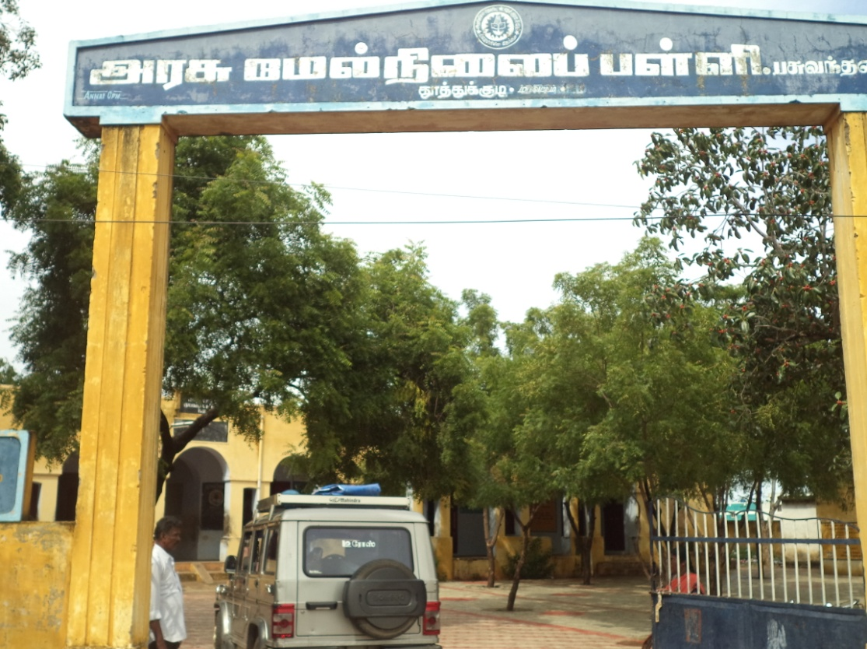
Continuous program conducted at pasuvanthanai Govt. Hr. Sec. School

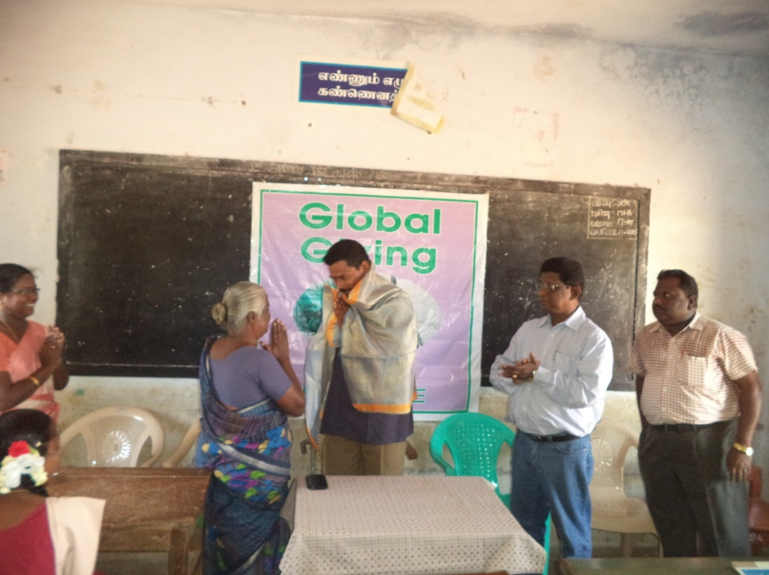

Mr. Nellai Nayagam (Forest Range officer Garland by Senior Science Teacher)

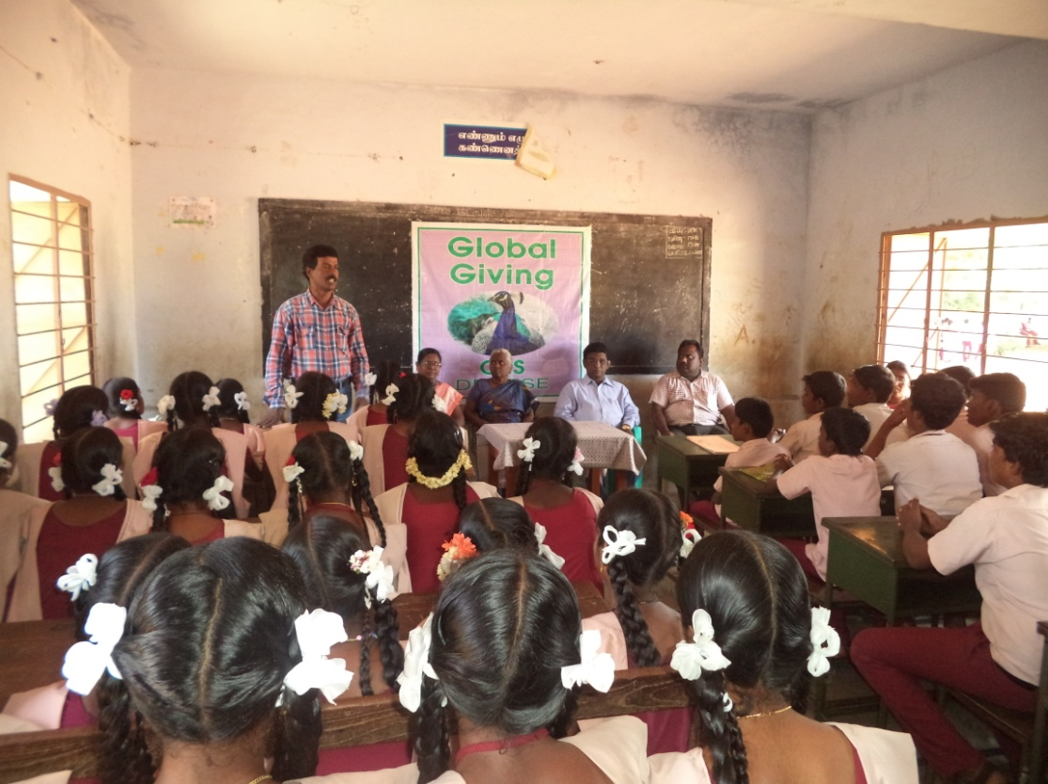
Project Manager delivered welcome address

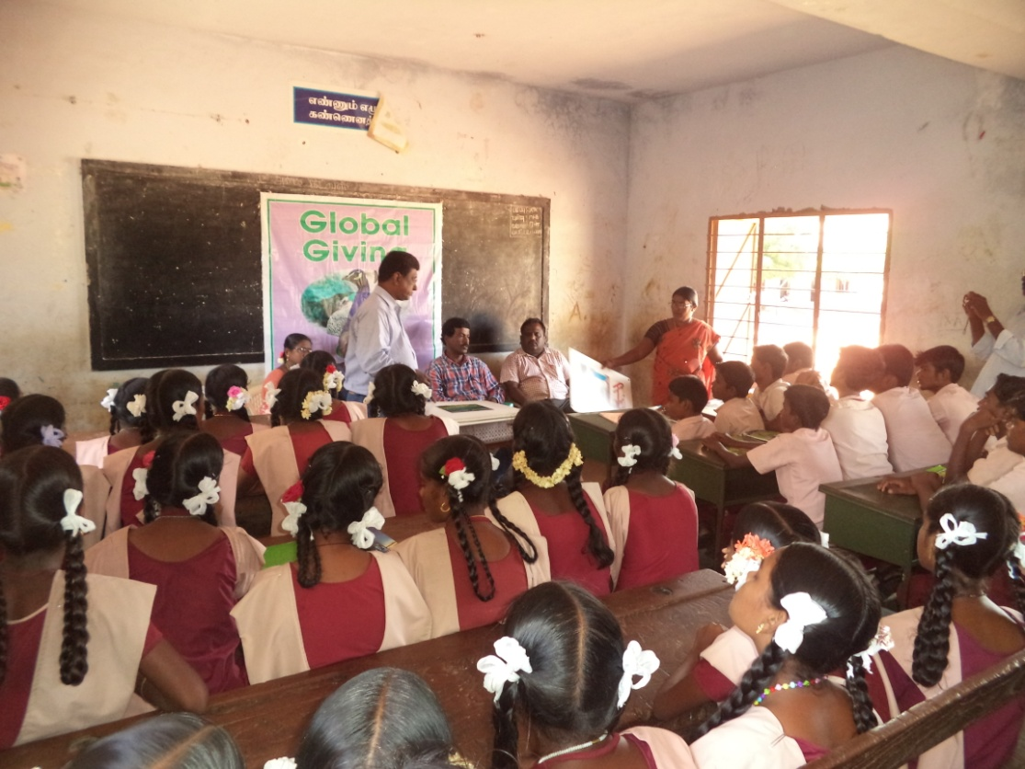
Project Director explained with plannel Board

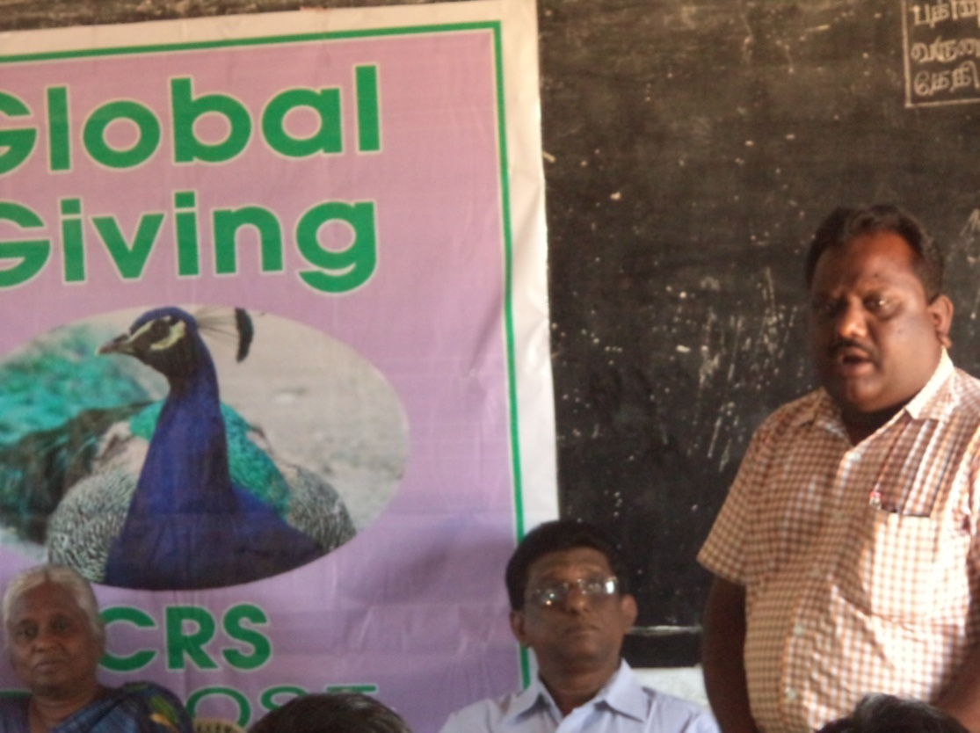
National Green Corp. In charge delivered lecture

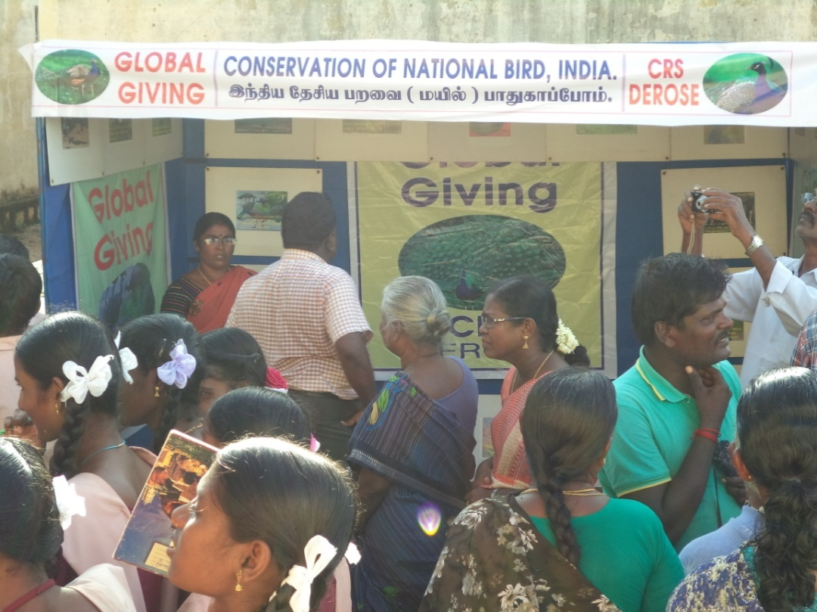
Awareness Creation Exhibition

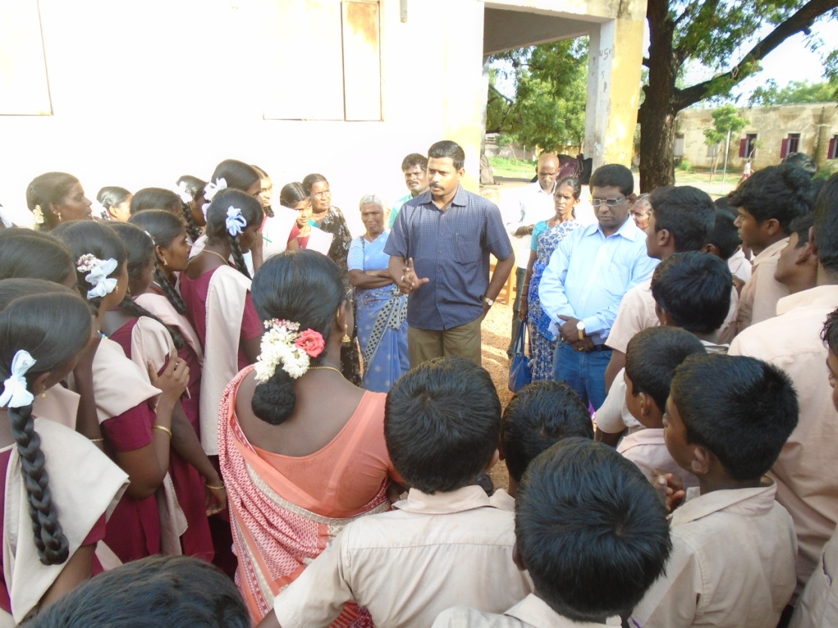
Group discussion by Forest Range Officer with our Team

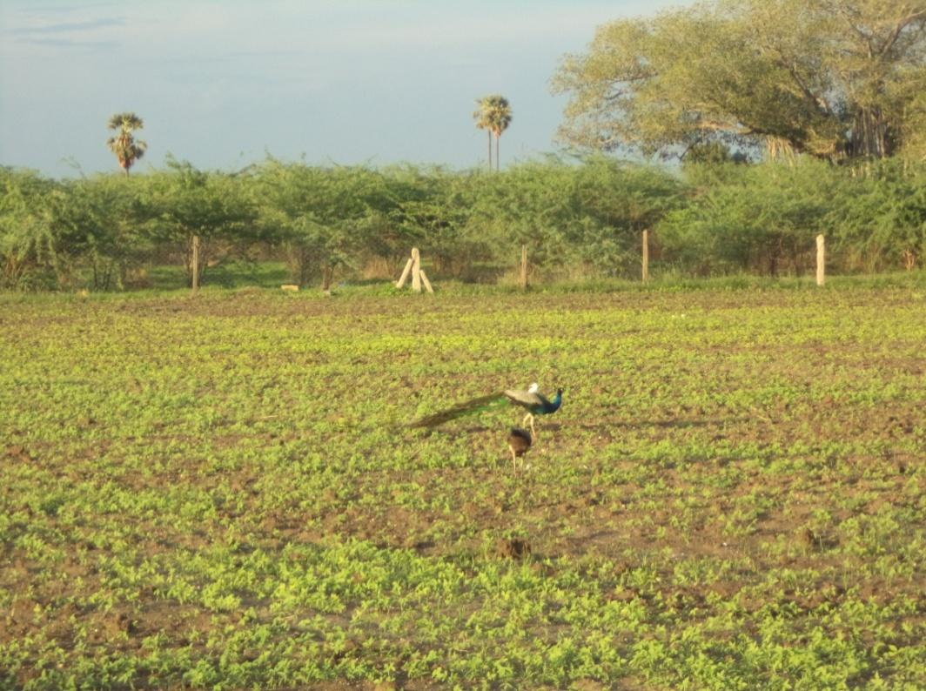
Peacocks in our Target site

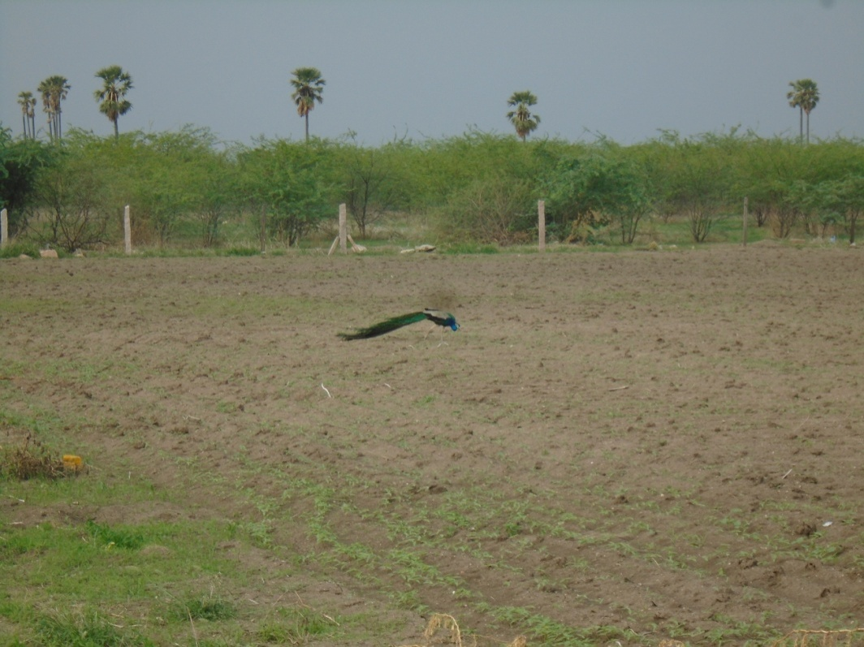

Peacock roosted at agricultural land

