AWARENESS CREATION SEMINAR
In order to protect our National Bird Peacock, Organizations Global Giving and Chevalier Roche Society jointly convened the “Peacock Protection Awareness Programme” at Govt. Hr. Secondary School Ottapidaram for boys and Girls students. In this programme Mr. Sargunaraj, Headmaster presided over this function. Mr. S. Paramasivan, Science Teacher, Mrs. K. Meenakshi, Zoology teacher and Mr. Murugan, National Green Corps. (NGC) co – ordinator participated in the programme and delivered the speeches. Dr. J. Tagore Derose, Director, Chevalier Roche Society delivered the key note address of the programme. Mr. T. Jegadeesan Post Graduate Maths Teacher delivered the vote of thanks. These programme arrangements were made by the Global Giving aided Staff Team of the Organization Chevalier Roche Society.
POINTS DELIVERED BY MR. SARGUNARAJ, HEAD MASTER:
- In Ottapidaram, Vilathikulam & Karungulam areas of Thoothukudi district peacocks are dead because of so many reasons.
- Peacocks are killed by men’s hunting, pesticides being kept to kill the insects being found among the crop plants
- As the forests dense with Acacia tree destroyed and which are the living places of peacocks, they come into the villages or towns to seek their food materials and water they meet accidents on the roads and they lost their lives.
- Sometime they find no place for their stay. That is why they sit upon the high voltage transformers and they die accidentally.
- He asked the students to know about the risk factors being available for peacocks, our National bird and to take action to prevent these risk factors. All students were requested to co-operative with risk factors.
IDEAS DELIVERED BY MRS. MEENAKSHI, ZOOLOGY DEPT:
- All living being in this world have the right to live with freedom.
- Nobody has the right to torture either birds or animals and to kill them.
- Regarding our peacocks they are killed by them by using glasses and wire mesh.
- When some aged persons hunt the peacocks, you have the responsibility to create the awareness and understanding among them.
- In food market places peacocks take an important role
- Not only the peacock is our National Bird it takes and important role in bio diversity. Peacocks are helpful to block the poisonous lives like snake etc. Therefore peacocks must be protected by all of us unanimously.
POINTS DELIVERED BY MR. PARAMASIVAN SCIENCE TEACHER:
- Peacock is the vehicle of Tamil god Murugan in Tamil Nadu State. At the same time the same peacock is killed by hunting and by poisoned food.
- According to the suggestion of Agricultural Dept. officials farmers shall naturally develop the quality of seeds and do their agricultural work.
- For the purpose of strengthened seeds, short time Agricultural fields farmers apply poisoned medicines with the feeds of maize, chicer, paddy etc. When numerous birds and animals eat those seeds they die.
- For the remedy of Hand and leg pains, swellings common people apply peacock oil traditionally with the superstation. In order to manufacture peacock oil they need peacock’s fat content, that is why peacocks are hunted. In some other places peacocks are hunted for their meat.
- We must serve as a federation to protect our National Bird Peacock along with the Organizations Global Giving and Chevalier Roche Society.
POINTS DELIVERED BY MR.S. MURUGESAN, TEACHER, NATIONAL GREEN CORPS.:
- Important duty of our National Green Corps. (NGC) is to protect the Natural Resources and forest livelihoods.
- Our National Bird peacock is a protected bird in.
- According to the forest Dept. law it is a crime that killing the peacock by hunting or for any purpose.
- Peacock has the tendency of fearing the voice of human foot step. That is why we shall not do apply poison with the seeds and spray the chemical fertilizers. We must avoid this method of killing peacocks and persecuting of our National Bird peacock.
- It is very sad that peacocks are killed our students must create the awareness of protection peacocks.

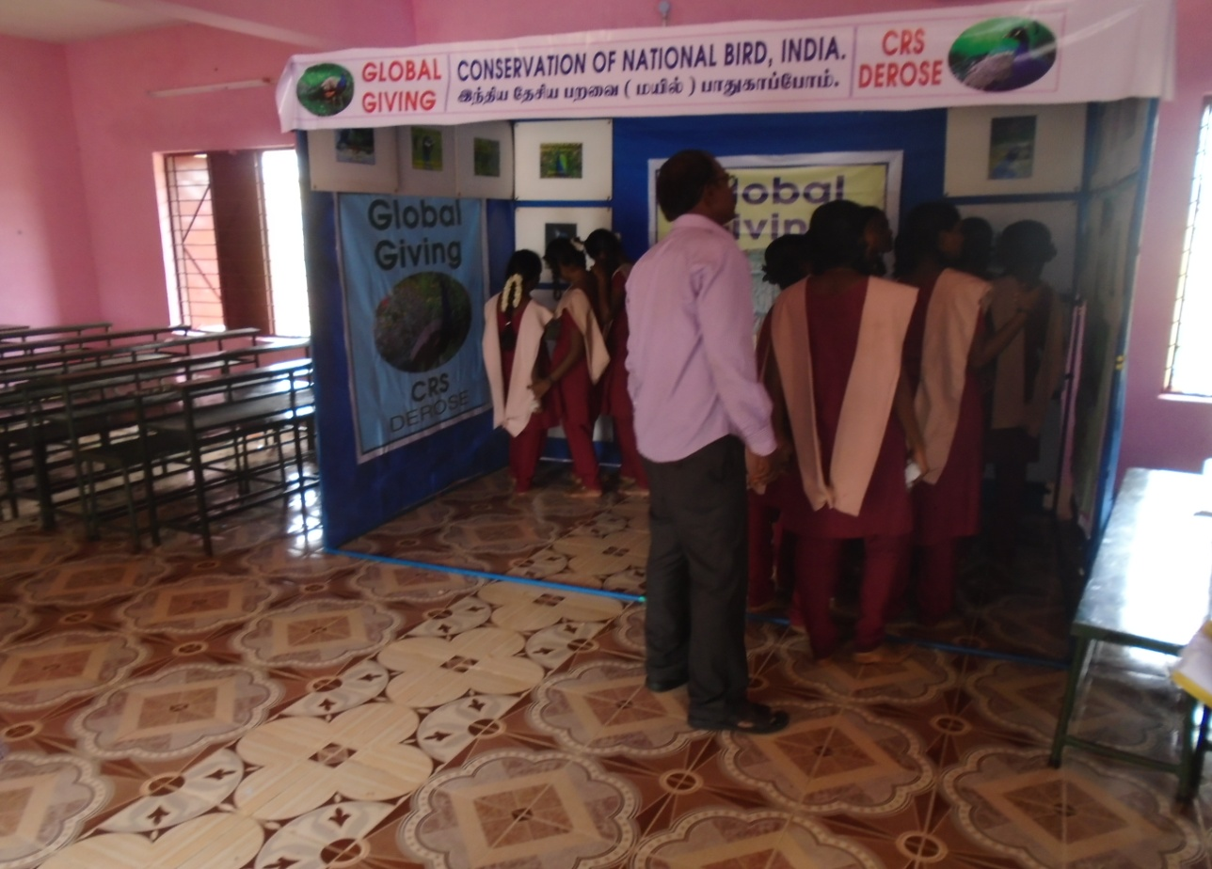

AWARENESS CREATION EXHIBITON FOR AGRI COMMUNITY STUDENTS AT
GOVT. HR. SEC. SCHOOL, OTTAPIDARAM, THOOTHUKUDI DISTRICT
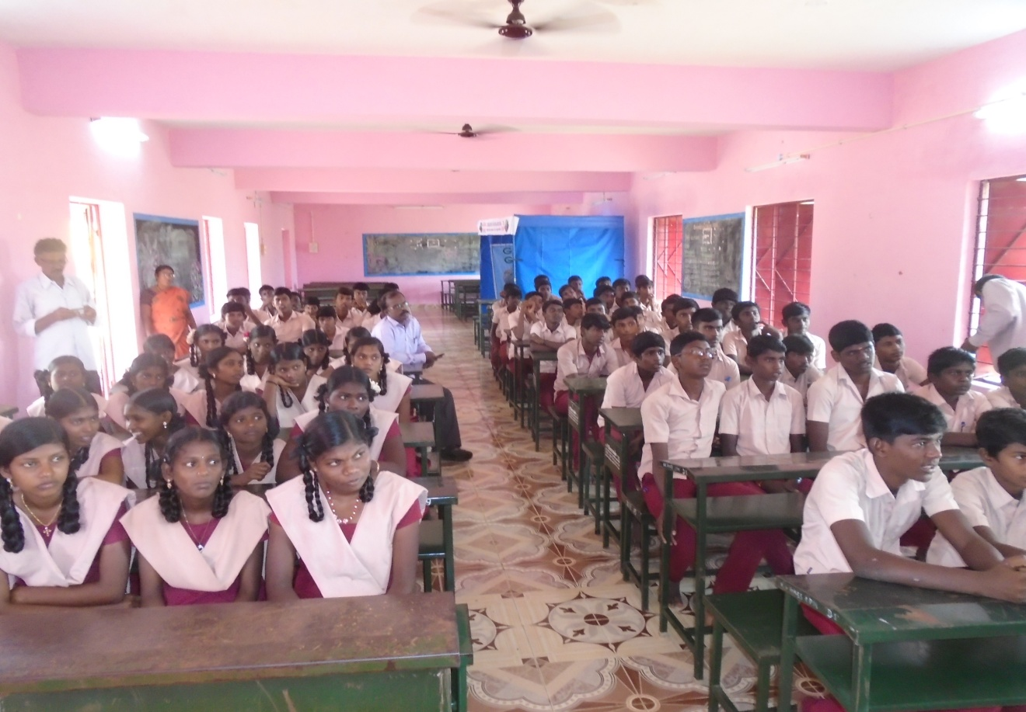

AWARENESS CREATION SEMINAR AT GOVT. HR. SEC. SCHOOL, OTTAPIDARAM, THOOTHUKUDI
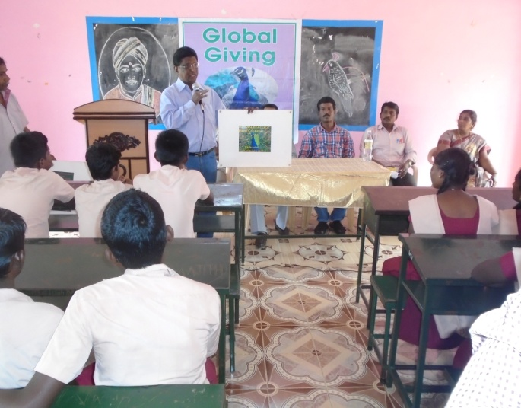
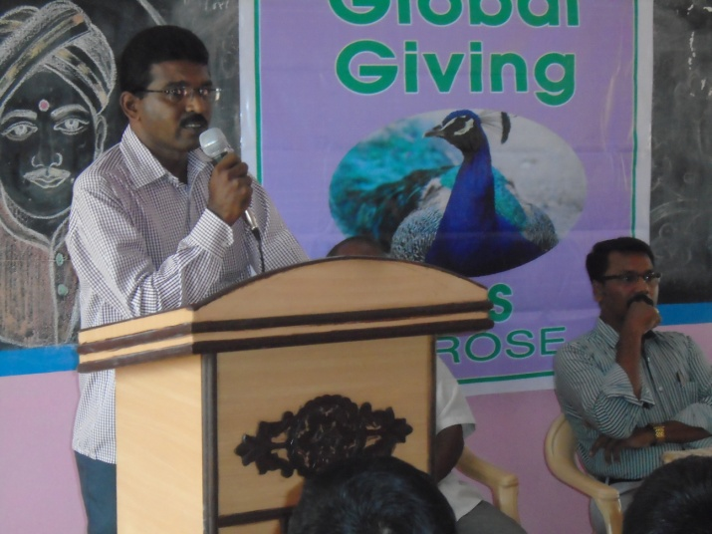

PROJECT MANAGER DELIVERED WELCOME ADDRESS DIRECTOR CREATED AWARENESS THRO
PLANNEL BOARDS
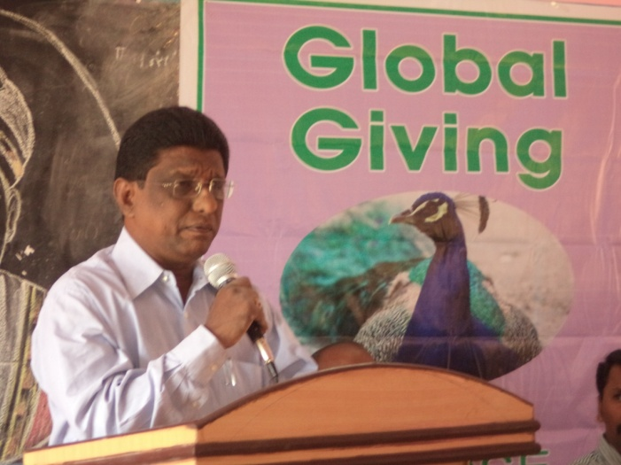
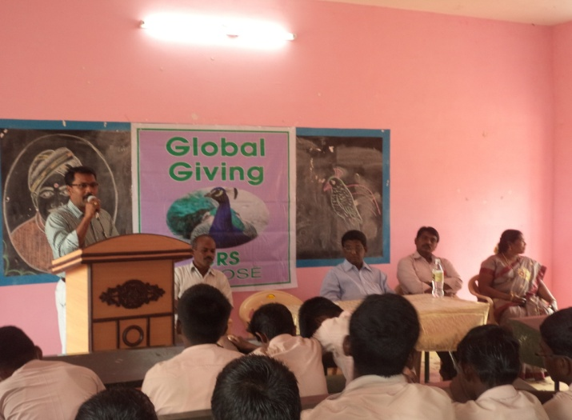

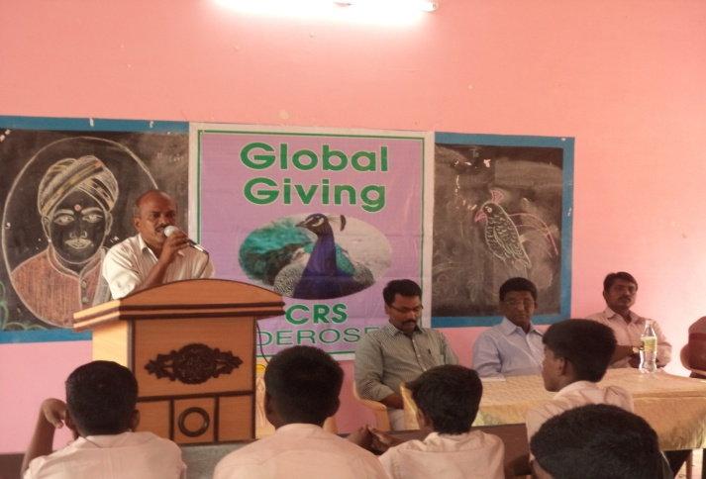
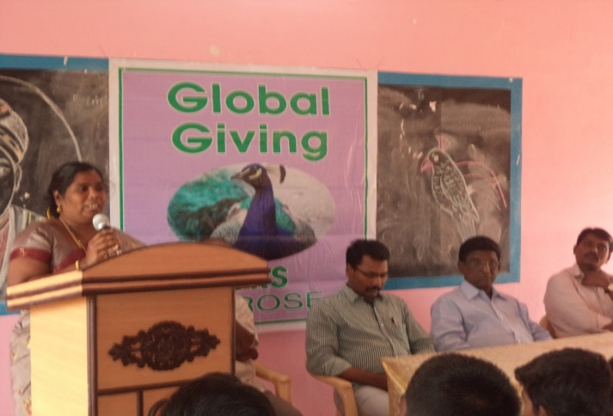
MR. MURUGAN SCIENCE TEACHER PROJECT DIRECTOR DELIVERVED

MRS. MEENAKSHI SCIENCE TEACHER MR. PARAMASIVAN, NGC CO-ORDINATOR
MIGRATED PEACOCKS:
Usually peacocks migrated to the vulnerable town areas due to the shortage of food and water. The problem is they fund very dangerous sites. We will plan to build small water tanks in the roosting sites through Global Giving Online Donation.

PEACOCK AT DANGEROUS ELECTRIC POST PEACOCK AT CHURCH
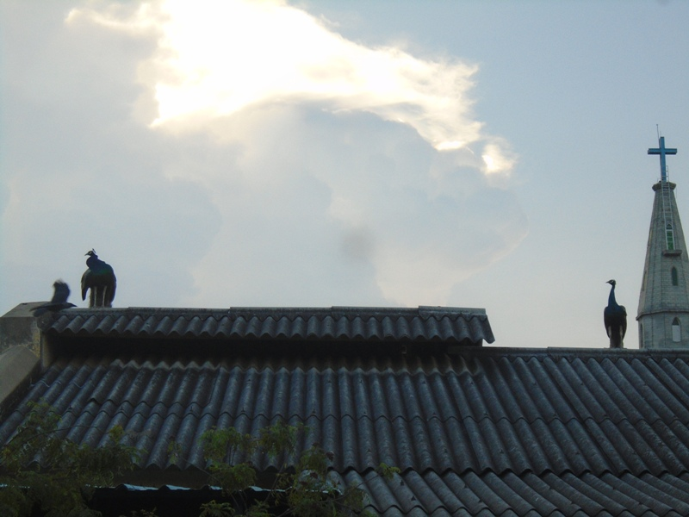
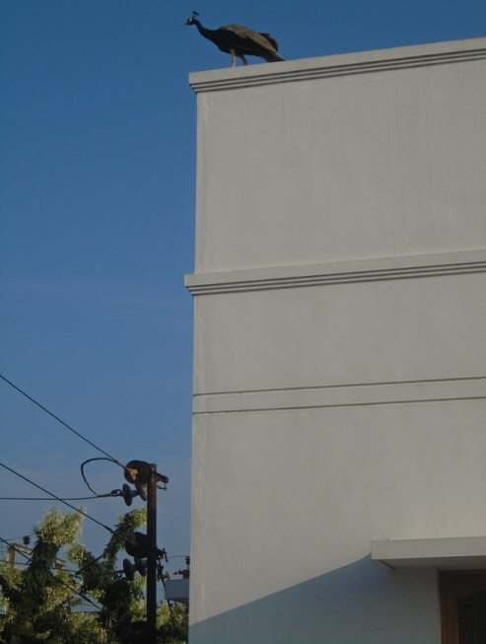

PEACOCK AT DANGEROUS ELECTRIC POST PEACOCK AT OIL MILL

