Plannel Boards being kept in Exhibition and the points here mentioned.

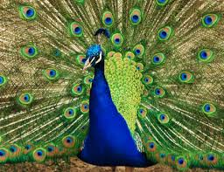
INDIAN PEACOCK
Pavo Cristatus

,e;jpa kapy;
Nghpdk; NgNth rpw;wpdk; fpwp];Nll;l];

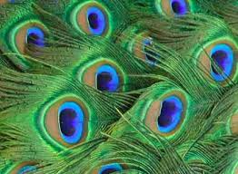
SWAN SIZED BIRD
FAN SHAPED CREAST
WHITE PATCH UNDER EYE
LONG SLENDER NECK

md;dtbt gwit
jiyapy; fhw;whb
fz;izr; Rw;wp nts;is tisak;, ePs; fOj;J

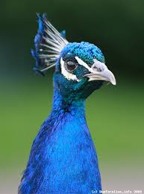
fhZk; ,lk; ,e;jpah,
rpe;J ejp, fh\;kPh;,
m];]hk;, kpNrhuk;& jkpo;ehL

ABUNDANCE: INDIA: INDUS
RIVER, KASMIR, ASSAM,
MISORAM & TAMILNADU

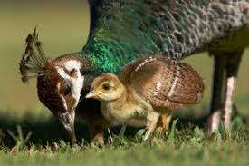
PROTECTED UNDER WILD LIFE PROTECTION ACT 1972 UNDER SHEDULE 1

,e;jpa td ghJfhg;Gr; rl;lj;jpd; gb (1972) n\l;A+y; 1 gphptpd; gb ghJfhf;fg;gl;Ls;Sj

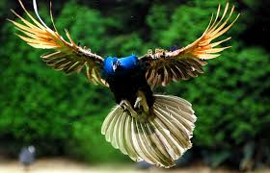

COMMON IN BANGLADESH - NOW EXTINCT
tq;fhs Njrj;jpy; jw;NghJ kapy;fNs ,y;iy, Kw;wpYk; mopf;fg;glLtpl;ld.

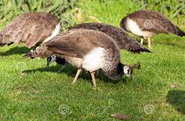
TAMILNADU - STREAM SIDE FORESTS, CULTIVATED LANDS & FOREST

jkpo;ehl;by; ePh; cs;s fhLfs; tptrha epyq;fs; kw;Wk; tdg;gFjpfspy; fhzg;gLk;.
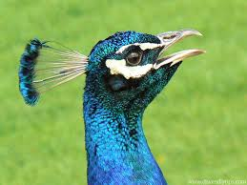
kapy; - tptrhapfspd; ez;gd; - ntl;Lf;fpsp kw;Wk; G+r;rpfis cz;Zk;

FARMERS FRIEND - EAT GRASSHOPPER & INSECTS

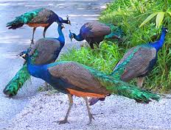

#hpa cjaj;jpw;F Kd;Dk; gpd;Dk; kl;LNk fhzg;gLk;
FORAGING AT EARLY MORNING & EVENING

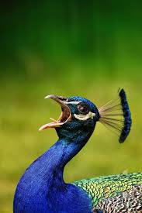
gy;Yaph; gl;rpdp
(tpijfs;, G+r;rpfs;)
OMNIVOROUS - SEEDS, INSECTS

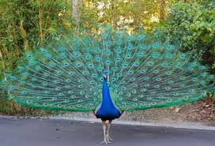

POLYGAMOUS, MATURED 2 - 3 YEARS OLD

kapy;fs; 2 - 3 tUlj;jpy; gUtkilAk;


LORD KRISHNA WITH PEACOCK FAN
fpU\;zh; kapypwFld;

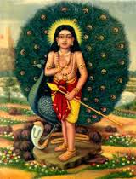

LORD MURUGA WITH PEACOCK
KUf flTspd; thfdk;
kapy;

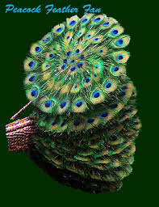
FEATHERS FAN

kapy; mopT

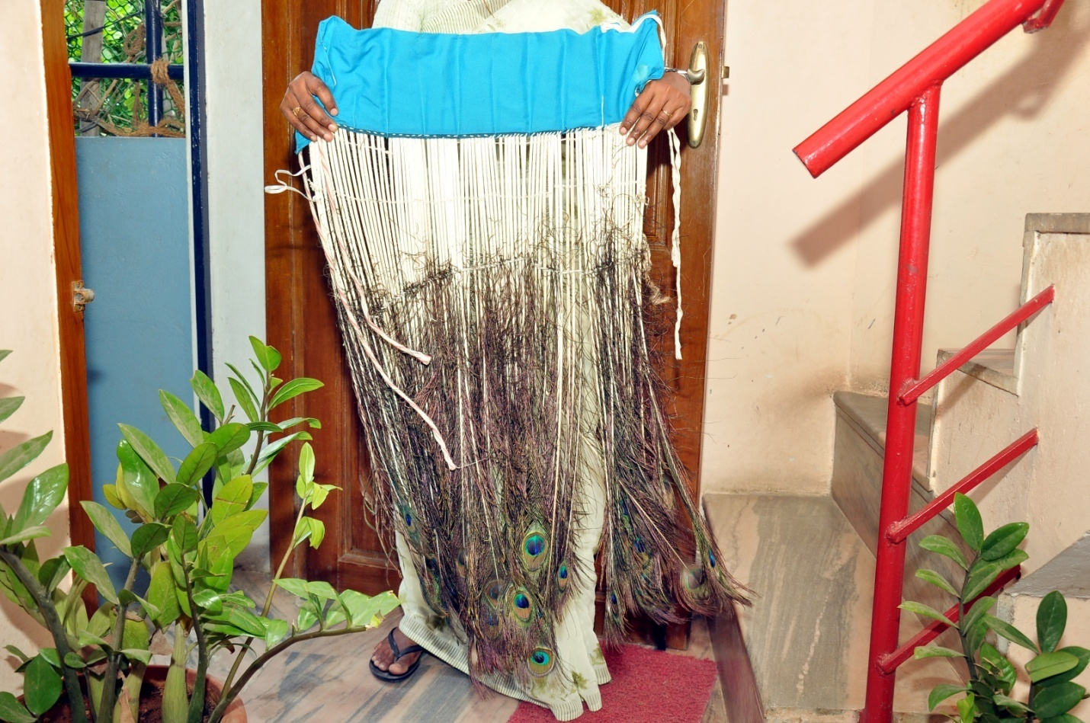

kapy; mopT - FANS SKIRT
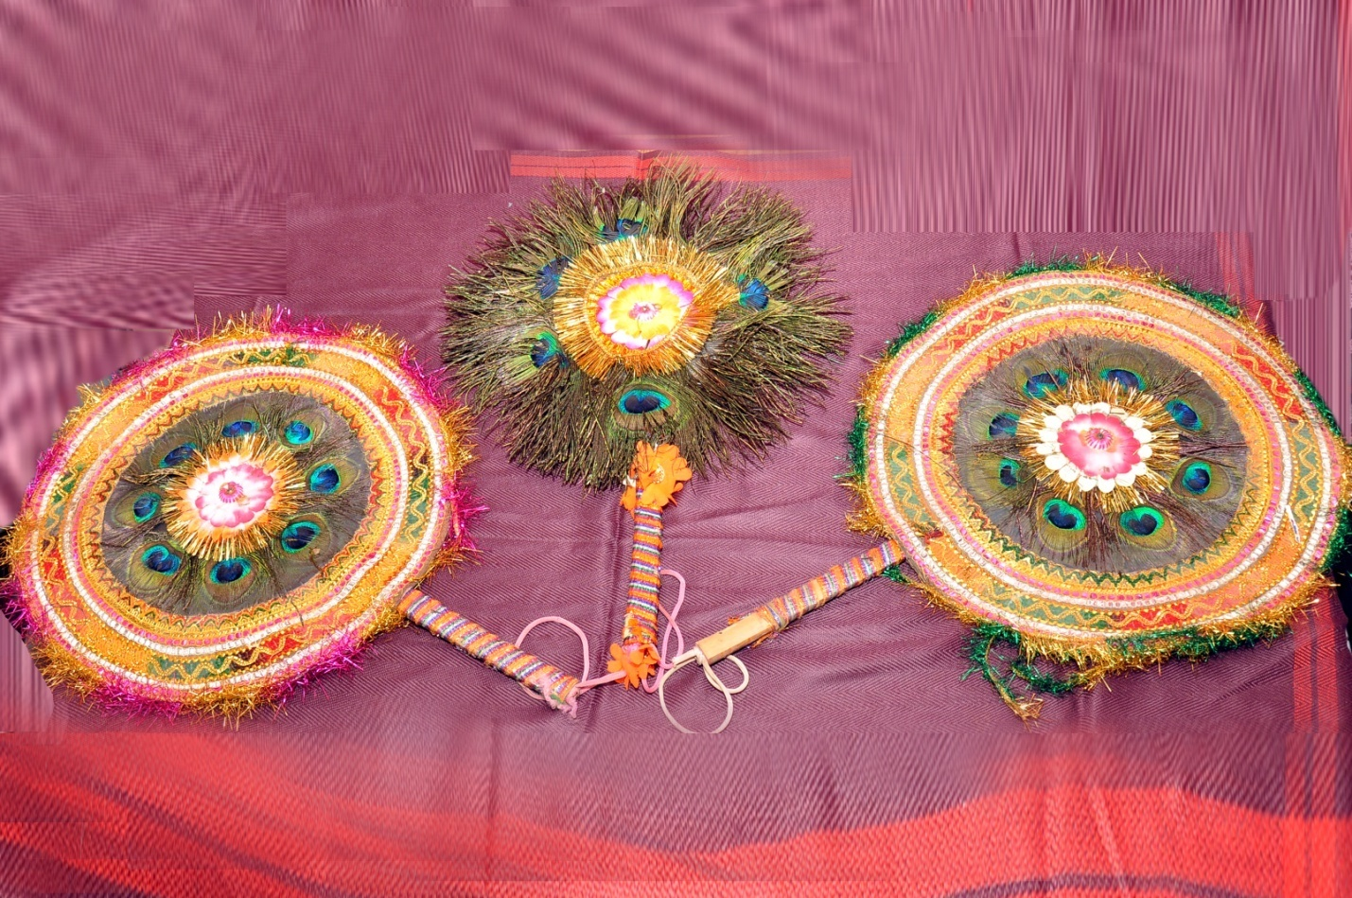
kapy; mopT

FEATHER FAN

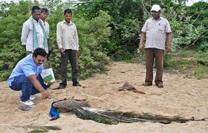

14 PEACOCKS DIED IN A.P - HYDERBAD
14 kapy;fs; Me;jpuh - i`juhghj;jpy; ,we;jd

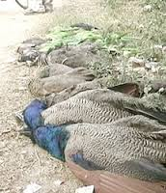
kapy; mopT

MASS DEATH

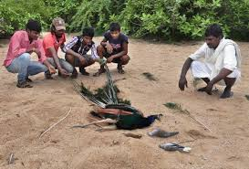
14 kapy;fs; Muhtyp]plk; 10 kapy;fs; khNdrh; Nfrk; rhT

14 PEACOCKS DIED AT ARAVALIS & 10 PEACOCKS DIED AT MANASER - KESAM
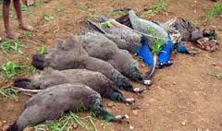
jkpo;ehL, jpUr;rp, #uf;Fbgl;b 12 kapy;fs;
tp\k; cz;L rhT

TAMILNADU, TRICHY, SOORAKUDIPATTI 12
PEACOCKS DIED BY POISON FOOD

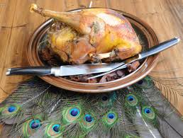
PEACOCK BPL SPEICIES
BELOW PROTECTION LINE SPECIES

ghJfhg;G Fiwe;j caphpdk;

