**CARE** Emergency Update

© Shafak/CARE

**SYRIA CRISIS HUMANITARIAN FUND**

**After a decade of crisis, more people than ever are in need**

**Background**

Ten years into the conflict in Syria, which triggered



one of the largest mass population displacements in history, the situation remains one of the world’s most complex humanitarian crises. Ongoing hostilities continue to force families from their homes – with some being displaced multiple times. Even as hundreds of thousands of people try to return to their homes in Syria, an estimated **6.7 million remain displaced inside the country,1 with nearly 5.7 million living as refugees,** mostly in neighboring countries.2

*The Syria crisis has disrupted traditional gender roles such as men as breadwinners, creating additional stresses for women – including gender-based violence, early and forced marriage. CARE’s support for women and girls includes our initiative Adolescent Mothers Against All Odds, which connects young mothers to sexual and reproductive health and other services. We work with local leaders, including men, to ensure community acceptance.*

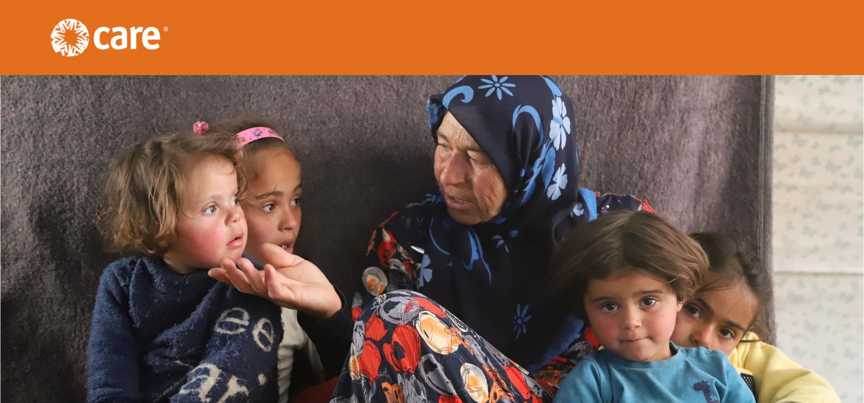

A spiraling economic crisis and the freefall in value

of the Syrian currency have left more than 90% of the population below the poverty line. An estimated

**13.4 million Syrians are in need of humanitarian assistance** – a 21% increase from 2020.3 While violence has decreased from the peak of the conflict, widespread destruction of homes, health care facilities and other infrastructure continues to cause immense suffering and hinder recovery. Economic crisis and the effects of the COVID-19 pandemic are causing distress to Syrian refugee populations in many countries.

As in many humanitarian emergencies, women and girls face elevated threats, including harmful gender norms and gender-based violence (GBV). However, men and boys are also subject to particular risks, including arbitrary detention, forced conscription and exposure to explosives. The effects of trauma, especially on children – half of whom have never known a life other than crisis – cannot be underestimated.

1 U.N. High Commissioner for Refugees (UNHCR). [Fact Sheet – Syria.](https://reliefweb.int/sites/reliefweb.int/files/resources/Factsheet%20Syria%20September%202021.pdf) Sept. 2021.

2 UNHCR. [Syria Regional Refugee Response.](https://data2.unhcr.org/en/situations/syria_durable_solutions) Updated Nov. 4, 2021

3 U.N. Office for the Coordination of Humanitarian Affairs. [2021 Humanitarian Needs Overview: Syrian Arab Republic.](https://reliefweb.int/report/syrian-arab-republic/2021-humanitarian-needs-overview-syrian-arab-republic-march-2021)

**COVID-19: Painstakingly slow progress**

The COVID-19 pandemic has placed additional burdens on vulnerable health systems. A second wave of infections in parts of Syria has overwhelmed hospitals and COVID-19 treatment centers. Camps where internally displaced people (IDPs) live in crowded conditions are at particular risk of outbreaks. Vaccination rates are extremely low – only 2.5% of the 4 million people living in Northwest Syria, for example, have received a first dose.4 CARE is responding with services, including prevention messaging and counseling, ambulance transportation, and outreach to mobilize the public for vaccination. In the face of a rapidly evolving pandemic, **CARE needs flexible funding from sources such as the Syria Crisis Humanitarian Fund** now more than ever.

**CARE’s response**

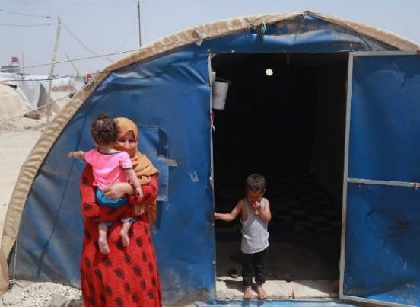

CARE began programming in Syria in 2013 in response to the growing civilian crisis caused by conflict. **We also work in multiple countries throughout the region to meet the needs of refugees and migrants from Syria as well as**

**their host communities**. During the last fiscal year,5 we responded to the displacement crisis inside Syria as well as assisting Syrian refugees and host communities in **Egypt, Jordan, Lebanon and Turkey** with both emergency aid and support for longer-term recovery.

As the crisis continues to develop in unpredictable ways, we are grateful for the support of donors to the **Syria Crisis Response Fund**, who make it possible for us to direct resources when and where they are needed most.

In the pages that follow we provide some key examples of our response in each country.

***Syria***

CARE conducts humanitarian activities in coordination with local partners in both northwest and northeast Syria. Whenever possible, emergency assistance, longer-term support and building resilience go hand-in-hand.

*Northwest:* Interventions include:

• GBV response and prevention services such as:

o Awareness-raising sessions;

o Information dissemination;

o Mental health and psychosocial support;

o Life skills, recreational and vocational activities;

o Case management and referrals;

© Delil Souleiman/CARE

“The situation of people in camps is particularly dire. So why would people live here? The answer is simple: They have nowhere else to go. Many people in the camps told me they have been displaced 10, sometimes 20 times. Despite the widespread destitution,

there is a lot we can do to reduce the plight of Syrians. It is also clear that we are not doing enough.”

– Jolien Veldwijk

Country Director, CARE Syria

o Community dialogues on protection and gender norms;

o Support for women-led and community-led networks; and

o Cash and in-kind assistance for GBV survivors and persons with general protection needs.

4 As of Sept. 26, 2021.

5 July 1, 2020 to June 30, 2021.

• Adolescent-friendly sexual and reproductive health rights (SRHR) support, including:

o Health facility-based prenatal care, normal delivery and newborn care, including lifesaving newborn resuscitation;

o Clinical management for rape cases;

o Family planning counseling and provision of

contraceptive methods, including long-acting

reversible contraceptives;

o Diagnosis and treatment of gynecological cases, referrals and nutrition services;

o Outreach awareness raising and referral through community health workers and community outreach workers; and

o Establishment of young mothers’ clubs.

• Meeting the protection needs of the affected population with various services, including establishment of safe spaces for women and girls, community centers and health facilities, as well as mobile service provision.

• Support for livelihoods and resilience, including:

o Income-generating opportunities;

o Improved access to inputs, strengthened

production and support for restoration of lost

agricultural and livestock assets;

© CARE

“It fills me with pride when I can help a baby or a small child, and I feel as if it is my own. I feel sorry for displaced infants who come to the hospital

from the camps. They do not have

any means of transportation and lack healthcare and medication. The living conditions in the camp are difficult.”

– Nawal (name changed), a nurse at the children’s ward at Al-Amal hospital in northern Aleppo, Syria

o Vocational training to improve market access and livelihood opportunities;

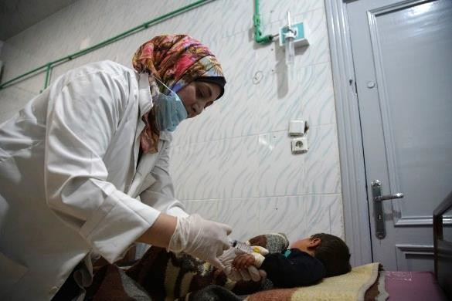

o Business grants supporting small-scale entrepreneurs and skilled business owners; and

o Establishment of veterinary clinics to conduct vaccination campaigns, provide emergency health

follow-ups and monitor reproductive health of livestock.

• Provision of ready-to-eat food, vouchers and cash-for-food.

• Health care support, including:

o Medical referral services by the ambulance referral system;

o First aid through immediate interventions by paramedics; and

o First aid trainings to community members by trained paramedics and volunteers.

• Shelter support including temporary housing materials, rehabilitation of IDP sites and housing upgrades.

• Emergency provision of safe water and sanitation systems, as well as long-term solutions, for IDPs and host communities.

• COVID-19 response activities, including:

o Hygiene and risk communication; and

o Transportation services for patients to COVID-19 treatment centers or specialized hospitals.

• Participation in a multi-agency winterization plan to provide fuel, stoves, shelter, blankets and winter clothes to 2.2 million people.

*Northeast:*

• Water, sanitation and hygiene (WASH) activities, including:

o Rehabilitation of water sources and water infrastructure;

o Hygiene promotion through door-to-door messaging as well as larger campaigns; and

o Installation and maintenance of latrines and handwashing stations, rehabilitation of sanitation systems, and de-sludging

services.

• Livelihoods activities, including:

o Cash-for-work for WASH activities;

o Training to support women-led businesses;

o Distribution of fodder and wheat seeds;

o Support for small businesses to improve

production and value chains;

o Grants or other support to women-led businesses; and

o Light rehabilitation of marketplaces and agricultural infrastructure.

• Emergency activities, including:

o Distribution of hygiene kits;

o Distribution of multipurpose cash assistance;

and

o Distribution of winterization items and clothing kits.

• Protection activities, including:

© Delil Souleiman/CARE

With a grant and business training from CARE, Leyla (name changed) was able to refurbish the fitness center she operates with her husband. This allowed her to attract new customers and double her profit within one year. “The war is so hard on all of us. I think physical exercise really helps improve our mental well-being. I am really grateful that

we can offer a great gym for people to help

them do something for themselves.”

o Outreach and awareness raising on key protection issues;

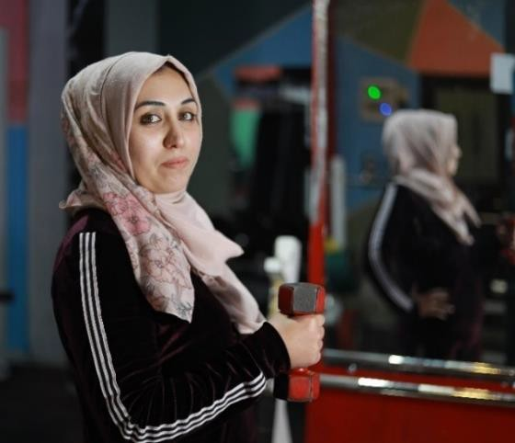

o Support to community centers;

o Case management and referral;

o Psychosocial support through structured sessions and counseling; and

o Distribution of dignity kits containing items such as sanitary napkins and underwear.

***Egypt***

Egypt hosts more than 135,000 refugees from Syria – who make up a majority of the country’s 267,000 registered asylum seekers and refugees. Most live in urban settings, especially greater Cairo, Alexandria, Damietta and towns on Egypt’s North Coast.6 As in other host countries, economic challenges and the disruption of traditional social and family structures pose threats to women – including elevated rates of GBV and pressures on families to force daughters into early marriage for financial reasons.

CARE works to reduce GBV among refugee communities in greater Cairo and Alexandria, by ensuring that women are empowered to tackle the issues they face and that they have access to quality services. This builds on CARE’s long experience in Egypt, addressing barriers to women and girls’ potential. Approaches include:

• SRHR awareness sessions for women, teenage girls and teenage boys addressing topics such as:

o Raising awareness about GBV, women’s bodies and the pregnancy process;

o Cultivating safe and healthy practices; and

o COVID-19 awareness.

6 UNHCR. [Egypt Monthly Statistical Report.](https://www.unhcr.org/eg/wp-content/uploads/sites/36/2021/11/Oct-Statistical-Report.pdf) Oct. 31, 2021.

• Legal awareness sessions for women covering:

o GBV and legal procedures regarding marriage licenses, divorce and birth certificates, and legislation concerning sexual harassment; and

o Awareness about GBV, custody and early marriage.

• Basic psychosocial sessions for women, girls and men aimed at:

o Raising awareness about basic trauma support and anger management;

o Providing skills to deal with stress and anxiety during the COVID-19 pandemic;

o Reinforcing the importance of reporting violence and seeking support; and

o Taking steps toward helping men manage their anger and change their view from being a

perpetrator of violence to supportive of stopping violence.

• Early marriage training for women and girls focusing on:

o Increasing awareness of women’s and girls’ legal rights, with respect to marriage;

o Discussing physical and gender differences and the dangers of early marriage; and

o Supporting women’s power to say “no” to attempts to marry off young daughters.

• Children’s camp for girls and boys.

• Services for GBV survivors, including:

o Access to case management;

o Housing support;

o Legal consultations and support; and

o Psychosocial support.

***Jordan***

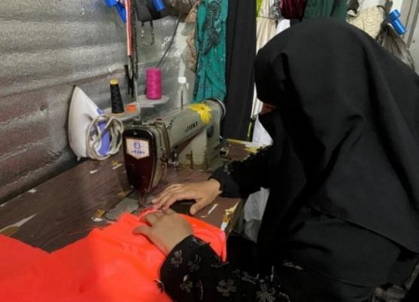

CARE’s programming in Jordan comprises humanitarian response and longer-term development, reaching a mix of vulnerable Jordanian families, refugees and migrant populations. Most refugees in Jordan live in urban

areas, and so the majority of CARE’s work is focused on Jordanians and refugees who live in towns and cities. About 22% of participants in CARE’s programming in Jordan are residents of the Azraq refugee camp.

Program activities in Jordan include:

• Protection activities, such as:

o Vulnerability assessments; and

o Information provision.

• Activities to ensure food security and basic needs are met, including:

o Emergency cash assistance;

o Cash assistance for shelter construction

and rehabilitation;

o Cash assistance to support renewal or certification of legal documents; and

o Winterization cash assistance.

• Economic empowerment programming, including:

o Vocational training and life skills training;

o Facilitating women’s participation in village

savings and loan associations; and

o Business startup-grants and development training for small and medium-sized enterprises (SMEs).

© CARE

Mona and her five children fled war-torn Syria for Azraq refugee camp in Jordan, where she was reunited with her husband after four years. “For me, living in the camp is like being in heaven…. I do not have to worry about my children’s lives.” She enrolled in sewing and beauty workshops organized by CARE. “Back in Syria, I dropped out of school when I was only 12 years old,” she recalls. “For the first time in years, I felt happy to be investing in myself to become more knowledgeable and capable. My first official project with CARE was to make school uniforms. It was an amazing feeling to see the beautiful results and the faces of the young, happy children.”

• Education and child protection activities, including:

o Conditional cash grants for school-related expenses;

o Day care support;

o Online activities; and

o Child protection awareness sessions.

• Psychosocial support interventions, including:

o Recreational and awareness sessions;

o Peer support groups;

o Individual counseling sessions;

o Outreach activities; and

o Community events.

• Support for civic engagement, including:

o Participation the Women’s Leadership Council;

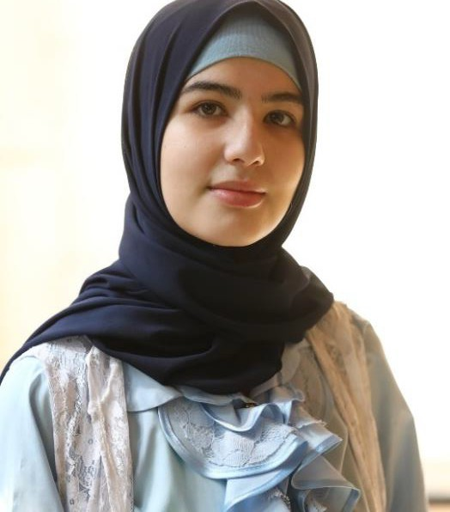

o Activities of the CARE Child Education Board; and

o Psychological first aid training.

***Lebanon***

Lebanon is experiencing one of its worst socioeconomic crises since its civil war over three decades ago, with hyperinflation, currency depreciation, and widespread unemployment. Refugees, including Syrians, are among those worst affected by the complex crisis facing Lebanon, which has the highest per capita refugee population in the world (1.5 million out of a population of 5.5 million).

CARE targets the most vulnerable Lebanese households as well as Syrian refugees, other nationalities and host communities. Last fiscal year, CARE responded to the Syria crisis, COVID-19 pandemic, the explosions at Beirut’s port in August 2020 and the worsening socioeconomic crisis.

Our interventions have included basic assistance,

protection, shelter, food security and livelihoods, and WASH, or more specifically:

• Sustainable livelihood opportunities through small ruminants (sheep and goats) value chain;

• Establishment of networked information systems that link people in need with social service providers, both local and external resources, and track current and emerging trends;

• Strengthening access to protection, participation and services for women refugees, IDPs and host communities;

• Improved safe access to efficient and sustainable water supply through enhanced water management;

• Strengthening SMEs to become more resilient and contribute to the local economy;

• Support for farmers and other value chain actors focused on the production of cereals and vegetables, promoting linkages with other value chains;

Bayan Akkari, now 19, fled with her family to Lebanon at age 10 as bombs fell on their city of Homs, Syria. After enrolling in CARE-sponsored remedial courses – as well as dance and self- defense classes – she radiates a new self-confidence.

With the economic crisis in Lebanon, she cannot afford to commute to classes or a computer to study at home. She and her siblings share her mother’s phone, downloading and reading books on its tiny screen.

Still, she has big ambitions. “I would like to be able to continue my studies,

maybe even be able to go to university, earn a law degree to defend women and really lay the foundations to fight against gender discrimination.”

• Provision of lifesaving assistance to the most vulnerable people affected by the Beirut port explosions, with special focus on women and girls;

• Support for building repairs and rehabilitation of homes affected by the port explosions;

• GBV prevention and response measures, including psychosocial support, awareness raising, case management and referrals to mental health services;

• Distribution of hygiene kits and self-care sessions to front-line workers; and

• As part of COVID-19 mitigation efforts, provision of food parcels, fruit and vegetable vouchers and

WASH kits to vulnerable Lebanese households, migrant households and Syrian refugee families.

***Turkey***

Turkey hosts about 4 million refugees and asylum-seekers, including over 3.7 million Syrians under temporary protection. Syrian refugees live dispersed in communities across Turkey, with a very small number hosted in seven temporary accommodation centers managed by the Turkish government. While Turkey has coped relatively well compared to neighboring countries hosting Syrian refugees, the situation has become increasingly politicized, social services are overstretched and anti-migrant sentiments are on the rise.

CARE has been responding to the refugee crisis in Turkey since 2013. In the last fiscal year, we have implemented refugee-focused programming in sectors including:

• Livelihood and early recovery support, such as:

o Business start-up kits and seed capital; and

o Cash assistance for shelter, WASH and health care access.

• Education, including building teaching capacity.

• Shelter and basic needs, including:

o Construction of refugee housing units and provision of tents and temporary housing materials; and

o Technical assistance and training.

• WASH, including hygiene promotion.

• Protection, including GBV response.

• COVID-19 mitigation and response activities, including:

o Hygiene and risk messaging;

o A tele-counseling hotline sending outgoing messages and answering incoming questions;

o Support for COVID-19 vaccination – in particular helping migrants overcome specific barriers;

o Awareness campaigns promoting vaccination and addressing misinformation; and

o A partnership with Facebook to promote accurate information and, particularly, to encourage

refugee women of childbearing age to get vaccinated.

**Conclusion**

The humanitarian crisis caused by years of conflict in Syria demands both sustained emergency response and a commitment to long-term solutions. CARE remains dedicated to meeting the needs of displaced people and host communities in Syria and in countries throughout the region. We support the recovery of destroyed livelihoods and missed educations, while striving to address the deep trauma and loss caused by a decade of terror. Thanks to donors like you to the **Syria Crisis Humanitarian Fund,** CARE is able to address these needs – and nurture hope for a future of dignity and safety.7 We thank you for your generosity.

*November 2021*

7 In order to effectively manage the current emergency response and continue to be able to rapidly deploy resources for other emergencies, CARE will reserve 20 percent of donations to the Syria Crisis Humanitarian Fund to cover technical support, administration and emergency preparedness expenses, including the rapid deployment of staff to emergencies such as this one.