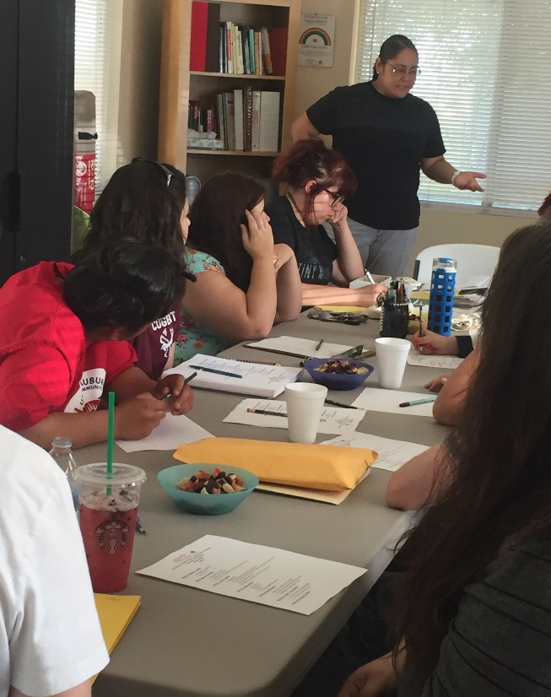
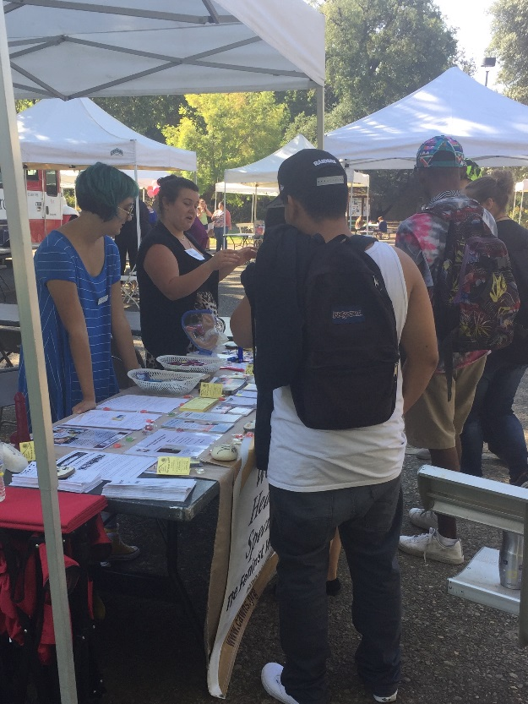
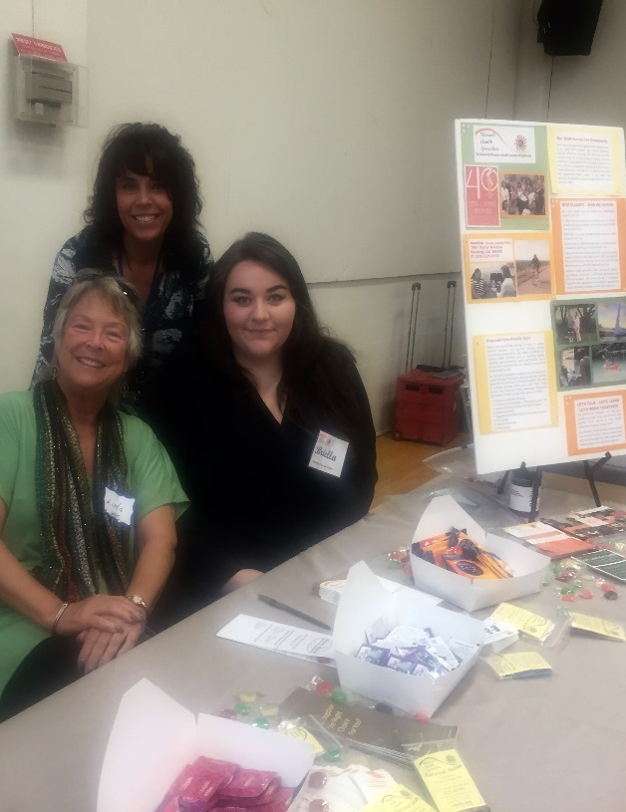
Youth Peer Education Training Shasta College Safety Fair Event
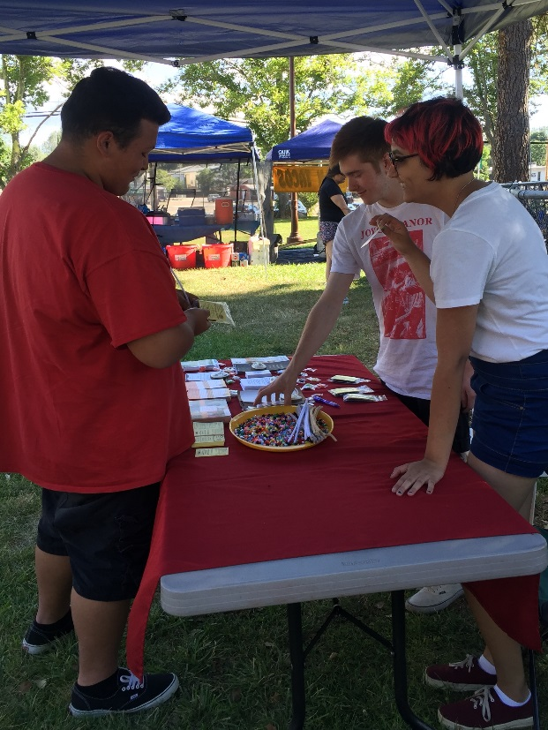

Friday Night in the Park Weekly Event Monthly STOPP Community Parole Meeting

