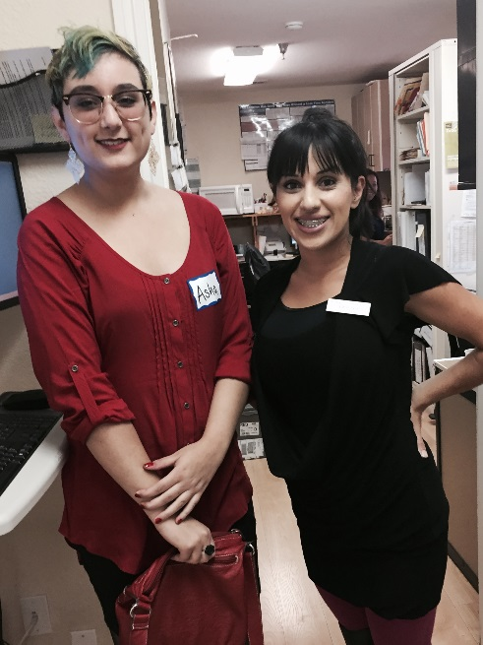
Northern California Young Women Leaders Progress
These young women are continuing to provide positive word of mouth information to their friends, peers, and family. This has supported the trusted referral network while continuing to build leaders in reproductive health education.
Asha, continues to volunteer in the Redding Women’s Health Center Clinic. She is continuing her training in Electronic Medical Records, Input, Clinic Services, Clinic Flow, and learning to be an advocate for all in reproductive health. She also assists other volunteers and Interns in becoming a supportive and educated members of the WHS staff.
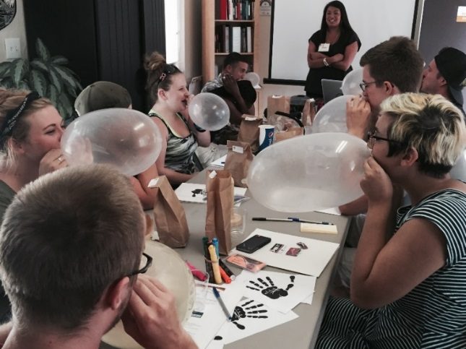
Asha, completed our HIV/AIDS Education Training, and helped facilitate and put on 2nd Training with other community youth. She continues to be a very trusted peer outreach educator among her peers and our community

These young women and men are now Educated Peer Outreach Educators in their individual High School Campuses in Shasta County. They hold one on one education sessions and refer young teens to WHS for Information and Services. This method of education helps to remove many barriers to services for teens in our community.

SafeZone Train-the Trainer Certification Program
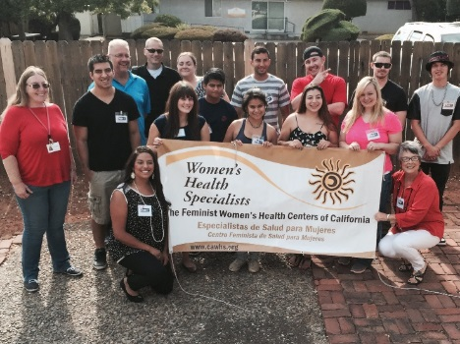
This program is a fast paced, interactive workshop Created to develop confident, knowledgeable and effective Safe Zone Trainers, who can establish
Sustainable Safe Zone Programs on their campuses and in their communities. Our young women are trained to be allies, educators for the Lesbian, Gay, Bisexual, Transgender communities. They help support to create safe people and places that are known to within these communities where they can get help and information.
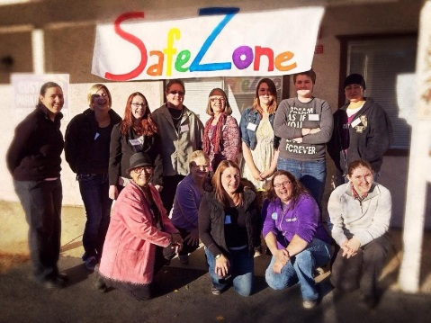
Bisexual, Transgender communities. They help support to create safe people and places that are known to these communities where they can get help and information.

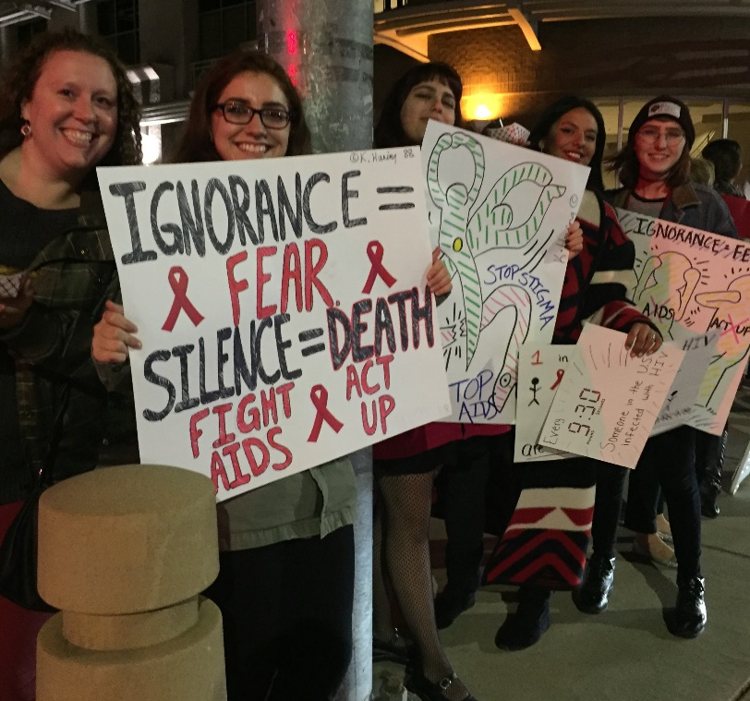
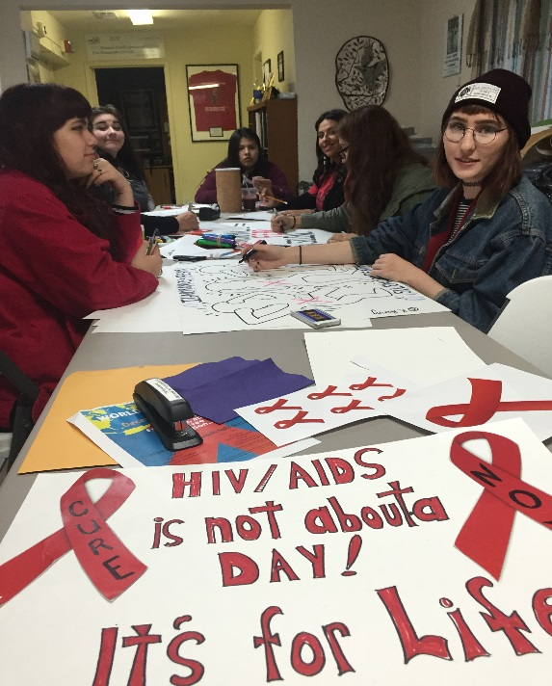
WORLD AIDS DAY Event – Redding California

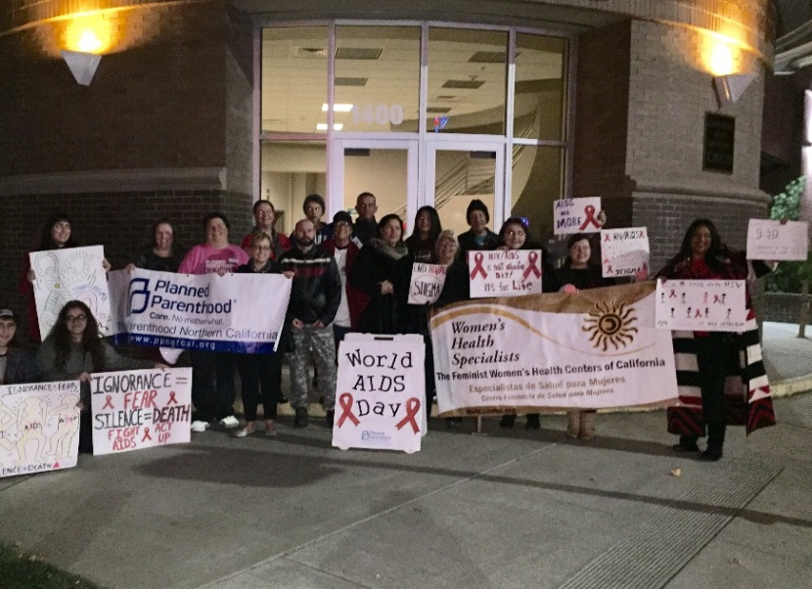
Our young women leaders planned, supported
And participated in World AIDS DAY in Redding
On behave of Women’s Health Specialists.
These young women came from local High Schools, and colleges.

Other projects that these young women are involved in are the following:
: Assisting Women’s Health Specialists in STD Education Workshops
: Planning and supporting the upcoming 43rd Roe v. Wade Event
: Planning and supporting International Women’s Day Event
: National Condom Week Events
With all of our on-going support these awesome young women will continue to be empowered, educated, and unite their voices for reproductive health care of all.

