Youth Health Outreach “Knowledge is a Life Safer Project” 2017
WHS Peer Outreach Workers have been “Rocking it in the Northstate”. They have put on one more training for 15 to 19 year old youth with the theme “Knowledge is a Life Saver”. Continuing messages that encourage sexually active teens to access contraception; and to reduce the incidence of gonorrhea in Shasta County. Peer Outreach has been so successful, that Shasta County has gone from number two in the state, to number four, going down is a good thing.
Peer Outreach workers have partnered with Shasta College Campus Clubs, and organizations to get the word out that “Knowledge is a Lifesaver” at campus meetings and events. This has increased clinic visits for birth control information, STD information, services and testing in our community. WHS Outreach workers continue to have information booths at Shasta College events with much success.
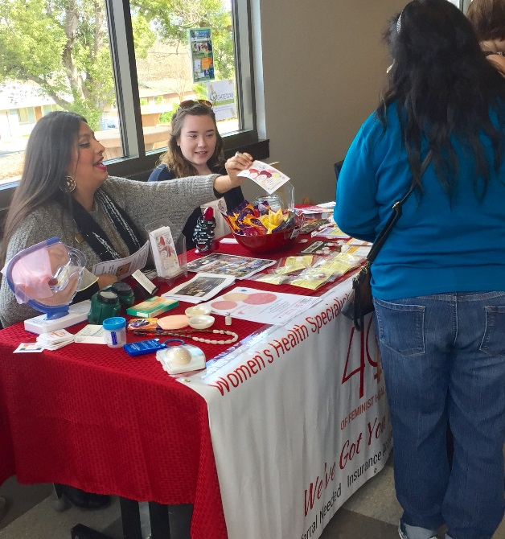

WHS has outreached to the Shasta College Community Engagement Program for Interns, for our 19 to 20 year olds for Peer Education Sessions this summer. There has been a great response, and looking forward to working with these young adults.
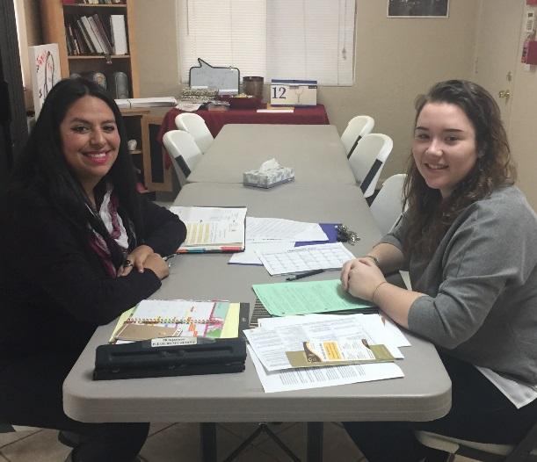

Peer Outreach Workers have also been engaged with our local Native American Youth in our community. Local Indians for Education, located in Shasta Lake City has been very welcoming for our native youth that has been trained to put on their education sessions and train their youth from their cultural perspective. WHS Peer Outreach have attended native events, education sessions, and family nights at the center.
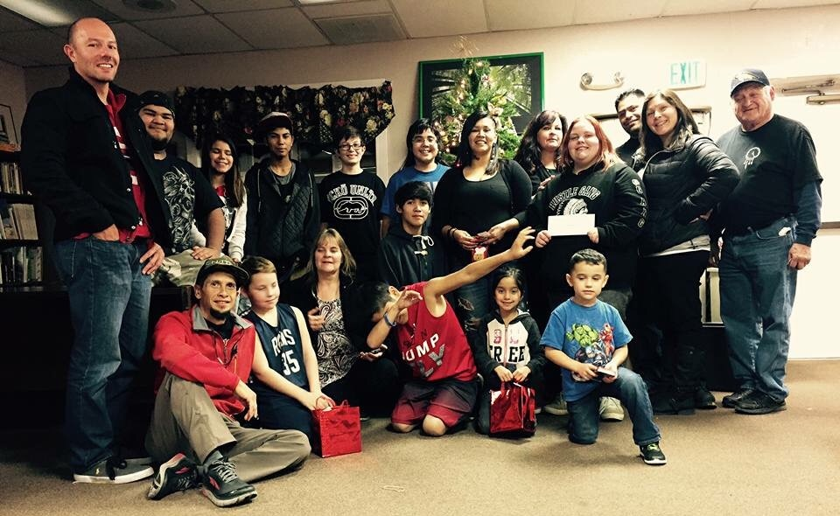

Girls Inc., of Northern California requested peer outreach workers to attend “Vagina Monologues” theater events here in Redding and Red bluff. They had a table at both events and shared information with all that attended. They had a “Vagina Costume” and this broke the ice for many positive “Knowledge is a Lifesaver” conversations.
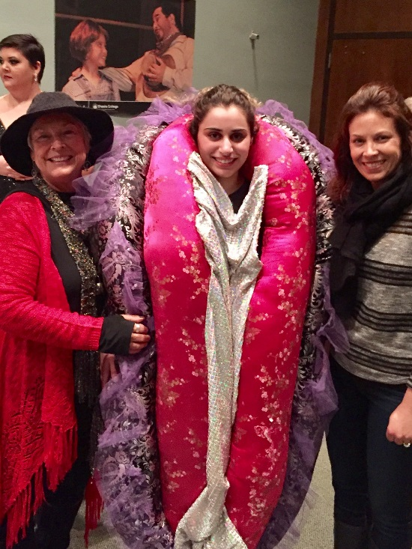

Our peer community outreach workers have also assisted in training session to get youth ready for a busy summer here in the Northstate. Information, ideas were shared where the best outreach places for young teens and young adults will be hanging out, and how to reach them. So, sharing WHS services, hours, and how it can be for free removes the barriers to reproductive health service for all. Plus, continuing to have information tables at Shasta College for summer school classes, helps provide

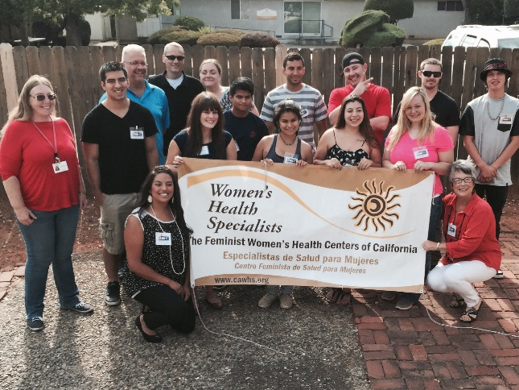
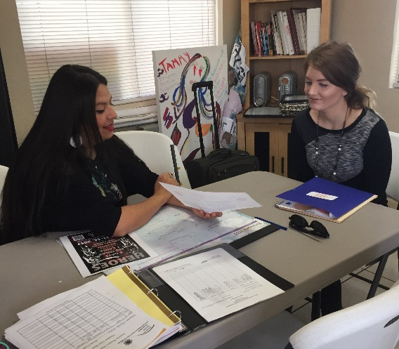

New Interns, and outreach workers continue to escort at our clinic and support client services. These young people continue to show their power and voice for positive change in their community.
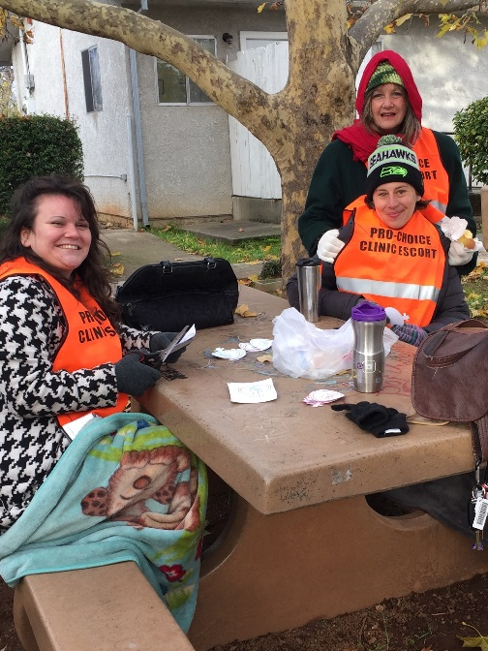

Peer Outreach Workers continue to show that “Knowledge is a Lifesaver” to all young people here in their community and beyond.

