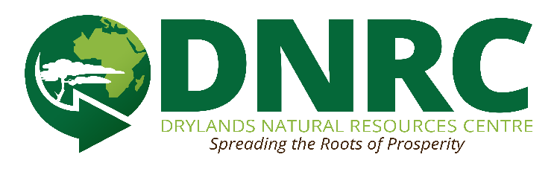

**DRYLANDS NATURAL RESOURCES CENTRE (DNRC) BIO**

Founded and led by a Kenyan National, Nicholas M. Syano, Drylands Natural Resources Centre (DNRC) is a locally registered NGO whose primary goal is to promote sustainable development of resources of the drylands regions of Kenya in order to bring about improved livelihoods of the marginalized communities and people living there. The organization equips subsistence farmers in drylands to restore their degraded lands and address the challenges of deforestation, falling agricultural yields, failing livelihood, water scarcity, loss of traditional knowledge and climate variability through permacultural and agro ecological best practices. DNRC Vision is “sustainable and resilient communities in the drylands” While the mission is **‘**To promote sustainable development in the drylands of Kenya in order to bring about improved livelihoods of the marginalized communities living there by sharing the best practices and delivering effective program related and not limited to: agroforestry, agro ecology, and permaculture and culture regeneration. Currently working with 800 plus households (about 4,200people) and 12 schools (about 3,000 pupil) in the drylands of Kenya and specifically Makueni County

**Core programs**

* Dryland Tree Nursery
* Community Training and outreach
* Rain water harvesting
* Green charcoal production
* Agro ecological food production
* Culture regeneration
* Poultry production
* Permaculture/Agroecology short courses trainings
* Traditional food promotion
* Agroecology/permaculture trainings and promotions
* Eco-building/Cob building
* Traditional/log beehive production/keeping
* Agroecology/permaculture student apprenticeship, mentorship and volunteership