Nutrition through food forest and gardens in Kenya quarterly report Dec. 2015 Pictures

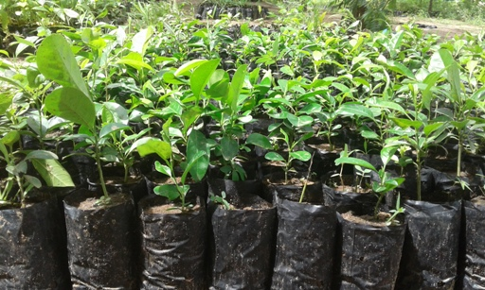
Tree saplings in the tree nursery

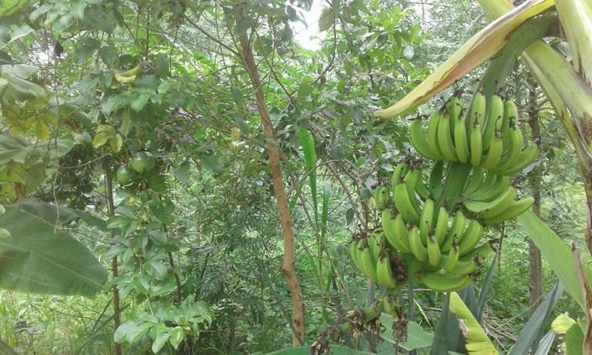
Food forest at DNRC site

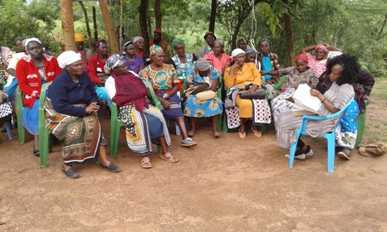
Farmers in one training at DNRC site

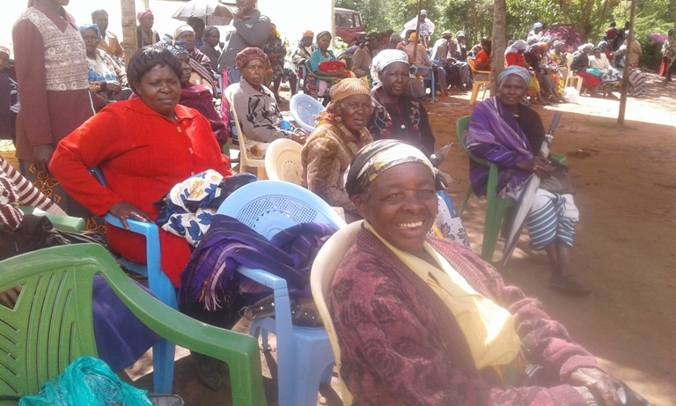
DNRC farmers during the get-together

