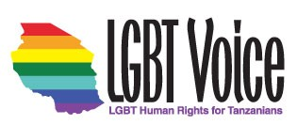

LIVED REALITIES OF LGBTQ+ PEOPLE IN TANZANIA

A Community-Based Study of Discrimination, Resilience, and Urgent Needs

Prepared by LGBT Voice Tanzania
May 2025
P.o.Box Tanga Tanzania
Email: info@lgbtvoicetz.org
Tel: +255 715 334419

Cover Letter
Dear Donors, Friends, Supporters, and Allies in Government, Law, Education, Religion, Medicine—and to the People of Tanzania and the Global Community:,
We are honored to share with you our latest report, “Lived Realities of LGBTQ+ People in Tanzania.” This report captures the voices of 367 LGBTQ+ individuals across the country and sheds light on their day-to-day experiences in education, healthcare, employment, housing, safety, and mental health.
Your support has made this possible. By standing with us, you help amplify these voices and push for change in systems that continue to marginalize our community. We hope this report serves as a critical resource in driving policy reform, legal protections, and inclusive programming.
With deep gratitude,
James Wandera Ouma
Executive Director
LGBT Voice Tanzania

Table of Contents
Executive Summary
Introduction
Methodology
Legal and Policy Environment
3.1 Current Legal Framework
3.2 Institutional and Policy Gaps
3.3 International and Regional Human Rights Obligations
3.4 Implications for Tanzanian Institutions
3.5 Pathways for Reform
Key Findings
4.1 Education
4.2 Health Access
4.3 Employment and Livelihood
4.4 Legal and Institutional Harm
4.5 Social Rejection and Violence
4.6 Homelessness, Survival Sex & Mental Health
4.7 Comparative and Trend Analysis
4.8 Intersectional Analysis: Overlapping Vulnerabilities
Resilience and Community Power
Recommendations
6.1 To Government and Institutions
6.2 To Civil Society and Donors
6.3 To International Donors and Partners
6.4 Policy and Legal Reform Roadmap
Conclusion
Acknowledgements
End Notes
References
Annexes / Appendix
Annex A: Methodology Details
Annex B: Supplementary Charts
Annex C: Participant Questionnaire

Definitions and Acronyms
LGBTQ+: Lesbian, Gay, Bisexual, Transgender, Queer/Questioning.
LGBTQIA+: Expanded acronym including Intersex, Asexual, and other diverse identities.
SOGI: Sexual Orientation and Gender Identity.
Survival Sex: Exchange of sex for shelter, food, or money in conditions of vulnerability.
Trauma-Informed Approach: Method of engaging with participants that recognizes the impact of trauma, emphasizes safety, and avoids re-traumatization.
UDHR: Universal Declaration of Human Rights.
ACHPR: African Charter on Human and Peoples’ Rights.
Yogyakarta Principles: International legal framework applying human rights law to issues of sexual orientation and gender identity.

Foreword
The struggle for equality is never abstract — it is lived in the bodies, minds, and daily realities of people who are too often silenced. This report, *Lived Realities of LGBTQ+ People in Tanzania*, documents those realities with clarity, courage, and care.
It arrives at a pivotal moment. Across Africa, laws and policies are being contested in ways that will shape a generation. Some governments, like Botswana and Angola, have moved to decriminalize consensual same-sex relations, showing that progress is both possible and beneficial. Others, such as Uganda, have intensified repression, placing lives at risk and undermining development. Tanzania now stands at a crossroads.
What makes this report invaluable is that it is grounded not in speculation but in the voices of 367 Tanzanians — young people, workers, students, and community members — who bravely shared their experiences. Their testimonies expose patterns of violence and exclusion, but they also reveal resilience, solidarity, and hope.
For policymakers, this report is evidence that criminalization and discrimination undermine public health, weaken education, and erode national development. For civil society and donors, it provides a roadmap for interventions that are both urgent and achievable. And for the global community, it is a reminder that solidarity is not optional: silence allows injustice to deepen.
As you read these pages, I encourage you not only to see the statistics but to hear the voices behind them. This is not just data — it is a call to conscience. Tanzania’s constitution guarantees dignity and equality to all its citizens. Realizing those principles requires us to act now, together, to ensure that LGBTQ+ Tanzanians live not in fear, but in freedom.

Signed,

James Wandera Ouma
Executive Director
LGBT Voice Tanzania

Acknowledgements
We extend our deepest gratitude to the 367 courageous individuals who participated in this study, especially those who shared stories of trauma and survival. Your voices form the heartbeat of this report and will continue to guide our work.
We also thank the dedicated peer researchers, interpreters, data analysts, and volunteers who made this project possible—often under deeply challenging conditions.
To our partners, allies, and funders: thank you for standing with us. Your support affirms our belief that equality is possible—and worth fighting for.
Together, we move forward in the ongoing struggle for dignity, justice, and safety for every LGBTQ+ person in Tanzania.

Purpose Statement
This report exists to break the silence surrounding the lives of LGBTQ+ people in Tanzania. For too long, our stories have been erased, our struggles ignored, and our resilience overlooked. By gathering voices from across the community, we aim to shine a light on both the pain inflicted by violence and the unyielding strength that allows us to survive, resist, and hope.
Our purpose is not only to bear witness but also to demand change. Every testimony shared here is a call to action—for justice, for dignity, and for the recognition that LGBTQ+ people are part of the fabric of Tanzania’s present and future. This report is meant to stir empathy, to inspire solidarity, and to galvanize decision-makers, allies, and communities into standing with us until equality and safety are no longer dreams but lived realities.

Executive Summary
LGBTQ+ people in Tanzania continue to face systemic discrimination, violence, and exclusion, reinforced by criminal laws and harmful social attitudes. Despite this hostile environment, communities have shown resilience, courage, and solidarity in defending their dignity and rights. This report, “Lived Realities of LGBTQ+ People in Tanzania,” draws on the lived experiences of LGBTQ+ individuals across the country to document patterns of abuse and highlight pathways toward justice and inclusion.
Key Findings
- Criminalization and Fear: The Penal Code criminalizes same-sex relations with penalties ranging from 30 years to life imprisonment. Vague provisions have enabled arbitrary arrests, harassment, and extortion, creating a climate of fear.
- Violence and Discrimination: Participants reported physical attacks, family rejection, loss of employment, eviction, and denial of healthcare. Law enforcement was frequently identified as a source of abuse rather than protection.
- Resilience and Support Systems: Despite risks, LGBTQ+ communities have built informal support networks to provide safety, healthcare access, and psychosocial support. Many respondents emphasized the importance of solidarity in navigating daily life.
- Legal and Policy Gaps: Existing policies not only fail to protect LGBTQ+ people but actively contribute to their marginalization. Advocacy entry points exist in areas such as public health, human rights commitments, and regional dialogues.
Advocacy Messages
- Protecting LGBTQ+ rights strengthens communities. When people live free from violence and discrimination, societies become safer, healthier, and more innovative.
- Criminalization harms everyone. It undermines public health efforts, weakens trust in institutions, and fuels cycles of violence.
- Resilience is not enough. LGBTQ+ communities should not have to rely solely on survival strategies—legal and policy reforms are urgently needed.
Recommendations
- Legal Reform: Repeal discriminatory provisions in the Penal Code and align national laws with international human rights standards.
- Protection Measures: Strengthen anti-violence mechanisms, ensure access to justice, and hold perpetrators accountable.

- Health and Social Services: Guarantee non-discriminatory access to healthcare, housing, and education.
- International Engagement: Encourage regional and global human rights bodies to maintain focus on Tanzania and support civil society advocacy.

Conclusion
The evidence presented in this report shows that the denial of rights to LGBTQ+ people in Tanzania is not only a violation of individual dignity but also a barrier to national development and social cohesion. Urgent action is required—from government, civil society, and international partners—to ensure that all people can live free, equal, and safe..
At a Glance: Lived Realities of LGBTQ+ People in Tanzania
Key Data from the 2023–2024 Community-Based Study
Participants | 367 LGBTQ+ Tanzanians interviewed (ages 18–40, urban & rural)
Education | 41% expelled or forced to drop out due to identity
Healthcare | 71% avoided services; 1 in 5 denied care
Employment | Only 1% of trans women and 2% of gay men employed
Safety | 79% faced discrimination or violence
Homelessness | High rates among youth; many pushed into survival sex
Mental Health | Widespread depression, anxiety, and suicidal ideation

Urgent Priorities
• Repeal laws criminalizing LGBTQ+ identities
• Guarantee safe, inclusive access to education, health, and jobs
• Fund safe spaces, mental health care, and livelihood programs
• Train police, teachers, and healthcare providers on equality

Bottom Line: Criminalization and stigma drive exclusion across every sector. Reform is urgent for dignity, health, and national development.

1: Introduction

LGBT Voice Tanzania is a human rights organization founded in 2009 to advocate for the rights, dignity, and safety of lesbian, gay, bisexual, transgender, and queer (LGBTQ+) people in Tanzania. Our mission is to promote visibility, challenge systemic injustice, and support the health and wellbeing of LGBTQ+ individuals who are often forced to live in secrecy and fear.

LGBTQ+ stands for:

Lesbian – women who are romantically or sexually attracted to other women,

Gay – men attracted to other men,

Bisexual – people attracted to more than one gender,

Transgender – individuals whose gender identity differs from the sex assigned at birth,

Queer – an umbrella term for those who don’t conform to traditional sexual or gender norms.

While Tanzania’s history is shaped by colonial legacies and current political realities, this report situates LGBTQ+ struggles within broader national development goals. Ensuring equality is not only a matter of rights but also of achieving Tanzania’s commitments under the Sustainable Development Goals (SDGs), particularly SDG 3 (health), SDG 4 (education), SDG 8 (decent work), and SDG 16 (justice).
Despite growing global recognition of LGBTQ+ rights and protections, Tanzania remains one of the most hostile environments for sexual and gender minorities. The country’s legal system, which criminalizes same-sex relations under colonial-era laws, is used as a tool of repression.
This criminalization is not only enforced by statute but reinforced by widespread social stigma, religious condemnation; political rhetoric, and institutional neglect, humiliation campaigns have become alarmingly common. These actions foster a climate of fear in which openness about one’s identity can lead to violence, imprisonment, or complete social isolation
The effects are devastating. LGBTQ+ Tanzanians face barriers to education, employment, housing, healthcare, and justice. Many are disowned by their families, bullied in schools, denied medical treatment, and harassed or extorted by police. And yet, despite these immense challenges, LGBTQ+ individuals continue to live, love, organize, and resist—often at great personal risk.

This report is grounded in the belief that LGBTQ+ people are entitled to the same dignity, freedom, and rights as all Tanzanians. It documents lived realities through personal testimonies—offering insight into both the brutality of marginalization and the unshakable resilience of those who refuse to disappear.

By listening to these stories and examining the patterns they reveal, this report aims to inform policy reform, service provision, public education, and international solidarity. In a society where silence has too often been enforced by violence, this report is an act of truth, visibility, and resistance.

Protecting LGBTQ+ Tanzanians is not a foreign demand—it is consistent with the Constitution of the United Republic of Tanzania, which upholds the equality and dignity of all citizens. By ensuring inclusive access to education, healthcare, and justice, institutions can strengthen public trust, improve public health outcomes, and reduce inequality. Building a Tanzania where no one is excluded supports our shared national values of umoja (unity), utu (dignity), and usalama (safety).

2: Methodology
Between 2023 and 2024, LGBT Voice Tanzania carried out an extensive community-based survey involving 367 LGBTQ+ individuals across various regions of the country, including both urban centers and rural areas. The primary goal was to capture a broad and representative range of experiences among sexual and gender minorities in Tanzania, while prioritizing ethical integrity, safety, and respect for participants.
2.1: Limitations and Strengths:
The study relied on purposive and snowball sampling, which may not capture all LGBTQ+ experiences in Tanzania, particularly those in highly rural or inaccessible areas. However, the breadth of participation across identities, regions, and age groups gives this study unique strength as one of the most comprehensive community-led data collections to date.
2.2: Participant Demographics
The individuals interviewed self-identified across a spectrum of sexual orientations and gender identities, including lesbian, gay, bisexual, transgender, queer, intersex, and gender-nonconforming people. Ages ranged from 18 to 40 years old, reflecting both youth and young adults—a demographic particularly vulnerable to systemic discrimination, family rejection, and economic exclusion. Special effort was made to include voices from marginalized rural communities, who are often excluded from formal LGBTQ+ research and policymaking.
2.3: Sampling and Recruitment
Participants were recruited using purposive and snowball sampling methods—widely recognized approaches in qualitative social science research for accessing hard-to-reach or marginalized populations1. These methods were selected due to the high levels of stigma, criminalization, and safety concerns facing LGBTQ+ individuals in Tanzania. Recruitment was supported by trusted peer educators and leaders from local LGBTQ+ networks and grassroots organizations, who helped identify others willing to participate. This community-led approach fostered a measure of trust and minimized potential risks for participants.
Participant classification into LGBTQ+ identities was based on self-identification. Individuals were asked to describe how they identify in terms of their sexual orientation and/or gender identity, using language and terms they were most comfortable with. This approach respects the autonomy, dignity, and fluidity of identity—especially important in a context where imposed labels may not reflect personal realities or may increase vulnerability.
The decision to center self-identification is also in line with ethical research standards for working with marginalized groups. It avoids assumptions, allows for nuance, and acknowledges the agency of individuals to define themselves within or beyond traditional categories.
2.4: Data Collection
A mixed-methods approach was used to gather both qualitative narratives and quantitative survey data, enabling a comprehensive understanding of the lived experiences of LGBTQ+ individuals in Tanzania. Each participant engaged in a semi-structured interview that included both open-ended questions and a structured questionnaire. The qualitative component invited participants to share personal stories related to identity, violence, resilience, and access to basic services. The quantitative component captured key indicators such as health status, educational attainment, employment, housing stability, and legal awareness.
The structured survey tool was developed collaboratively with LGBTQ+ community leaders and peer educators to ensure relevance and cultural sensitivity. This questionnaire is included as an Appendix to this report, in line with best practices for transparency and reliability in social research.
All interviews were conducted in either Swahili or English, depending on the participant’s preference. Interviewers received specialized training in LGBTQ+ cultural competency, trauma-informed interviewing, and confidentiality protocols. Informed consent was obtained from each participant prior to the interview. Participants were clearly informed of their right to skip any question or terminate the interview at any time, without explanation or consequence.
2.5: Ethical and Safety Considerations
The limitations of this study must also be acknowledged. Due to stigma and safety risks, some voices—particularly older LGBTQ+ persons, people with disabilities, and those in extremely remote areas—remain underrepresented. Nevertheless, the sample reflects a wide demographic and geographic spread, making it the most comprehensive community-led study of LGBTQ+ realities in Tanzania to date. For donors and researchers, this underscores the urgent need to fund expanded data collection, particularly in rural and marginalized regions.
Due to the criminalization of same-sex relations and the high levels of social stigma, extreme care was taken to protect the privacy, dignity, and security of all participants. Interviews were conducted in safe, discreet locations, often arranged in collaboration with community partners. No identifying information (names, addresses, etc.) was collected, and all interview data were anonymized using pseudonyms.
Audio recordings were only made with explicit consent and were stored securely in encrypted files accessible only to the core research team. Transcripts were de-identified, and all personal identifiers were removed or generalized. A list of local support services was made available to participants in case of emotional distress or a need for follow-up assistance.
2.6: Data Analysis
Qualitative data were transcribed, translated when necessary, and analyzed through thematic coding. Key themes were identified through close reading of participant responses, including patterns related to discrimination, resilience, family dynamics, healthcare access, and legal encounters. Quantitative survey responses were compiled and summarized to provide statistical context for the lived experiences described.
3. Legal and Policy Environment
The lived realities of LGBTQ+ people in Tanzania are deeply shaped by the legal and policy environment. Laws and institutional practices not only restrict rights but also legitimize violence, stigma, and exclusion. This chapter examines the current legal framework, institutional and policy gaps, Tanzania’s international obligations, the implications for national institutions, and pathways for reform. It concludes with clear advocacy entry points for policymakers, donors, and civil society.
3.1 Current Legal Framework
Tanzania’s Penal Code (Cap. 16), inherited from colonial-era law, criminalizes consensual same-sex relations between adults. Sections 154–157 prescribe penalties ranging from 30 years to life imprisonment for acts categorized as “carnal knowledge against the order of nature.” These provisions are vague and open to interpretation, allowing law enforcement to target individuals based on appearance, rumor, or association rather than evidence.
3.2: Additional restrictions intensify this repression:
- In 2016, the government banned the importation and distribution of water-based lubricants, a move that undermined HIV prevention efforts.
- Police raids on LGBTQ+ gatherings and organizations have become common, often accompanied by public shaming.
- Healthcare providers and NGOs offering services to LGBTQ+ clients have been harassed and, in some cases, arrested.
Advocacy Message: Tanzania’s Penal Code punishes identity instead of protecting dignity. Decriminalization is urgent for public health, equality, and national development.
3.3: Institutional and Policy Gaps
While the 1977 Constitution guarantees equality and dignity, it does not explicitly prohibit discrimination on the basis of sexual orientation or gender identity. This silence leaves LGBTQ+ Tanzanians vulnerable to abuse and systemic neglect.
Sectorial policies—including health, education, housing, and labor—largely ignore LGBTQ+ needs. As a result:
- LGBTQ+ students are expelled or forced to drop out of schools with no recourse.
- Health workers deny or delay care, citing moral or religious grounds.
- Employers dismiss workers based on suspicion of their identity.
- Law enforcement officers engage in extortion, arbitrary arrests, and harassment with impunity.
Advocacy Message: Institutional neglect fuels violence and exclusion. Explicit non-discrimination protections are needed in law and policy.
“Colonial-era laws continue to criminalize identity, while international treaties Tanzania has ratified demand equality and protection.”
Donor/Policy Angle
Beyond criminalization, the absence of anti-discrimination protections leaves LGBTQ+ people vulnerable to abuse without redress. Donors and policymakers should note that reforming colonial-era laws and embedding protection clauses in education, health, and labor policies would align Tanzania with its treaty obligations while strengthening social cohesion.
3.4 International and Regional Human Rights Obligations
Tanzania has ratified multiple international and regional human rights treaties, including:
- The African Charter on Human and Peoples’ Rights.
- The International Covenant on Civil and Political Rights (ICCPR).
- The International Covenant on Economic, Social and Cultural Rights (ICESCR).
- The Convention on the Rights of the Child (CRC).
These instruments obligate Tanzania to uphold equality, protect privacy, and guarantee access to health, education, and justice without discrimination. However, the continued enforcement of colonial-era penal codes and failure to embed non-discrimination protections in domestic law create a clear gap between commitments and practice.
Advocacy Message: Tanzania cannot meet its treaty obligations while criminalizing LGBTQ+ people. Reform is essential for credibility and compliance

Chart 1: Disconnection between Legal Commitments and Practice
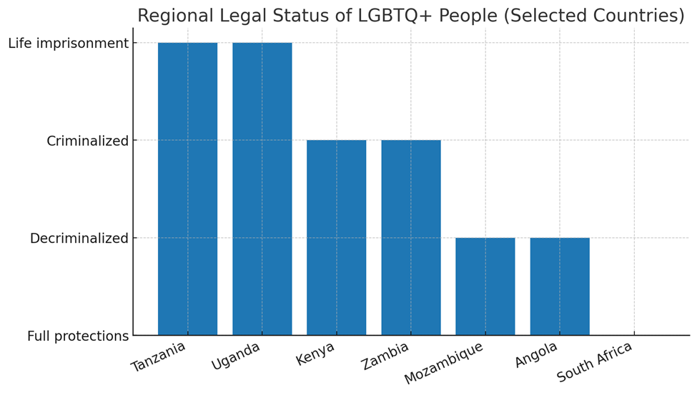
- Key Data Insight: Tanzania has ratified major human rights treaties but continues to criminalize LGBTQ+ identities, creating a gap between international obligations and domestic law.
- Advocacy Message: Donors and policymakers must press for alignment between Tanzania’s obligations under the ICCPR, ICESCR, and African Charter with national law to end systemic violations.

Chart 2: Policy Gaps and Institutional Neglect

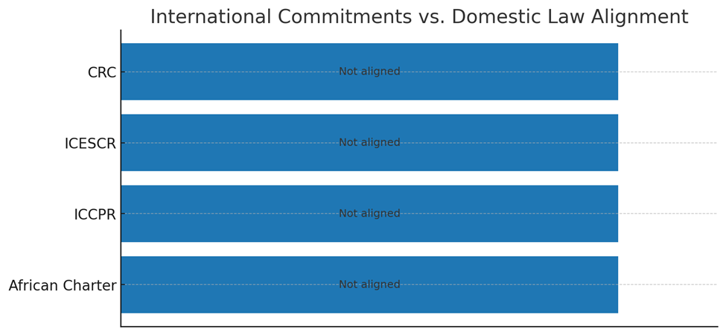
- Key Data Insight: Existing policies on health, education, and housing omit LGBTQ+ protections, leaving institutions free to deny services.
- Advocacy Message: Reforming sectoral policies to explicitly include LGBTQ+ needs will strengthen public trust and improve national development outcomes.
3.5. Implications for Tanzanian Institutions
The failure to protect LGBTQ+ people has broad negative impacts on Tanzanian institutions and national development:
- Public health: fear of arrest and stigma drives LGBTQ+ individuals away from clinics, increasing HIV risk and undermining national health goals.
- Education: expulsions and dropouts reduce human capital and future workforce productivity.
- Economy: exclusion from employment entrenches cycles of poverty and limits economic participation.
- Justice: police harassment and extortion erode trust in the legal system and fuel corruption.
Conversely, reforming this environment would:
- Build trust in public health and education systems.
- Increase workforce participation and economic productivity.
- Restore public confidence in justice institutions.
- Improve Tanzania’s international reputation as a rights-respecting country.
Advocacy Message: Protecting LGBTQ+ rights is not only a human rights imperative—it strengthens development, justice, and national unity..
3.6 Pathways for Reform
Reform is both possible and necessary. Priority actions include:
- Repeal or amend colonial-era Penal Code provisions criminalizing consensual same-sex relations.
- Embed explicit non-discrimination protections in the Constitution and in health, education, employment, and housing policies.
- Integrate LGBTQ+ sensitivity and human rights training into police academies, teacher training programs, and healthcare curricula.
- Protect the operating space of LGBTQ+-led organizations, ensuring they can deliver services and advocacy without harassment.
Advocacy Message: Decriminalization and protection are not distant ideals—they are practical reforms that will save lives, reduce costs, and build a stronger Tanzania.
3.7 Advocacy Entry Points
To translate the above findings into action, advocates, policymakers, and donors can focus on the following strategic entry points:
1. Government Engagement: Lobby Parliament and the Ministry of Justice to repeal Penal Code provisions and embed anti-discrimination clauses in the Constitution.
2. Health Sector Reform: Press the Ministry of Health to reinstate essential HIV-prevention commodities and fund LGBTQ+ sensitivity training for health workers.
3. Education Policy: Advocate for Ministry of Education directives to stop expulsions and enforce anti-bullying measures in schools.
4. Police Accountability: Establish oversight mechanisms, including independent complaints bodies, to curb police extortion and abuse.
5. International Mechanisms: Use Tanzania’s Universal Periodic Review (UPR) at the UN Human Rights Council and African Commission sessions to raise pressure for reform.
6. Donor Leverage: Encourage bilateral and multilateral donors to tie funding in health, education, and governance to measurable progress on equality and human rights.
7. Civil Society Empowerment: Provide flexible funding and legal protections for LGBTQ+-led organizations to deliver essential services and advocacy safely.

4. Key Findings
The following sections highlight the lived realities of LGBTQ+ people across education, health, employment, legal systems, and family life. These findings reveal overlapping vulnerabilities shaped by identity, class, and geography. For example, rural respondents often reported more limited access to healthcare and safe spaces than those in urban centers, underscoring the need for both national and localized responses.
4.1 Education
Many LGBTQ+ youth in Tanzania face intense discrimination in educational settings. A significant number of participants reported being bullied, harassed, or publicly shamed by both peers and educators due to their real or perceived sexual orientation or gender identity. Several were expelled or forced to drop out after being outed or accused of violating school norms. Others experienced unsafe conditions in dormitories or were ignored by school administrators when they reported violence. In the absence of protective and inclusive policies, schools become hostile environments, stripping LGBTQ+ youth of their right to education and a safe learning space.
“When my classmates found out I was gay, they beat me until I could not walk. The teacher told me I had brought shame to the school. I never went back.” – 19-year-old gay student, Mwanza
Chart 3: School Dropout Linked to Identity

- Key Data Insight: 41% of LGBTQ+ youth were expelled or forced to drop out, with trans and gay students most affected.
- Advocacy Message: Donors and policymakers should prioritize inclusive education policies and invest in safe school environments to protect the right to education for all.
Advocacy Entry Points
- Advocate for anti-bullying and non-discrimination school policies.
- Push Ministry of Education to reinstate expelled LGBTQ+ students.
- Engage teacher unions in training on inclusion.

4.2 Health Access
LGBTQ+ individuals encounter systemic obstacles when seeking healthcare. Many shared that they avoid clinics or hospitals for fear of exposure, humiliation, or outright denial of services. Participants reported being mocked or questioned aggressively by healthcare workers, particularly when seeking treatment related to sexual health. Transgender participants described being denied gender-affirming care or being misgendered by medical professionals. The government’s ban on water-based lubricants—an essential tool for HIV prevention—compounds these challenges, increasing health risks while reinforcing institutional stigma.
Inclusive healthcare is central to Tanzania’s national HIV strategy. Ensuring that LGBTQ+ Tanzanians can access clinics without fear will reduce infection rates, improve community trust in healthcare workers, and save lives. Training programs for medical staff, already used for maternal health, could be adapted to cover LGBTQ+ sensitivity.

Chart 4: Healthcare Avoidance Due to Fear of Discrimination

- Key Data Insight: 71% avoided care, while only 21% accessed services safely.
- Advocacy Message: Inclusive healthcare is not optional—it is essential to meeting national HIV prevention goals and SDG targets.
Advocacy Entry Points
- Lobby for the reinstatement of HIV-prevention tools (e.g., lubricants).
- Advocate for integration of LGBTQ+ sensitivity into national health training.
- Push donors to fund peer-led health initiatives.

Chart 5: Types of Mistreatment in Healthcare

- Key Data Insight: Participants reported denial of care, mocking, invasive questioning, and misgendering, with trans people disproportionately affected.
- Advocacy Message: Donors should fund training for healthcare providers, while policymakers embed anti-discrimination protocols into national health strategies.
4.3 Employment and Livelihood
Economic exclusion is a pervasive reality. Many LGBTQ+ individuals are denied employment, dismissed from jobs, or forced into unsafe informal work due to discrimination. Employers frequently act on suspicion rather than fact, firing individuals based on appearance, mannerisms, or hearsay. With no legal protections in place, LGBTQ+ people are left vulnerable to financial instability, workplace abuse, and exploitation. As a result, many hide their identities to survive, which takes a toll on mental health and personal safety.
Economic exclusion not only harms individuals—it undermines Tanzania’s overall development. Donors and partners can expand livelihood programs by funding safe vocational training, microfinance, and entrepreneurship opportunities specifically targeting LGBTQ+ youth. Such investments reduce vulnerability to exploitation and strengthen resilience against poverty.

Chart 6: Employment Exclusion of LGBTQ+ People

Key Data Insight: Only 1% of trans women and 2% of gay men were employed, compared to 72% of bisexual respondents.
Advocacy Message: Urgent legal protections and donor investment in safe livelihood programs are needed to reduce poverty and exploitation among LGBTQ+ youth..
Advocacy Entry Points
- Advocate for anti-discrimination protections in labor law.
- Push for donor-funded LGBTQ+ livelihood and vocational training programs.
- Engage private sector allies to adopt inclusive workplace policies.

Chart 7: Workplace Discrimination across Identities

- Key Data Insight: Respondents cited dismissal, harassment, and exploitation across all groups, with trans women most targeted.
- Advocacy Message: International partners should press for workplace equality measures and fund entrepreneurship programs for excluded groups.
4.4 Legal and Institutional Harm
Tanzania's legal framework—rooted in colonial-era penal codes—criminalizes same-sex relationships and legitimizes societal and institutional abuse. Many participants reported being arrested, harassed, or blackmailed by law enforcement. Police officers often exploit the law’s ambiguity to extort money or coerce silence, knowing LGBTQ+ individuals fear being outed in court or imprisoned. These laws not only deny LGBTQ+ people legal protection but also encourage violence and impunity.
Law enforcement agencies have the responsibility to serve and protect all Tanzanians. Ending practices of arbitrary arrest and extortion would restore community trust in the police and reduce corruption. Respecting constitutional guarantees of equality will also strengthen Tanzania’s reputation in regional human rights bodies.

Ripple Effects of Criminalization on LGBTQ+ Lives

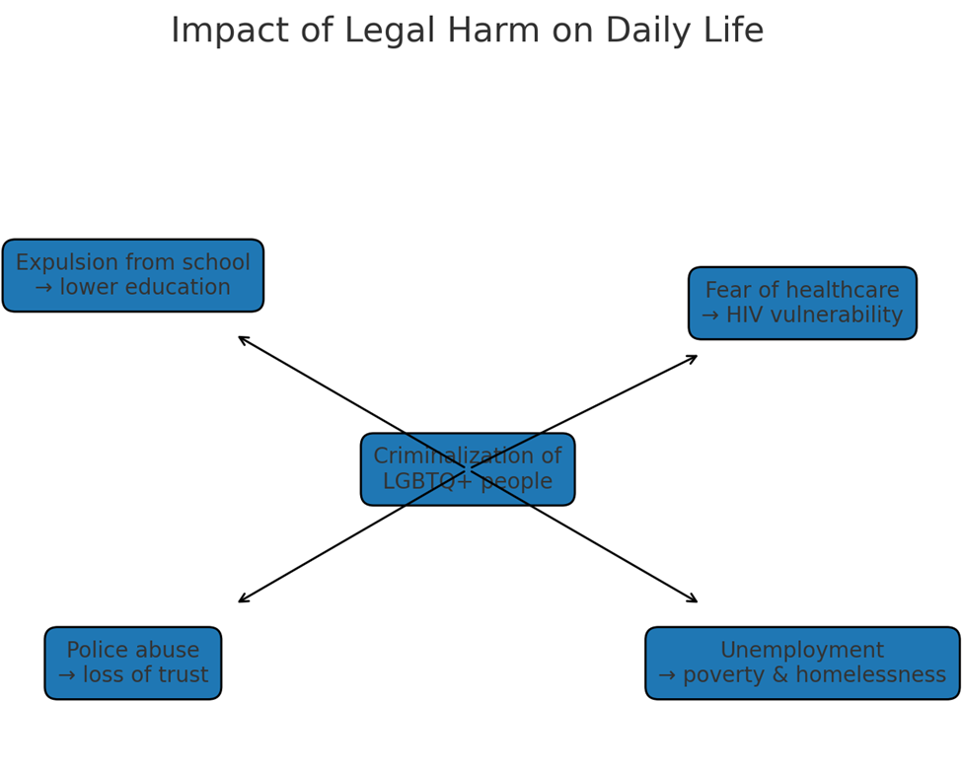
- Key Data Insight: The criminalization of LGBTQ+ identities in Tanzania fuels systemic exclusion—denial of education, healthcare, justice, and livelihoods—creating a cycle of poverty and vulnerability.

- Advocacy Message: Donors should support legal reform campaigns and community resilience programs, while policymakers must prioritize decriminalization to dismantle the root cause of these overlapping human rights violations.
Advocacy Entry Points
- Press for an end to arbitrary arrests and extortion by police.
- Advocate for legal aid programs to support victims.
- Use Tanzania’s treaty commitments to push for constitutional reform.

Chart 8: Perceptions of Safety among LGBTQ+ People

- Key Data Insight: 79% reported experiencing at least one form of discrimination, eroding trust in institutions.
- Advocacy Message: Safety is a systemic issue. Legal reform and police accountability are critical to restoring dignity and public trust.
Chart 10: Legal and Police Violations by Identity

- Key Data Insight: Arrests, extortion, and blackmail disproportionately target trans women and gay men, intensifying exclusion.

- Advocacy Message: Ending impunity for police abuse must be a priority for donors and policymakers committed to justice reform.
4.5 Economic Impact of Exclusion
Excluding LGBTQ+ Tanzanians harms national development. Loss of workforce participation, untreated health needs, and disrupted education reduce productivity and increase public costs. Addressing discrimination is not only a human rights imperative but also an economic investment: safe healthcare, legal protection, and livelihood programs stabilize incomes and lower long-term public expenditure.
- Suggested Metrics to Include (presented as bullet visuals or side-box):
- Unemployment gap: Compare unemployment in the LGBTQ+ sample against the national average.
- Lost productivity: Estimate the average days of work/study lost per year due to discrimination, illness, or violence.
- Healthcare costs: Estimate the public savings if stigma-free primary healthcare reduced reliance on emergency and crisis care.
- Education disruption: Percentage of LGBTQ+ youth forced to drop out or expelled compared to the national dropout rate.
- Informal economy reliance: Proportion of LGBTQ+ respondents working informally vs the national average, showing limited access to stable income.
Advocacy Message:
Protecting LGBTQ+ rights is not only a human rights priority — it is also smart economics, lowering public costs and boosting national productivity.
4.6 Social Rejection and Violence
Social rejection emerged as one of the most painful and common experiences. Participants recounted being disowned by their families, evicted by landlords, and attacked by neighbors or mobs. In some cases, local leaders actively incited violence or encouraged community members to report LGBTQ+ individuals to the authorities. This widespread ostracism forces many to live in secrecy, isolation, or displacement—cut off from their roots and any semblance of safety.
“When my family discovered I was transgender, they locked me out of the house. I slept outside for three nights until a friend took me in. I still love my family, but they refuse to see me as their child.” – 24-year-old trans woman, Arusha

Chart 11: Sources of Support after Rejection

- Key Data Insight: Most LGBTQ+ people rely on peers and informal networks, not institutions, when facing violence or rejection.

- Advocacy Message: Donors should fund safe spaces and shelters, while policymakers expand psychosocial support services to reduce reliance on fragile informal networks.
Advocacy Entry Points
- Advocate for shelters and psychosocial support funded by donors.
- Push for community dialogues led by civil society to reduce stigma.
- Engage religious leaders in inclusive messaging.

Chart 12: Optimism about the Future

- Key Data Insight: Many LGBTQ+ respondents—especially youth—expressed optimism despite systemic exclusion.

- Advocacy Message: Donors should invest in youth empowerment; policymakers must create an enabling environment that sustains this resilience.
4.7 Homelessness, Survival Sex, and Mental Health
The intersection of rejection, poverty, and discrimination has led to alarming levels of homelessness among LGBTQ+ youth. Many young people are cast out of their homes, unable to continue schooling or secure stable jobs. With no institutional support or housing alternatives, they are pushed into survival sex—trading sex for food, shelter, or basic necessities. This exposes them to heightened risks of abuse, sexually transmitted infections, and trafficking.
Homelessness among LGBTQ+ youth is not just a social issue but a public health crisis. Without safe housing, many are pushed into survival sex and substance use. Donors can play a life-saving role by supporting shelters, psychosocial care, and reintegration programs. For the Tanzanian public, these are young people—our children, our brothers, our sisters—whose only “crime” is being themselves.
Substance use is frequently adopted as a coping mechanism. Participants spoke of using alcohol and drugs to numb emotional pain, deal with rejection, or survive life on the streets. Mental health challenges—including depression, anxiety, and suicidal ideation—were disturbingly prevalent. However, mental health services remain inaccessible for most due to high costs, stigma, and a lack of LGBTQ+-affirming care providers.
Advocacy Entry Points
- Advocate for national mental health programs inclusive of LGBTQ+.
- Push donors to fund emergency housing and trauma counseling.
- Link to child protection frameworks (CRC obligations).
4.8 Case Studies with Human Faces:
While statistics reveal the scale of exclusion, individual experiences show its human cost. The following anonymized stories highlight the daily realities of LGBTQ+ people in Tanzania. Names have been changed to protect identities.
Amina (pseudonym), 19 — Mwanza
Amina was expelled from her family home after being outed. Unable to continue her education, she now relies on precarious informal jobs and avoids healthcare facilities due to stigma.
“I stopped going to the clinic because they treat me like I brought the problem.”
Why it matters: Demonstrates the link between family rejection, interrupted education, and barriers to health access.
Joseph (pseudonym), 27 — Dar es Salaam
Joseph was denied routine care at a public hospital after disclosing his sexual orientation. He delayed treatment until his condition became an emergency.
“They made me feel I was not a person.”
Why it matters: Shows how healthcare denial results in delayed treatment and higher long-term costs.
Neema (pseudonym), 22 — Arusha
Neema, a trans woman, was beaten by neighbors after rumors spread in her community. She lost her job and has struggled to find safe housing.
“I wish I could just live without fear of someone attacking me for who I am.”
Why it matters: Highlights the cycle of violence, displacement, and economic insecurity faced by trans individuals.
David (pseudonym), 30 — Mbeya
David was evicted by his landlord after neighbors reported his sexual orientation. He now moves frequently, paying inflated rents because few landlords will rent to him.
“Every time I move, I lose my stability and my work suffers.”
Why it matters: Illustrates the economic toll of housing discrimination and instability.

Chart 13: Regional Variations in Enforcement
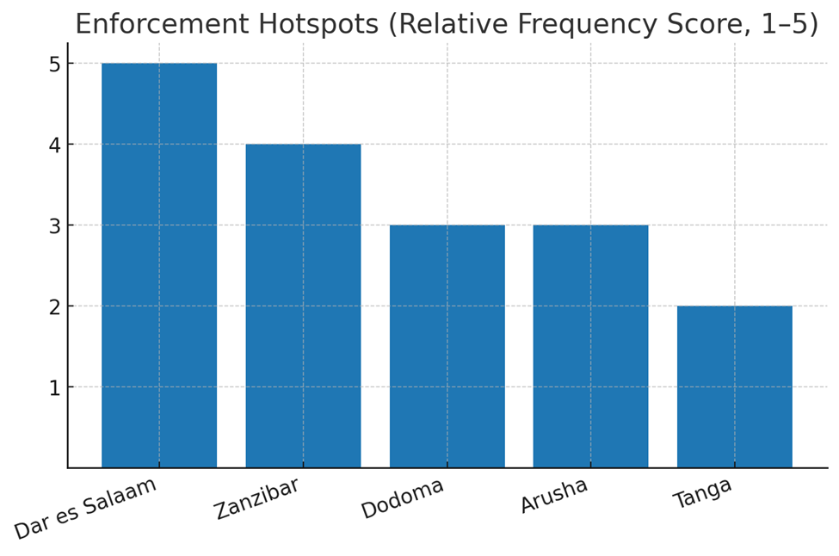
- Key Data Insight: Harassment and enforcement were highest in Dar es Salaam and Zanzibar.

- Advocacy Message: Donors should support shelters in these hotspots; policymakers must halt discriminatory enforcement practices.

4.8 Comparative and Trend Analysis
The findings of this study align with, and in many cases expand upon, previous research documenting the marginalization of LGBTQ+ people in Tanzania. Examining changes over time and across the region provides important context for advocacy.
Trends over Time (Tanzania)
Human Rights Watch (2018) reported widespread police raids, forced anal examinations, and denial of healthcare for LGBTQ+ persons. At the time, denial of HIV services was a central concern.
In this 2023–2024 study, healthcare exclusion remains severe—71% of respondents avoided clinics due to fear of discrimination—but community reports of forced anal examinations appear to have declined, likely due to international pressure.
Expulsions from schools, however, have increased since 2018, with 41% of participants reporting school dropout linked to identity compared to roughly 25% in past reports.
Public raids continue, but participants noted they are now often accompanied by media exposure and humiliation campaigns, amplifying the risks of outing.
Regional Comparison (East Africa)
In Uganda, the passage of the 2023 Anti-Homosexuality Act introduced life imprisonment and even the death penalty for certain consensual same-sex acts. Tanzania does not yet have such laws, but activists warn that the climate of hostility in the region emboldens Tanzanian authorities to intensify repression.
In Kenya, courts have upheld the criminalization of same-sex relations, but civil society space remains comparatively larger. Kenyan activists have successfully advanced cases for gender marker changes and limited protections in employment. Tanzania lags significantly behind Kenya in terms of access to justice and institutional engagement.
Compared to both Uganda and Kenya, Tanzania’s enforcement practices are inconsistent but unpredictable—raids and arrests spike during political campaigns or morality crusades, creating a climate of fear.

Table : Comparative Regional Lens: East Africa
Country | Legal Status (same-sex relations) | Gender Identity Recognition | Anti-Discrimination Protections | Recent State Actions (since 2018) | Notes for Advocates
Tanzania | Criminalized under colonial-era laws (up to life imprisonment) | No recognition; gender-affirming healthcare restricted | None. | Intensified crackdowns, expulsions from universities, health provider surveillance, arrests. | High risk of persecution, limited legal recourse, growing invisibility
Kenya | Criminalized under Penal Code (up to 14 years), though enforcement is uneven. | No recognition; trans people struggle for legal name/gender changes. | None specific to LGBTQ+. | Supreme Court allowed LGBTQ+ NGOs to register (2023); continued police harassment and political hostility. | Mixed: small legal gains amid ongoing hostility.
Uganda | Harshest laws: 2023 Anti-Homosexuality Act introduces death penalty for “aggravated homosexuality. | No recognition; trans people face extreme risk. | None. | Widespread arrests, evictions, mob violence, NGO shutdowns. | Most repressive in the region; donor sanctions already underway.

Key Data Insights
- Tanzania: Same-sex relations criminalized (up to life imprisonment). Intensified crackdowns include expulsions from schools, health surveillance, and arrests.
- Kenya: Same-sex relations criminalized (up to 14 years). No legal gender recognition, but Supreme Court recently upheld the right of LGBTQ+ groups to register.
- Uganda: Harshest environment in the region — 2023 Anti-Homosexuality Act introduced the death penalty for “aggravated homosexuality,” triggering widespread arrests and donor sanctions.

Advocacy Message
Tanzania sits between Kenya and Uganda: legally aligned with colonial-era criminalization, but increasingly adopting Uganda-style crackdowns in practice. This moment is pivotal — timely donor support and diplomatic engagement can prevent further regression and push Tanzania toward a more rights-respecting path.
Advocacy Entry Points
- Position Tanzania’s advocacy as preventing “Uganda-style regression.”
- Engage African Union and EAC human rights bodies.
- Push international partners to use diplomatic pressure tied to SDGs.

Implications for Advocacy
The persistence of systemic exclusion shows that progress is uneven and fragile. Gains in one area (e.g., reduction in forced anal examinations) are offset by worsening conditions elsewhere (e.g., education and employment).
Regional developments suggest that without sustained international pressure and domestic advocacy, Tanzania risks moving closer to Uganda’s model of extreme criminalization rather than Kenya’s slow legal reform trajectory.

Key Message:
Comparative data shows that conditions for LGBTQ+ Tanzanians have not improved meaningfully since 2018, and in some areas have worsened. Placing Tanzania alongside Uganda and Kenya underscores both the risks of regression and the urgent need for targeted reform and international solidarity.
4.9 Intersectional Analysis: Overlapping Vulnerabilities
The lived realities of LGBTQ+ Tanzanians are not uniform. Experiences of exclusion, violence, and resilience vary significantly depending on gender identity, geography, class, and age. Recognizing these intersecting vulnerabilities is critical for designing effective interventions.
Gender Identity
- Trans women reported the most severe marginalization across nearly all indicators. Only 1% were employed, and they were disproportionately targeted by police raids, harassment, and extortion. Many described being stopped in public spaces due to their visibility and were denied access to housing and healthcare at higher rates than other groups.
- Gay men also faced heightened risks, particularly of police abuse, blackmail, and forced outings.
- Bisexual and lesbian participants reported somewhat higher employment rates, often attributed to lower visibility or “passing” in heteronormative settings. However, they too faced rejection in families, schools, and healthcare systems.

Geography
- Urban participants (Dar es Salaam, Zanzibar, Arusha) experienced higher rates of police raids, surveillance, and public harassment, reflecting the concentration of state enforcement in cities.
- Rural participants, while less likely to face direct police persecution, were more isolated and excluded from education and healthcare. Many reported complete absence of safe spaces or peer networks in their areas.
- LGBTQ+ individuals in Zanzibar described a particularly hostile environment due to both legal enforcement and religious conservatism, with frequent community-led reporting to authorities.
Age
- Youth (18–24) were most vulnerable to school expulsions, family rejection, and homelessness. Many were pushed into survival sex after being forced out of homes or schools.
- Older participants (30+), though fewer in the sample, reported longer-term economic exclusion and ongoing secrecy to maintain safety. They carried the psychological toll of decades of hiding, with limited opportunities for livelihood recovery.
Class and Economic Status
- Participants from poorer households were at higher risk of homelessness and survival sex, with fewer safety nets or resources to relocate after rejection.
- Those with access to some education or middle-class backgrounds could sometimes “pass” in formal employment but still faced sudden dismissal when suspected of being LGBTQ+.
Disability
Although underrepresented in the sample, participants with disabilities reported “double stigma”—first as persons with disabilities, and second as LGBTQ+. They described complete lack of tailored services, making them the most invisible subgroup in this study.
5. Resilience and Community Power
Amidst the pervasive discrimination, violence, and exclusion documented in this report, LGBTQ+ Tanzanians continue to resist, rebuild, and support one another. Far from being passive victims, community members demonstrate remarkable resilience and creativity in forging pathways to survival and dignity.
Despite exclusion, community resilience remains a powerful force. Optimism expressed by many respondents (see Figure 11) reflects determination to imagine safer futures. Donors and policymakers can amplify this resilience by funding peer-led organizations, supporting youth initiatives, and strengthening regional solidarity networks.
Peer Support and Chosen Families
When biological families reject them, many LGBTQ+ people turn to chosen families—trusted peers who provide shelter, food, and emotional care. These informal networks are lifelines, ensuring that no one is entirely alone. Participants described rotating safe sleeping arrangements, sharing meals, and pooling resources to cover medical bills or bail money.
“After my parents chased me out, a group of friends let me sleep in their living room for months. We call each other family now, because that’s what we are.” – 22-year-old lesbian woman, Tanga
Safe Houses and Shelters
In urban centers such as Dar es Salaam and Arusha, community-led shelters provide temporary refuge for LGBTQ+ youth facing violence or homelessness. Though often underfunded and at risk of police scrutiny, these safe houses serve as spaces of healing and empowerment. Residents reported gaining not only safety, but also access to vocational skills training, counseling, and information about legal rights.
Livelihood and Survival Strategies
Faced with exclusion from formal employment, many LGBTQ+ individuals create their own opportunities through entrepreneurship, informal trade, and small-scale farming. These strategies allow them to maintain independence and reduce vulnerability to exploitation. Some community groups have formed micro-savings collectives, rotating funds to help members start small businesses.
Mental Health and Coping Mechanisms
Participants spoke about resilience through creative expression, spirituality, and activism. Some found strength in music, poetry, or dance, using art to reclaim dignity and visibility. Others drew upon faith—sometimes outside mainstream religious structures—as a source of hope. Community-led mental health support circles, often facilitated by peer counselors, provided safe spaces to share trauma and build collective strength.
Advocacy and Movement-Building
LGBTQ+-led organizations continue to challenge stigma and push for change despite immense risks. By documenting violations, providing emergency response, and engaging regional human rights bodies, these groups keep the struggle visible. Importantly, they connect Tanzanian experiences with broader African and global movements, amplifying voices that the state seeks to silence.
“We cannot wait for the law to protect us. Until then, we protect each other.” – Activist, Dar es Salaam
Key Message:
Resilience is not just survival—it is resistance. Through chosen families, shelters, entrepreneurship, art, and advocacy, LGBTQ+ Tanzanians are carving out spaces of safety and dignity even in hostile environments. For donors and allies, investing in these grassroots solutions is not charity but solidarity—supporting strategies that are already working and led by the community itself.

6. Recommendations
This report highlights urgent areas where action is required to protect the rights, dignity, and lives of LGBTQ+ people in Tanzania. The following recommendations are directed at government authorities, civil society actors, and donor partners.
Summary of Recommendations:
- Government of Tanzania: Repeal criminalizing laws; enact anti-discrimination protections; expand inclusive education and health policies.
- Civil Society: Expand safe spaces, legal aid, and psychosocial support; strengthen advocacy coalitions.
- Donors: Increase funding for livelihoods, mental health, and legal reform campaigns; support rural outreach.
- International Partners: Sustain diplomatic pressure for compliance with human rights treaties; fund cross-border solidarity and research.
6.1 To the Government of Tanzania
- Repeal discriminatory laws: Urgently review and repeal Penal Code provisions criminalizing consensual same-sex relations.
- End harmful practices: Prohibit forced anal examinations, harassment, and raids against LGBTQ+ organizations and gatherings.
- Protect access to health services: Ensure that Ministry of Health policies guarantee non-discriminatory access to HIV services and other healthcare.
- Inclusive education policies: Safeguard LGBTQ+ students from expulsion, bullying, and exclusion from schools.
- Police accountability: Establish clear oversight mechanisms to address police abuse, extortion, and arbitrary arrests of LGBTQ+ individuals.
- Uphold international commitments: Align domestic law with Tanzania’s obligations under treaties such as the ICCPR, ICESCR, CRC, and African Charter.

6.2 To Civil Society Organizations in Tanzania
- Community support: Expand safe spaces, legal aid, and psychosocial support for LGBTQ+ people facing violence and exclusion.
- Documentation and advocacy: Continue collecting evidence of rights violations and engage in regional and international advocacy.
- Coalition-building: Strengthen alliances with women’s rights, youth, and health movements to frame LGBTQ+ rights as part of broader human rights and development goals.
6.3 To International Donors and Partners
- Direct funding for protection: Provide flexible and sustained funding to grassroots LGBTQ+ organizations for legal aid, security, and emergency response.
- Support advocacy: Invest in evidence-based advocacy targeting regional and international human rights mechanisms.
- Capacity strengthening: Fund training and institutional development to enable LGBTQ+ organizations to operate safely and effectively.
- Diplomatic engagement: Use bilateral and multilateral platforms to press the Government of Tanzania to respect its human rights commitments.
Donor Action Checklist
Practical Steps for Immediate Impact
1. Fund Safe Spaces & Shelters
- Provide flexible grants for community-run shelters that offer LGBTQ+ youth housing, food, and psychosocial care.
- Prioritize urban hotspots (Dar es Salaam, Arusha, Zanzibar) and expand into rural regions.
2. Invest in Mental Health & Trauma Care
- Support training of LGBTQ+-affirming counselors.
- Fund peer-led mental health support circles and community helplines.
3. Strengthen Livelihood Programs
- Support vocational training, microfinance, and entrepreneurship projects targeting excluded LGBTQ+ youth.
- Build economic independence to reduce reliance on survival sex.
4. Expand Access to Healthcare
- Provide resources for inclusive HIV prevention programs (including lifting bans on essential tools like lubricants).
- Train healthcare workers in LGBTQ+ sensitivity and rights.

5. Support Legal Reform & Advocacy
- Fund campaigns that document rights violations and push for decriminalization.
- Support legal aid and strategic litigation to challenge discriminatory practices.
6. Build International Pressure & Solidarity
- Use diplomatic platforms to hold Tanzania accountable to its treaty obligations.
- Support cross-border advocacy, linking Tanzanian activists with regional and global movements.
7. Resource Rural Outreach
- Fund mobile health and legal aid clinics that reach LGBTQ+ people in rural and hard-to-access areas.
- Ensure that community support is not limited to urban centers.
6.4 Policy and Legal Reform Roadmap
The following phased roadmap outlines priority reforms and interventions needed to protect the rights, dignity, and wellbeing of LGBTQ+ Tanzanians. Staging these actions helps clarify immediate, medium-term, and long-term entry points for government, civil society, and donors.
Short-Term (1–2 years)
- End harmful practices such as forced anal examinations and arbitrary arrests.
- Issue ministerial directives guaranteeing non-discriminatory access to health services, especially HIV treatment.
- Establish oversight and accountability mechanisms within the police to reduce extortion and abuse.
- Pilot safe spaces and shelters for LGBTQ+ youth in urban centers.
Medium-Term (3–5 years)
- Embed anti-discrimination protections in key policies (health, education, employment, housing).
- Integrate LGBTQ+ sensitivity training into police, healthcare, and teacher training curricula.
- Expand safe spaces and community centers to rural areas.
- Introduce national mental health programs inclusive of LGBTQ+ populations.
Long-Term (5–10 years)
- Repeal colonial-era Penal Code provisions criminalizing consensual same-sex relations.
- Amend the Constitution to explicitly prohibit discrimination on the basis of sexual orientation and gender identity.
- Strengthen civil society protections to ensure LGBTQ+ organizations can operate safely.
- Position Tanzania as a regional leader in upholding dignity, equality, and inclusive development.
Key Message:
This roadmap shows that reform is not a distant ideal—it is a practical, staged process. Civil society and donors can align their support with each stage, from emergency protections today to structural reforms in the coming decade.

7. Monitoring & Evaluation (M&E) / Next Steps
LGBT Voice Tanzania views this study not as an end point, but as part of a sustained process to ensure that the lived realities documented here lead to meaningful change. To that end, we commit to the following:
Tracking Implementation of Recommendations
We will use the advocacy recommendations from this report as benchmarks, monitoring whether government agencies, civil society partners, and international stakeholders take measurable steps to address them.
Continuous Community Engagement
We will maintain close contact with LGBTQ+ individuals and grassroots networks to assess whether there are tangible improvements in safety, dignity, and access to services. This ensures that our advocacy remains rooted in the lived experiences of the community.
Updating the Evidence Base
The findings of this report provide a baseline. LGBT Voice Tanzania will continue documenting testimonies, case studies, and quantitative data to expand and update this evidence, ensuring that both progress and setbacks are captured.
Accountability Through Reporting
We will regularly publish briefs, fact sheets, and advocacy updates to share progress, highlight gaps, and keep LGBTQ+ issues visible at national, regional, and international levels.

Next Steps
- Disseminate Findings widely among policymakers, human rights institutions, media, and international partners to maximize visibility and influence.
- Use Evidence for Advocacy by pressing for legal and policy reforms that dismantle criminalization, discrimination, and violence.
- Support Community Resilience by working with local networks to design responses to the challenges highlighted in this report.
- Strengthen Alliances with regional and global partners to situate Tanzania’s realities within broader human rights struggles.
- Institutionalize Monitoring by establishing clear indicators and reporting cycles to track reforms and highlight ongoing challenges.
Through these commitments, LGBT Voice Tanzania ensures that the findings of this study remain an active tool for advocacy, accountability, and long-term social change.

8. Conclusion
The stories shared in this report are painful, powerful, and profoundly urgent. They reflect a reality in which LGBTQ+ Tanzanians continue to be criminalized, dehumanized, and excluded—but they also testify to extraordinary resilience. Community networks, brave individuals, and local activists are holding the front lines of resistance and hope.
But community alone cannot bear this burden. Structural transformation—legal, political, and cultural—is urgently needed. We call on the government, civil society, donors, and the international community to move beyond words and toward sustained action.
This report is more than evidence—it is a call to conscience. For Tanzanian institutions, it is a reminder that dignity and safety are constitutional rights owed to every citizen. For donors and civil society, it is a call to invest in community-led solutions that save lives. And for the public—whether Tanzanian or global—it is an invitation to stand with LGBTQ+ people, to reject violence, and to affirm that love, safety, and dignity are not privileges but rights.
The evidence is clear: criminalization and exclusion undermine Tanzania’s development and violate the rights of its citizens. We urge the Government to act decisively to end systemic discrimination. We call on donors and international partners to stand in solidarity with Tanzanian LGBTQ+ communities, providing resources that transform resilience into structural change. History will judge Tanzania not by its silence but by its willingness to extend dignity and equality to all.

End Notes:
As community members and advocates of LGBT Voice Tanzania, we stand firmly in our commitment to justice, visibility, and dignity for every LGBTQ+ person in our country. This report is not merely a collection of data—it is a living document of testimony, survival, and resistance.
Through the voices of 367 LGBTQ+ Tanzanians, we hear the consequences of systemic discrimination—yet also the power of community. These lived realities demand urgent reforms: decriminalization of same-sex relations, inclusive service delivery, protection from violence, and the affirmation of every individual’s right to exist without fear.
We call on policymakers to repeal outdated colonial-era laws. We urge civil society to amplify queer voices and fund safe spaces. And we invite international allies and donors to invest in community-driven change. As long as the state remains silent, we will continue to speak. As long as systems exclude us, we will organize. Because our existence is not the problem—discrimination is.

Together, let this report mark not only the exposure of injustice but the beginning of transformation.

References
- Amnesty International. 2020. The State of the World’s Human Rights: Tanzania 2019/20. London: Amnesty International. https://www.amnesty.org/en/countries/africa/tanzania.
- Babbie, Earl R. 2013. The Practice of Social Research. 13th ed. Belmont, CA: Cengage Learning.
- Human Rights Watch. 2018. “If We Don’t Get Services, We Will Die”: Tanzania’s Anti-LGBT Crackdown and the Right to Health. New York: Human Rights Watch. https://www.hrw.org/report/2018/02/02/if-we-dont-get-services-we-will-die.
- ILGA World. 2023. State-Sponsored Homophobia Report: Global Legislation Overview Update. Geneva: ILGA. https://ilga.org.
- LGBTI Coalition of Tanzania. 2022. The Shadow Report on the Human Rights Situation of LGBTIQ+ Persons in Tanzania. Dar es Salaam: Tanzania Network of Legal Aid Providers.
- Legal and Human Rights Centre (LHRC). 2021. Tanzania Human Rights Report 2020. Dar es Salaam: LHRC. https://www.humanrights.or.tz.
- Ministry of Health, Community Development, Gender, Elderly and Children. 2021. National Guideline for Comprehensive Package of HIV Interventions for Key and Vulnerable Populations. Dodoma: United Republic of Tanzania.
- Noy, Chaim. 2008. “Sampling Knowledge: The Hermeneutics of Snowball Sampling in Qualitative Research.” International Journal of Social Research Methodology 11 (4): 327–344. https://doi.org/10.1080/13645570701401305.
- Open Society Foundations. 2019. Out of the Shadows: LGBTIQ Inclusion in Development. New York: Open Society Foundations. https://www.opensocietyfoundations.org/publications/out-shadows.
- The Citizen. 2017. “Police Raid Gathering Suspected to Be Promoting Homosexuality.” The Citizen, November 17, 2017. https://www.thecitizen.co.tz.
- United Republic of Tanzania. 1977. The Constitution of ths
- United Republic of Tanzania. Dar es Salaam: Government Printer. https://www.constitutionnet.org.
- United Republic of Tanzania. 2022. The Penal Code (Cap. 16). Dar es Salaam: Government Printer.
- UN Human Rights Council. 2021. Report of the Independent Expert on Protection against Violence and Discrimination Based on Sexual Orientation and Gender Identity. A/HRC/47/27. Geneva: United Nations. https://www.ohchr.org.

Annexes / Appendix
Annex A: Methodology Details
Research Design
This study used a mixed-method approach combining 133 structured interviews with LGBTQ+ individuals across Tanzania between January and April 2025. Both quantitative (structured survey responses) and qualitative (narrative testimonies) data were collected.
Sampling Techniques
- Purposive sampling was used to ensure representation of diverse sexual orientations and gender identities (gay, lesbian, bisexual, transgender, queer, and gender-nonconforming individuals).
- Participants were drawn from both urban and rural settings, with an age range of 15 to 40 years.
- Community networks and peer researchers played a key role in reaching hidden populations often excluded from mainstream surveys.
Ethical Safeguards
- All participants were informed of the study’s purpose and gave voluntary, informed consent.
- Confidentiality was strictly maintained; identifying details were anonymized to protect participants in Tanzania’s hostile legal environment.
- A trauma-informed approach guided interviews to minimize re-traumatization and ensure emotional safety.
- Participants were provided with referrals for psychosocial support where needed.
Data Analysis
- Quantitative data were analyzed using descriptive statistics to identify patterns in education, health access, employment, and housing.
- Qualitative data were coded thematically to highlight recurring challenges (rejection, discrimination, violence) and strengths (resilience, community support).
- Findings were triangulated across sources to increase validity.

Annex B: Supplementary Charts
Figure 1: Age Distribution of Respondents
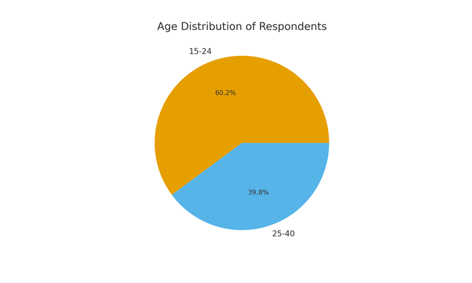
Figure 2: Reported Employment Challenges
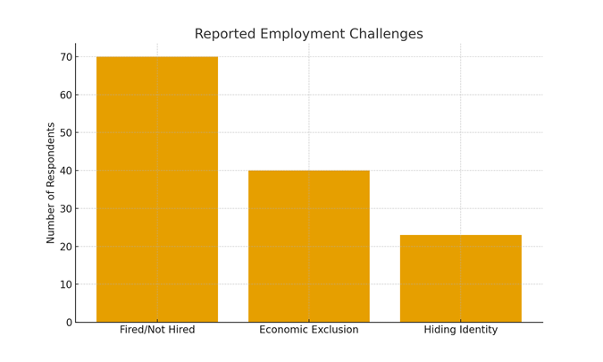

Appendix D: Participant Questionnaire
This questionnaire was administered to participants prior to the semi-structured interview. It was designed to collect quantitative data relevant to the social, economic, and legal challenges faced by LGBTQ+ individuals in Tanzania. All responses were voluntary and confidential.

Section 1: Demographic Information
Age: ________
Gender Identity:
Sexual Orientation:
Place of Residence (District): ___________________________
Education Level:
Employment Status:
Section 2: Access to Services
Do you feel safe accessing healthcare services in your area?
----------------------------------------------------------------------------------------------------------------------------------------------------------------------------------------
Have you ever been denied healthcare because of your sexual orientation or gender identity?
----------------------------------------------------------------------------------------------------------------------------------------------------------------------------------------
Do you feel safe in your current housing situation?
----------------------------------------------------------------------------------------------------------------------------------------------------------------------------------------
Have you experienced eviction or denial of housing due to your LGBTQ+ identity?
----------------------------------------------------------------------------------------------------------------------------------------------------------------------------------------
Section 3: Experiences of Discrimination and Violence

Have you experienced physical violence due to your LGBTQ+ identity?
----------------------------------------------------------------------------------------------------------------------------------------------------------------------------------------
Have you experienced verbal abuse or threats?
----------------------------------------------------------------------------------------------------------------------------------------------------------------------------------------
Have you been arrested or detained due to your LGBTQ+ identity?
----------------------------------------------------------------------------------------------------------------------------------------------------------------------------------------
Do you know others in your community who has faced similar experiences?
----------------------------------------------------------------------------------------------------------------------------------------------------------------------------------------
Section 4: Legal Awareness and Support Networks
Are you aware of any laws in Tanzania that criminalize same-sex relations?
----------------------------------------------------------------------------------------------------------------------------------------------------------------------------------------
Are you aware of any organizations that support LGBTQ+ rights in Tanzania?
----------------------------------------------------------------------------------------------------------------------------------------------------------------------------------------
Do you feel supported by your family?
----------------------------------------------------------------------------------------------------------------------------------------------------------------------------------------
Do you participate in any LGBTQ+ support groups or networks?
----------------------------------------------------------------------------------------------------------------------------------------------------------------------------------------
Thank you for your participation. Your responses are confidential and will contribute to greater understanding and advocacy for LGBTQ+ rights in Tanzania.

