Picture for ‘ELECTRONIC TEACHING AIDS FOR DISABLED CHILDREN’

***(A Project by Balajothi Centre for the Disabled Trust – Project # 21529)***

Funds required : $2000 : Funds raised till date : $431.51

Due date of Project Report : Oct 3, 2019

Date Report sent : Sep 15, 2019

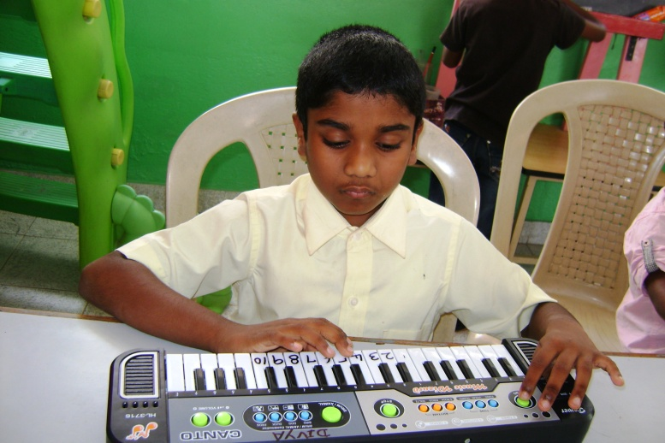

A special child enjoys playing the keyboard

***