

Financial Literacy Course
Impact Assessment

Kris Cronin
Mhaswad, Maharashtra
June-August 2009
Contents
EXECUTIVE SUMMARY 2
INTRODUCTION 3
Program Description 3
Motivation 3
Methodology 4
FIRST STAGE of ASSESSMENT 4
Survey Design and Implementation 4
Challenges 5
Interviewee Information 6
Findings 8
Overall Rating 8
Course Logistics 8
Course Topics 9
Economic Benefits 9
Social Benefits 16
Relations with Mann Deshi 17
SECOND STAGE of ASSESSMENT 19
Data Collection 19
Methodology 20
Challenges 22
Results and Findings 22
Testing for Significance 22
Time Series/Diff-in-Diff Analysis 26
CONCLUSIONS 30
APPENDICES 31
Appendix 1—Assumptions 31
Appendix 2—Surveys 33

EXECUTIVE SUMMARY
In June of 2009, the researcher was asked to conduct an impact assessment of Mann Deshi Mahila Bank’s two-year old Financial Literacy program. The primary objective of the assessment was to understand if the course was meeting the expectations of the Bank, its clients, and the Financial Literacy course trainers.
The assessment was conducted in two stages. The first stage was based on data from about 30 survey interviews with Bank clients, and the second stage analyzed database information on the loan histories of over 120 clients. Both stages involved a control group of Bank clients who have loans but have not taken the financial literacy course.
Qualitative feedback from the clients was generally very positive and confirmed that the course is meeting their expectations. In terms of logistics, most of the clients were satisfied with the timing of the course, the class size, and the amount of class time, although their experiences did vary widely. Most of the clients appreciated the topics that were covered and in general were able to restate the most important lessons from the course.
Quantitative, economic returns to the clients and the Bank in terms of savings, loans, and loan repayment, were also relatively positive. Clients who had taken the Financial Literacy course improved their savings by almost 200 percent and started saving in more secure savings locations like the Bank.
Clients who had taken the Financial Literacy course took out larger loans, more often, for more productive purposes. In particular, Financial Literacy students are estimated to take out on average INR 3,503.69 ($74.55) more in loans than clients who have not taken the course. They also take out about 0.60 more loans, and consequently are approximately 50.0 percent more like to be an active loan client than a client who has not taken the course.
In terms of loan repayment, clients who have taken the Financial Literacy course miss fewer scheduled payments and default less. According to the data, a client who has taken the course will miss an estimated 0.12 fewer scheduled loan repayments than a client who has not taken the course. Former Financial Literacy students are also about 7.0 percent less likely to default on a loan.
The Financial Literacy course is also serving to improve relations between the clients and the Bank, including use and publicity of Bank services and ease of working with the Bank. Finally, 92.0 percent of the Financial Literacy students interviewed said that they have experienced an increase in their control over household resources since taking the course, especially in terms of family members asking them for advice.
This research formed part of a larger project to improve the impact of the Financial Literacy course. The researcher worked in close collaboration with Bank staff on the other aspects of the project and used the findings from the surveys and data analyses to inform the work of enhancing the curriculum, teaching methods, and teaching material.

INTRODUCTION

Program Description
The Mann Deshi Group decided to implement a Financial Literacy program to improve their clients’ knowledge of savings and loan basics. The objectives were to help their clients become more financially independent and while also improving their use of Bank services.
Located in western Maharashtra, the mission of the Mann Deshi Group is to provide women in this drought-prone area with the tools necessary for achieving financial self-sufficiency and economic growth. The primary division of the group is the Mann Deshi Mahila Sahakari Bank (Bank), a regulated cooperative bank run by and for women. It was founded in 1997 and was the first rural financial institution to receive a cooperative license from the Reserve Bank of India. The Bank now has five branches in the Satara district of Maharashtra.
The Bank works closely with two non-profit organizations: the Mann Deshi Foundation and the Mann Deshi Self-Help Group Federation. The Foundation provides non-financial services to Mann Deshi’s clients in order to further the Group’s goals of economic empowerment and financial inclusion. One of the main means through which it accomplishes this is through Mann Deshi Udyogini (Business School), a business school that provides poor rural women with vocational and financial training. The Federation consists of more than two hundred self-help groups (SHGs), which are made up of self-employed women like vegetable vendors, milk sellers and weavers. It receives loans directly from the Bank and, with additional support from the Indian government, conducts group-lending activities.
Financial Literacy is currently taught in the three Bank branches where there are Business Schools: Mhaswad, Dahiwadi and Vaduj. The Financial Literacy course represents a collaborative effort between the Bank and the Business School.
The Financial Literacy course started being taught in Dahiwadi in December of 2006 and in Mhaswad in July of 2007. It is technically required for all new loan clients, whether or not they previously had savings or were part of a Self Help Group. It is also recommended to all current loan clients and clients who have taken out loans in the past. The course covers the basics of savings and loans, including: financial planning; the importance of saving; secure forms of saving; where, how, and why to take out loans; how to repay on loans; other available financial services; and also understanding important documents, such as property papers.

Motivation
Two years into the program, the Bank management wanted to conduct an impact assessment in order to:
  - Ascertain what is going well and what could improve from the perspective of Mann Deshi clients, the Bank, and the Business School trainers;
  - Determine the quantitative impact of the course on the Bank in terms of savings, loans and repayment rates.
In particular, the Bank management had begun to notice resistance on the part of Bank staff to support the teaching of the Financial Literacy course to all new loan clients. They assumed that this was because of the time and energy demands of the course on the staff, and they wanted to better understand the effects of the course and if it was having the desired impact.
The impact assessment was part of a larger project to improve the Financial Literacy program, including: standardization of the course curriculum; more effective teaching methods; enhanced teaching materials; better logistical coordination between Bank staff and Business School trainers; and sensitization of all Mann Deshi employees as to the importance of teaching the course. The culmination of the project was a Training of Trainers workshop held on July 23, 2009, for 16 new and old Financial Literacy trainers. The findings of the impact assessment were presented on this day.

Methodology
The assessment was conducted in two stages in order to gather the most comprehensive and accurate information for Mann Deshi. The first stage involved about 30 survey interviews of Bank clients, both those who have taken the course and those who have not. The survey included both qualitative questions to gather feedback on the course and quantitative questions concerning the client’s savings, loan, and repayment behavior before and after taking the course. This stage also involved survey interviews with 4 of the primary Financial Literacy trainers and 3 of the Bank branch managers to gather their feedback on the course.
The second stage of the survey utilized the Bank’s software system to gather the most accurate data on clients’ loan and repayment behavior. Approximately 60 clients who had taken the Financial Literacy course and 60 clients who had not were randomly selected from the Mhaswad branch database, and detailed histories of their loan accounts were individually recorded. This method of collection allowed for the creation of a time series dataset. (Please see Appendix 1 for a discussion of the statistical assumptions made in order to carry out these analyses.)

FIRST STAGE of ASSESSMENT

Survey Design and Implementation
The first stage of the assessment was based on detailed survey interviews of Bank clients. Interviews were conducted with 18 Mann Deshi Bank clients who had taken the Financial Literacy course and 11 clients who had not. They were asked questions concerning: their overall ranking of the course; course logistics like timing and class size; the topics covered; their savings behavior; their loan and repayment history; their control over resources in the household; and their relationship with Mann Deshi Bank. (Please see Appendix 2 for copies of the surveys.)
Interviews conducted 8-27 June, 2009
Branch | Mhaswad | Vaduj | Dahiwadi | Total
Number of Interviews in Treatment Group | 9 | 6 | 3 | 18
Number of Interviews in Control Group | 6 | 4 | 1 | 11

Occasionally, in order to check some of the findings from the initial stage one analysis, the research ran the survey data for significance in Stata, using information on the treatment group after the course to compare to the control group. Although the sample sizes of both the treatment and control groups are too small to approximate normal distribution, the survey data allowed for controlling for personal characteristics such as age, level of education, village, size of household and number of dependents, whereas this personal information was unavailable in the second, larger sample size stage. The data used in these analyses is summarized below.

Variable | Measurement | Obs. | Mean | Std. Dev. | Min. | Max.
flcourse | =1 | 29 | .6206897 | .493804 | 0 | 1
village | 1-8, see coding | 29 | 2.275862 | 1.666831 | 1 | 8
age | age in years | 29 | 39.51724 | 12.61128 | 21 | 68
levelofeducation | 1-7, see coding | 29 | 2.827586 | 1.338148 | 1 | 5
caste | 1-19, see coding | 29 | 10.06897 | 5.27752 | 1 | 19
maritalstatus | 1-4, see coding | 29 | 2.068966 | .3713907 | 2 | 4
sizeofhouse | # of people | 29 | 7 | 4.38341 | 3 | 18
noofdependents | # of people | 29 | 3.965517 | 3.375148 | 1 | 17
savings | average weekly savings | 23 | 190 | 301.2361 | 12.5 | 1200
avgloanamount | total loans/# of loans | 27 | 16218.74 | 42467.08 | 0 | 200000
shareinfindec | =1 | 29 | .8275862 | .3844259 | 0 | 1
familyasksadvice | =1 | 29 | .7241379 | .4548588 | 0 | 1
ownmoneysep | =1 | 29 | .4827586 | .5085476 | 0 | 1
usebankonown | =1 | 29 | .6551724 | .4837253 | 0 | 1
MDsavings | =1 | 29 | .8275862 | .3844259 | 0 | 1
MDindivloan | =1 | 29 | .7586207 | .4354942 | 0 | 1
MDSHGloan | =1 | 29 | .1034483 | .309934 | 0 | 1

Challenges
There were challenges encountered in correctly implementing this stage of the assessment. First, there were difficulties in acquiring a qualified English-Marathi translator. In Mhaswad, interviews were translated by the Bank CEO’s high school-aged son. In the other branches, the only qualified English speaker was the Financial Literacy trainer herself. The issue of impartial translation was the main motivating factor behind concluding the first stage of the assessment with just a sample size of 30 clients and conducting a second stage of the assessment.
Also, the interviewing environment was not always conducive to honest, impartial answers. In some cases, clients came into the main branch office to be interviewed. Other were interviewed in the market or in their homes. Most of the clients were alone when interviewed. However, in two cases the husbands were present and helped with the answers, and in one case the loan officer was present and listening to the interview. (These cases are noted in the dataset.)
As a result of these challenges, clients often seemed reluctant to provide answers that were overtly contradictory to Mann Deshi’s mission, particularly if they had spent loan money on anything other than what they had originally stated on the application and if they used any informal forms of lending.
There was no distinction made between before and after for the control group, as it was deemed unfeasible to ask clients who had not taken the course to recall savings and loan behavior before and after an indistinguishable date.

Interviewee Information
Overall, there was an effort to interview a variety of clients from all three branches, different villages, and with diverse personal backgrounds and financial histories. The clients interviewed came from the villages shown below.
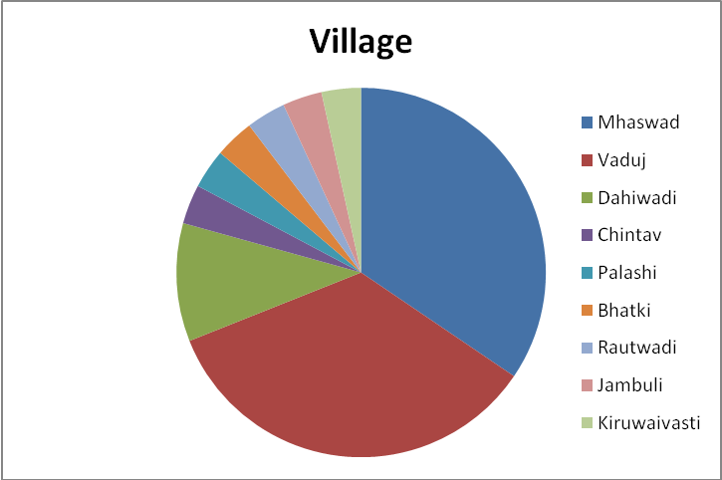
The clients represented a variety of Hindu castes, 58.6 percent came from Other Backward Castes, and 3 clients were of the Islamic faith. All of the clients interviewed were women and were married, except for one woman who was divorced.
Although the clients interviewed came from a variety of age brackets, clients who had not taken the course tended to be older. The average age for clients who had taken the course was 36.4 years old, compared to 44.6 years old for clients who had not. This is most likely due to the fact that new loan clients are required to take the course, and newer clients to the Bank tend to be younger. Most of the clients who had not taken the course had been with the Bank longer and had more time to take out loans before the course became required.
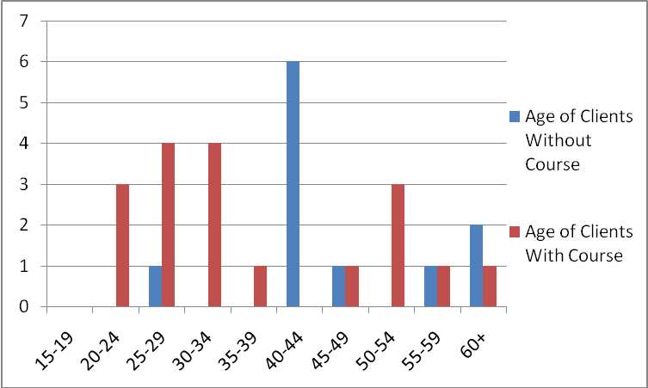
The breakdown on level of education has a similar dynamic. Although the clients interviewed came from a variety of educational backgrounds, those who had taken the course fell slightly more frequently in higher educational brackets. This may be because the younger population in these villages tends to be more highly educated.
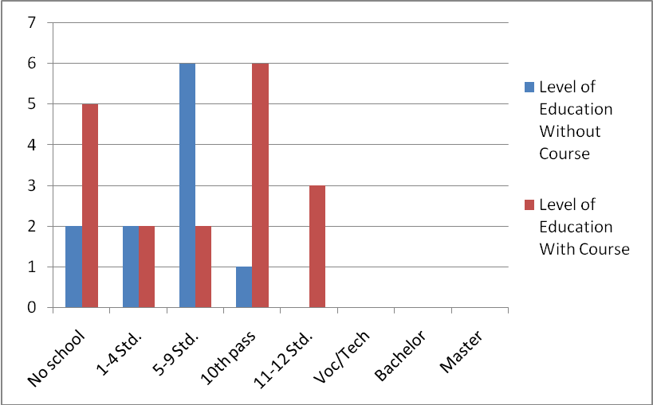
In terms of size of household and number of dependents, there were no noticeable differences between the treatment and control groups.

Findings

Overall Rating
All of the clients who had taken the course ranked the class positively; 40 percent of respondents ranked the class as “very good.”
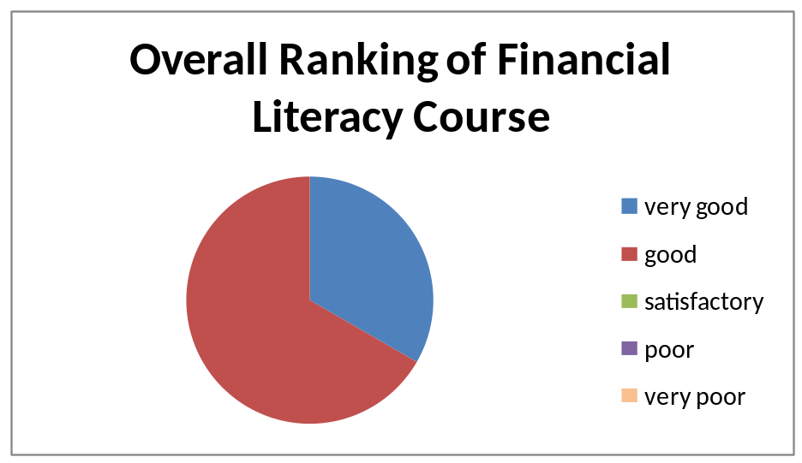

Course Logistics

Class Size
The average class size was 9 students. Most of the respondents thought that the size of the class was “satisfactory,” though 35.7 percent said the class size was “too small” and would have like more students in the class with them.

Timing of Class
A majority of the courses took place in the mornings. While 78.5 percent of respondents thought that the class was held “at a good time,” 27.2 percent thought it was held “too early,” and a few clients responded that the afternoon was a better time.

Amount of Class Time
The average class time was 1 hour and 10 minutes. A majority of the courses lasted over 1 hour, although 2 respondents said their course lasted less than ½ an hour, 1 of these lasting only 10-20 minutes. Almost all of the participants (over 90.0 percent) thought the amount of class time was “sufficient,” although one client thought the class was “too short” and would have appreciated more time. Also, 1 client stated that 1 hour of class time was good because she had learned what she had wanted, and so it was worth the time commitment.

Course Topics
Half of the financial literacy students interviewed found the material covered in the course to be “very useful,” while the rest found the material to be at least “somewhat useful.”
In response to “What was the most memorable thing you learned?” clients responded in the following manners:
- “That a little money can be paid monthly to clear a loan.”
- “Women have a respectable place in the bank, where they are trusted to take out a loan and repay.”
- “That it is good to take a loan, but that you must repay regularly, like at weekly intervals, and on time.”
- “The course was very helpful. I learned that even if you have only a little money you can save.”
- “I liked the topics that were covered. The trainer covered the material slowly, so I came to understand it well. I learned how to take out loans. We learned that women should take loans depending on how much they can pay, and that it is good to pay as soon as you can.”
- “How to take out a gold loan, and that there are other Business School courses that I would like to take.”

Other topics that clients would like to have covered in the Financial Literacy course include:
- Percentages, to help them better understand interest rates
- Other Bank services, like pension and insurance programs
- More idea on how to save money

Economic Benefits

How much saved
Clients who took the Financial Literacy course started saving nearly 3 times as much, from an average of INR 62.95 ($1.34) per week before taking the course to an average of INR 184.81 ($3.93) per week after taking the course. Also, of the 18 Financial Literacy students interviewed, 3 clients who did not save anywhere before started saving. One client said that she no longer saves because she has to use that money to pay back her loan.
In order to further test the first finding, the researcher created time series data with the survey results, using the same responses for the control group for both before and after. The difference-in-difference estimation for the significance of Financial Literacy on savings is statistically insignificant, but the direction and magnitude of the effect are the same as measured by simple averages. According to the data, clients who take the Financial Literacy course are estimated to increase their savings by INR 116.8 per week.
 | (1) | (2)
 | savings | savings
finlitcourse | -133.8036 | -155.7522
 | (-1.16) | (-1.30)
after | -1.74e-13 | -1.66e-13
 | (-0.00) | (-0.00)
finlitafter | 121.8613 | 116.8301
 | (0.69) | (.71)
levelofeducation |  | 23.68033
 |  | (0.59)
age |  | -.763031
 |  | (-0.19)
N | 47 | 47
R-squared | 0.0480 | 0.0638
t-stats in parenthesis
* p<0.10, ** p<0.05, *** p<0.01

This amount still did not exceed average weekly savings for clients who had not taken the course, who saved on average INR 196.75 ($4.19) per week. However, as shown below, clients who took the financial literacy course did move to higher savings brackets, outweighing clients who did not take the course in these savings categories.
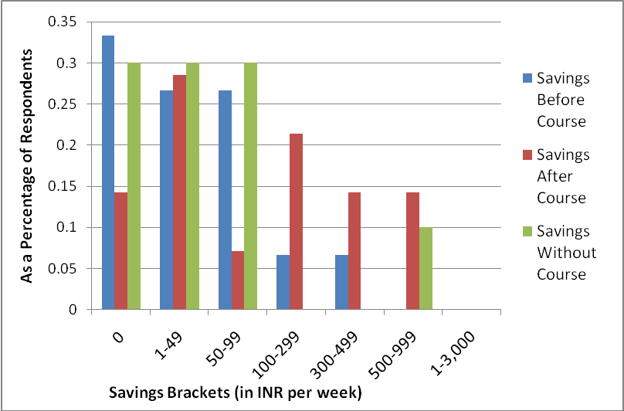
Therefore, the slightly lower average could be a result of various factors. First, the data could be slightly skewed by the small sample size, especially for the control group. Also, specific characteristics of the control group, such as their older age and longer history with the Bank, could be contributing to their slightly higher average savings. They may have more established forms of income or more developed savings histories. Also, since most of the clients in the treatment group took the course in order to secure a loan, their new loan requirements may be affecting how much income they are currently able to save.
In order to test the personal characteristics hypothesis, the researcher used the survey data to regress savings on Financial Literacy course, controlling for age, level of education, and number of dependents. There is a slightly negative relationship. However, the magnitude of the difference is small, INR 11 per week. Also, the relationship is statistically very insignificant, with a t-stat of -0.25, and the regression has a very small R-squared, 0.0316, meaning that Financial Literacy, in this dataset, explains a very small proportion of savings behavior. Furthermore, the variables used for personal characteristics also appear not to explain much of savings behavior.
Finally, although one client did mention that she is no longer saving because she now uses her extra income to pay off her loan, this does not appear to be norm. The relationship between savings and average loan amount was found to be positive and significant. Clients who take out bigger loans save more, and vice versa. Financial literacy, which is shown to increase both savings and loans, positively reinforces these relationships.
Thus, the most convincing conclusion is that the survey data is slightly inaccurate due to the small sample size, and that the improvement in savings in the treatment group, rather than the comparison in savings between the treatment and control groups, is the more substantial finding. This analysis is supported by fact that Financial Literacy students self-select themselves into the program to a certain degree, and clients with lower initial savings or less established savings behavior may be more likely to decide to take a class on savings and loans.
 | (1) | (2) | (3) | (4) | (5)
 | savings | savings | savings | savings | avgloanamount
flcourse | -11.94231 | -40.63227 | -34.0631
 | (-0.09) | (-0.25) | (-0.20)
age |  | -1.65444 | -3.398762
 |  | (-0.56) | (-1.07)
levelofeduc |  | 17.66367 | 17.24868
 |  | (0.50) | (0.55)
noofdependents |  | -7.204931 | -5.372062
 |  | (-0.76) | (-0.46)
avgloanamount |  |  | .0033971 **** | .0032925***
 |  |  | (4.74) | (3.21)
savings |  |  |  |  | 75.07089
 |  |  |  |  | (1.3)
N | 23 | 23 | 21 | 21 | 21
R-squared | 0.0004 | 0.0316 | 0.2927 | 0.2472 | 0.2472
t-stats in parenthesis
* p<0.10, ** p<0.05, *** p<0.01, **** p<0.001

Where saved
Of the 18 former Financial Literacy students interviewed, 3 clients moved from less secure means of savings, such as piggy bank and bishe (rotating savings) groups, to more secure savings locations, such as the Bank and SHGs. As shown below, the savings methods of clients who did not take the Financial Literacy course more closely resembled the behavior of students before they took the course, with more clients saving through informal methods like piggy banks.
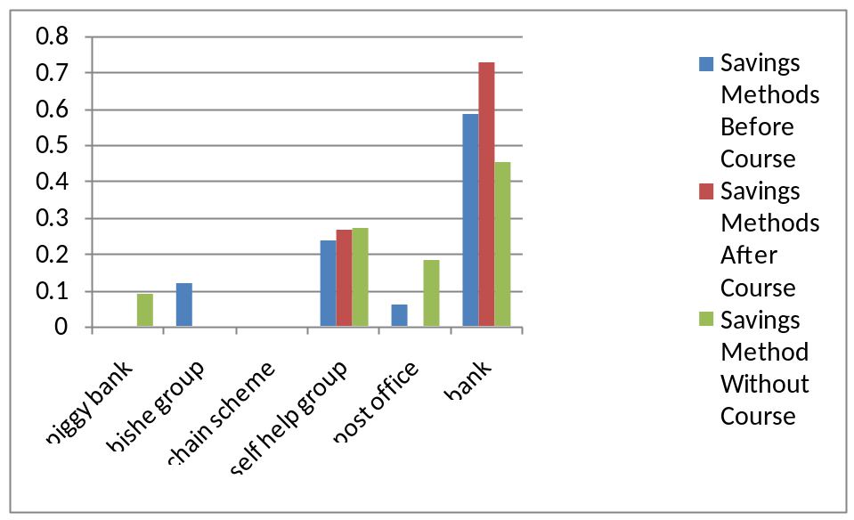

How much loan
After taking the Financial Literacy course, clients took out more loans in larger loan brackets. Average loan size went from INR 8,861.11 ($188.53) for students who had taken out loans before to an average of INR 81,134.62 ($1,726.27) for Financial Literacy students after, averaging up to two loan cycles each. This is compared to an average loan size of INR 48,645.75 ($1035.02) for up to four loan cycles for clients who have not taken the Financial Literacy course.
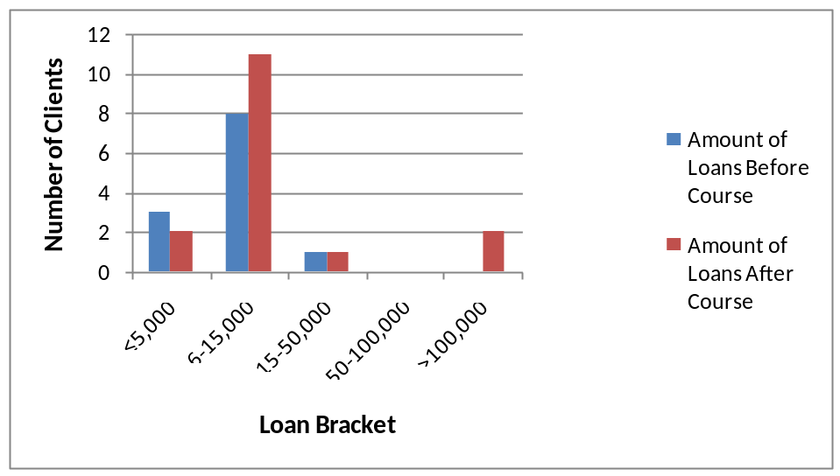
Reverse causality may play a role in these findings, as many of the Financial Literacy students took the course in order to take out loans. However, many of the clients in the control group were newer loan clients, which is related to a smaller loan size, as will be illustrated in stage two of the assessment. In addition, half of the clients in the treatment group had taken out loans before taking the course, so there is room for comparison. Finally, these numbers reflect average loan sizes and so account for the number of loans a client had. Regardless, these results on average loan size will be further tested with more accurate data from a larger sample in stage two of the assessment.

Where loans
Clients seemed reluctant to admit if they had ever loaned money from anywhere other than a SHG or a bank, such as a “money lender” or “relatives or friends.” Therefore, the data on this question was determined incomplete and inaccurate and was not analyzed.

Purpose of loans
Clients who took the Financial Literacy course took out loans for more productive, income-generating, purposes after taking the course. While only 2 clients each had taken out loans for “starting own business” and “expanding existing business” before the course, 3 former Financial Literacy students took out loans for “starting own business” and 6 for “expanding existing business” after. Also, the number of loans taken for non-productive purposes, such as “funerals/temples” and “household repairs” fell by 1 client each.
Purpose of Loan | Before | After
Starting own business | 2 | 3
Contributing to husband's business | 1 | 2
Expanding existing business | 2 | 6
Farming | 4 | 0
Education | 0 | 0
Marriage | 0 | 1
Health | 0 | 1
Funerals/temple | 1 | 0
Festival/temples | 0 | 0
Repay old loan | 0 | 1
Household repairs | 2 | 1
Household or consumer goods | 0 | 0
Livestock | 3 | 1

The change in the purposes of the loans before and after, as a percentage of the loans taken out, is illustrated below.
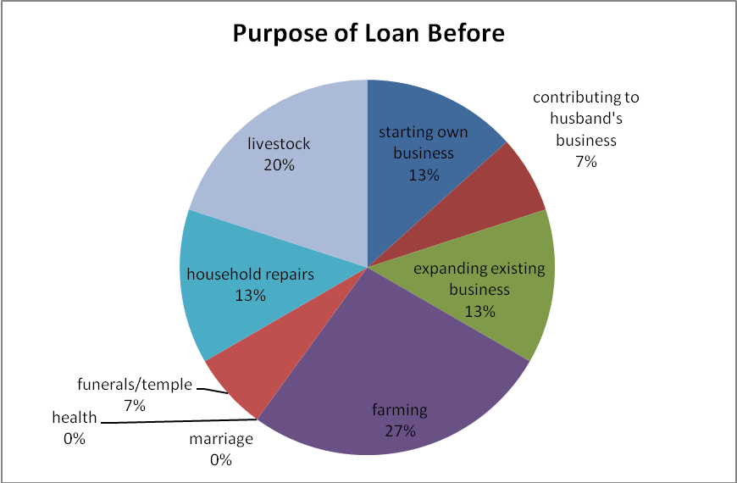
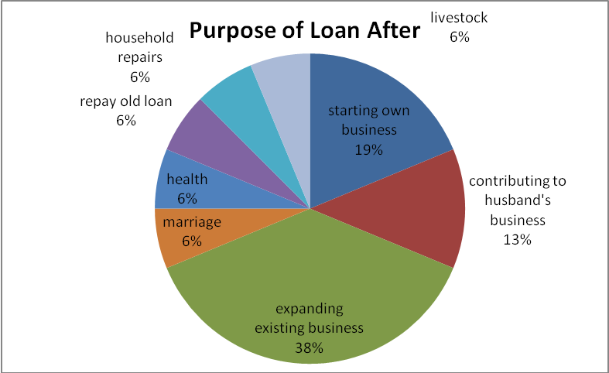
The following pie chart show the comparison to clients who had not taken the Financial Literacy course, whose loan behavior looks more like that of clients before they took the course, with substantially more loans for household and consumer goods, marriage, and funerals/temples. Clients who took the Financial Literacy course also clearly applied for a larger percentage of loans for income generating purposes such as starting own business and expanding existing business, compared to clients who have not taken the course.
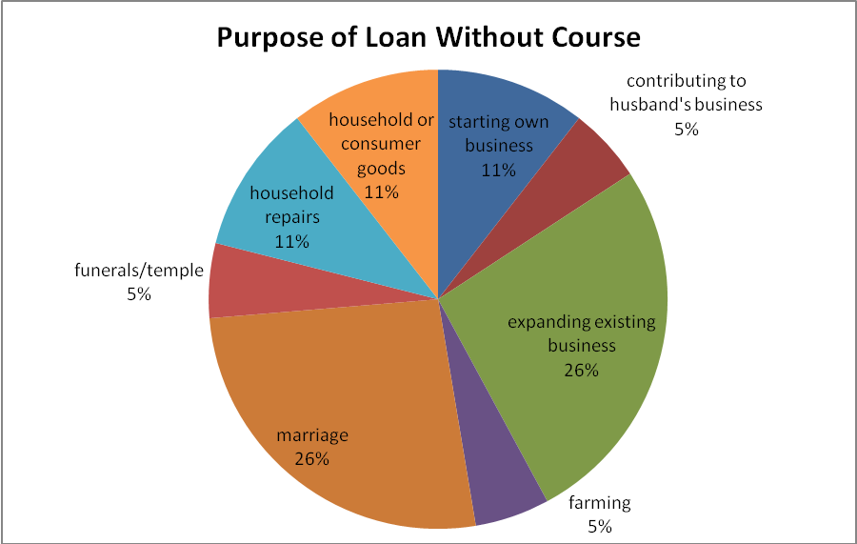
As explained above, clients failed to accurately self-report if they had ever spent loan money on anything other than the original purpose of the loan, except for one client, who said that she had also spent loan money on education for her daughter. Therefore, this question was also removed from the final study.

Repayment rate
Clients were often unable to exactly state how much they have paid back on loans and when. This is likely due to the difficulty of recalling such information, especially when repayments amounts and timing are irregular or dependent upon a variety of factors. Thus, repayment behavior, based on more accurate data, will be analyzed in detail in the second stage of the assessment.

Social Benefits
In the treatment group, 92 percent of respondents said that their control over resources in the household had improved since taking the Financial Literacy course.
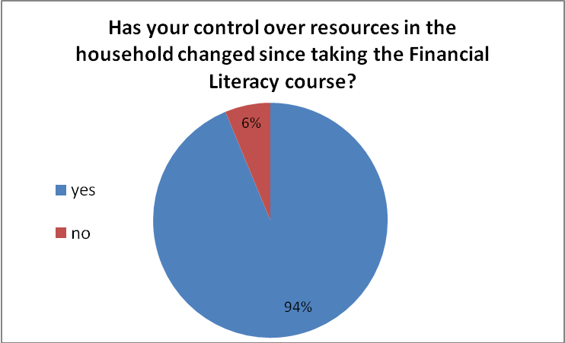
Although clients in the control group reported having a noticeably greater degree of control over household resources than clients who had taken the course in terms of “share in financial decisions” and “keep own money separate,” more clients who had taken the course responded that “family members ask you for advice on financial decisions.” This may be an indication that the course is having the desired effect of improving financial knowledge amongst clients and their social relations, if not yet gender empowerment.
Control of Resources in Household | After Course | Without Course
Share in financial decisions (about how money spent) | 77.8% | 90.9%
Family members ask you for advice on financial decisions | 77.8% | 63.6%
Keep your own money separate | 38.9% | 63.6%
Use bank services on your own more | 61.1% | 63.6%
Pursue new business or job | 11.1% | 18.2%

Relations with Mann Deshi

Comfort working with Mann Deshi
All respondents in the treatment group said that they fell more comfortable working with Mann Deshi after taking the Financial Literacy course.
They explained that this is because:
- “I now know that there are mostly women working in the Bank, and I feel comfortable discussing with them and feel like I can learn things easily.”
- “The Bank and the course have helped me with reading and writing, with recording loan information and filling out other household papers.”
- “Now I know about all of the facilities of the Bank, and I have all of the information I need, so now I can do savings and loans on my own.”
- “I have a lot of work in the house and don’t have a lot of extra time. But in the class they said that women can come to the Bank on their own, and pay alone, so there is no problem, because the Bank is all women and we can feel comfortable there.”

Use of Mann Deshi services
Clients who took the Financial Literacy course have opened more savings accounts and taken out more and bigger loans with Mann Deshi Bank. As shown below, the percentage of clients in the treatment group with savings accounts went from 66.7 percent before the course to 88.9 percent after. They took out 22.3 percent more loans, with a larger percentage of these loans in the higher loan brackets of “INR 5,000-15,000” and “greater than INR 15,000.”
They also currently use Mann Deshi Bank savings and loan services more than clients who have not taken the course. Almost twice as many clients who had taken the course had savings accounts, and a slightly larger percentage had individual loans, compared to clients who had not taken the course.
Part of this effect could be due to the fact that half of the clients in the treatment group are prospective new loan clients, although 3 of the clients in the treatment group who had loans before did not take out loans after the course. It is also important to note that when new clients want to take out a loan and do not have a savings account, they must open one with the Bank.
Mann Deshi Bank Services | Before Course | After Course | Without Course
Savings-individual | 66.7% | 88.9% | 45.4%
Loan-individual | 44.4% | 66.7% | 63.6%
Loan-SHG | 5.6% | 0.0% | 9.1%
Loan < INR 5,000 | 27.8% | 11.1% | 0.0%
Loan INR 5,000-15,000 | 44.4% | 55.6% | 45.5%
Loan > INR 15,000 | 0.0% | 5.6% | 9.1%

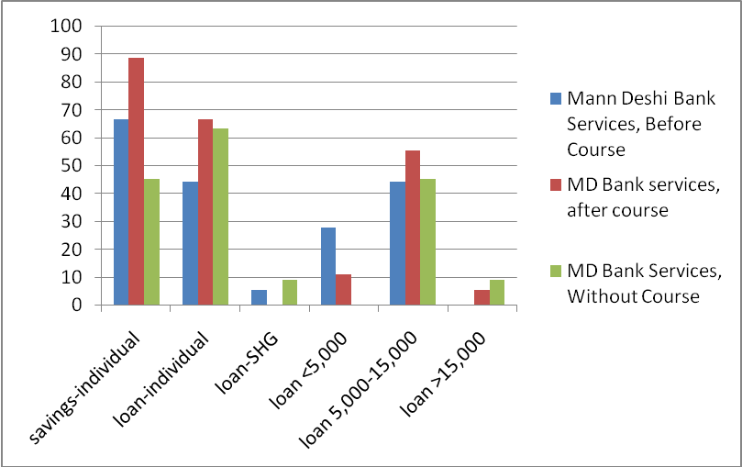
Additionally, one client signed up for the Mann Deshi Bank pension scheme after taking the course, compared to none in the control group or the treatment group before.

Missed loan payment
For reasons already explained above, responses to this question were unreliable and therefore it was taken out of the analysis.

Publicizing finanacial literacy course and Mann Deshi services
Of the 18 clients who had taken the course, 88.9 percent had told someone about the Financial Literacy program, including relatives, neighbors, friends and business clients.
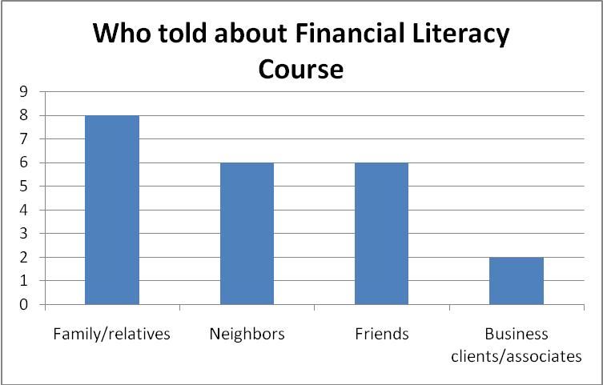
Of the 11 clients in the control group, 5 had already heard about the Financial Literacy course from community members or Bank staff, and 7 would be interested in taking a course on savings and loan basics in the near future. Two clients mentioned that they would like to take the course but they do not have the time and live far from the Bank.

SECOND STAGE of ASSESSMENT
This stage of the assessment looked at detailed loan histories of a larger sample of clients in order to better understand possible changes in their loan behavior as a result of the Financial Literacy course.

Data Collection
To carry out this stage of the assessment, the researcher gained access to Mann Deshi Bank’s Mhaswad Branch software system and client database. Clients for the control group were randomly selected from the database in an approximate proportion of the overall loan scheme makeup of the Bank. For example, “general loans” and “medium terms loans” make up the largest share of Bank loans awarded, at about 1/3 of loan volume each; therefore about 2/3rds of the control group’s client information was randomly selected from these loan scheme databases. “Refinancing loans,” “gold loans,” “hire purchase loans,” and “Mann Deshi Bachat Thev (Self Help Group)” made up the rest of the control group’s loan profile, in approximate proportion to their share of Bank business.
Of the 56 randomly selected clients who had taken the Financial Literacy course, 18 had never taken out loans. While this information was useful for the Bank, it was problematic for the study of loan behavior. Therefore, 18 other Financial Literacy students who had taken out loans were selected for the study.
In the final dataset, there are 51 clients who took the Financial Literacy course and 70 clients who did not. These comprise the treatment and control groups, respectively. To compile the dataset, the researcher looked up each individual loan account and recorded information on their debit and credit histories, including: when the loan was taken out, status of the loan, loan size, date of repayment, amount of repayment at each date, scheduled repayment plan, number of installments, total repayment to date, number of missed scheduled payments, and due date on the loan. This information was used to calculate the desired indicators for each client, including: “average loan size,” “average number of missed payments” (per installments), “loan cycle,” “active loan client status,” and “default status.” The dataset is summarized here.
Variable | Measurement | Obs. | Mean | Std. Dev. | Min. | Max.
course | =1 | 121 | 0.4214876 | 0.4958506 | 0 | 1
noofloan | # of loan cycle | 121 | 1.280992 | 0.8187708 | 1 | 8
avgloansize | total loan amount/# of loans | 121 | 17320.92 | 16973.21 | 400 | 100000
totalmissedpmnts | total missed scheduled installments | 121 | 2.002893 | 4.043366 | 0 | 33.85
totalnoinstallments | total installments in repayment plan | 121 | 17.70248 | 12.10898 | 1 | 80
avgmissedpmnts | missed payments/installments | 121 | 0.1178586 | 0.2174792 | 0 | 1.099
default | =1 | 121 | 0.0991736 | 0.3001377 | 0 | 1
activeloanclient | =1 | 121 | 0.7272727 | 0.4472136 | 0 | 1

In order to create the time series dataset, a dummy variable was used for time, with 0=before and 1=after. The date used to distinguish the time periods for clients in the treatment group was the date they took the Financial Literacy course, and for clients in the control group was the date the Financial Literacy program was initiated. The interaction term “finlitafter” was created to represent course x time. All of the information on loan cycle, average loan size, average missed payments, and default status were divided into the time periods before and after and averaged where needed. The time series dataset is summarized here.
Variable | Measurement | Obs. | Mean | Std. Dev. | Min. | Max.
course | =1 | 242 | 0.4214876 | 0.4948207 | 0 | 1
time | before=0, after=1 (Financial Lit course) | 242 | 0.5 | 0.5010363 | 0 | 1
loancycle | # of loan cycle | 242 | 0.6404959 | 0.6929495 | 0 | 4
avgloansize | total loan amount/# of loans | 242 | 10323.99 | 20256.77 | 0 | 200000
avgmissedpmnts | missed payments/installments | 242 | 0.0921901 | 0.2214388 | 0 | 1.099
default | =1 | 242 | 0.049868 | 0.2175396 | 0 | 1
activeloanclient | =1 | 242 | 0.5495868 | 0.4985662 | 0 | 1
finlitafter | =1 (if time=1 and course=1) | 242 | 0.2107438 | 0.4086821 | 0 | 1

Methodology
The first step in this stage was to check the significance of the Financial Literacy course for average loan size, loan cycle, average missed payments, default status and active loan client status. This was done using bivariate regressions and multivariate regressions where possible, using the OLS and probit statistical methods, and calculating robust standard errors wherever heteroskedasticity was deemed a problem.
In the multivariate step, the researcher attempted to control for the extent to which the other variables might affect a client’s propensity to miss scheduled payments, take out another or larger loan, default on a loan, or be an active loan client. In each case, the motivation behind the controls used is explained, and any statistically significant findings are discussed.
In the second step of this second stage, it was determined that average loan size and loan cycle (“noofloan”) were highly correlated. Therefore, in cases where the researcher wanted to control for the effect of either of these variables, only one was used so as to prevent multicollinearity, which would have served to reduce the statistical significance of the results. A similar relationship was found between average missed payments and default, and active loan client and loan cycle, in the second step, so only one of these variables was used as a control as a result.
 | correlation
loancycle | 1.0000
avgloansize | 0.4170 | 1.0000

 | correlation
avgmissedpmnts | 1.0000
default | 0.5572 | 1.0000

 | correlation
activeloanclient | 1.0000
loancycle | 0.8385 | 1.0000

These strong correlations between the variables were only detected in the time series data and not in the single cross-sectional data, suggesting that these effects become much more significant with time. This makes intuitive sense, as time allows for the relationships between average loan size and loan cycle, or average missed payments and default status, to develop and take effect. Additionally, the time series data was averaged over the entire time periods of “before” and “after,” so this data better accounts for the cumulative effects of these relationships.
The second step in this analysis used time series panel data to estimate the difference-in-difference between the treatment and control groups for “average loan size,” “loan cycle,” “average missed payments,” “default,” and “active loan client.” The researcher used the difference-in-difference method to control for any omitted but time-invariant factors and account for common trends between the two groups. This estimation allowed the researcher to remove any bias in the second period comparison between the treatment and control groups that could be a result of either permanent differences between the groups or biases from comparisons over time as a result of trends.
The steps of the tests run are detailed below.
Step 1: Estimated impact of Financial Literacy on “average loan size,” “loan cycle,” “average missed payments,” “default status” and “active loan client status” with bivariate regressions.
Step 1.2: Estimated impact of Financial Literacy on “average loan size,” “loan cycle,” “average missed payments,” “default status” and “active loan client status” with multivariate regression.
Step 3: Difference in Differences for “average loan size,” “loan cycle,” “average missed payments,” and “default.”

Challenges
Challenges encountered during this stage of the assessment stemmed primarily from the nature of the information available in the Bank’s database, in terms of what information the Bank regularly records on individual clients and in what format. The researcher was unable to acquire any additional information on clients in order to better control for other factors that may affect average loan size, loan cycle, average missed payments, active loan client status, or default status.

Results and Findings

Testing for Significance

Average Loan Size
 | (1) | (2) | (3)
 | avgloansize | avgloansize | avgloansize
course | -3176.361 | -3435.018 | -4686.349
 | (-1.07) | (-1.12) | (-1.43)
noofloan |  | 1346.071 | 1076.091
 |  | (-0.89) | -0.7
avgmissedpmnts |  |  | -14811.93***
 |  |  | -3.14
activeloanclient |  |  | 3361.195
 |  |  | -1.21
N | 121 | 121 | 121
R-squared | 0.0086 | 0.0128 | 0.0562
t-stats in parenthesis
* p<0.10, ** p<0.05, *** p<0.01

According to this initial test for significance, average loan size is not significantly related to whether or not a client has taken the Financial Literacy course. In addition, the relationship appears to be in a negative direction. However, these tests do not account for differences in the starting points of the treatment and control groups in terms of average loan sizes, and do not show the difference in trends. Therefore, the difference-in-difference estimation in the second step will prove much more useful for understanding the impact of the Financial Literacy course on average loan size.
It is interesting to note that loan cycle is not significantly related to average loan size here. However, average missed payments is statistically significantly negatively related to loan size. This makes intuitive sense, because the more payments a client misses, the less likely the Bank is to award them higher loans. This is an interesting finding for the Bank, because it proves that the loan officers are doing a good job of dealing with poor performing clients.

Loan Cycle
 | (1) | (2) | (3)
 | noofloan | noofloan | noofloan
course | .1921569 | .2020567 | .2211288
 | (1.16) | (1.20) | (1.25)
avgloansize |  | 3.12e-6 | 2.58e-6
 |  | (.81) | (.67)
avgmissedpmnts |  |  | .0030239
 |  |  | (.01)
activeloanclient |  |  | .1951938
 |  |  | (1.43)
N | 121 | 121 | 121
R-squared | 0.0135 | 0.0177 | 0.0288
t-stats in parenthesis
* p<0.10, ** p<0.05, *** p<0.01

The number of loan, or client loan cycle, is positively related to whether or not a client has taken the Financial Literacy course. It is not highly statistically significant, but it could be considered significant at the 78.7 percent level. According to the data, clients who take the Financial Literacy course are estimated to take out loans more frequently, on average about 0.20 more loans than clients who have not taken the course. This means that for every 5 Financial Literacy students the Business School trains, the Bank will receive 1 more loan that would not have existed in absence of the course.

Average Missed Payments
 | (1) | (2)
 | avgmissedpmnts | avgmissedpmnts
Course | -.1117569*** | -.1193126***
 | (-3.26) | (-3.35)
Avgloansize |  | -2.38e-6***
 |  | (-2.91)
N | 121 | 121
R-squared | 0.0649 | 0.0991
t stat in parenthesis
* p<0.10, ** p<0.05, *** p<0.01
To estimate the effect of the course on average missed payments, the researcher controlled for average loan size, which was shown above to be significantly related to average missed payments for obvious client risk assessment reasons. Average loan size is also somewhat related to course, so leaving out this control would result in a slightly positive Omitted Variable Bias, which is this case detracts from an important finding.
Average missed payments is statistically significantly negatively related to whether or not a client has taken the Financial Literacy course. According to the data, a client who has taken the course will miss an estimated 0.12 fewer scheduled loan repayments than a client who has not taken the course. For the Bank, this translates into more consistent loan repayments, for the scheduled repayment amount and at the scheduled time, on the scale of a little over 10.0 percent.

Default Status
 | (1) | (2) | (3)
 | default¹ | default¹ | default¹
course | -.0697479 | -.0716155 | -.069887
 | (-1.27) | (-1.38) | (-1.40)
avgloansize |  | -2.99e-6 | -2.61e-6
 |  | (-1.12) | (-1.02)
activeloanclient |  |  | -.1019768
 |  |  | (-1.68)*
N | 121 | 121 | 121
psuedo R-squared | 0.0217 | 0.0628 | 0.0819
z-stats in parenthesis
* p<0.10, ** p<0.05, *** p<0.01
¹ dF/dx is for discrete change of dummy variable from 0 to 1

The Financial Literacy course is only statistically significantly related to the default status of a client at the 83.9 percent significance level. However, this is still a relevant finding for the Bank in terms of magnitude and direction. According to the data, clients who have taken the Financial Literacy course are estimated to be about 7 percent less likely to default on a loan than clients who have not taken the course.
This holds true even controlling for average loan size, which is slightly related to course and arguably a significant explanatory variable for default, in that the larger the loan size, the more likely a client will not be able to pay it all back, although this data does not show a strong relationship. As seen in test (1), leaving out average loan size resulted in a positive Omitted Variable Bias, which detracted from the strength of the finding.
Active loan client was also deemed related to both the dependent and independent variable and controlled for in test (3). It was found to be statistically significantly related to default status, at the 90.0 percent level, and in the negative direction. This makes intuitive sense, as a client who has defaulted is less likely to be an active client now. This variable is related to course in that if a client has not been active with the Bank within the past two years, it is less likely that they were made aware of the opportunity to take the course.

Active loan client status
 | (1) | (2)
 | activeloanclient¹ | activeloanclient¹
course | -.1047619 | -.0959115
 | (-1.27) | (-1.17)
avgloansize |  | 3.69e-6
 |  | (1.21)
N | 121 | 121
pseudo R-squared | 0.0114 | 0.0234
z-stats in parenthesis
* p<0.10, ** p<0.05, *** p<0.01
¹ dF/dx is for discrete change of dummy variable from 0 to 1

According to the data, a client who has taken the Financial Literacy course is actually about 10.0 percent less likely to be an active loan client. However, as explained above, this variable is also proven to be highly correlated with loan cycle in the time series data, and thus obviously dependent upon time for the relationship to develop. The same argument may hold true for the Financial Literacy course—that time is required for the course to have the desired effect upon loan client status, so the findings from the difference-in-difference analysis held in step 2 should carry more weight.

Time Series/Diff-in-Diff Analysis

average loan size
 | (1) | (2)
 | avgloansize | avgloansize
course | -3794.441 | -4119.547
 | (-1.01) | (-1.09)
time | -1994.538 | -1836.437
 | (-0.58) | (-0.53)
finlitafter | 3503.689 | 3433.111
 | (0.66) | (0.65)
avgmissedpmnts |  | -3898.841
 |  | (-0.64)
N | 242 | 242
R-squared | 0.0045 | 0.0062
t-stats in parenthesis
* p<0.10, ** p<0.05, *** p<0.01

The findings from this time series analysis are not statistically significant, but they are relevant for the Bank in terms of magnitude and direction, especially given the contradictory findings in the survey data of stage 1 of the assessment and the simple multivariate regression of step 1.2 of stage 2 of the assessment. The coefficient on finlitafter shows the difference-in-difference estimation for the impact of the Financial Literacy course on average loan size. According to the data, clients who have taken Financial Literacy are estimated to take out INR 3,503.69 ($74.55) more in loans than clients who have not taken the course.
This is not as large as the difference found in the survey data of stage 1 of the assessment, but this is a more statistically sound, and therefore relevant, finding. These results hold even when controlling for average missed payments, which was illustrated above in step 1 to explain a portion of average loan size. In the time series data, average loan size and loan cycle were found to be highly positively correlated, so this variable was left out of the regression to avoid the effects of high multicollinearity between independent variables.

loan cycle
 | (1) | (2) | (3)
 | loancycle | loancycle | loancycle
course | -.222409* | -.1689505 | -.1415852
 | (-1.79) | (-1.49) | (-1.24)
time | -.3428571*** | -.3147569*** | -.3275148***
 | (-3.00) | (-3.03) | (-3.16)
finlitafter | .6369748**** | .5876127**** | .5929337****
 | (3.62) | (3.67) | (3.72)
avgloansize |  | .0000141**** | .0000142****
 |  | (7.20) | (7.30)
avgmissedpmnts |  |  | .3216623*
 |  |  | (1.76)
N | 242 | 242 | 242
R-squared | 0.0593 | 0.2282 | 0.2221
t-stats in parenthesis
* p<0.10, ** p<0.05, *** p<0.01, **** p<0.001

As stated earlier, average loan size was found to be highly correlated with loan cycle in the time series data. Therefore, in this case, the researcher controlled for the known effect of loan size on loan cycle in order better to isolate the effect of course on loan cycle. Even controlling for the effects of average loan size and missed payments, which were both proven related to course in the tests for significance in step 1 above and are shown as related to loan cycle here in step 2, the findings on loan cycle have high statistical and economic significance for the Bank.
According to the data, the difference-in-difference estimation for the impact of the Financial Literacy course on loan cycle is approximately 0.60. This means that a client who has taken the Financial Literacy course is estimated to take out about 0.60 more loans than a client who has not taken the course. Therefore, for every 2 Financial Literacy students the Business School trains, the Bank gets more than 1 additional loan that would not have been taken out in absence of the course. This is an even more statistically sound and economically important finding for the Bank than the results in step 1.

average missed payments
 | (1) | (2)
 | avgmissedpmnts | avgmissedpmnts
course | -.0833853** | -.0850748**
 | (-2.17) | (-2.18)
time | .0405507 | .0396627
 | (0.90) | (0.88)
finlitafter | -.0181023 | -.0165422
 | (-0.35) | (-0.32)
avgloansize |  | -4.45e-7
 |  | (-1.37)
N | 242 | 242
R-squared | 0.0486 | 0.0503
t-stats in parenthesis
* p<0.10, ** p<0.05, *** p<0.01

The results of the difference-in-difference estimation for the impact of Financial Literacy course on average missed payments are not statistically significant. However, the direction and magnitude of the estimates are still interesting of the Bank and supports the findings of the test run in step 1. In this step, controlling for any omitted but time-invariant factors and accounting for any common trends between the treatment and control groups, the Financial Literacy course is estimated to result in approximately 0.017 fewer missed scheduled payments.

default
 | (1) | (2)
 | default | default
course | -.0274684 | -.0235421
 | (-0.75) | (-0.65)
time | -.0109875 | -.0035036
 | (-0.34) | (-0.11)
finlitafter | -.0165483 | -.0241858
 | (-0.31) | (-0.48)
loancycle |  | .0199235
 |  | (1.08)
N | 242 | 242
pseudo R-squared | 0.0218 | 0.0332
z-stats in parenthesis
* p<0.10, ** p<0.05, *** p<0.01

Again, the findings for this test are not statistically significant, but they still have importance for the Bank in terms of direction and magnitude. According to the difference-in-difference estimation for this data, clients who take the Financial Literacy course are 2.4 percent less likely to default on their loan than clients who have not taken the course.
This result holds even when controlling for loan cycle, which is necessary because the relationship between loan cycle and course is positive, and the coefficient on loan cycle is positive, so leaving it out of the regression would result in a positive Omitted Variable Bias, which in this case would detract from the findings. This is a smaller percentage effect than found in step 1 of stage 2 of the assessment, but the magnitude is this time series step is similar to a recorded drop in overall Bank defaults since the start of the Financial Literacy program of about 2 percent.

Active Loan Client Status
 | (1) | (2)
 | default¹ | default¹
course | -2.99269*** | -.2958848***
 | (-3.21) | (-3.15)
time | -.4280344**** | -.4303041****
 | (-5.06) | (-5.05)
finlitafter | .4969184 | .4991214****
 | (4.71) | (4.47)
default |  | .2291779
 |  | (1.50)
N | 242 | 242
pseudo R-squared | 0.0904 | 0.0975
z-stats in parenthesis
* p<0.10, ** p<0.05, *** p<0.01, **** p<0.001

Using time series data, the Financial Literacy course is found to have a very statistically significant positive impact on the status of a loan client. The coefficient on the interaction term finlitafter shows that a client who has taken the Financial Literacy course is approximately 50.0 percent more likely to currently be an active loan client than someone who has not taken the course. This relationship holds even when controlling for default, which was found in step 1 to be related to both course and active loan client status.

CONCLUSIONS
In the course of the interview process, the researcher noted that in some cases, the clients stated that they had learned a great deal and could repeat some of the main lessons of the course, but they had not significantly changed their savings and loans behavior. This clearly reflects the challenges inherent in changing behaviors. However, this does not mean that the Financial Literacy students are not acquiring knowledge. It just shows that it may take more information, practice, and experience over time for them to really internalize the messages.
However, despite these challenges, the Financial Literacy program, implemented only two years ago, is already clearly having a positive impact for the Bank and its clients. Clients who have taken the course are saving more in more secure places; they are taking out bigger and more loans more frequently and for more productive purposes; and they are repaying more regularly and defaulting on loans less.
All of these findings should be incorporated into the larger effort to improve the impact of the Financial Literacy course. Suggestions to improve uptake of the material include: a longer class time; a follow-up or Advanced Financial Literacy course; more interactive teaching methods that require students to apply the material; a simple evaluation at the end of the course to better assess what information students are retaining; more accessible learning material for students; and a more comprehensive and standardized curriculum and better teachers’ manuals to help the Financial Literacy trainers consistently implement these changes. To aid in these improvements, a better system of communication and coordination between the Business School and Bank should be established at each branch.
It is highly recommended to use the results of the impact assessment to sensitive Bank staff to greatest extent possible about the numerous positive effects of the course for both clients and the Bank, so that they will support all efforts to enhance its impact.

Many of these ideas were incorporated into the improvements made the Financial Literacy program over the course of 2009, particularly: a comprehensive curriculum, updated teachers’ manual, and a new course pamphlet to hand out to students. This enhanced material was covered, along with more interactive teaching methods, at the Training of Trainers workshop. During this workshop, a discussion on the importance of the Financial Literacy program and ideas for improving coordination between the Bank and Business School was also held.

APPENDICES
Please see attachments for compiled survey data, excel spreadsheets, and SPSS and Stata datasets.

Appendix 1—Assumptions
In order to conduct this assessment using a variety of statistical techniques, certain assumptions about the dataset were made. The extent to which these assumptions hold true is discussed below.
Random selection—The researcher tried to randomly select the sample for these studies to the greatest extent possible. In the first stage of the assessment, it was more difficult to ensure a random sample, as the interviewer was dependent upon the Bank staff to select clients to interview. It is highly possible that the Bank staff chose clients they thought would be most able to provide the desired information, and they often appeared to rely on clients who were either able to come into the Bank office or that the interviewing team would be able to access relatively easily. However, as is evident in the section on “interviewee information,” the researcher was still able to survey a variety of clients with diverse personal and financial backgrounds.
It was much easier to ensure a random sample for the second stage of the study, as the researcher could set up a system to randomly select clients from the treatment and control groups from the Bank database.
Selection bias—All new loan clients were required to participate in the Financial Literacy program, so the sample of clients who have taken the course included more clients new to the Bank and bank services. However, older loan clients were encouraged to take the course and often did. Of the 18 former Financial Literacy students interviewed in the first stage of the assessment, 9 had taken out loans before. In the second stage, 24 out of 51 clients in the treatment group had taken out loans before taking the course. This breakdown was unintentional on the part of the researcher but did help to mitigate the effect of selection bias.
Reverse Causality—Related to selection bias, reverse causality may play a role in some of the findings. Teaching the Financial Literacy course may result in clients who save more, take out more and larger loans, and repay more frequently, but these may also be reasons why clients take the course—because they want to take out a loan or improve their savings and loan behavior.
Zero Conditional Mean—This means that the explanatory variables are uncorrelated with anything else that may affect the dependent variable. The researcher attempted to control for this wherever possible, though the ability to do so was often limited by the data available.
Heteroskedasticity—In order to achieve the Best Linear Unbiased Estimates, the data needs to be relatively homoskedastic. In some of the regressions in the study, the data was found to be heteroskedastic using the Breusch-Pagan test for heteroskedasticity (Stata command “hettest”). The researched accounted for this by using robust standard errors wherever necessary.
Linearity—For the sake of the assessment, the researcher assumed that all of the variables were linear in the parameters.
No Perfect Collinearity—In order to run the regressions, there can be no perfect collinearity. In cases where there was possible collinearity, the researcher explained the strong correlation between the two variables and dropped one of the variables in the regression.

Appendix 2—Surveys
SURVEY OF CLIENTS who have taken financial literacy course

I. Information about interviewer
Branch: ________________________
Name of interviewer: _______________________________________________
Date and time of the interview (dd/mm/2009) ___________ at ________ am/pm

II. Information about interviewee
Name: ________________________________________________
Village: _______________________________________________
Age: ____________________ years old
Level of education: completed _____ th grade
Caste: ________________________________________________
Marital Status: ◻ Unmarried ◻ Married ◻ Widow
Size of household: _______________________________________
Number of dependents: ___________________________________

III. Overall ranking
1. When did you take the financial literacy course? (dd/mm/yy) __________________
2. What is your overall ranking of the financial literacy course?
◻ Very Good ◻ Good ◻ Satisfactory ◻ Poor ◻ Very Poor

IV. Course Logistics
3. How was the size of the class? ◻ Too Big ◻ Satisfactory ◻ Too Small
4. How was the timing of the course? ◻ Too Early in the day ◻ At a Good Time ◻ Too Late in the day
5. How was the amount of class time? ◻ Too long ◻ Sufficient ◻ Too short

V. Course Topics
6. How did you find the topics and skills covered in the financial literacy course?
◻ Very Useful ◻ Somewhat Useful ◻ Not Useful
7. What was the most memorable thing you learned? (mention some lessons from class)
_____________________________________________________________________________________
_____________________________________________________________________________________
_____________________________________________________________________________________
8. What other topics or skills would you like to have covered in the course? __________________________________________________________________________________________________________________________________________________________________________

VI. Benefit of Course to Clients
Economic Benefits
9a. Approximately how many rupees a week did you save before taking the financial literacy course? __________ rupees/week
9b. Where/how did you save this money?
◻ Piggy bank
◻ Bishe group (rotating savings group)
◻ Chain scheme
◻ Self Help Group
◻ Post office
◻ Bank
10a. Approximately how many rupees a week did you save after taking the financial literacy course?
_________ rupees/week
10b. Where/how did you save this money?
◻ Piggy bank
◻ Bishe group (rotating savings group)
◻ Chain scheme
◻ Self Help Group
◻ Post office
◻ Bank
11a. Approximately how much in loans did you take out before completing the financial literacy course? ______________________ rupees
11b. Where did you get these loans from? _____________________________________________________________________________________
11c. What did you apply for the loan for?/What was the purpose of these loans?
_____________________________________________________________________________________
11d. What did you spend this loan money on?
◻ Starting own business
◻ Contributing to husband’s business
◻ Expanding existing business
◻ Education
◻ Marriage
◻ Health
◻ Funerals
◻ Festival
◻ Repay old loan
◻ Household repairs
◻ Household or Consumer goods (including refrigerator, tables/chairs, pots/pans, mobile phone, television, bike, etc.)
◻ Other _______________________
12a. About how much in loans did you take out after completing the financial literacy course? ______________________ rupees
12b. Where did you get these loans from? _____________________________________________________________________________________
12c. What did you apply for the loan for?/What was the purpose of these loans?
_____________________________________________________________________________________
12d. What did you spend this loan money on?
◻ Starting own business
◻ Contributing to husband’s business
◻ Expanding existing business
◻ Education
◻ Marriage
◻ Health
◻ Funerals
◻ Festival
◻ Repay old loan
◻ Household repairs
◻ Household or Consumer goods (including refrigerator, tables/chairs, pots/pans, mobile phone, television, bike, etc.)
◻ Other _______________________
13a. How much and how often did you pay back on your loans before taking the course?
__________ rupees per ________
13b. How much and how often did you pay back on your loans after taking the course?
__________ rupees per ________

Social Benefits
14a. Has your control over resources in the household changed since taking the financial literacy course?
◻ Yes, more control ◻ No, no change
14b.If yes, how has changed? (Check all that apply):
◻ Share in more financial decisions (about how money spent)
◻ Family members ask you for advice on financial decisions
◻ Keep own money (income/earnings, savings, and loans) separate
◻ Use bank services on own more
◻ Pursue new business or job
◻ Generally improved control over resources in household
◻ Able to get more money to pay back loan, from:
◻ New business
◻ Growing business
◻ New job
◻ New or more livestock
◻ Other

VII. Improved Relations with Mann Deshi Bank
15. Do you feel more comfortable working with Mann Deshi and using bank services after taking the financial literacy course? ◻ Yes ◻ No
Why or Why not? __________________________________________________________________________________________________________________________________________________________________________
16a. What Mann Deshi Bank services did you use before taking the financial literacy course?
◻ Savings
◻ Loan (type and amount)
Type:
◻ Individual Loan
◻ SHG loan

Amount:
◻ less than 5,000 rupees
◻ 5,000 – 15,000 rupees
◻ more than 15,000 rupees
◻ Pension
◻ Insurance
◻ 5 year policy
◻ 10 year policy
16b. What Mann Deshi Bank services did you use after taking the financial literacy course?
◻ Savings
◻ Loan (type and amount)
Type:
◻ Individual Loan
◻ SHG loan

Amount:
◻ less than 5,000 rupees
◻ 5,000 – 15,000 rupees
◻ more than 15,000 rupees
◻ Pension
◻ Insurance
◻ 5 year policy
◻ 10 year policy
17a. Have you ever missed a loan payment with Mann Deshi? ◻ Yes ◻ No
17b. If yes, how many times? _________ times

18a. Have you told anyone about the financial literacy course? ◻ Yes ◻ No
18b. If Yes, who have you told? _____________________________________________________________________________________

SURVEY OF CLIENTS who have NOT taken financial literacy course

I. Information about interviewer
Branch: ________________________
Name of interviewer: _______________________________________________
Date and time of the interview (dd/mm/2009) ___________ at ________ am/pm

II. Information about interviewee
Name: ________________________________________________
Village: _______________________________________________
Age: ____________________ years old
Level of education: completed _____ th grade
Caste: _________________________________________________
Marital Status: ◻ Unmarried ◻ Married ◻ Widow
Size of household: _______________________________________
Number of dependents: ___________________________________

III. Benefit of Participation to Clients
Economic Benefits
1. Approximately how many rupees a week do you save? __________ rupees/week
2. Where/how did you save this money?
◻ Piggy bank
◻ Bishe group (rotating savings group)
◻ Chain scheme
◻ Self Help Group
◻ Post office
◻ Bank
3a. Approximately how much in loans have you taken out (in your lifetime)? _____________ rupees

Loan #1
3b. Where did you get these loans from? __________________________________________________________________________________
3c. What did you apply for the loan for?/What was the purpose of these loans?
__________________________________________________________________________________
3d. What did you spend this loan money on?
◻ Starting own business
◻ Contributing to husband’s business
◻ Expanding existing business
◻ Education
◻ Marriage
◻ Health
◻ Funerals
◻ Festival
◻ Repay old loan
◻ Household repairs
◻ Household or Consumer goods (including refrigerator, tables/chairs, pots/pans, mobile phone, television, bike, etc.)
◻ Other _______________________
Loan #2
3b. Where did you get these loans from? __________________________________________________________________________________
3c. What did you apply for the loan for?/What was the purpose of these loans?
__________________________________________________________________________________
3d. What did you spend this loan money on?
◻ Starting own business
◻ Contributing to husband’s business
◻ Expanding existing business
◻ Education
◻ Marriage
◻ Health
◻ Funerals
◻ Festival
◻ Repay old loan
◻ Household repairs
◻ Household or Consumer goods (including refrigerator, tables/chairs, pots/pans, mobile phone, television, bike, etc.)
◻ Other _______________________

4. How much and how often do you usually pay back on your loans? __________ rupees per __________

Social Benefits
5. Please describe your current control over household resources (Check all that apply):
◻ Share in financial decisions (about how money spent)
◻ Family members ask you for advice on financial decisions
◻ Keep own money (income/earnings, savings, and loans) separate
◻ Use bank services on own
◻ Pursue new business or job
◻ Get money to pay back loan, from:
◻ New business
◻ Growing business
◻ New job
◻ New or more livestock
◻ Other

IV. Relations with Mann Deshi Bank
6. What Mann Deshi Bank services have you used?
◻ Savings
◻ Loan
Type:
◻ Individual Loan
◻ SHG loan

Amount:
◻ less than 5,000 rupees
◻ 5,000 – 15,000 rupees
◻ more than 15,000 rupees
◻ Pension
◻ Insurance
◻ 5 year policy
◻ 10 year policy
7a. Have you ever missed a loan payment with Mann Deshi? ◻ Yes ◻ No
7b. If yes, how many times have you missed a loan payment? _____________ times

8. Have you heard about the financial literacy course Mann Deshi is now offering? ◻ Yes ◻ No
9. Do you think you will take the course? ◻ Yes ◻ No
Why or Why not? __________________________________________________________________________________________________________________________________________________________________________

Statistically significant at the 50.0 percent significance level, using time series data.
Statistically significant at the 99.9 percent level, using time series data.
Statistically significant at the 99.9 percent level, using time series data.
Statistically significant at the 99.0 percent significance level, using single cross-sectional data.
Statistically significant at the 83.9 percent significance level, using simple cross-sectional data. According to the difference-in-difference estimation for this data, clients who take the Financial Literacy course are 2.4 percent less likely to default on their loan than clients who have not taken the course, significant at the 46.6 percent level.
Throughout the assessment, savings are calculated as average per week; loan repayments are calculated as average per month. An exchange rate of INR 47 to $1 is used to show significance in dollar values.
For further information on the effect of Bank services on the economic and gender empowerment of its clients, please see other impact assessments conducted on behalf of the Bank, particularly the work of Mathieu Begaud, Samrachana Adhikari, and Keyur Shah (2008-09).
In order to address fact that some of the clients who take financial literacy are new to the Bank (about 20 percent, based on clients in the first stage of the study) the control group was chosen from the more recent Bank software program, which was installed in November of 2007 and contains information only on new or active clients as of that date. The old database was accessed for historical loan credit and debit information on all of the subjects in the study.
Active clients refer to those with loans still pending, but not if the account has been paid in full and closed, and not if the client has defaulted.
Tests for correlation and bivariate regression between average loan size and default status are not statistically significant, with a t-stat of -1.04 and a correlation of -0.0949, but are in the expected direction.
As stated in the Mann Deshi Leasing and Finance Company Ltd. (MDLFC) Business Plan (July 2008).
Please see materials produced by Leena Scaria (March-August, 2009).

