TANZANIA ANIMALS PROTECTION ORGANIZATION

P.O.Box 1016 Kahama .Shinyanga Tanzania Tell: +255 756 027419, +255 715 800900
E-mail: tap_org@yahoo.com
Web-Blog; www.tanzania-animals-protection-org.blogspot.com

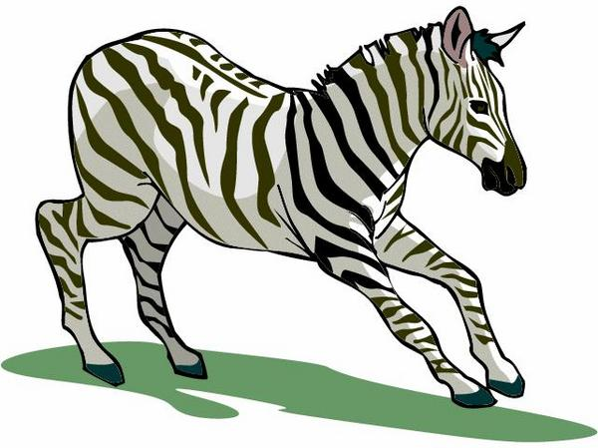

Mwakitolio Local Gold Mining Park Saddle Education Training Proposal

TABLE OF CONTENTS
- Title of project.....................................................................................3
- Summary of project.............................................................................3
- Introduction............................................................................................3
- Problems..................................................................................................4
- Location of the project........................................................................5
- Time frame................................................................................................5
- Target donkey population...................................................................5
- Target community....................................................................................5
- Total budget requested .........................................................................5
- Objectives and expected impact.........................................................5
- Donkey welfare assessment taken.....................................................6
- Training approach…................................................................................7
- Resources.....................................................................................................9
- Timetable and topics for sessions......................................................9
- Monitoring and evaluation..................................................................10
- Budget...........................................................................................................14

- Title of project
Protecting donkey welfare through pack saddle making and behavior change training at Mwakitolio local gold mining in Kahama District, Shinyanga Region, Western Tanzania
- Summary of project
Donkeys are the most worked animal indifferent areas of Kahama district, with more than 10,000 donkeys being present.

The donkeys’ working system is constrained by lack of appropriate and affordable pack saddles, oxen padding and poor veterinary services and knowledge of donkey welfare, negative cultural beliefs and animal mistreatment.
Many donkeys’ owners have no time or resources to cope with the needs of their animals after they have cared for their families as best as their resources allow. Many donkeys are abandoned in the streets.
TAPO’s primary objective is to improve the welfare of all animals living in this area. To achieve this in a sustainable manner it will be necessary to change the way donkey owners and users respect and treat their animals. It is TAPO’s intention to tackle this through the delivery of a multifaceted programme that aims to create amongst key stakeholders an improved understanding of why donkeys should be treated better and how by doing so they themselves will stand to benefit.

The primary target populations for the programme will be working donkeys and their owners and users at Mwakitolio local gold mining at Kahama district. TAPO will provide training on making pack saddles and behaviour change among donkey owners and handlers, mining owners and village local officers.

- Introduction

Tanzania Animals Protection Organization (TAPO) will conduct an intervention using animal welfare and training activitiesin the Kahama District, which is situated 121 km from Shinyanga Town in the mainland of the United Republic of Tanzania. Donkey welfare, including pack saddle making and donkey welfare education (wound prevention, common diseases and their treatment, proper nutrition and handling) and building water troughs, will be taught to owners and users at six sites at the recently discoveredMwakitolio local gold mines.
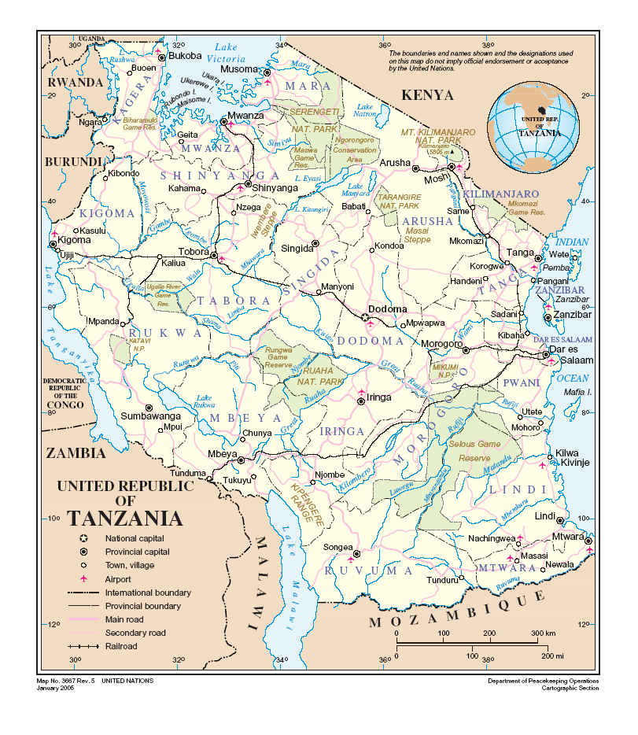

There are more than 10,000 donkeys working in Kahama (2001 LivestockCensus), and 246,196 households use donkeys as transport animals, but the quality of veterinary services provided to the donkeys is poor.

Because of their importance for transport, donkeys are recognized as a means of delivering practical, effective and suitable socio-economic assistance to reduce poverty among the people of Kahama.

4. Problems

- Donkey owners at local gold mines don’t use pack saddles and don’t treatinjuries, sores, wounds or disease. Donkeys are loaded with mining rocks and sandeven while they have injuries and sores, and no materials or equipment are provided to prevent additional trauma. When a donkey falls ill it is left to die without any help, and when injuries or sores are present they are left to become fly-infested or an owner may apply ash or crude oils which are not effective.

- Among donkey owners and handlers welfare knowledge is poor, and this is the biggest constraint to improving donkey welfare among the local miners. People tend to think that donkeys are worthless compared to cattle because donkeysdo not provide meat or milk.

- Animal welfare laws and regulations are not enforced in mining areas.

- Kahama District Veterinary Services are very poor as there are only government veterinarians, few veterinary resources and the veterinary medicine store deals mostly with livestock (cattle, goats. sheep and chickens) because donkeys are seen as worthless animals.

- Location of the project
The Mwakitolio local gold mining site is situated35 km by dirt road from Kahama town atlatitude 32.734634 and longitude -3.396236.1176.9. It is divided into six sites.

- Time frame
- The project is expected to start in spring/summer 2015

- Target donkey population
The project expects to reach 1000 donkeys.

- Target community
The target community comprises donkey owners and handlers, mining owners and village officers located in of six mining sites.

- Total budget requested
USD $4,979.50

- Objectives and expected impact

Mwakitolio localgold mining pack saddle and donkey welfare education training is responsible for promoting and protecting the health, safety, and welfare of all donkeys at Mwakitolio local gold mines. The 30 day programmewill care for donkeys’ wounds and prevent diseases. It will also enhance local miners’ understanding of donkeys and increase respect for them as living beings. The project has the following objectives:

- To empower donkey handlers and owners with skills needed to produce appropriate pack saddles by themselves from natural materials available locally. The saddles will improve donkey welfare by protecting their wounds. They will also lead to human behaviour change, thus improving the care provided to the working donkeys.

- To promote adherence to the animal welfare law among mining owners, village officers and donkey handlers and owners.

We expect to improve the welfare of more than 300 donkeys at Mwakitolio local gold mines by
- Decreasing the number of donkeys with wounds and severe wounds
- Improving the body condition score of donkeys
- Improving behaviour of donkeys and their owners and handlers
- Decreasing the number of donkeys with lameness
- Decreasing the number of donkeys suffering from dehydration and burns
- Increasing the number of donkeys fitted with pack saddles
- Decreasing the number of donkeys with other signs of injury or disease
- Decreasing the number of beating sticks used by donkey handlers
- Increasing the number of blow pipes
- Increasing the number of donkey owners with knowledge of donkey care
- Increasing the application of animal welfare law regulations at mining sites

- Donkey welfare assessments performed

Site | # donkeys | Beh | BCS | Wnd | Lame | Other | Work
Mwakitolio No.1 Gold Mine | 1 | 1 | 2.5 | 2 | 2 | 1 | Mines, packs
Mwakitolio No.1 Gold Mine | 11 | 1.5 | 2.5 | 2 | 1.5 | 1 | Mines, packs
Mwakitolio No.1 Gold Mine | 70 | 1.5 | 2.5 | 2 | 1 | 1 | Mines, packs

- Behaviour/Demeanour (Beh)
The donkey’s behaviour score is 1 to 1.5 on average because we found all assessed donkeys were not aggressive.

- Body condition Score (BCS)
The body condition scores were 2.5 because all assessed donkeys were in moderate or ideal condition, meaning that some donkeys’ ribs were not visible but could be felt with ease.

- Wounds (Wnd)
The donkeys’ wounds score was 2, because all assessed had wounds caused by beating and loading without pack saddles.

- Lameness (Lame)
The lameness scores of donkeys score were 1to 2 because we found some donkeys with lameness caused by falling in mining hole accidents.

- Other signs of injury or disease (Other)
The score of assessed donkeys was 1 because there were no other visible signs of injury or disease.

- Work
All assessed donkeys were worked by being loaded with mining rocks and sand from the top of the mountain to the bottom without any pack saddle materials.

- Training Approach

Our training approach is based on providing preventative and improvement services to working donkeys. Dedicated teams of highly experienced harness makers and animal handlers, veterinarians, animal health professionals and animal welfare education teachers will provide free harnessing and education training services to donkey owners and handlers by involving local government officials, village leaders, mining owners and local animal health workers at Mwakitolio local gold mining sites 1 through 3.

Relief of pain and addressing immediate welfare problems are our first priority. We ensure that our training teams are provided with all needed equipment and knowledge so that all attendeeswill receive proper education and training.

We aim to provide high quality pack saddle training by using appropriate locally available materials and equipment.
.
  - Pack saddle making training
Packing is one of the most ancient forms of transport which preceded even the invention of the wheel. That it has survived to the present day serves to emphasize its value. The major advantage of pack transport is its effectiveness in the absence of roads, in hilly and mountainous terrain and in muddy and marshy areas. It is particularly effective where access is limited;this applies not only to remote mountainous areas but also to areas of high population density as in city centers. Donkeys are usually cheap compared to other draught animals and an adequate pack saddle normally requires relatively little monetary investment. However pack donkeys do have some limitations which include:
- Small size of the load
- Relative slowness
- High labor requirement (although this could be an advantage in some circumstances)
- The pack saddle is an important component of the packing system in that it represents the point of interaction between the load and the animal. It often rests on a saddle blanket and, at its simplest, it can be a bag stuffed with dried grass (rice husks) placed over the back of the donkey and held with a rope or belt around the belly. Chest and/or rump straps may be used to minimize the movement of the saddle during work.
- The purpose of the saddle is to distribute the weight of the pack as evenly as possible on each side of the spine and to keep the weight over the shoulders. It has been demonstrated that loads carried over the shoulders require less energy to move than those carried on the back. This implies that with properly distributed loads donkeys will be less easily tired because they will use less energy.
- The characteristics of a good pack saddle include lightness, durability, balance, correct padding and the absence of protrusions. It should not cause saddle sores or rope burns.
- Energetically less efficient than using a cart.

  - Pack saddle materials and equipment

- Rice husks: Kahama district is very famous for mining activities and rice farming.Rice husks are widely available and inexpensive.
- Fertilizer nylon sacks
- Sisal sacks
- Sisal rope
- Nylon thread
- Scissors
- Tape measurer
- Sewing needles (locally-made)

12.3 Donkey welfare training education (available in hard copy by request)

This education workshop is expected to improve donkey welfare at mining sites by improving knowledgein the following areas:
- Training and behaviour for your donkey - Kumfunzapundawako
- Harnessing your donkey - Kumvishalijamupundawako
- Feeding your donkey - Kumlishapundawako
- Preventing diseases in your donkey - Kuzuiamagonjwakwapundawako
- Sheltering your donkey - Makaziyapundawako
- Hoof care of your donkey - Kutunzakwato za pundawako

The five freedoms are incorporated into the educational materials.

- Resources required
Budget
ITEM | UNIT | NUMBER OF UNITS | COST/UNIT in US $ | TOTAL COST
Pack saddles | Saddle | 100 x 6 sites = 300 | 5 | $3000.00
Water trough | Trough | 1/site x 6 sites =6 | 450 | $2700.00
Photocopies | Educational materials | 6 x 100 = 600 | 1 | $600.00
Medication | Veterinary | -------- | ------------ | $2000.00
GRAND TOTAL |  |  |  | $8300

- Animal Welfare Educators (Dr. Ntanwa, a veterinarian, animal traction specialist, animal food specialist) will be responsible for delivering the donkey welfare workshops in 6 mining areas.
- TheAnimal Welfare assessors will be responsible for evaluating donkey welfarein the 6 mining areas; they will also conduct data analysis and write the final project report.
- Donkey carts will be shared among owners/users. The government officer responsible for livestock and domestic animals will be appointed as the “Donkey Welfare Coordinator” and will work with the district veterinarian and TAPO animal welfare assessors to ensure that donkeys are not overloaded (using pack saddles or the carts) and that they are provided adequate rest and water breaks outlined by law.
14. Timetable and session topics

All sessions will be held on Wednesday mornings from 9.00 am to12.00 pm and Wednesday afternoons from 1:00 pm to 4:00 pm. At each site an estimated 50-70 donkey owners/users are expected to attend. The group at each site will divided into two so that there are no more than 35 owners/users in a session.All educators will visit the same sites together as they have different expertise related to project activities.

15Monitoring & Evaluation

The Monitoring and evaluation of Mwakitolio local gold mining pack saddle and donkey welfare education training will be based on a hands-on Donkey Welfare Assessment scoring system. Each donkey at all 6 sites (3 intervention sites, 3 control sites) will be assessed and the results of the intervention group compared with results from the control group. The following indicators will be used to measure training outcomes:

Indicators
Quantitative indicators
- behaviour of donkeys and their owners or handlers
- body condition of donkeys
- number of donkeys with wounds and severe wounds and possible causes
- lameness of donkeys
- number of donkeys with other signs of injury or disease
- number of donkeys fitted with pack saddles
- number of beating sticks being used by donkey handlers
- number of blow pipes, which produce a sound used to motivate donkeys to work and are used in place of sticks
- change in knowledge of owners/users from before the intervention to after the intervention in the intervention group; comparison of knowledge at the end of the project between intervention and control groups. Knowledge will be assessed using questionnaires with as much pictorial content as possible, and their administration will be overseen by the mine coordinator.

Qualitativeindicators
- condition of the provided pack saddles
- adherence to animal welfare law regulations
- donkey handling, fitting and behaviour skills and knowledge of donkey care among donkey owners and handlers.

Methodology
The following methods will be used during participatory impact assessment atmining sites

Scoring: Usingahands-on Donkey Welfare Assessment scoring system

Personal interviews: interview donkey owners and handlers, village officers and mining owners

Timelines
In order to assess the impact of the pack saddle and donkey welfare education training programme, follow-up evaluation will be conducted on three occasions. Evaluators will spend one day at each of the six sitesaccording to the following schedule:

- One month after the end of the training programme (6 days total)
- Three months after the end of the training programme (6 days total)
- Six months after the end of the training programme (6 days total)
- Report preparation and submission 9 months after the end of the training programme

No of Donkeys | Without Pack saddle
(Reason)
Comments
Name of Project Coordinator |  | Date Checked
Comments

TAPO
2015

