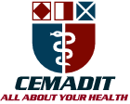
MEDITECH GROUP
RECEADIT
ALL ABOUT YOUR HEALTH

MEDITECH GROUP
CEMADIT
ALL ABOUT YOUR HEALTH

Research Center for Analytic Diagnosis and Imaging Trends (RECEADIT)
School of Health, Biomedical and Computer Sciences (SHBCS)
2015-2016 Academic Year
P.O. Box 19, Belo-Kom, Belo Sub-Division, Boyo Division, Cameroon, North-West Region,
West Africa - Tel: 011 (237) 6 73 91 21 14
CEMADIT@yahoo.com http://www.meditech-group.org

Motto: Health Care Research and Education for Services to Humanity

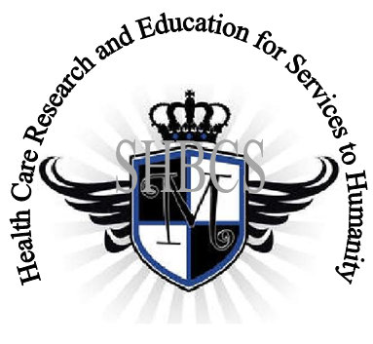

Ministry of Higher Education Ministry of Public Health Registration No. 3342 of August 31, 2011 Registration No. 4042 of August 31, 2011

GlobalGiving RECEADIT Provide Health Care Services to Fulani Community Project
First Report of November 6th, 2015
On behalf of our RECEADIT Team, I take this opportunity to thank you so much for your generosity and willingness to join us and to partnership with us in our journey of serving humanity.
We are glad to report that for our “Provide Health Care Services to Fulani Community Project” thanks to your generosity, we have:
1) Identified Rasidatou Yunusa, a female student of the Fulani Community with the General Certificate of Education (GCE) at the Advanced Level, to be trained as an Assistant Nurse at our School of Health, Biomedical and Computer Sciences (SHBCS). She started the Program on Monday, October 5, 2015. The total cost of the program is going to be $1,000.00;
2) Found a two-room building/structure within the Bafmen Fulani Community, which we intend to rent and use it for the meantime as a small pharmacy, to be operated under our supervision by Grace Ndong, one of our Pharmacy Assistants from the Bafmen Community, who graduated from our School of Health, Biomedical and Computer Sciences (SHBCS) in 2013; and
3) Purchased and stocked initial drugs/medication for a total of $500.00 for this intended small pharmacy.
We will continue to provide you with monthly reports and updates of our other projects, activities, accomplishments and challenges.
We hope that you will continue with us on this our journey of serving humanity which has now taken us to this Fulani Community in Bafmen through our new link: https://goto.gg/21490
Again, thank you immensely for your generosity, support and partnership.
Jilly M. Ngwainmbi RECEADIT Project Leader

