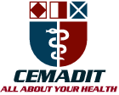
MEDITECH GROUP
RECEADIT
ALL ABOUT YOUR HEALTH

MEDITECH GROUP
CEMADIT
ALL ABOUT YOUR HEALTH

Research Center for Analytic Diagnosis and Imaging Trends (RECEADIT)
School of Health, Biomedical and Computer Sciences (SHBCS)
2015-2016 Academic Year
P.O. Box 19, Belo-Kom, Belo Sub-Division, Boyo Division, Cameroon, North-West Region,
West Africa - Tel: 011 (237) 6 73 91 21 14
CEMADIT@yahoo.com http://www.meditech-group.org

Motto: Health Care Research and Education for Services to Humanity

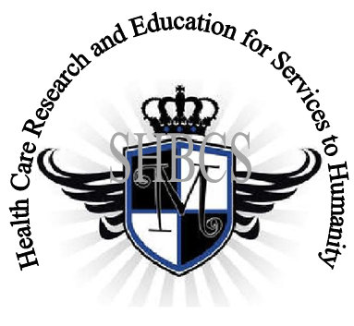

Ministry of Higher Education Ministry of Public Health Registration No. 3342 of August 31, 2011 Registration No. 4042 of August 31, 2011

GlobalGiving RECEADIT Provide Health Care Services to Fulani Community Project
Fifth Report of November 15th, 2016
On behalf of our RECEADIT Humanitarian Team, I take this opportunity to thank you so much for your generosity and willingness to join us and to partnership with us in our journey of serving humanity through the Guidance, the Blessings, the Love and the Grace of God Almighty.
We are glad to provide you with the following progress report and updates for our “Provide Health Care Services to Fulani Community Project” thanks to your generosity:
1) Our female student of the Fulani Community, whom we reported we had identified for medical training in our First Report, has successfully completed the Certificate Examination and is scheduled for graduation on Saturday, December 17, 2016;
2) With respect to our small pharmacy or more accurately, small drug store which we indicated in our First Report that we were going to open and have it operated under our supervision by one of our Pharmacy Assistants from the Bafmen Community, who graduated from our School of Health, Biomedical and Computer Sciences (SHBCS) in 2013, we continue to experience this serious setback and disappointment. This setback and disappointment, as we pointed out in our fourth report, resulted from the Pharmacy Assistant who abandoned the small drug store when she found a job in the city. This, as we noted and emphasized in our fourth report and are still noting and emphasizing in this report, is one of the main challenges we do face in our endeavors to bring health care services to our fellow human beings in these remote, rural communities. Even our own students who come from these remote, rural communities that we identify, recruit and train purposely to go back to these their remote, rural communities to provide health care services to their remote, rural communities do not always want to do so;

3) As we reported in our Fourth Report, on Wednesday, August 3rd, 2016 we rented a four-wheel truck, traveled to Bafmen purposely to re-evaluate and reassess the possibility of constructing a small health care facility there. On our way back, the truck got stuck in mud. Our team of four struggled to push it out of the mud until the next day when a group of villagers came and assisted us to push it out of the mud. We have realistically concluded that this project will be put on hold until the transportation infrastructure to this remote, rural community is improved in the next two years as government officials have indicated; and

4) As we indicated in our Fourth Report, to ensure that the initial drugs/medication which we purchased and stocked for a total of $500.00 for the small drug store at Bafmen did not expire and be wasted, we decided to use them to serve our patients at our other remote, rural communities of Aboh, Mbam, Muteff and Ngemsebo. This has now generated additional revenue of $150.00 since our Fourth Report.

We hope that you will continue with us on this our journey of serving humanity through the Guidance, the Blessings, the Love and the Grace of God Almighty, a journey which had taken us to this Fulani Community in Bafmen through our new link: https://goto.gg/21490.
Again, on behalf of our RECEADIT Humanitarian Team, I thank you immensely for your generosity, continuous assistance, support and partnership. We wish you God's abundant blessings in all your endeavors.
Jilly M. Ngwainmbi RECEADIT Project Leader

