Dear Friends,
We hope that you are all well and able to stay safe!
We’d like to start this note by bragging, and by thanking you. Kids 4 Afghan Kids has been helping children in Afghanistan for 20 years. Of course, you were a big part of making that happen. Thank you!
As you probably know, Kids 4 Afghan Kids was begun by a class of middle school students in Michigan. They, and the generations of student volunteers who have followed during the last two decades, have been a driving force in our fundraising efforts. These students contributed by finding creative ways to raise money to help their peers in Afghanistan. They’ve collected bottles, catered children’s birthday parties, and made products for sale at craft fairs. Since even a little money goes a long way in Afghanistan, their efforts have always been an important source of income.
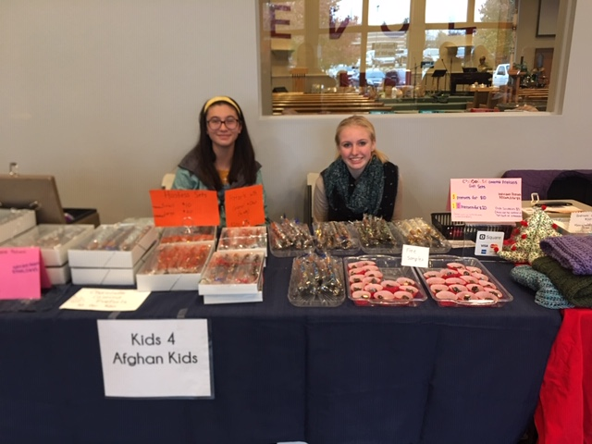
Volunteers at the Alternative Christmas fair, November 2019.
Unfortunately, none of these activities are possible this year due to the novel corona virus and social distancing requirements. Of course, the needs in the village are still as great as ever. Right now, we have an urgent need to fix the leaking roof on the now aging clinic.
You may have read that COVID19 is spreading to Afghanistan. Experts predict the consequences may be dire in many areas because of the poverty and crowded housing. We are happy to report that so far, we have no cases of this virus in our village. At the start of the outbreak, many younger people returned to the village from their jobs, or from college, in other parts of Afghanistan. We were concerned they would bring the virus back with them. However, it’s “so far, so good”. We suppose that being in such a remote village is a double edged sword – the poverty in the area is still very high due in part to the remoteness, but that remoteness also lessens the contact with the outside world.
Of course, we hope our luck continues, but we also must again thank our donors for the fact we have had a Kids 4 Afghan Kids medical clinic in the village for nearly 20 years, so that the people there have the opportunity for medical care for any health issues. We also have a hospital under construction. However, since completion of the hospital is still a year or more away, the clinic is of critical importance.
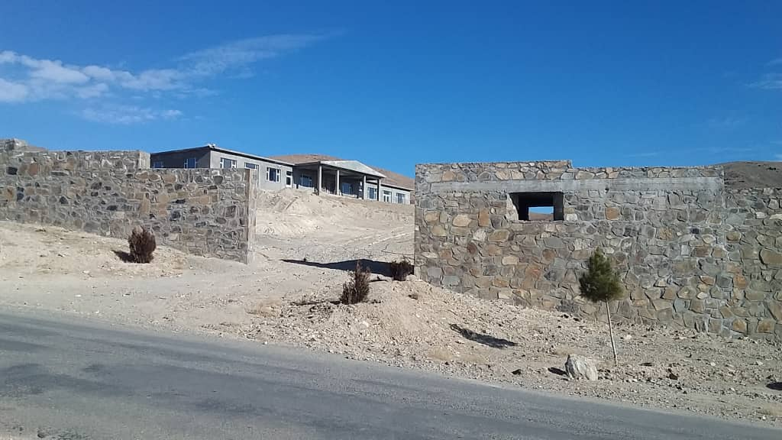
The new hospital under construction, Spring 2020.
We know these are tough times for many people in the US. However, if you can spare any donation, even a small one, it will help us make up for the loss of our other fundraising efforts and help us maintain the clinic and provide medical services, which will be even more needed if we eventually do get a COVID19 outbreak. As you probably know, we are an all-volunteer organization with no administrative costs, so one hundred percent of your donation will go toward the new roof.
We hope you’ll help us celebrate 20 years of success with a small contribution!

