Kids 4 Afghan Kids
9936 Hambleton Livonia, MI 48150
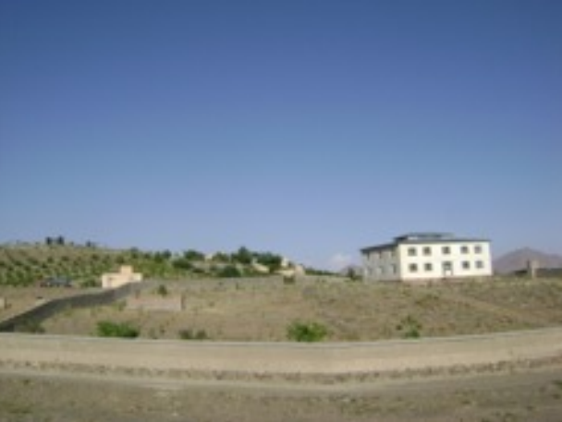
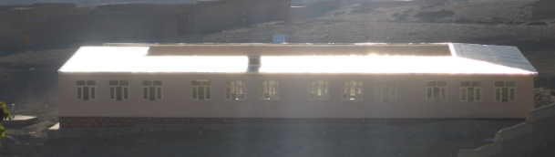
www.kids4afghankids.org
Dear Friends,
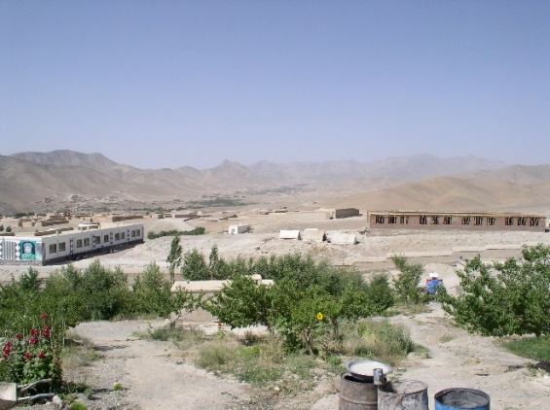
Thanks to your help, we earned a permanent spot on Global Giving by raising more than $5,000 in two weeks in September. Many thanks for your generous contribution toward that goal.
Many plans are currently being developed, like the future saffron garden. Saffron is a beautiful crimson red herb with an exotic taste. It is one of the most expensive spices in the world and is in high demand. The best part is the fact that Afghanistan’s climate near the village is perfect for growing saffron. We plan to establish a garden soon, which will have 1000 saffron plants, at a cost of three dollars per bulb.
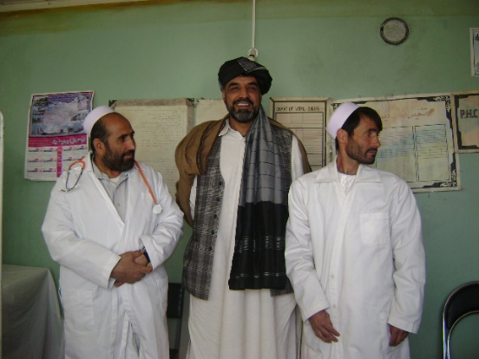
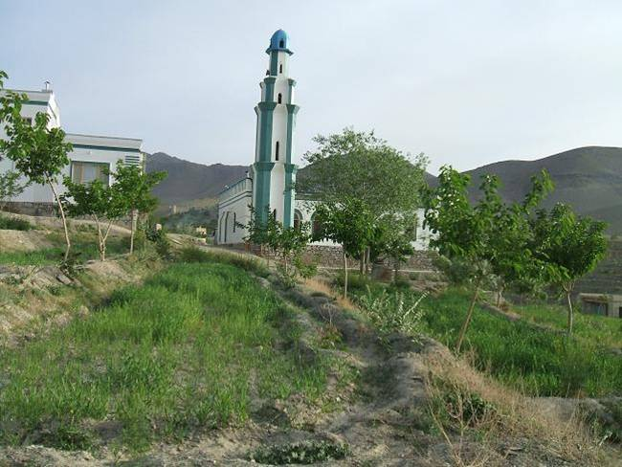
Another important project is the building of a hospital. Ground has been cleared for its construction. More news will come as construction progresses. Currently a dentist visits twice weekly, and we have a full time nurse in our clinic.
Here in Northville, we earned $600 selling drinks at the Victorian Festival. The Rotary Club will donate some of the proceeds of its Tour de Northville fundraiser, our own bike marathon. Northville High School volunteers helped Handicrafters’ Fair artists carry items to and from their cars. Thanks to that hard work, K4AK earned more than $600 in tips. We also got a generous donation from Northville’s American Association of University Women. Thank you everyone!
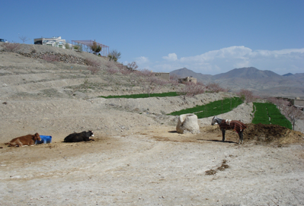
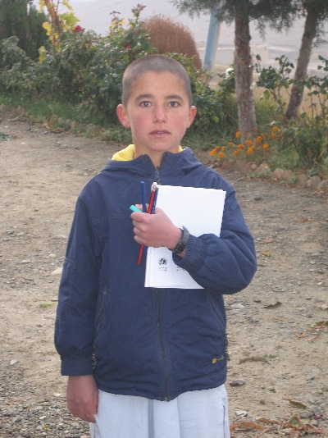
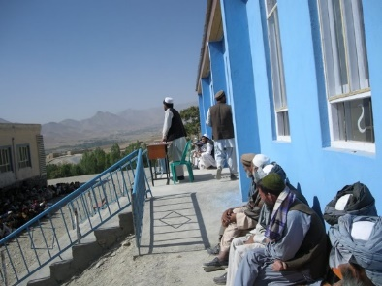
Education is one of the main tenets of the Kids 4 Afghan Kids program, which is why we are pleased to announce that 149 students graduated last year. These students started school mostly illiterate, and some walked for four hours each day just to attend school. We are also working to have 16 graduates be able to attend Kabul University. Most of the other graduates will go to Iran to work in masonry, and some will stay in the village. Unfortunately, the graduates are forced to go to Iran because the road to Kabul is heavily land-mined and dangerous. In other news, we are working on providing the students with laptops through a grant.
Completed Boys’ High School
The 1500 fruit and nut trees are doing well. Grapes, apples, pomegranates, almonds, apricots and greens are grown during the spring and summer seasons. All of these are harvested and eaten by the villagers. There is even a farm, which has a flock of sheep, three cows and three horses.
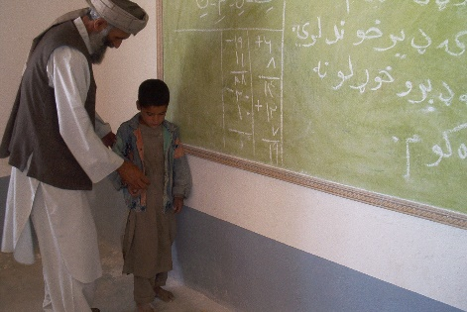
School looks similar to what we have here: math, social studies, science, and the two official languages (Dari and Pashto) are taught. However, there are no electives or extra-curriculars, such as art and music. That would be nice to change. We are working on gathering the funds necessary to purchase bicycles to make the teachers’ commute easier.
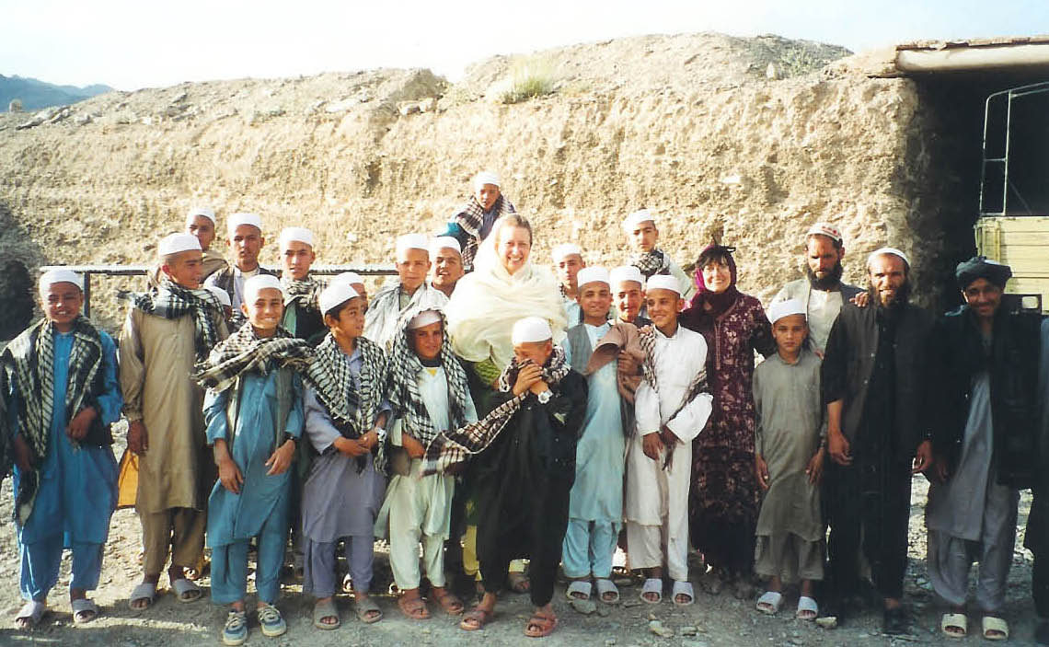
We have come so far from our humble beginnings of 165 students 15 years ago to our current number, 2400 students. Our project has grown to touch the lives of so many people, and it is all thanks to your continuous support. Thanks from all the students and villagers for all the happiness and futures you provide!
Brian,
High School Student Volunteer

