“No news is good news.” That English expression is often repeated in the U.S. in jest. However, when you are operating schools that include the education of girls in a war torn, impoverished, rural area of Afghanistan, no news really is good news.

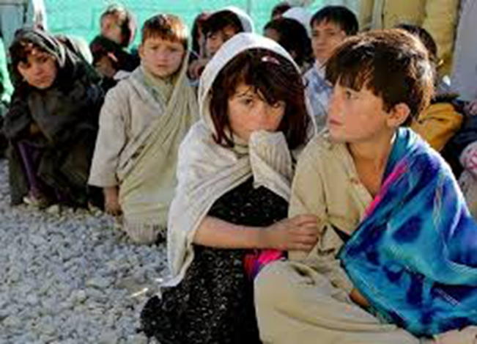

A picture taken outside the classrooms. Children in rural Afghanistan are more familiar with fear than are most American children. Their futures are less certain because famine, disease and political upheaval are never far away.

We are happy to report that we are in the middle of another very quiet school year with no violence and no damaging storms or other extreme weather conditions. The Village continues to support the school and the education of girls. The well continues to supply water to the surrounding area. The students are attending school as usual. (As you probably know, the students at the Kids 4 Afghan Kids project often own no shoes or coats and thus we run the school year over the summer and take off winter, which can sometimes be bitter cold.)

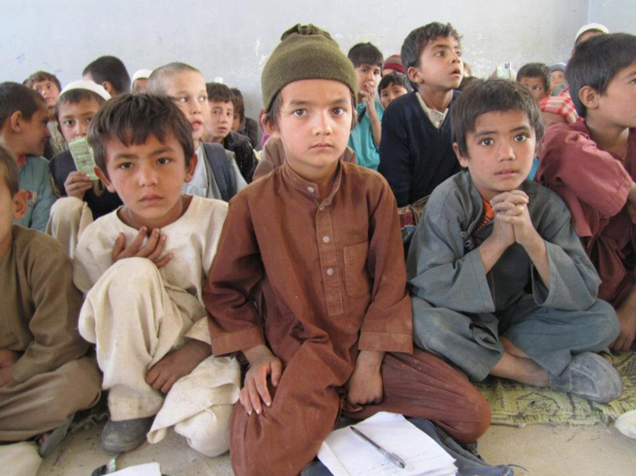

This is an elementary school boys' classroom at the K4AK project. In Afghanistan, it is considered improper for boys and girls to have classes together. We recently were able to purchase rugs for the students to sit on.

We certainly don’t have enough money to fund the extras students might have in the U.S. However, the children are learning math, reading, science, social studies and languages and 68 students were graduated from the high school last year. Several dozen students even go on to college or technical schools. Many find good jobs.

We also don’t have the money to move the construction projects along at a rate you might see in the U.S. However, construction of both the hospital and the second project in northern Afghanistan continues, so we are steadily advancing toward our goals - a real hospital on our first site, and a second project site with elementary and high schools and a clinic**.** We did hit one important milestone - the plumbing for the hospital’s heating system, sinks and bathrooms has been completed!

Because of disease and famine, children are much more likely to be orphans in Afghanistan than in the US. We care forboys in the K4AK orphanage. Children in Afghanistan typically help with their families’ farms and households. “Our” orphans perform similar chores around the project to learn life skills. They also usually make an effort to befriend the younger boys. Twelve of last year’s graduating high school students were orphan boys.

It isn’t considered proper for girls to live away from a family home, so K4AK has no girls’ orphanage yet. Girls are usually taken in by another family, but we are working on gaining acceptance for girl’s orphanage to provide an option for those who have no good place to go. We are pleased that six orphaned girls graduated from high school last year.

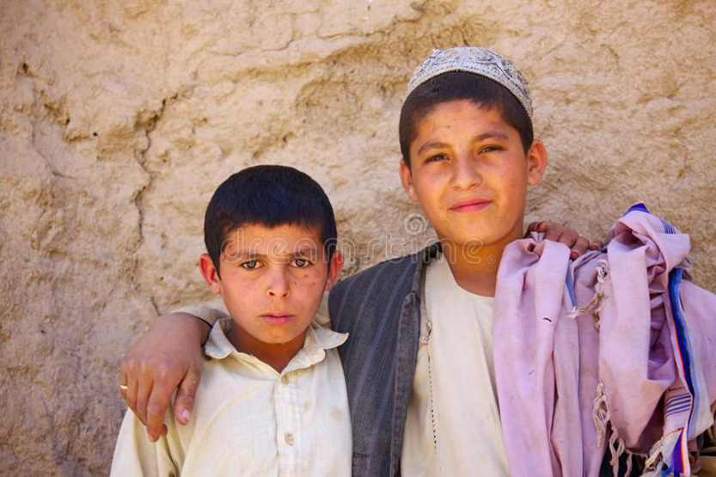

Orphans learn life skills by helping around the project. They often act as big brothers to the younger boys.

All in all, we are grateful for the lack of news! Quiet times are when the students are able to learn and be kids. We, and the people in the Village, are very grateful to you for providing this opportunity by supporting the school, water well, boys’ orphanage and medical clinic. These children have smiles on their faces and a hope for a better future because you chose to sacrifice and make a donation.

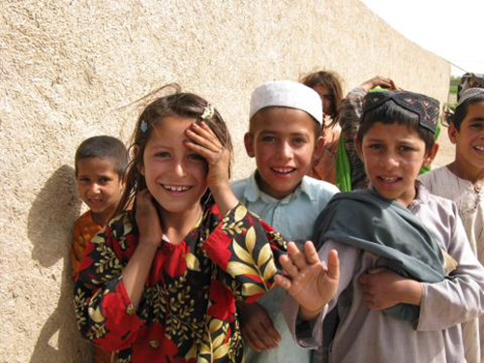

A lighthearted moment waiting for school to begin. These children have smiles on their faces and a hope for a better future because you chose to sacrifice and make a donation.

As always, Kids 4 Afghan Kids is an organization of all volunteers, with no administrative expenses. Every penny of your donation goes to purchase a necessary item.

Thank you for your continuing support of the Kids 4 Afghan Kids project!