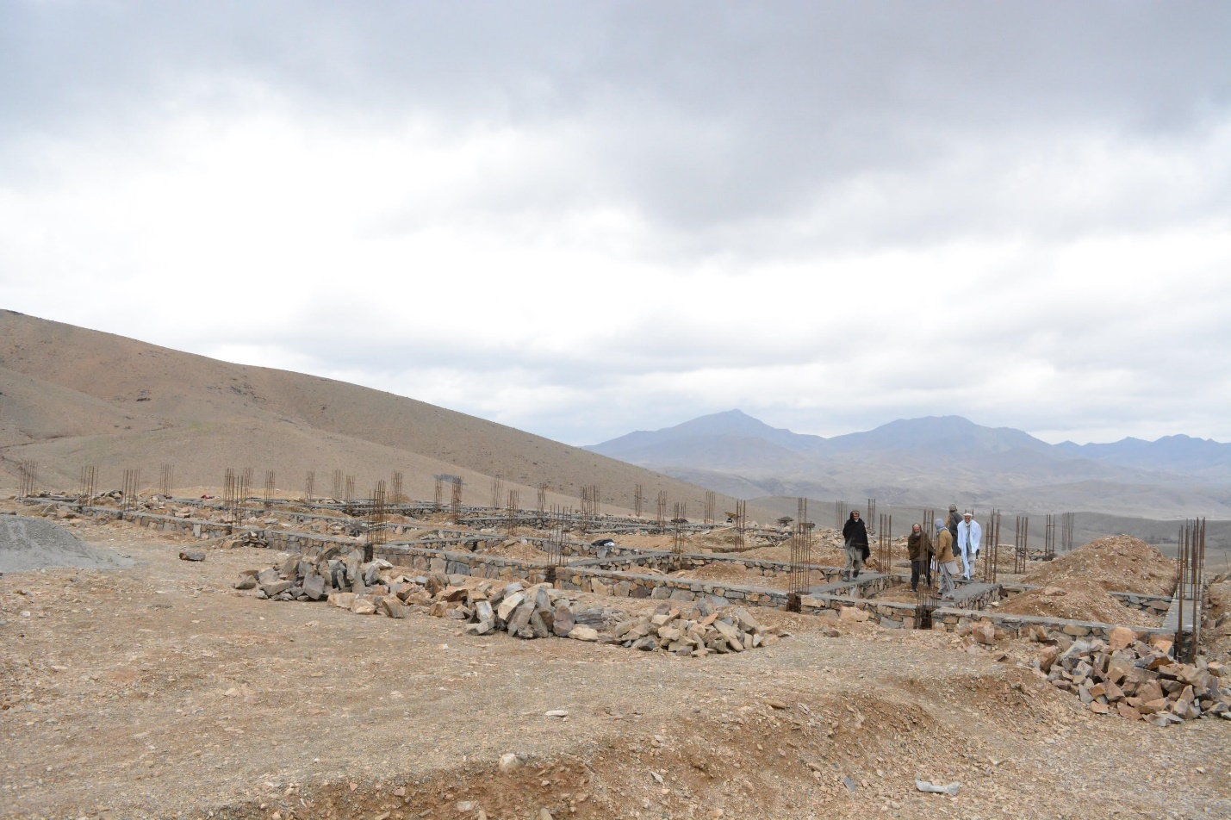
Recently, Kids 4 Afghan Kids undertook a massive project that will improve the quality of life for all of the people in our project. We decided to build a hospital, a much needed improvement to the small clinic and dentist’s room we currently offer. To erect a hospital in the cheapest possible manner, we decided to use the plentiful granite-like stone scattered across the Afghan landscape. We then only had to purchase supplies not readily available, like metal reinforcement rods, and lumber. A generous grant from the HELP Organization is funding this project. We started with the foundations, as can be seen in the following photograph.

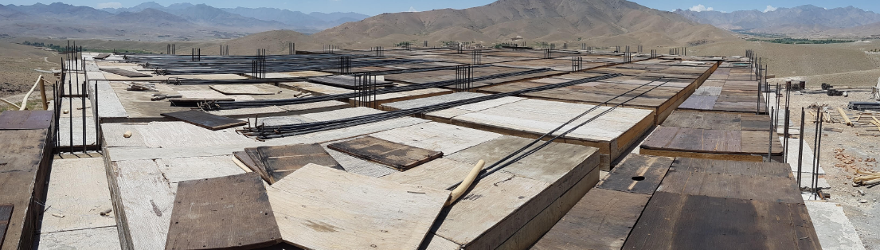
The metal rods sticking out of the ground are the reinforcements, and are there to ensure that the foundation is sturdy and safe. We made more progress and laid down the bottom of the foundation, shown in this photo:

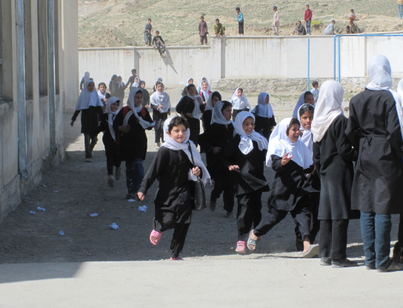
The hospital is steadily progressing from an innovative idea to a viable reality. We expect it to be completed within five years, and will be fully operational for our children and citizens. This hospital will be built on our current campus, as we are still developing and working out details of our satellite campus that is located north of our current campus.

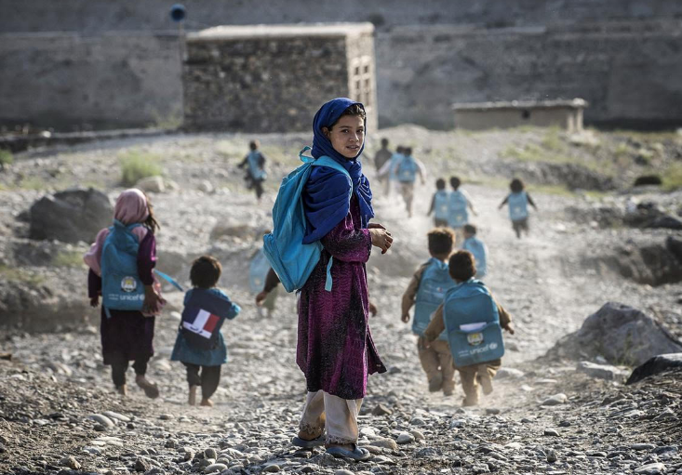
An Afghan family donated most of the land for the northern campus. Kids 4 Afghan Kids will purchase the remainder land, and we will set it up as soon as possible. This allows us to reach out to even more children who do not have access to education and health care.
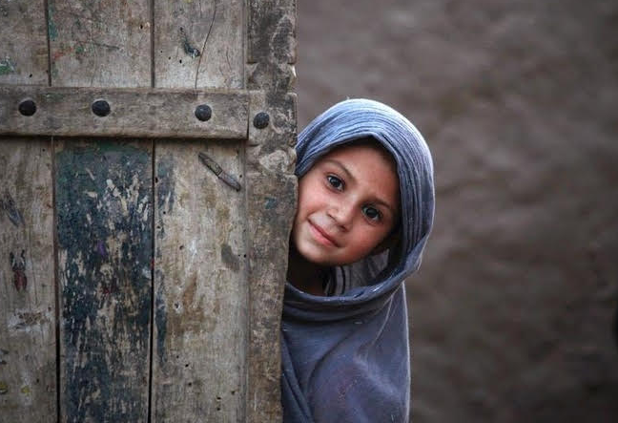
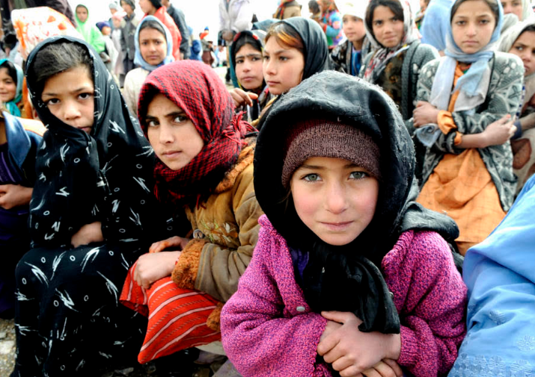
We did not just achieve steady progress in promoting our village’s health, but also their education. The schools we have built teach children important subjects much like one would see in any American primary school: English, the regional languages of Dari and Pashto, science, history, and mathematics. In fact, when the Taliban controlled large swaths of Afghanistan, women and girls were prohibited from attaining the education that they deserved. We uphold the ideal that all people, regardless of any inherent quality, are truly equal, so we built schools for our boys and girls. The fruits of our labor can be seen in the following photos, that perfectly showcase the happiness we inspired in the children who are lucky enough to have a school!

The joy on all of our students’ faces is what truly makes it all worth it. Thanks to global giving, we were able to raise funding to help these magnificent projects. With your support, we truly made a difference. According to the United Nations, which has already established schools for women in Northern Afghanistan, women only account for 20% of the population at Afghani universities. We are hoping to monumentally increase that number to 50%, and because of your help, we are steadfast in our journey towards equality and an ultimately better world!

Thank you!
Brian
Student Ambassador
July 9th, 2016

