Why We Succeed with At-Risk Girls
(We take them from nothing to a productive life)

Most of the ex-street girls and boys are from extremely poor backgrounds who have been through all sorts of serious trauma, suicidal tendencies, alcoholism, street life and drug addiction. They have gone through different types of programs designed to set them free from these challenges, but the programs have been unsuccessful. At Esther’s Aid, we not only repair their lives by providing education and skill training, but we also balance our work by nourishing their spiritual lives as well. That is the secret of our breakthrough – providing them a Holistic Package.

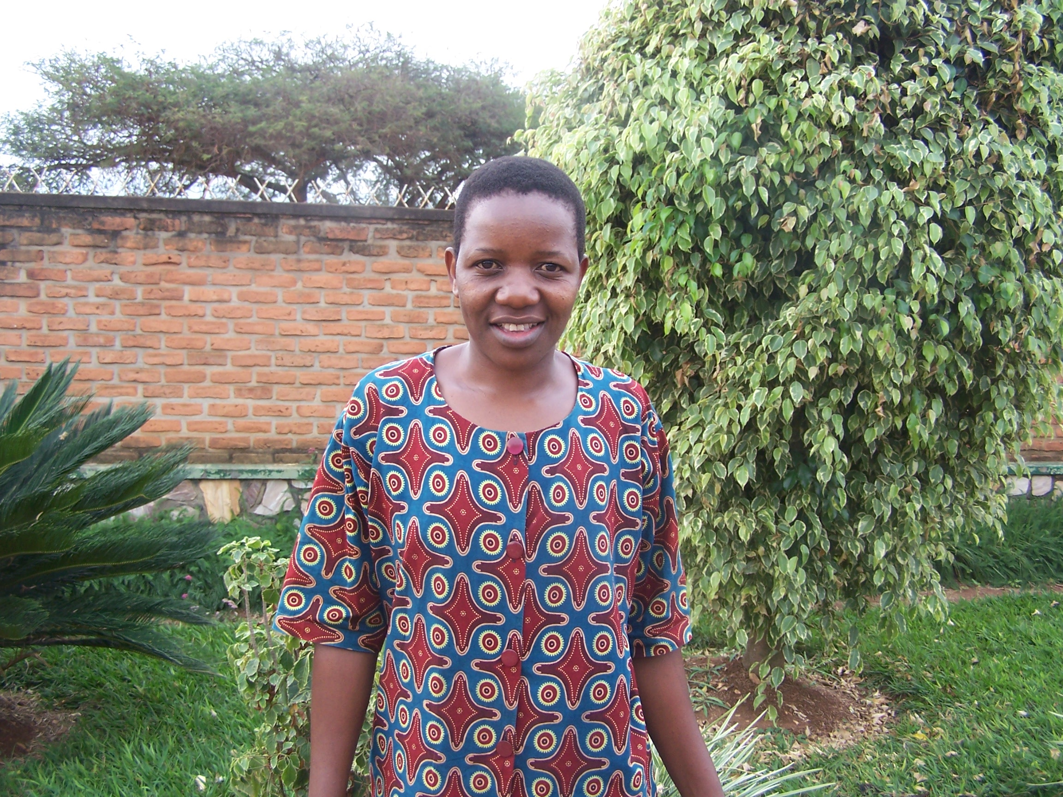
When these at-risk young people come to Esther’s Aid with unbelievably horrendous stories of rejection, hopelessness, hunger and often with suicidal tendencies, the first thing we do is open our hearts and arms to receive them with love and warmth. What we do is to restore hope to the hopeless.

Let’s hear from the ‘Horses Mouth’ – This is Jackline’s story.

I was born in a complicated family. My mother was a student, got pregnant and the man refused to take her home. My mother tried to abort me three times using local herbs but I refused to die. She was reported to the police and the police arrested her. She told her story to the Police and she was warned not to abort the baby. After I was born, the man denied me and refused to take me as his child.

As I was growing up in a very bad condition, and everyone knew that I was a bastard, I had no guidance nor help from nowhere. My mother couldn't help herself and me, so she took me and dump me at the compound where the man who rejected me as his child lived. My mum worked for some Indians as a house help and was able to make some money. She later found me where she dumped me and sent me to school.

At senior 4, my education stopped because my mother lost her job and couldn't support me anymore. I lost hope because everything was over for me as I couldn't continue my education. The next alternative was to disappear from my mother. Join groups of prostitute, evil practices and I tell you Mama Clare, there is nothing I did not do. I have been tortured by many people and have met with many challenges. I was completely hated from the womb.

For eight years, my mother didn't know where I was and I became like a mad person. I became the one leading the group of the prostitutes and thieves because I wanted to die. I even accused God because He didn't do anything to help me. What was on my mind was never to produce a child, because I didn't want what happened to my mum to happen to me.

A time came when my friends began to die one by one because of AIDS and other diseases. Then fear came upon me and I began to look for help. I cried to God asking Him why I come to this world, for how long will I continue the life of prostitution, the stealing and the lying. I wanted to die. I cried myself to sleep for hours, when I woke up, I felt different. I began to understand that it was not God that hated us and allowed us to suffer, but it was us that disobeyed God. My story is a long one. In all that I went through, God had a plan for me. That plan began to open up when Esther’s Aid admitted me into its Catering School. The reason I talk about God’s plan is that, God made it happen.

This is how it happened: Where I was staying as a house help, it was on a Tuesday morning and I worked so hard that morning to complete all the house chores. So by 10:30 AM, I was tired and I found myself sitting down on the kitchen chair and slept off. When my mistress saw me, she was very mad with me and shouted at me to get out of the house because I am lazy. I left the house and was walking on the street aimlessly thinking of what to do with my life.

That is when I saw a young muzungu girl (white girl) who said hello to me on the street, and I said hello. She asked me if I understood English, I said yes. She (Meredith) wanted to buy some fruits but she couldn't communicate with the women traders, so I helped her. Then I asked her for help and she introduced herself to me that she is from America and works with Esther’s Aid. Then she gave me contact to the school director for help. I didn't have to ask her where the school was located because everybody in the community knows Esther’s Aid. I asked the petty traders and they told me where it’s located.
The admission process was already finished but God helped me, one student changed her mind and dropped out, that created a room for me.

I work for people because I don’t want to go back to the street, I work so hard with my hands and people will just abuse me because I am poor.
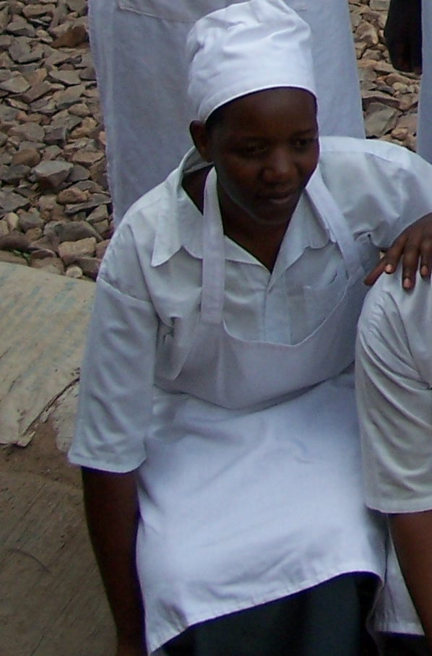
For 16 years I have been out of Education, before I came to Esther’s Aid I never thought I would have the opportunity to be in school again. God brought you from America to help people like me to go to school free. Right now I thank God that I am in Esther’s Aid. Since I entered the school, my hope rose up, I began to see my future so bright. The blessing I see in my life now is different. Now I meet people and they are encouraging me. The brain which was locked up is opened. I believe after my education, things would be much better. I now have hope for the future. The desire to die has changed. Through Esther’s Aid, I got a job while still in school and my life is getting better. These American people are wonderful!

Jackline’s story is just one of many breath-taking stories from these young women and men whose hope is slowly being restored. We thank all our supporters who have made this project possible.

