THIS THANKSGIVING, WE ARE GRATEFUL FOR YOU!
Dear Supporters of Esther's Aid,
This Thanksgiving, we are especially grateful for you!
Last year, when Esther's Aid created this program, Rescue the Victims and Survivors of Sex Trafficking, we focused our efforts on these vulnerable girls and young women. It was to last from 9-12 months with specific answers for the needs of these survivors. These included, short term room and board, short term financial aid, emergency health care, counseling and advocacy. They would be enrolled in Esther's Aid current training programs (Culinary Arts, Sewing and Fashion Design) to gain skills. These skills would empower them with dignity and confidence to seek employment. Because of your help through Global Giving, we began our work. The challenge was to provide intervention and practical assistance when and where it was most needed. Esther’s Aid has met this challenge successfully – but there is so much more to do!

The project has helped transition the girls and women from their past life of controlled abuse to stable independence. It has provided short-term room and board, healthcare, counseling, advocacy, and financial aid, intervention and practical assistance. when it was most needed. We watched these young people daily with excitement and fulfillment, because hope has been restored for a greater tomorrow and there is confidence and power to achieve success!.

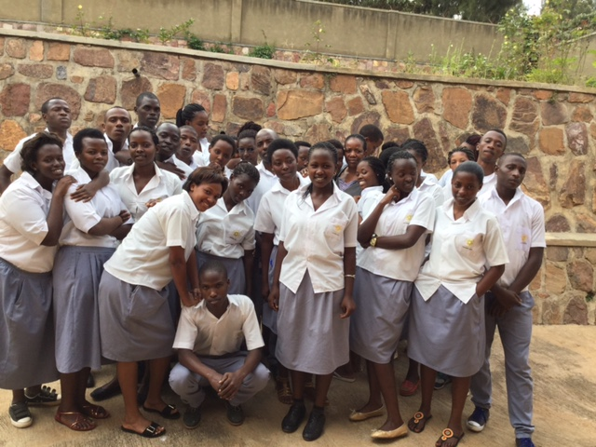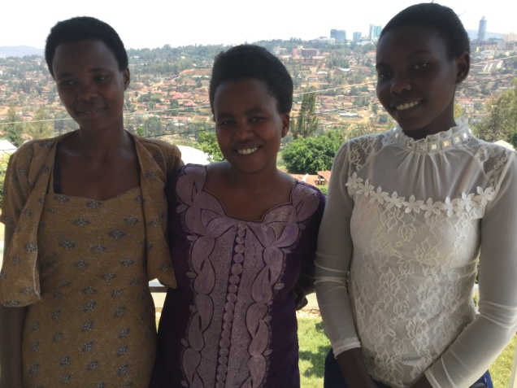

In our previous reports, we mentioned the significant transformation in the lives of the victims, who escaped the cruel hands of traffickers. Those whom we brought into Esther’s Aid school to join other students in our Culinary Arts and Hospitality Program are experiencing a newness of life. We continue to watch carefully our young women we empowered with petty trading in charcoal, tomatoes and Bridal rental. They are all coming out from the depth of despair to light with vibrancy.

Remember Emeritha M. in our second report. Her life story has changed for the best. Her charcoal business is doing well. “This support from Esther’s Aid is a surprise to me. We will make our supporters proud, with all glory to God.”
Also, Jose and her friends are making waves, with the hair salon business. They are saving to buy their own small property to expand their business instead of renting. “My survival is a miracle. I have seen the worst in life, and now I am beginning to see the newness of life.”

Counseling Sessions
In our continuous efforts to identify these groups or individuals, we partner with community leaders, especially in the villages near the nation’s borders. We organized a close-knit meeting to listen and hear from the victims to learn about their specific situation, so we could provide intervention based on needs, age, and a desire to overcome the trauma.

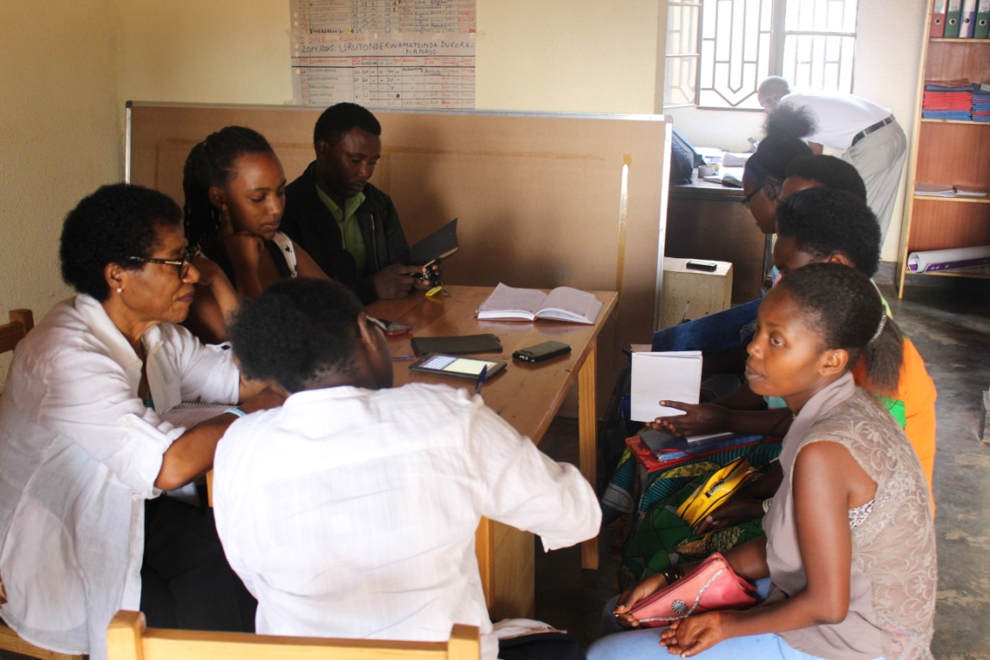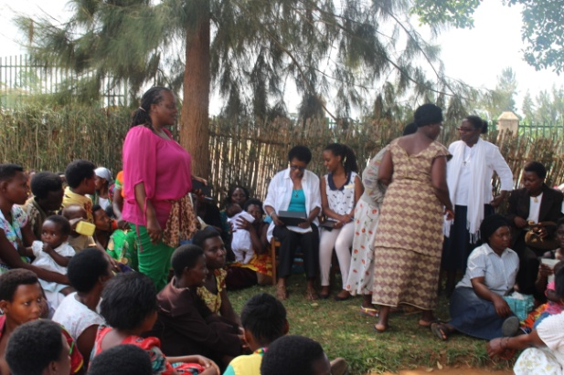

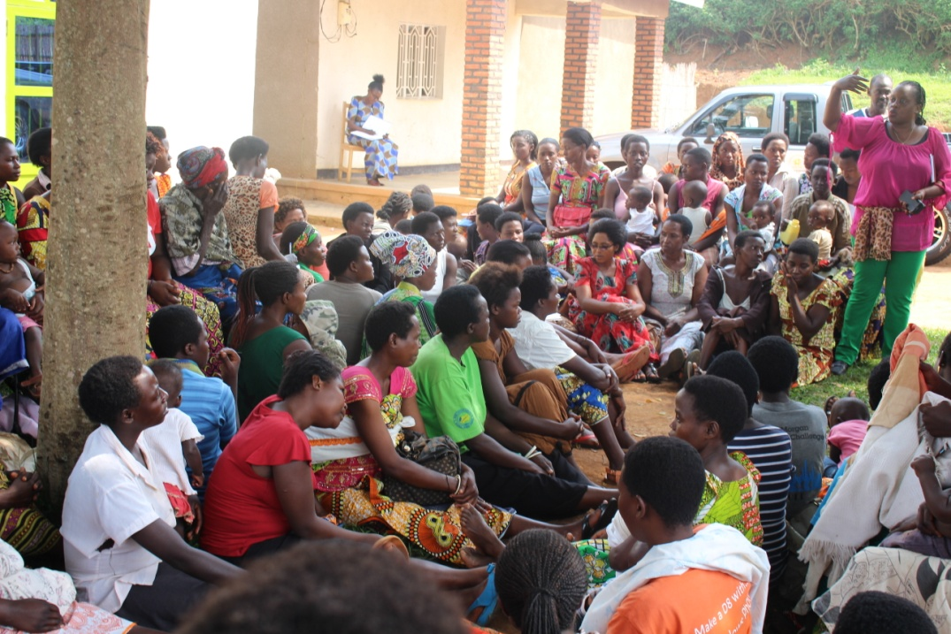

Long-Term Impact
This project has provided opportunity for these vulnerable young women to break free from traffickers. They have found refuge when most needed and are on their way to achieving productive and independent lives, because they feel confident and empowered with skills. Esther's Aid will mentor these girls and women on Entrepreneurship and Cooperative Creation of Small Businesses.
But Esther's Aid is limited because of the limited resources. We were not able to get in the trainer to provide classes on hat design. Since we started reaching out to the victims, more are coming out and seeking help. We continue to provide transition support, counseling and helping them to restore self-worh – giving them the confidence to handle any self-sustaining project. We want to do so much more!
Please continue to support Esther's Aid on Global Giving! Please, remember us on Giving Tuesday, November 29, 2016 so that your donations will have matching dollars. We are so grateful for your support. God bless you this Thanksgiving and in the years to come. Help us to give all these victims an opportunity to be part of next year's graduating class!
Respectfully yours,

Clare Effiong
Executive Director
Esther's Aid
Rwandan Mission



