Global Giving Progress Report 3
Olive, Laisa and Valentine were in terrible situations, but they all found hope in Esther’s Aid. These young women were orphaned and lived in various homes and circumstances that drove them into attempting to commit suicide. After their rescue from these deplorable situations, they felt unwanted, rejected, abandoned, and ultimately had no faith in any human being. Now, they have completed their training and Esther’s Aid is empowering them with sewing skills to help them build a productive future.
Olive
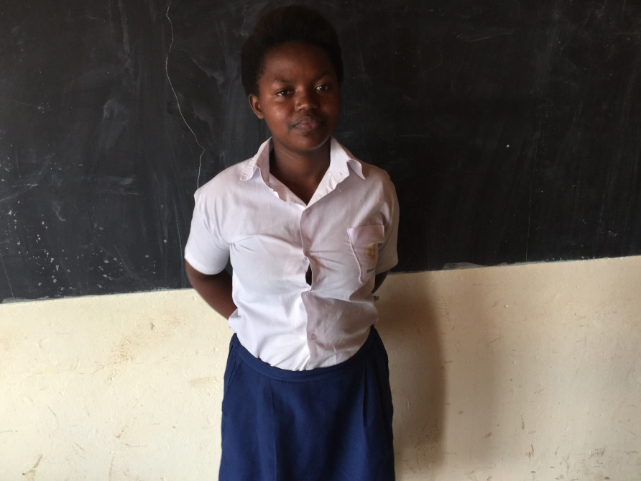
Olive's story: Both parents are infected with HIV/AIDS and she lost her father to the disease. In the struggle to take care of her sick mother and siblings, she dropped out of school, and found herself in a bad situation – a victim of inconceivable depravity.Now, as a rescued survivor, she has completed her study in sewing and fashion design at Esther’s Aid School. The rest is her new story. She is interested in becoming a model. She has the disposition and poise to succeed.
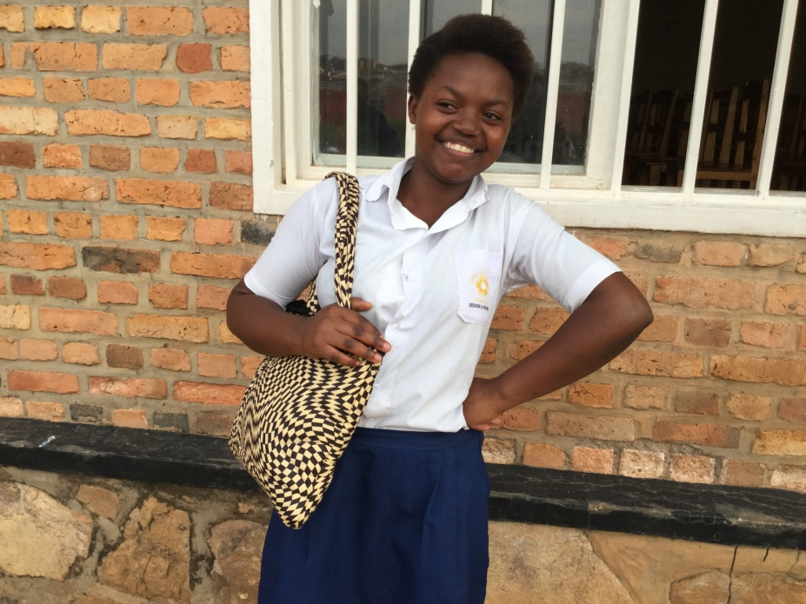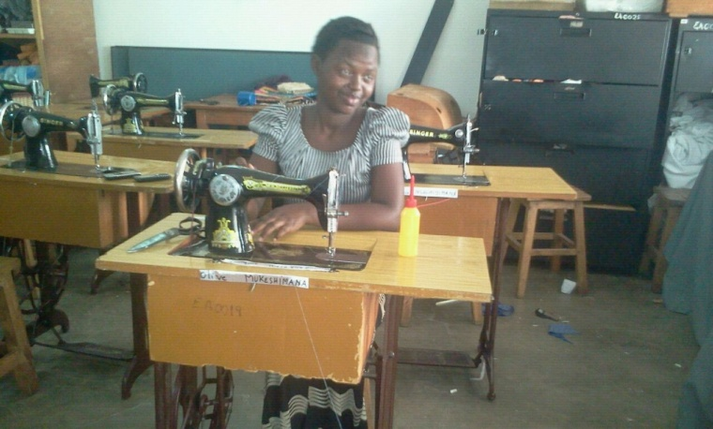

Laisa
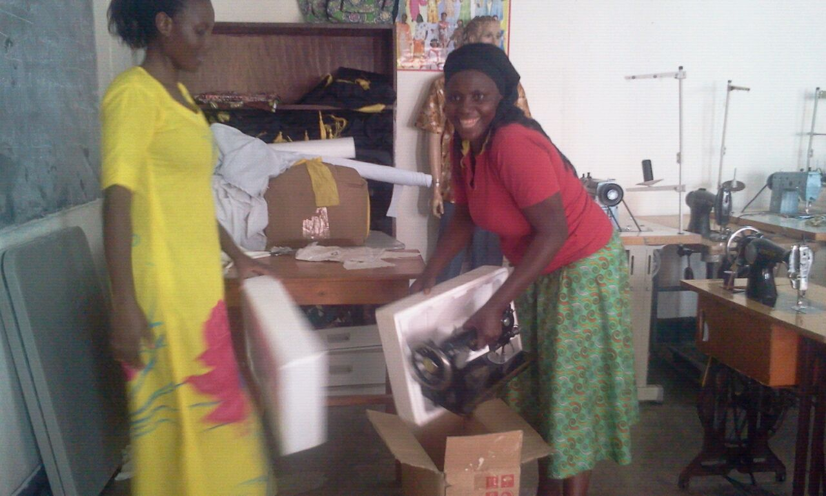
Laisa's story: “I thank God for Esther’s Aid and its Global Giving Project.” We met Laisa during our outreach to the vulnerable youth at the outskirts of Kigali. A victim and now a victor! She is overcoming the traffic abuse stigma and looking forward to a brighter future.

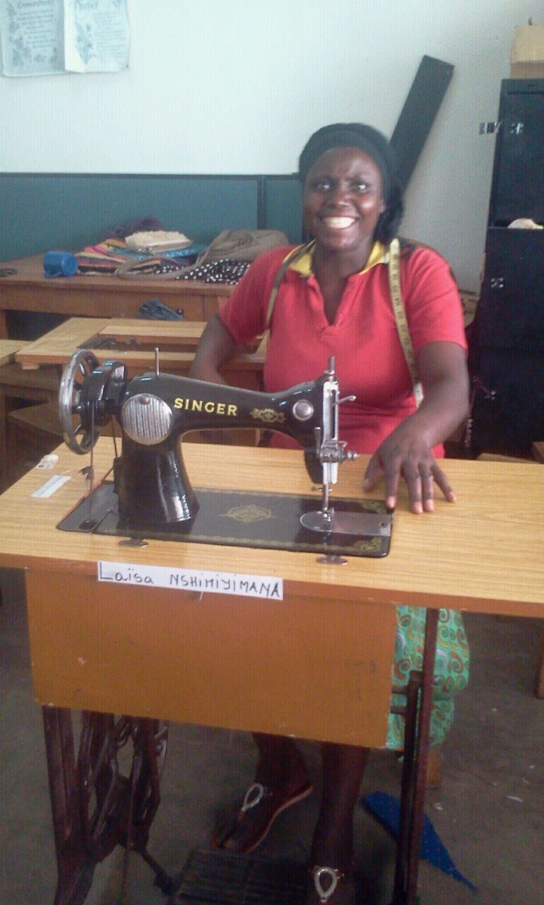

Valentine

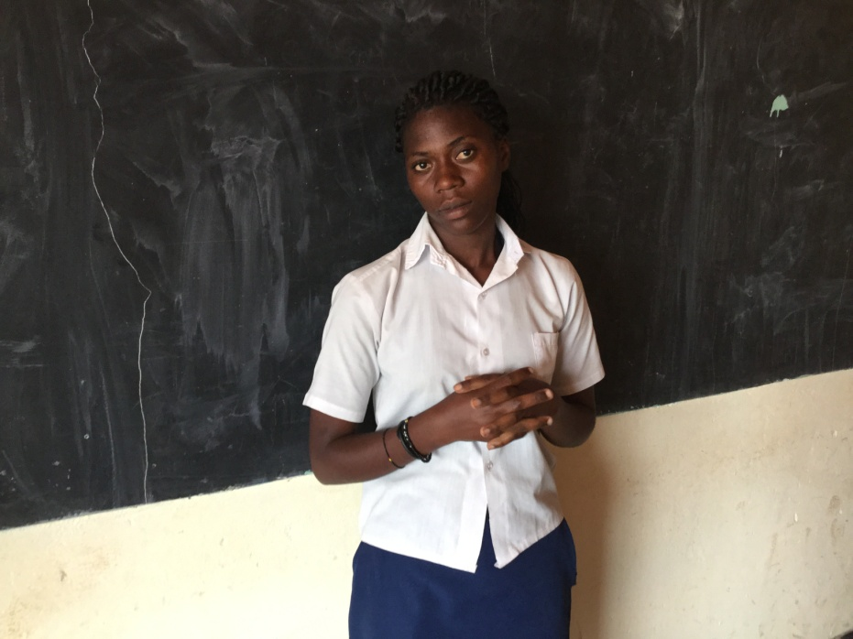
Valentine's story: I have mother who is extremely sick and poor in the village. I became a domestic helper in another family to help myself and my poor mother. I was treated like a slave with too much work from morning to night. I was also abused. I escaped the endless labor and joined a group of a few friends. I thought that was the end of my suffering. To me, it became what they call “from frying pan to fire.” After that, I felt that my life was hopeless. I attempted suicide twice, but God intervened. Today, my life has changed forever. I feel this great change right inside of my soul. My gratitude to Esther’s Aid and any group, who supported them to give me a newness of life.

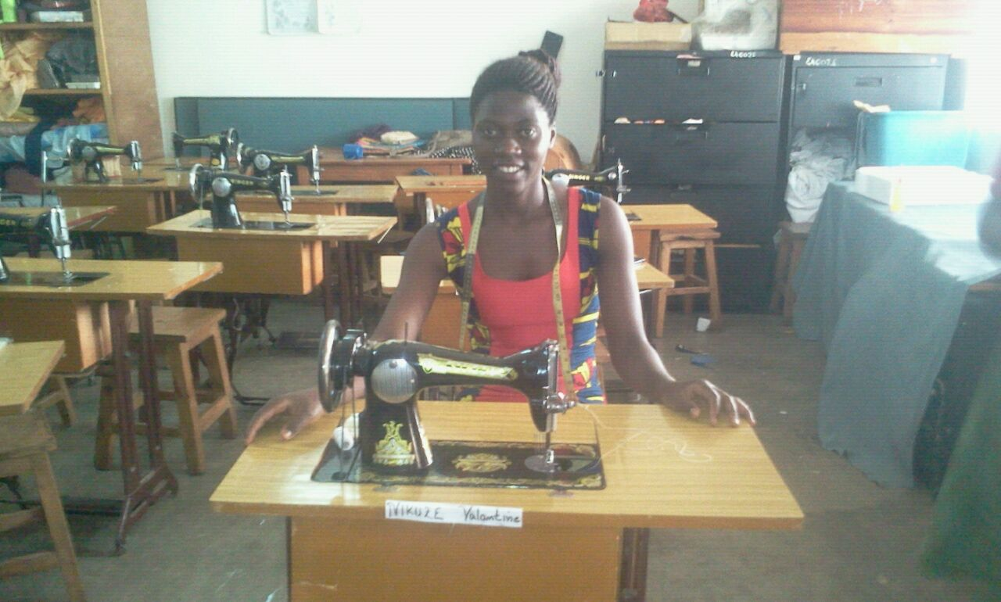
In our Sewing and Fashion Design Program, we are still working on securing a trainer for the fabric tie-dye and hat-making project. We hope by the end of summer, this project will end well with great success.

The story about these girls' progress demonstrates the power of love and commitment to raise the poor and needy from the dunghill. We watch these girls daily with excitement and fulfillment because they are now fully empowered and hope is restored for a greater tomorrow.
Equally, we are monitoring our young women whom we empowered with petty trading in charcoal, tomatoes, and bridal rental. They are all coming out from the depths of despair to the light, revealing vibrant spirits that were buried.
Culinary Arts Students: Those brought into Esther’s Aid school through the Global Giving Empowerment Project are gearing up for their internship programs in the next two months. After graduation, there is opportunity for securing jobs at the entry point into the hospitality and food industry.
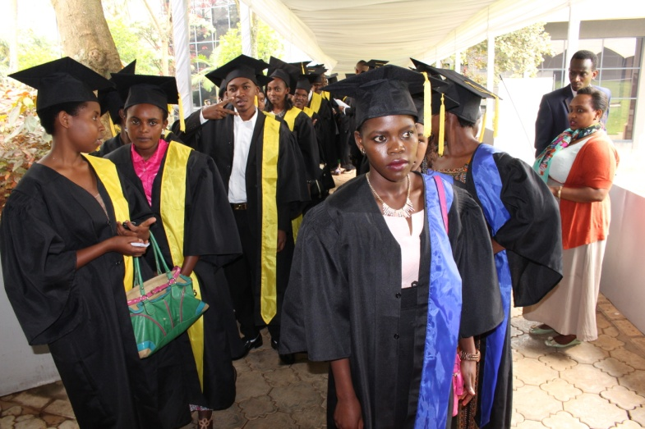

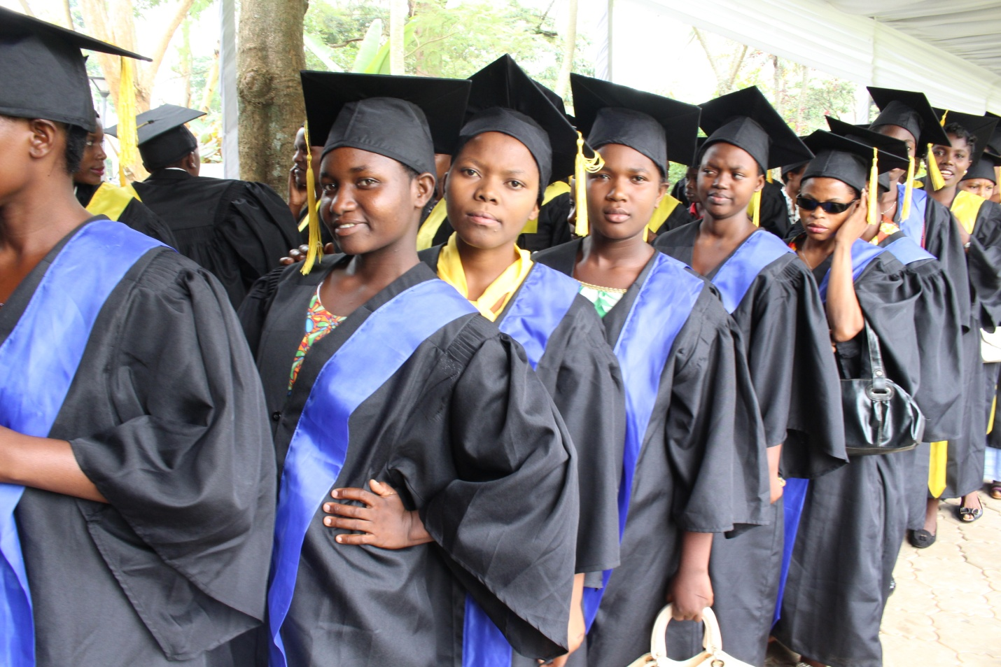Thank you Global Giving!

