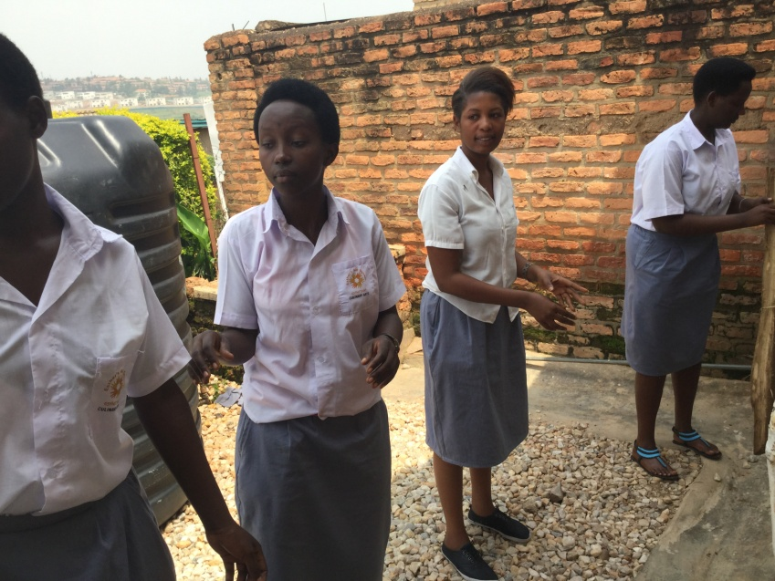
Above: Young Women, Survivors of Sex Trafficking, in their uniforms.
And registered at Esther’s Aid School.

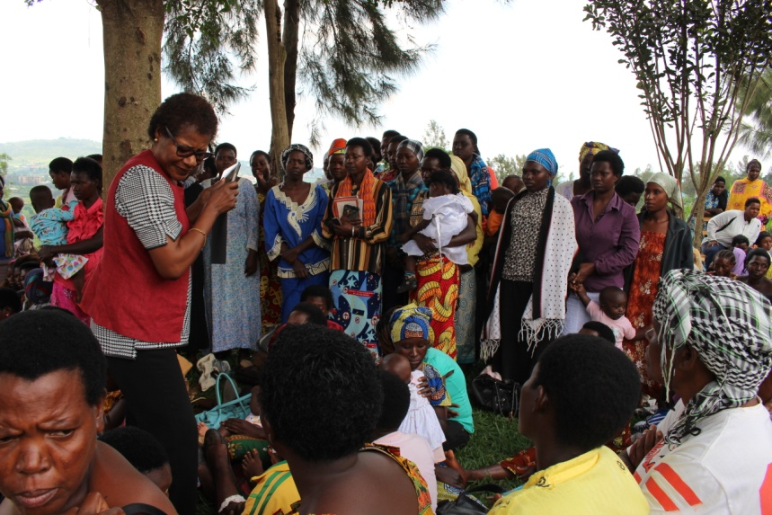
Clare Effiong (red vest), working with the young survivors.

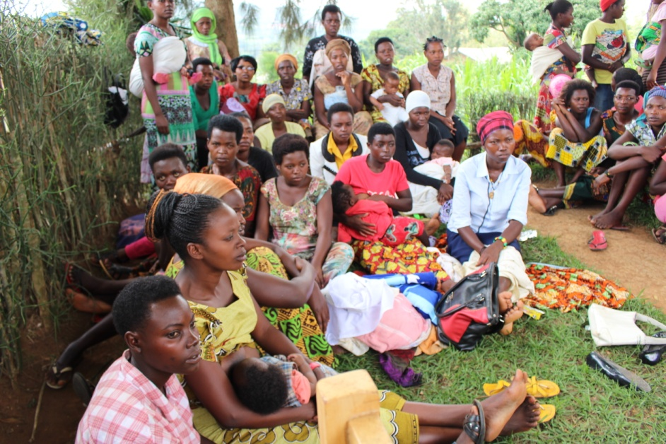

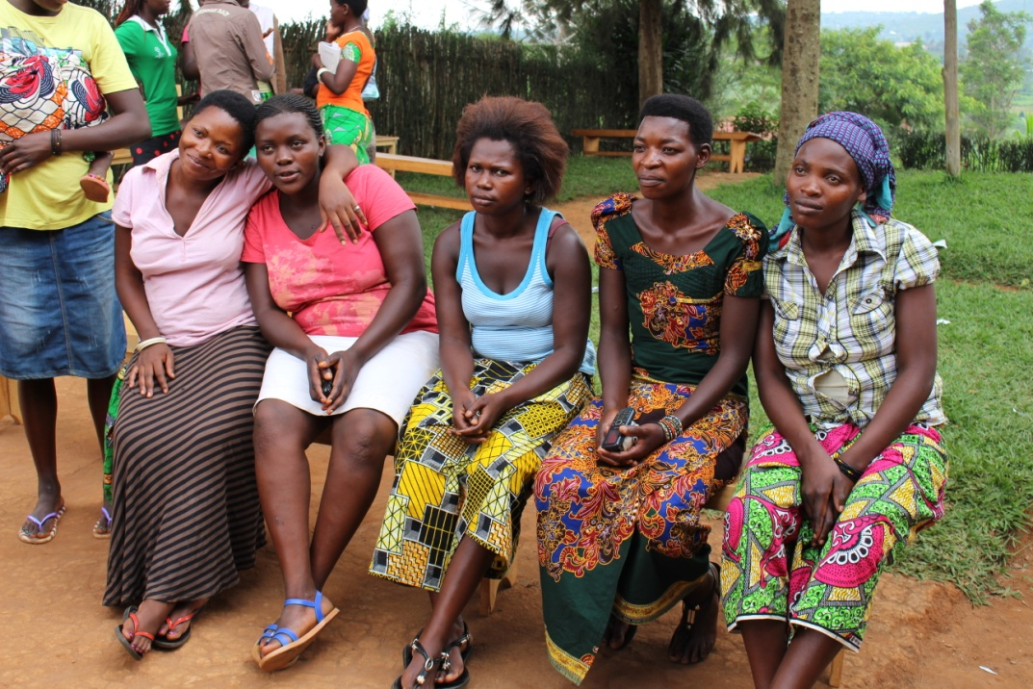

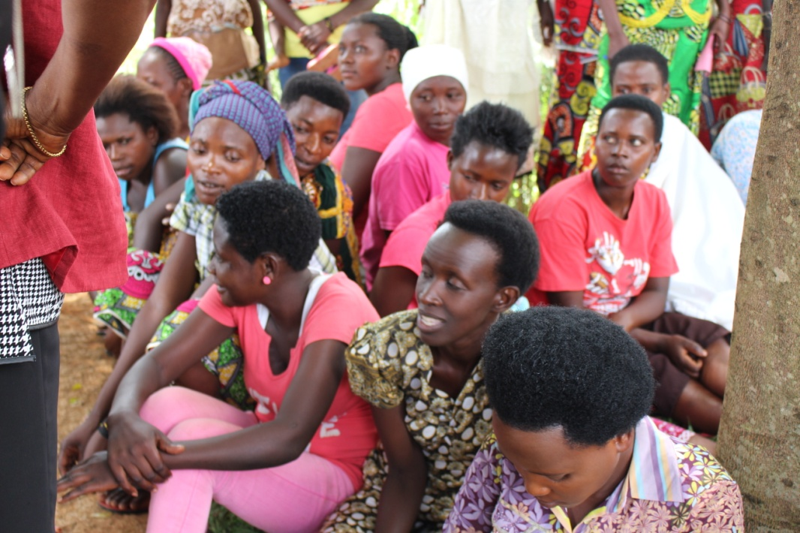

End of pictures.

Following pages blank.

