Esther's Aid GG Report 8/14/17 Photos Part 2 Page 1 of 2

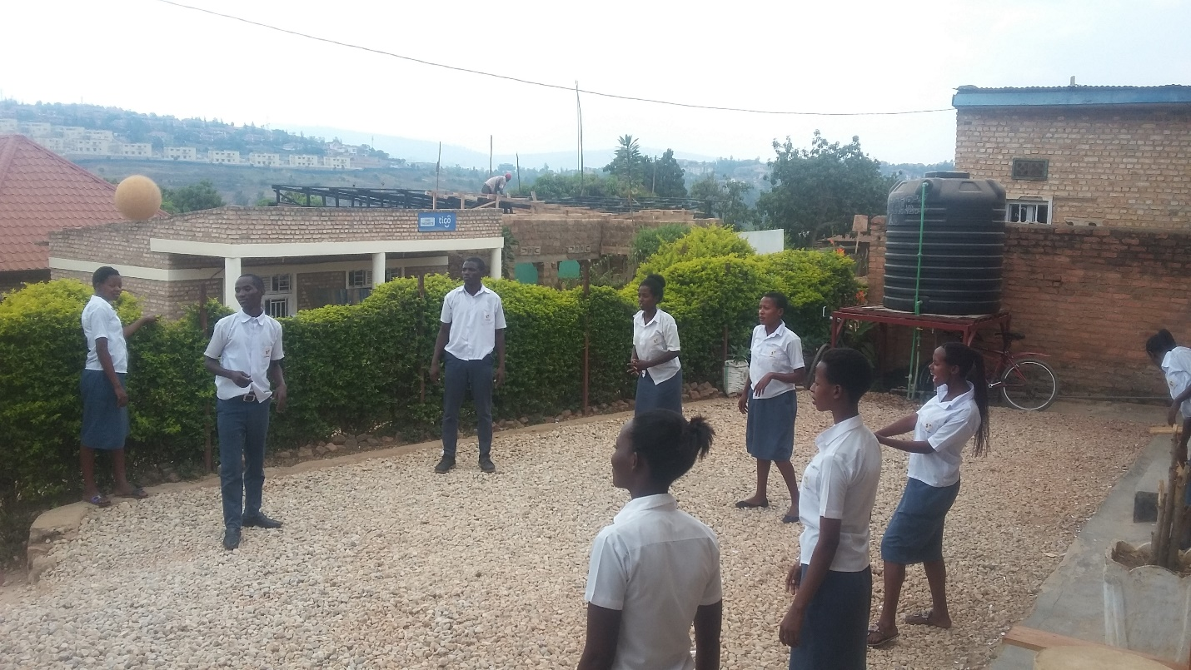
Student trainees on a break.

KABUGA SITE

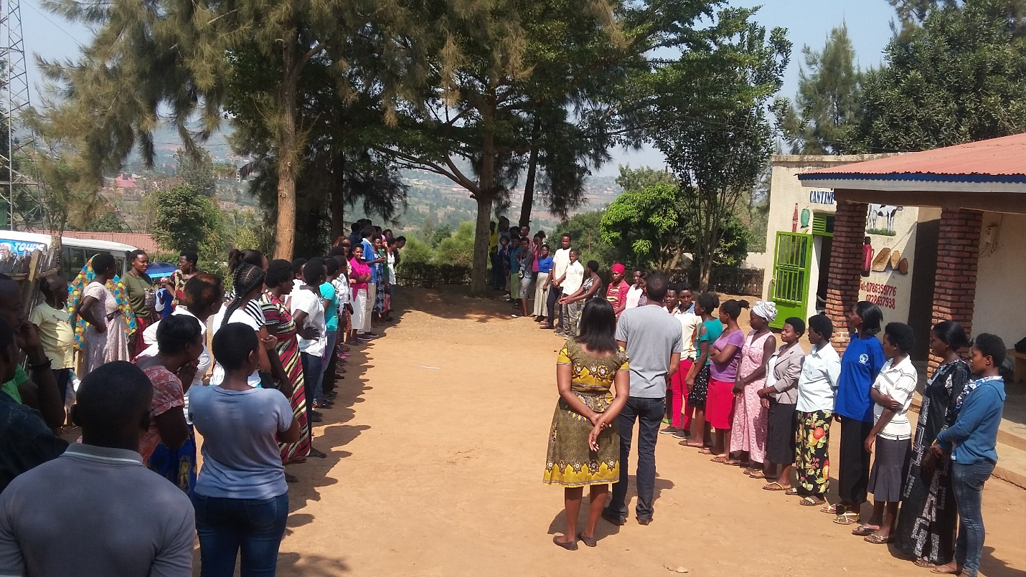

Page 2 of 2

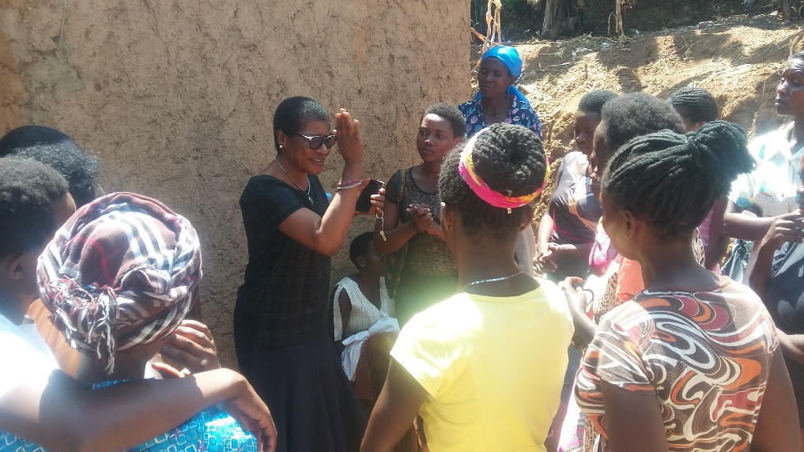
Esther's Aid Founder and Rwandan Country Director, Clare Effiong speaks
to the youth who will be part of the training.

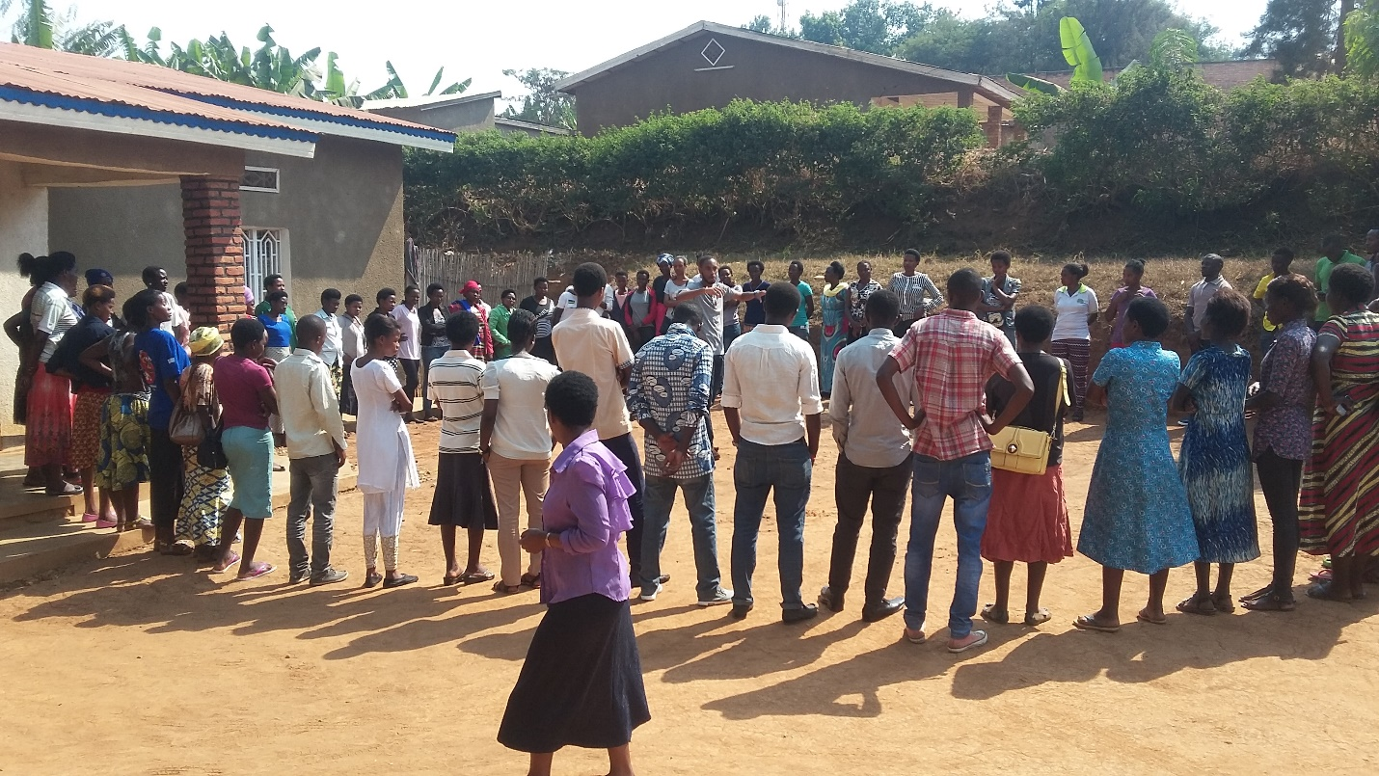

All Photos by Marius.

Done in Kigali on 23 July 29 2017
by RUSANGANWA Eustache Marius
Monitoring and Evaluation Officer

