Esther's Aid GG Report 8/14/17_Part One page 1 of 2

KACYIRU SITE (All photos by Marius) 1
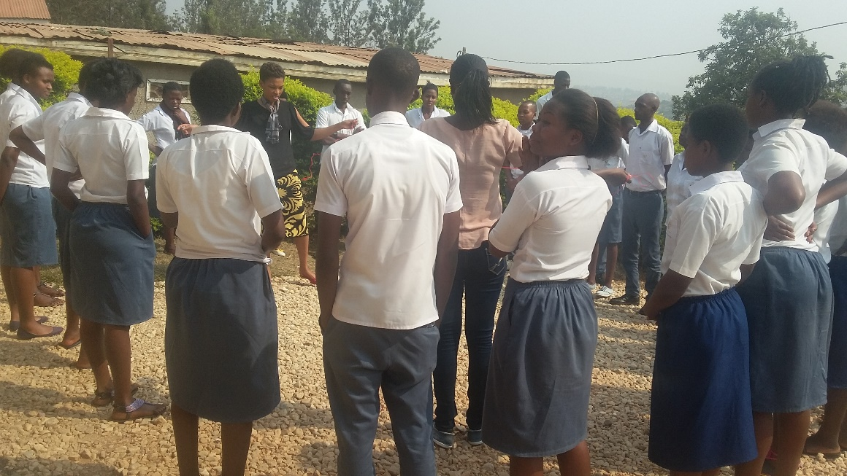

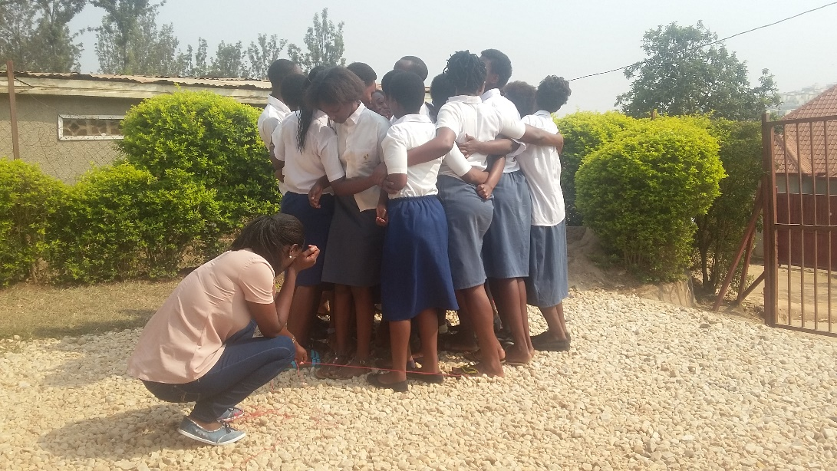

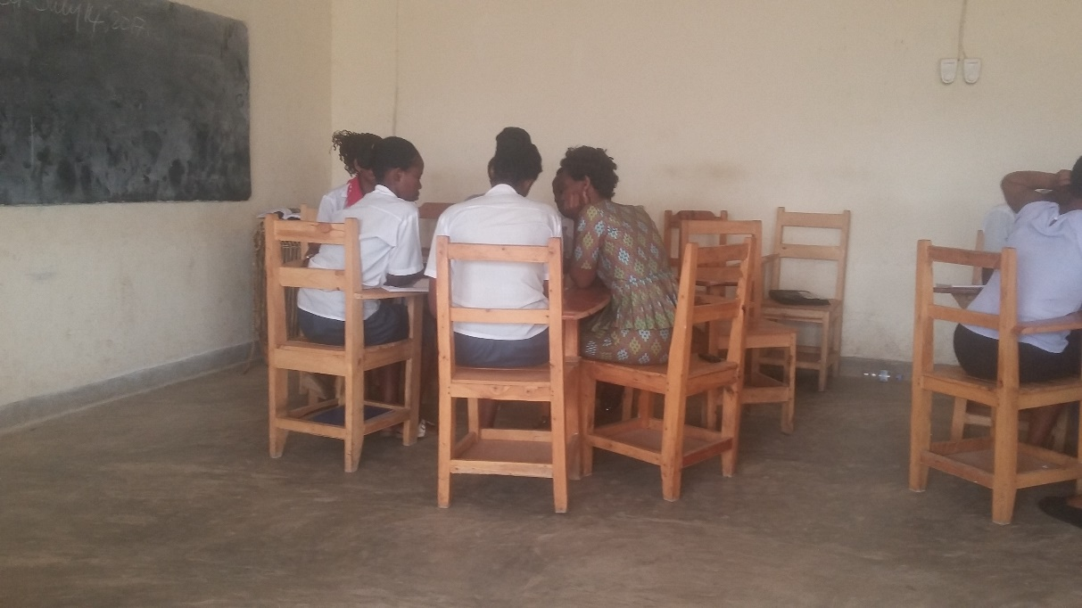

page 2 of 2

The pictures on Page 1 were taken on the Module 4, called Umuyobozi (leadership), when
the students were playing some leadership games and working in groups to identify the qualities of a good leader.

JABANA SITE

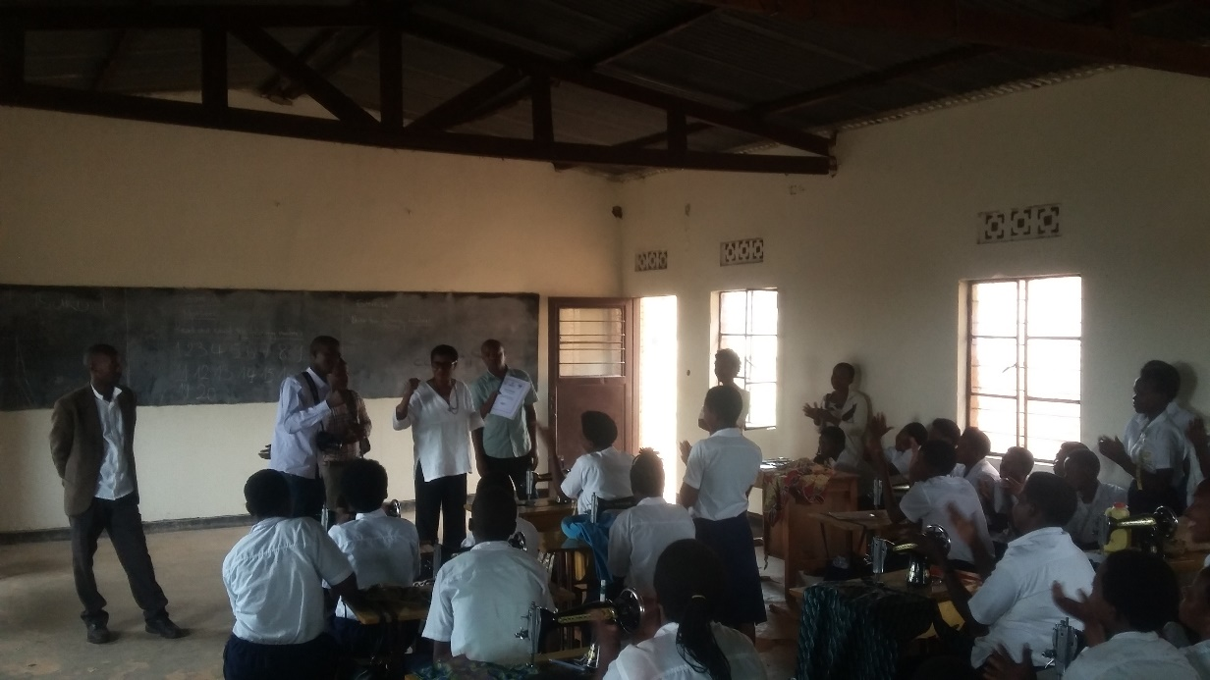
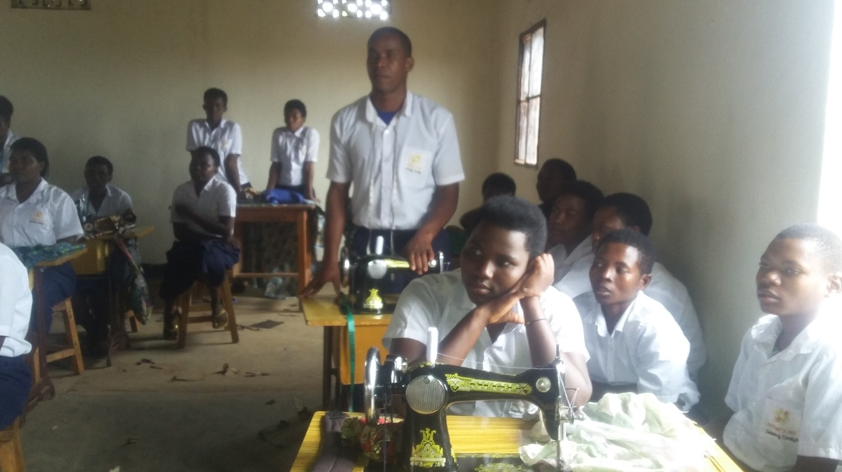
Students were very interested in the program and asked questions.

