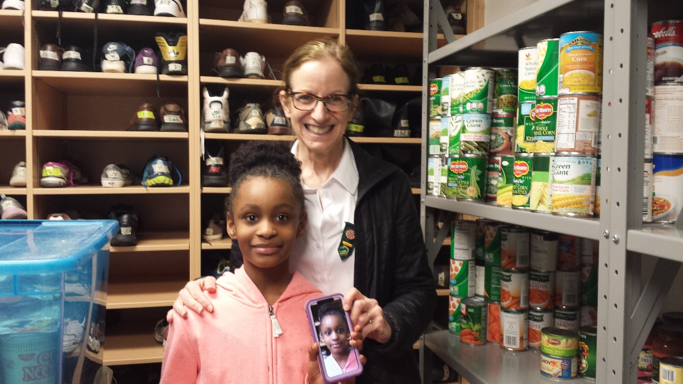
GSBB Troop member and leader at a day shelter.

