KANAVU PATTARAI – 2015-16
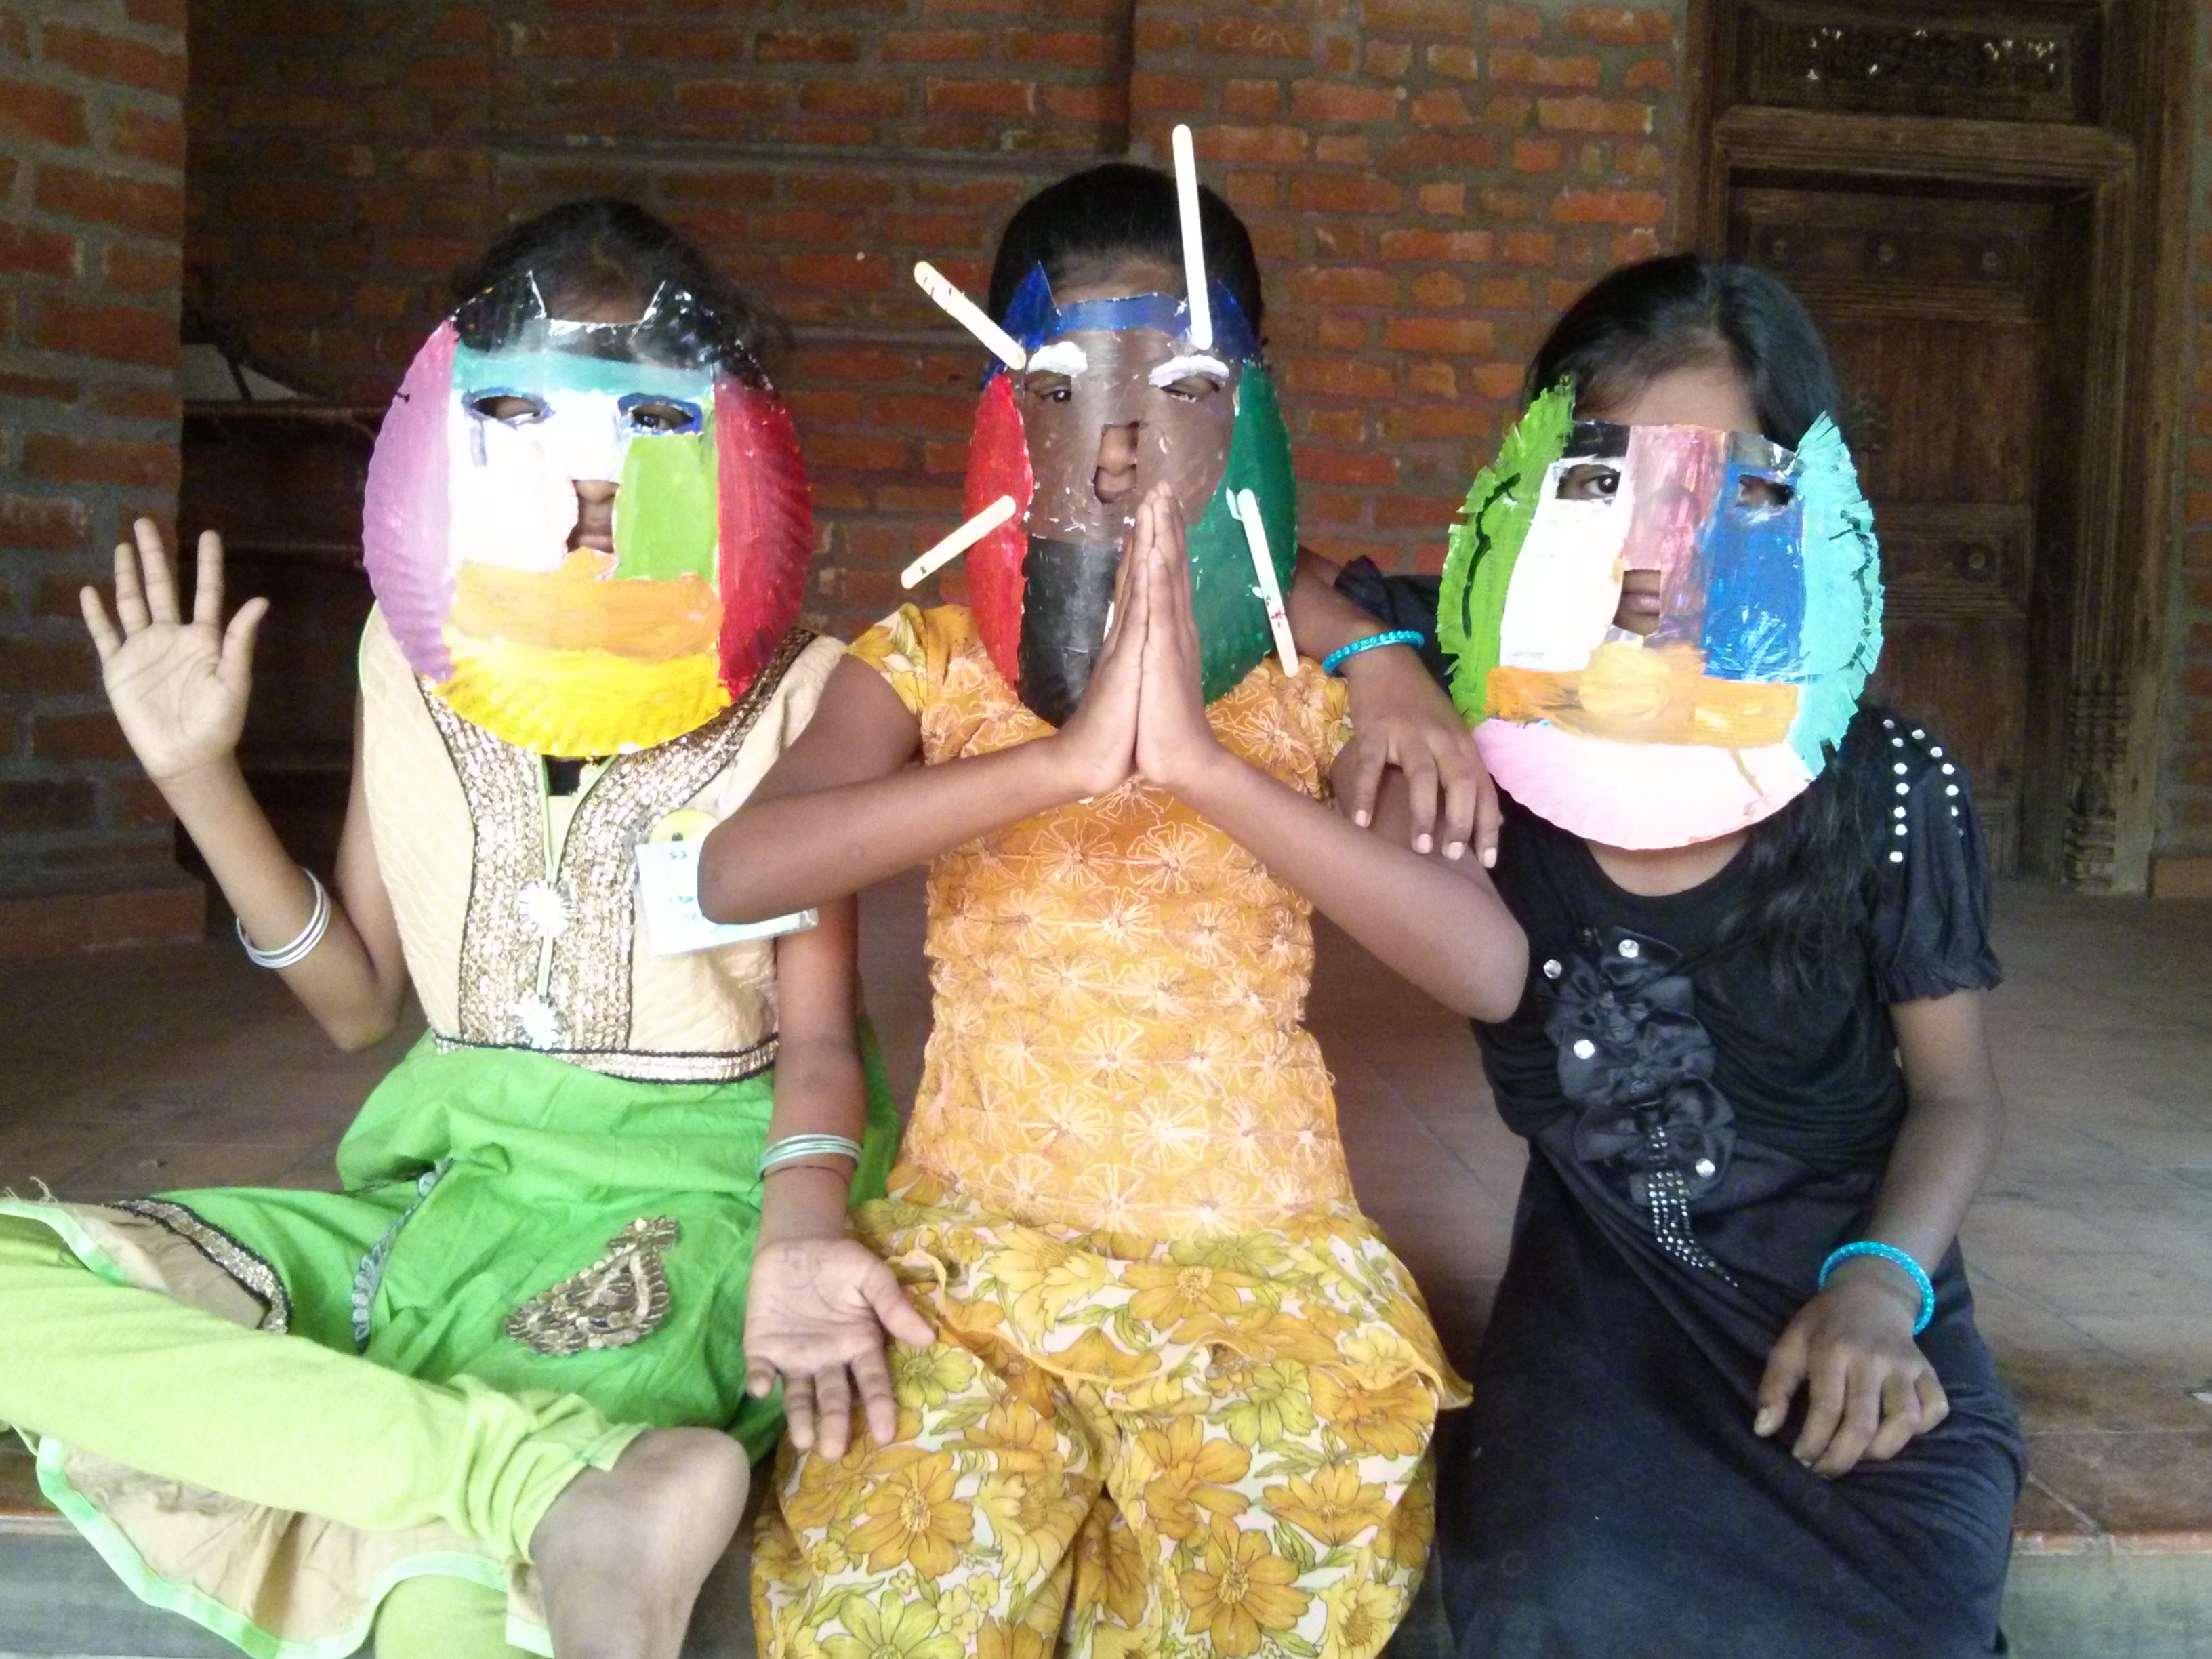
Kanavu pattarai (Workshop of Dreams in Tamil) is a 4 days residential art camp organized for adolescent children suffering from depression and disruptive behavior. A combination of theatre activities, creative games, sand therapy, yoga, dance, music and peer-to-peer conversations are used to bring about behavioral changes.

This year with a focus on instilling self esteem and a sense of belonging in children. We have touch 346 children (from 7th grade to 10th grade) from 15 schools in 2 states, between April 2015 to March 2016 in 14 camps. This was achieved by engaging children in several interactive sessions, inspiring and fun sessions comprising art in it. Group activities, inspiring discussions, talks by experts from the field of psychology, Art therapy and leadership, along with screenings and storytelling sessions had its greater part to play in these camps.
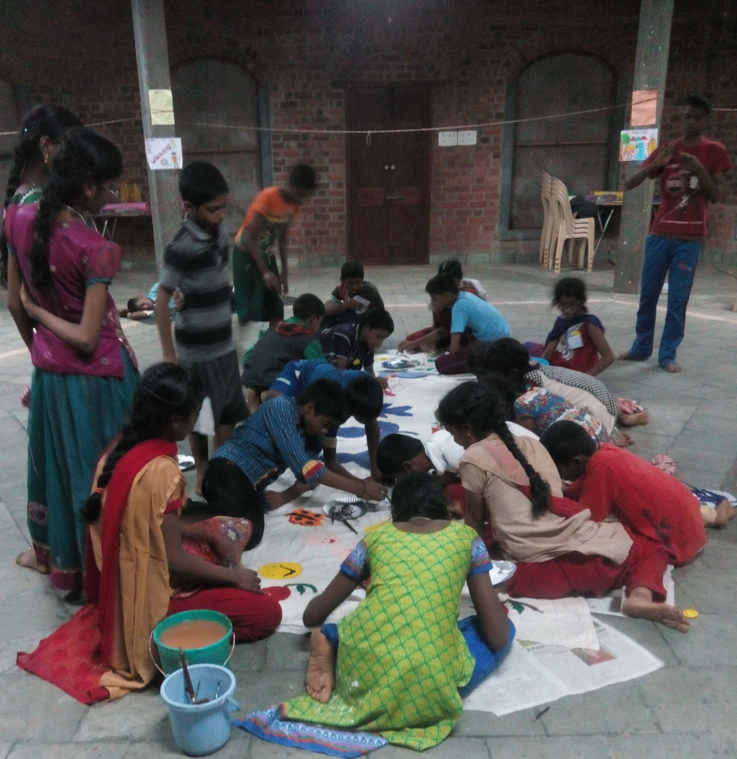

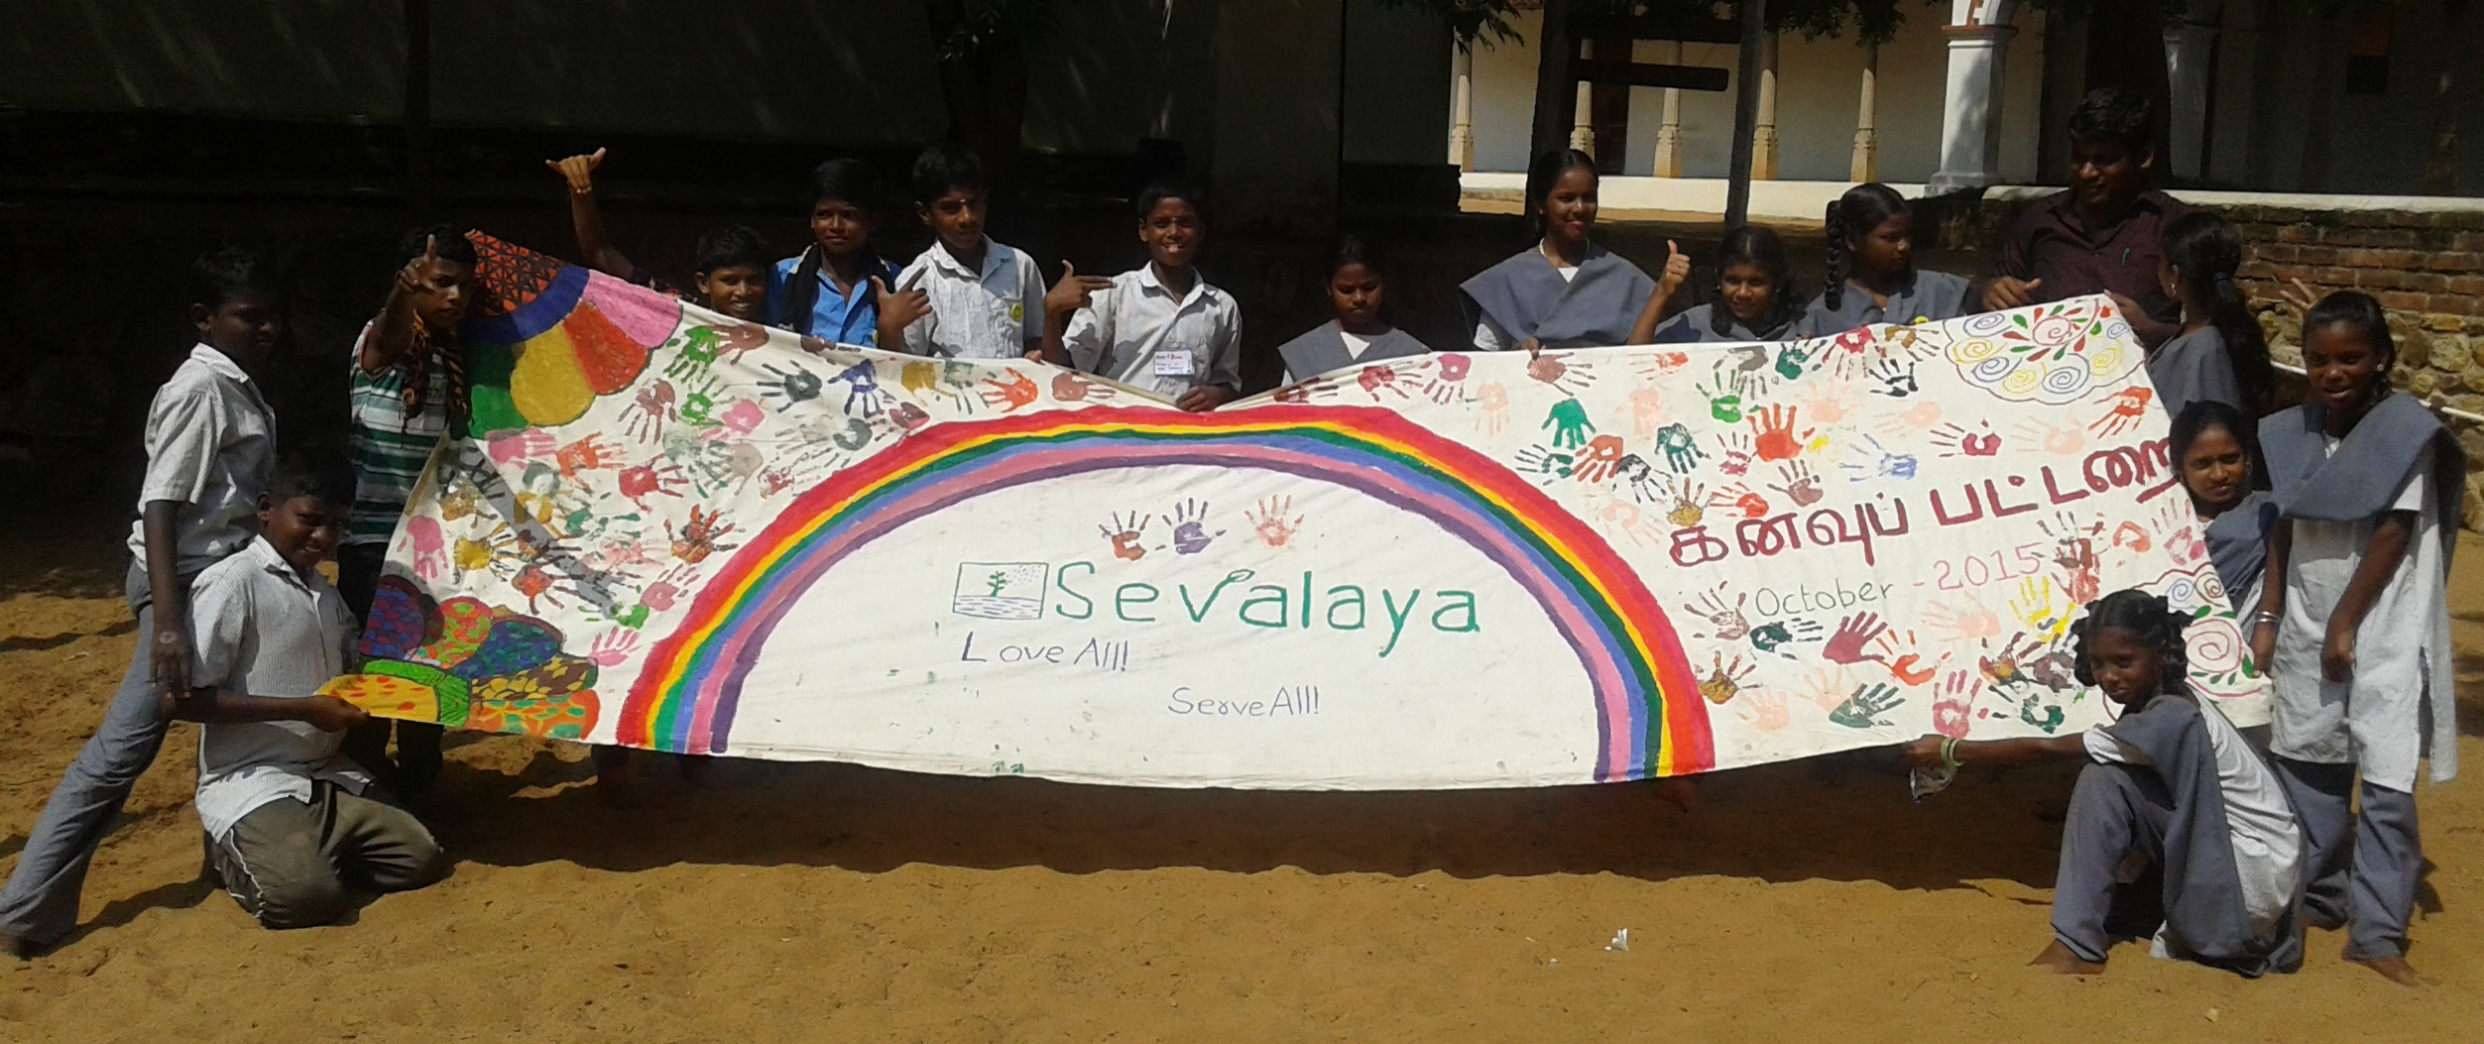

CASE STUDY:

Fearful and dull was Sandeep’s expression on the first day of the camp, he seemed to be a reclusive and not willing to interact with the facilitators. This was clearly visible in his body language. The transition happened during the self portrait activity , where initially he did not draw and sat silently. On enquiry he said ’ my friends are laughing on my drawing , why should I draw?’. After an individual counselling with him he started evincing interest and later his art seemed to be the best amongst his group.

Namma community – an activity which involves discussion of social issues gave him a chance to introspect on his behavior. After the session on “ Adolescent problems – dealing with accepting peers “
He confessed that he had been insensitive to his sight impaired brother whether introducing him to others, discouraging him in all his efforts, involving him in the activities at home. He ended his introspection with tearful eyes by saying ‘I realized my mistakes’.
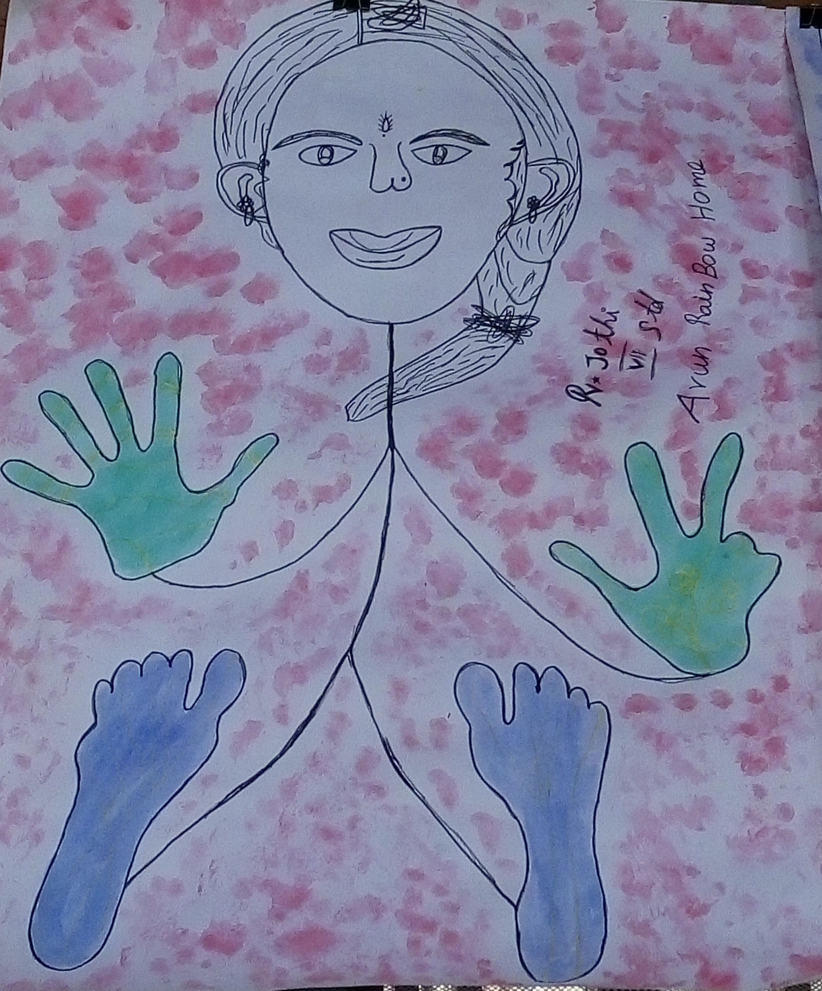
KANAVU PATTARAI- CAMP DETAILS – 2015-16
Camp No. | No. of Participants | School /Institution Name | Date of Camp
1 | 20 | CHES, Periyapalayam | April 25th to 27th, 2015
2 | 27 | Agastya Foundation, Kuppam | May 7th to 10th, 2015
3 | 26 | Rainbow Homes | July 6th to 9th, 2015
4 | 27 | SOS Village | August 3rd to 6th, 2015
5 | 29 | Sevalaya School, Thiruvallur | October 12th to 15th,2015
6 | 25 | Chennai High School, Ganeshapuram &  Chennai Higher Sec.School,MGR Nagar | October 26th to 29th,2015
7 | 29 | Agastya Foundation - k.G.B.V Kadapalli | October 28th to 30th,2015
8 | 23 | Chennai Middle School Seven wells &Chennai Middle School Begum Sahib Street | November 12th to 15th,2015
9 | 25 | Agastya Foundation - Morarji desaimadiri | November 25th to 27th,2015
10 | 25 | Sevalaya School | November 23rd to 26th,2015
11 | 17 | Pudiyador | December 28th to 31st,2015
12 | 25 | Agastya Foundation -Z.P.High School Kothaindlu | January 5th to 7th,2016
13 | 24 | Agastya Foundation - A P M S Shanthipuram | February22nd to 25 th February,2016
14 | 24 | Agastya Foundation - Zila Parishad | March 15th to 17th,2016
 | 346

MIND OVER ‘WATER’ FOR CHILDREN AFFECTED BY FLOOD - CHENNAI
Chennai had to face a serious loss that led to trauma and chaos all around during the floods. Corporation schools were the temporary shelter to many low-lying slums, river bank settlements. Emotional distress was significantly seen among children. NalandaWay Foundation believed that fun sessions in dance, drama, storytelling, teaching, playing games, singing can help the child to deal with its emotional distress.
On identifying the volunteers for fun sessions social media was a major platform to mobilize volunteers. In the process, 70 volunteers were enrolled and 13 centers were identified ideal for conducting the sessions. In the course of 6 days, 36 volunteers worked with 495 children in 13 centers (shelters).

Musician Vedanth Bharathvaj, Volunteer, Kalyanamandapam-Saidapet – I performed a song for them and even taught them to sing Kinaare Lagaao, by Mirabai. . The children were happy and it was a productive way to keep them engaged. Any form of Art, especially indulged in together, has a potential to heal. For me it was certainly a healing experience.
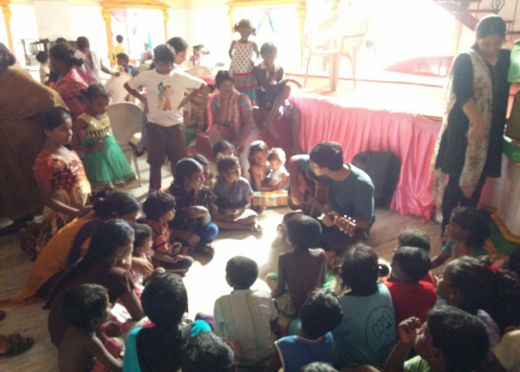

NalandaWay foundation also supported 441 households by providing dry rations to the families badly affected by floods. 1 pack of dry ration had : 5kg of rice,1kg of sugar, 1 ltr oil, salt 1 packet, chilli powder, garlic, coriander powder.

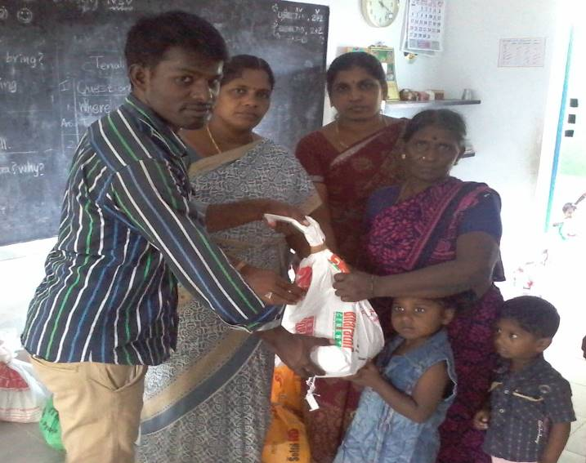
- 115 households in Karuneelam ,Kattangulathur,kancheepuram district
- 135 houses in Ninnakarai, Kattangulathur,kancheepuram district
- 41 residences from Keezhkaranai village, Kattangulathur,kancheepuram district
- 150 children from TTNA School received dry rations

Lunch packs were also distributed to 70 people stayed in shelter home Chennai Primary School, Koyambedu, Chennai district.

