Project Name:
Centre for Bear Rehabilitation and Conservation (CBRC)

Project Overview:
The Centre for Bear Rehabilitation and Conservation at Pakke Tiger Reserve focuses on the scientific rehabilitation and release of orphaned Asiatic black bear cubs, addressing a critical conservation challenge caused by poaching, habitat loss, and human-wildlife conflict. Implemented by the Arunachal Pradesh Forest Department in collaboration with the Wildlife Trust of India, the Center for Bear Rehabilitation and Conservation (CBRC) has, since 2002, developed a proven assisted-release protocol that has enabled the successful return of many rescued cubs to the wild. Since inception, CBRC has attended to 78 Asiatic black bear cases, out of which more than 55% have been released back into the wild. The initiative not only improves individual animal welfare but also genetic diversity and contributes to conservation of wild bear populations. Its significance lies in combining species conservation with ecosystem protection and community engagement, making it a key model for wildlife rehabilitation and landscape-level conservation in the region. Apart from bears, the CBRC also helps in rescue and rehabilitation of other wildlife in the state through a Mobile Veterinary Service (MVS) unit operating out of the centre. Since inception, this MVS unit have attended to 343 cases, including 81 species of mammals, birds and reptiles, with a release rate of 66.2%.
Key activities undertaken by CBRC in 2025-26:
- Orphan bear cub rescue and rehabilitation
- Care and husbandry of bears under lifetime care
- Other wildlife (apart from bears) rescue and rehabilitation
- Study on behavioural and cultural drivers for bear persecution and hunting by dominant tribes in Arunachal Pradesh
- Community engagement for bear and wildlife conservation
- Stakeholder training and sensitization for bear and wildlife rescue, rehabilitation and conservation.
Key achievements under the CBRC project in FY 2025-26:
- Rescue of 06 orphan Asiatic black bear cubs of which 04 are currently undergoing in situ rehabilitation at Upper Dikorai, Pakke TR.
- MVS unit attended 25 individual wild animal emergency cases, of which 17 animals (68%) have been released back to the wild.
- Two new bear cubs were rescued and admitted to CBRC in March 2026, and are currently being hand-raised at the centre.
- CBRC team organized/ participated in 11 community engagement/sensitization events including talks, marathons, bicycle rally, butterfly meet, etc. to build support for bear and wildlife conservation
- CBRC team helped organize community festivals including the Pakke Page Hornbill Festival, Golden Jubilee Sarok Festival and the Nyokum Festival to develop community trust and goodwill towards the project and wildlife conservation in general.
- Three training workshops were held for frontline forest staff, students, youth, volunteers, etc. on various tools and techniques in wildlife rescue and rehabilitation and conservation.
- The sociological study on behavioural and cultural drivers for bear persecution and hunting by dominant tribes in Arunachal Pradesh’s Lower Subansiri region, highlighted how traditional practices, situational encounters, and livelihood needs contribute to hunting and, sometimes, to the displacement of bear cubs. It concludes that hunting cannot be addressed through enforcement alone. Effective conservation must integrate community-led regulation, awareness, and alternative livelihoods while acknowledging the shared landscape between people and wildlife to develop practical, culturally sensitive solutions.

Project Photographs:
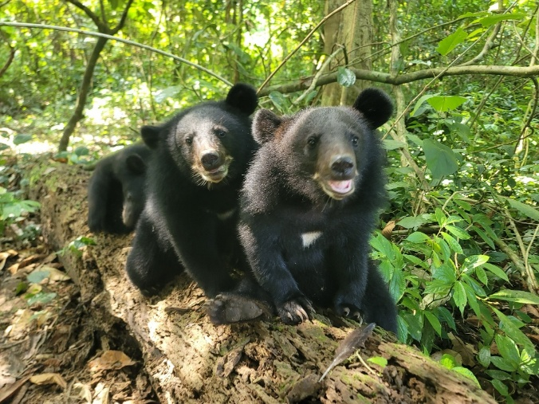
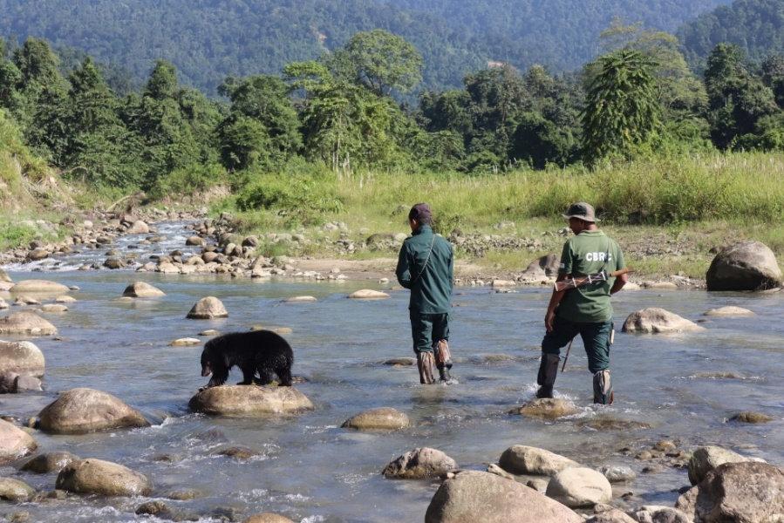

Fig.1: Keepers taking the bear cubs for ‘asssited’ walks at the in situ rehab site | Photo credit: Subhashish Arandhara
Fig. 2: Orphan bears undergoing in situ rehabilitation inside Pakke TR | Photo credit: Subhashish Arandhara
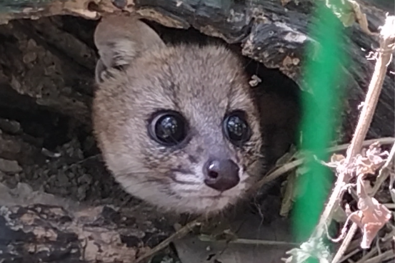
Fig.3: Small Indian civet under rehab at CBRC | Photo credit: Dr. Panjit Basumatary
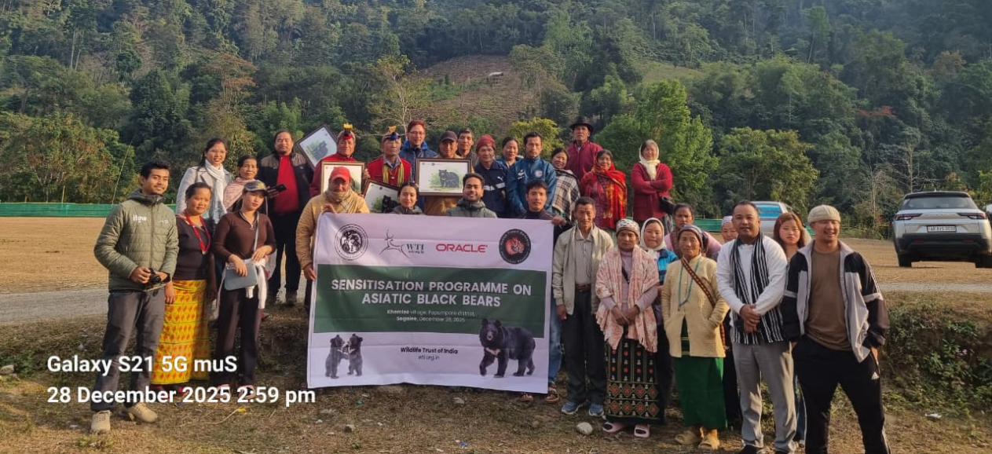

Fig.4: Community sensitization events conducted by CBRC in Arunachal | Photo credit: Dr. Panjit Basumatary

