Global Giving Report October 10, 2015

Project Report Macheo~US

‘Feed 30 malnourished young children in Kenyan slum’

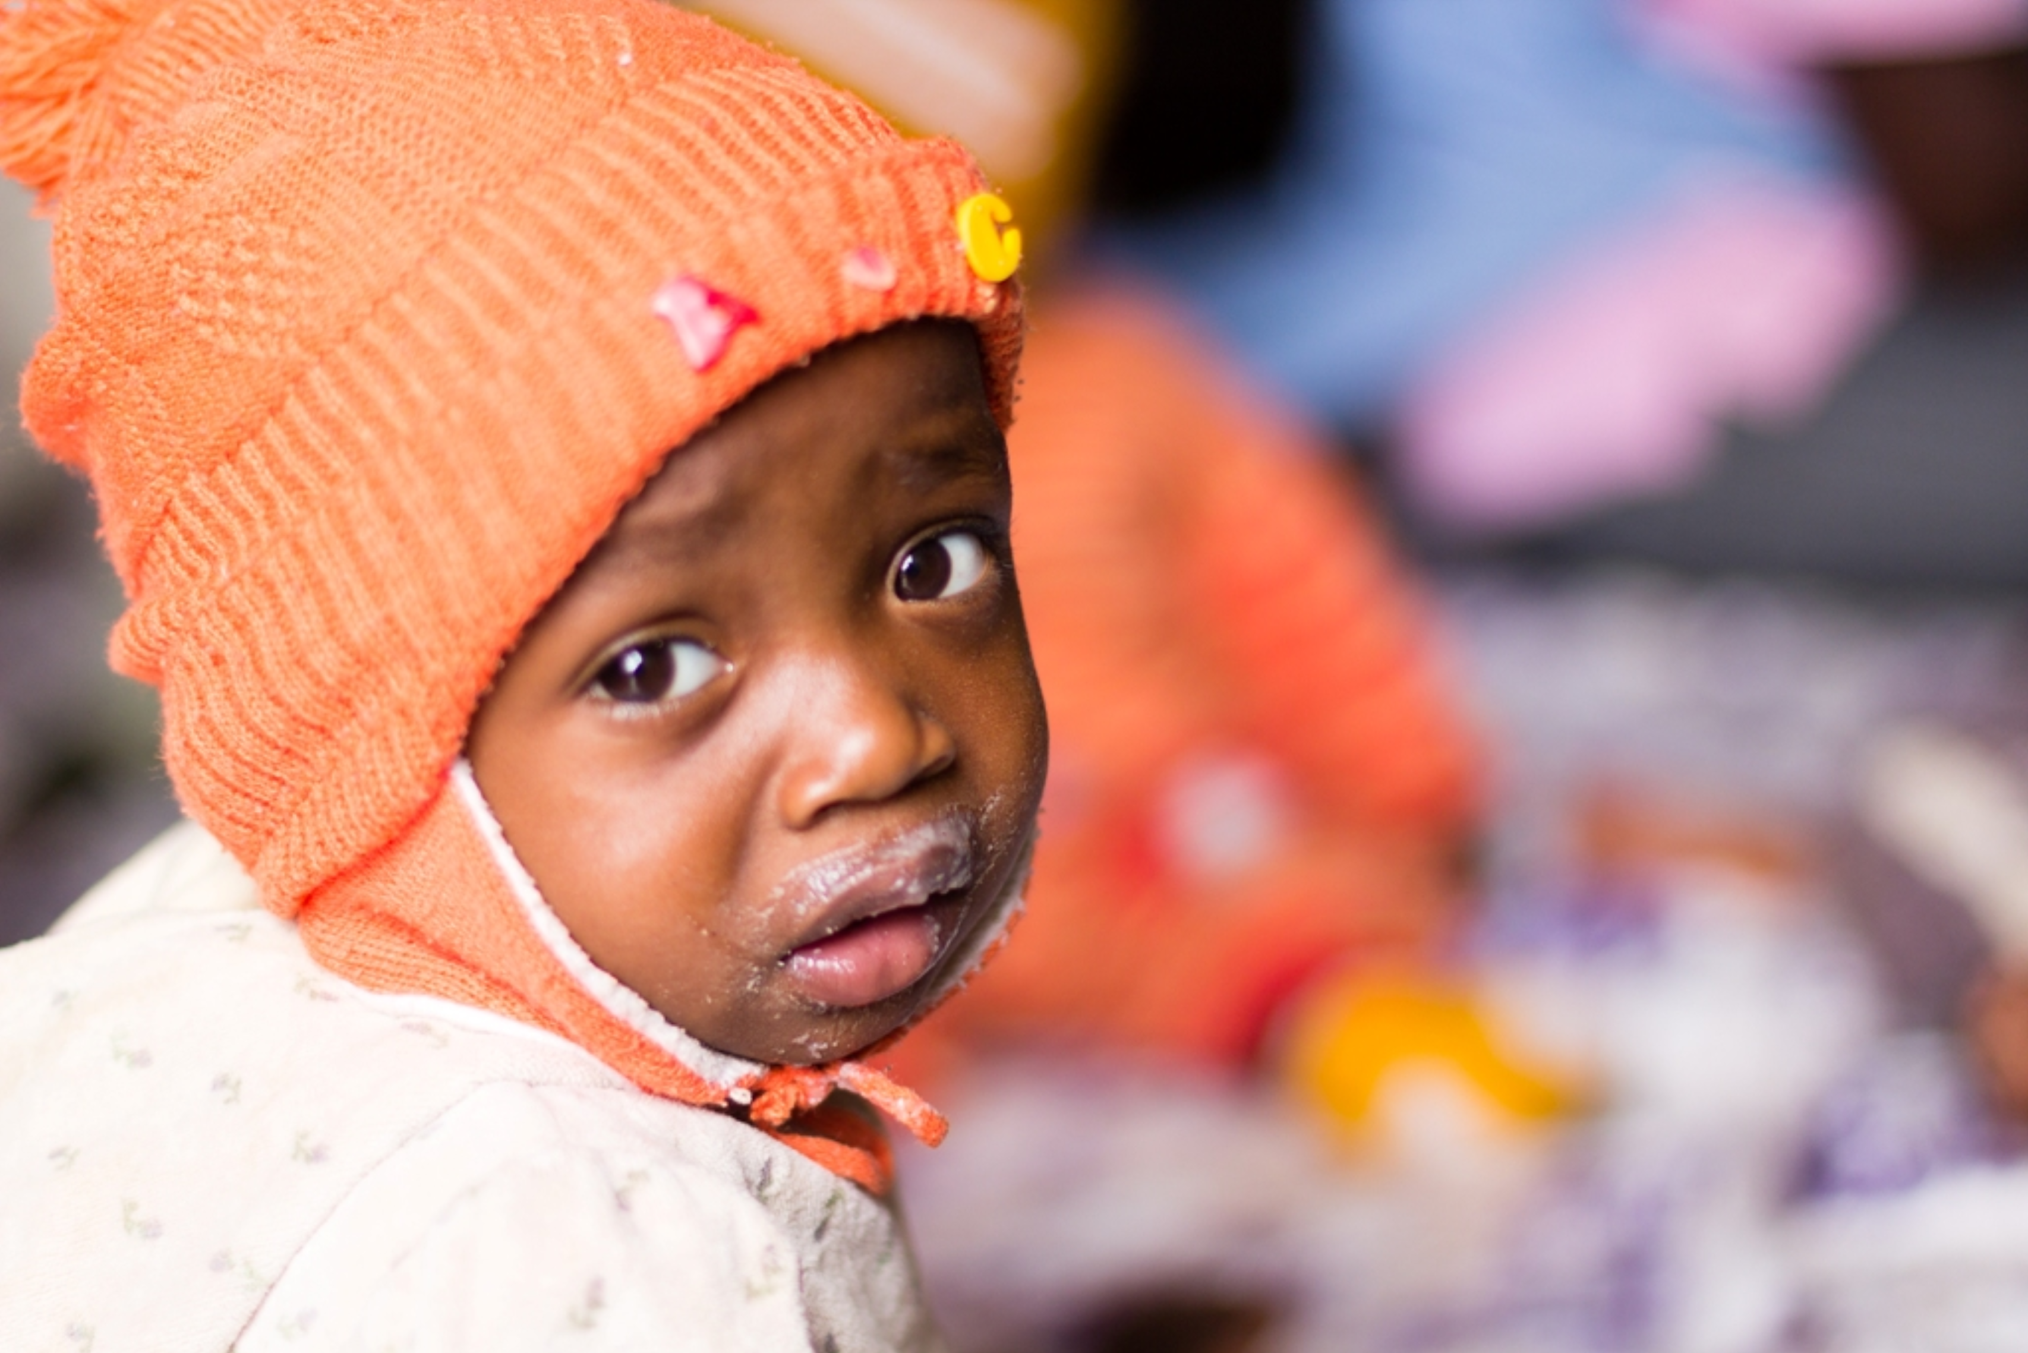

Macheo US is very excited to become a permanent member of the Global Giving web platform, due to our successful fundraising effort to raise $5000 from 40 unique donors in 15 days. Actually we made it in eight days, thanks to supporters from five countries, on three continents! Thank you so much to those that supported us in this crucial endeavor. Now the work of the Macheo Malnourished Children’s Program (MCP) in the Kiandutu slums of Thika, Kenya, will have enough funds to provide nutritious meals and also a stimulating environment for thirty young malnourished children into next year.

The report, below, was received from Macheo Kenya and details the second quarter of the MCP program in 2015. It provides information on how Macheo targets the malnourished children and how they are assessed throughout their time in care. Children are cared for daily during the work-week, and their guardians receive weekly education on a range of topics concerning nutrition and hygiene. Typically a child stays about four months in the nutrition program, but some have stayed as long a nine months, in order to reach an adequate nutritional status and reach developmental milestones.

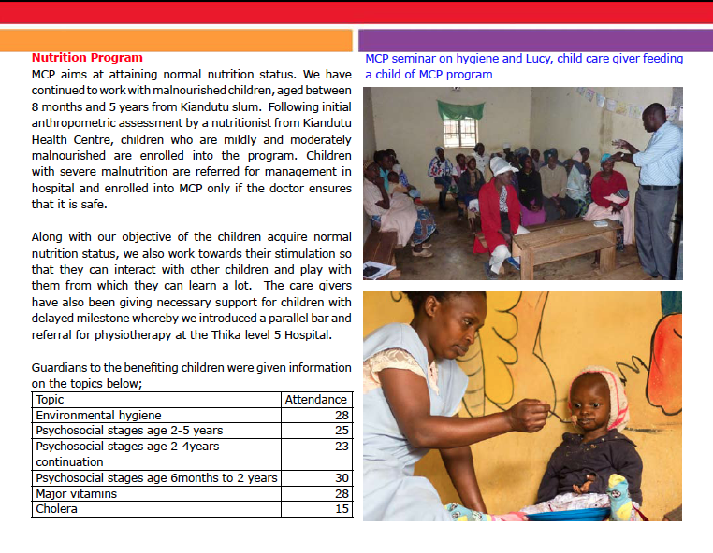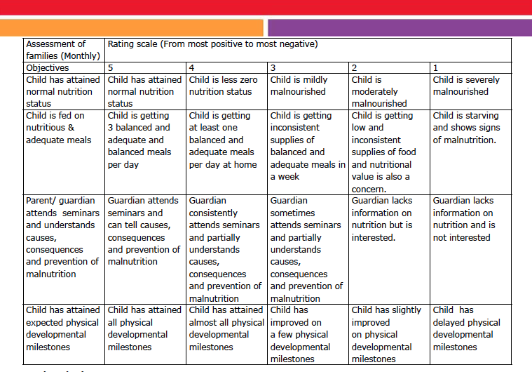
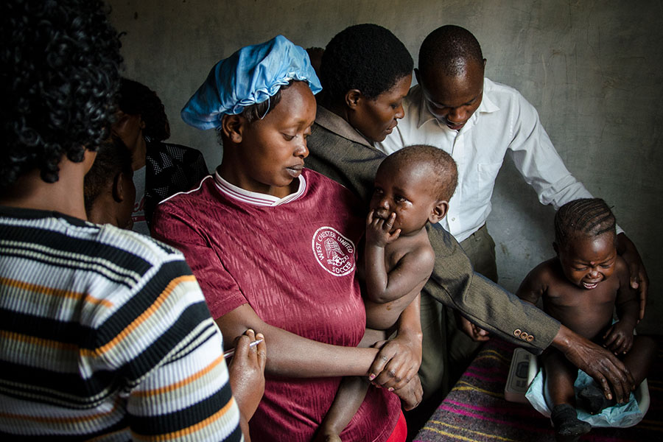

Malnourished Children’s Program Impact
All participants benefit from various interventions. Macheo created a monitoring and evaluation tool requiring each set-objective to be ranked on a scale of 1 – 5. This tool embodies objectives of the program and was distilled from a series of discussions between the M&E team, the staff in the MCP, and the manager of the Macheo Health Program. The table above shows the named objectives and explains the ranking of each. This has enabled Macheo’s social workers to make better judgments during the beneficiaries’ intake and also when monitoring and evaluating the beneficiaries’ progress. It eliminates bias and assists social workers to target the neediest cases, so that the greatest benefit is achieved. The named objectives apply to most of the beneficiaries but also each beneficiary tends to have other unique objectives, which are also addressed by the social workers depending on the need.

Reporting from Macheo in Kenya is a regular event and we will forward the information to you. Thank you again for all your concern and support and for contributing to the success of our outreach initiative.

With Kind Regards,

Anne Thompson, Lindy van Kats and Lisanne Kandiah
Macheo US Outreach Team

