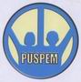
Life skills for women and children of earthquake victim in Bantul
By Andi Asriadi
Summary
Monitoring and Evaluation conducted Puspem on January 11, 2010 shows the life skills program that was implemented in Yogyakarta Kanten Imogiri till now still continue to happen, although with very little funds because many people are interested so that Puspem pressed to execute.
So it is with English skills, many young children, both elementary schools (SD), junior high school (SMP), and High School (SMA) also continued to press, because they assume that this program is very useful that they gradually less able to communicate with the tourists from abroad in English language.
As recognized by Sutima, sewing skills participants said, "Frankly I am very grateful to Puspem and GlobalGiving, for giving assistance sewing skills for free. Therefore, I hope this program can continue to be implemented and supported by GlobalGiving, because there are many people who are interested to participate. Our thanks also goes to Puspem and GlobalGiving ".
Life skills for women and children created to help mothers and children of earthquake victims in Bantul, province Yogyakarta.
This program providing skill such as;
1. Learn of sew
2. Learning printing / screen printing as printed invitations, banners, printed books, etc.
3. Learning to bake
4. Learning business management / accounting for mothers
5. Learning marketing product
6. Free computer course for children
7. Learn of English language for children
Also in this program will give venture capital for mothers so they can start a new business or expand their business.

You can see all our activities from film project belows;
- Education for earthquake victims in Bantul-1 http://www.youtube.com/watch?v=zIuFtMON_ho
- Education for earthquake victims in Bantul-2 http://www.youtube.com/watch?v=Q_fL6r-NTVg
- Education for earthquake victims in Bantul-3 http://www.youtube.com/watch?v=Eyp65BqKppo
- Education for earthquake victim in Bantul-4 http://www.youtube.com/watch?v=GHXsaj55mhA
- Education for earthquake victims in Bantul-5 http://www.youtube.com/watch?v=m9XLtgLBHuk
- Education for earthquake victims in Bantul-6 http://www.youtube.com/watch?v=ufkfcifK0u4
We expect the donors to continue to provide assistance so that this program can continue.
Again, we wish you many thanks for all your support and attention so that this program can continue.
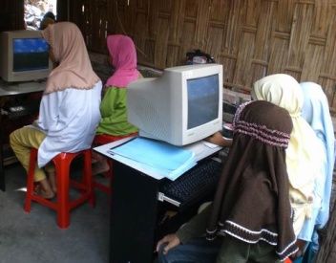  Free computer course for children | 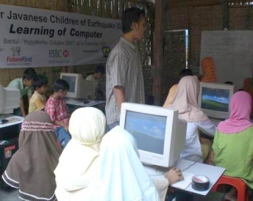  Free computer course for children
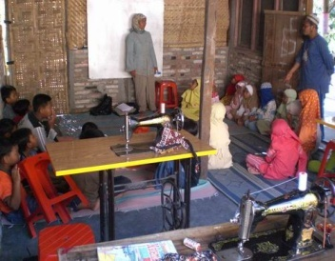  Learning practical sewing | 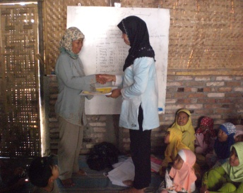  Mrs Sutima a participants in this program

