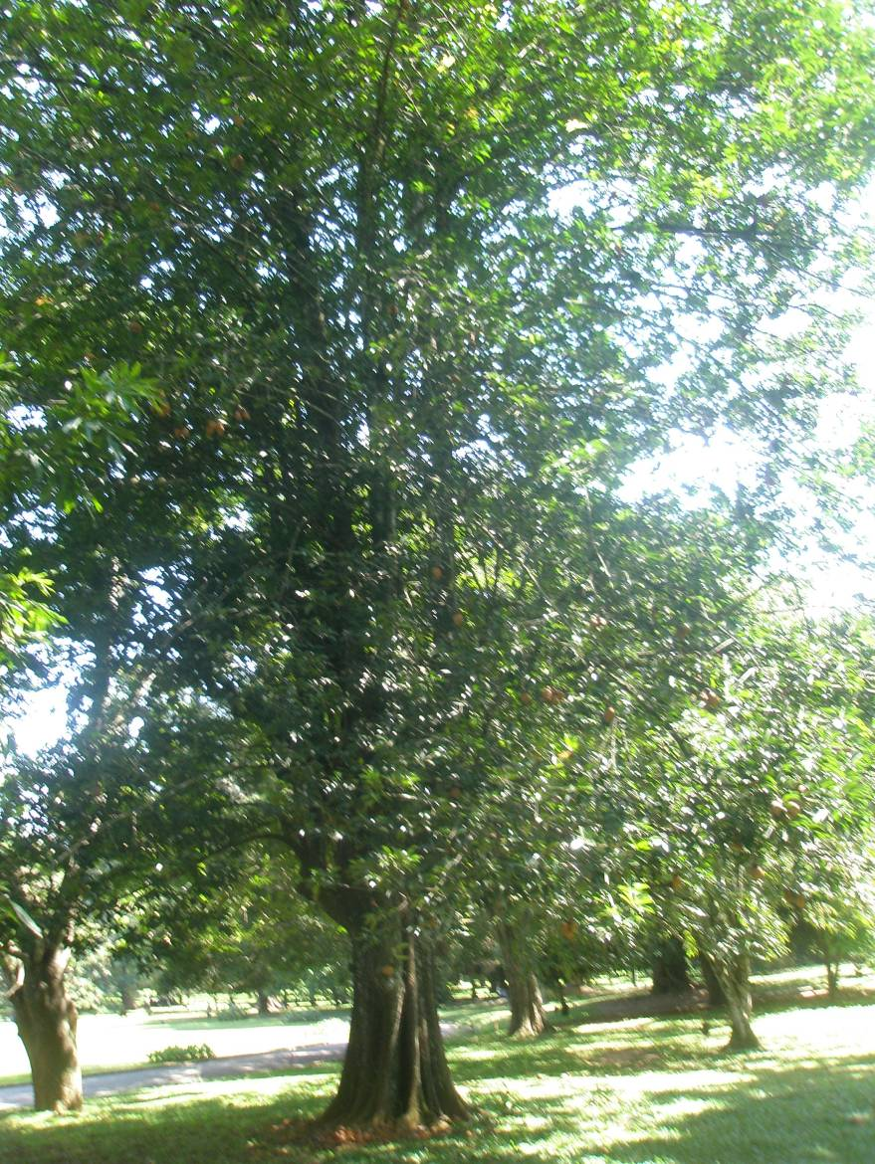

Pentadesma butyracea - 114 year old fully grown tree – Sri Lanka

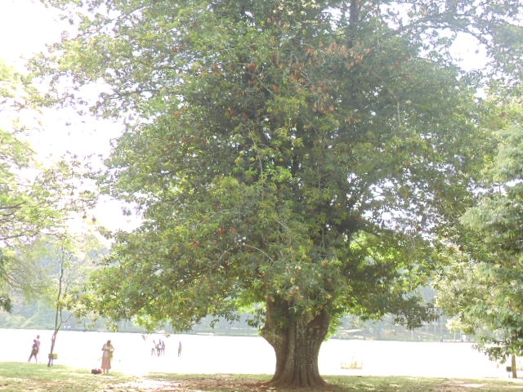

Pentadesma butyracea - 114 year old fully grown tree – Sri Lanka

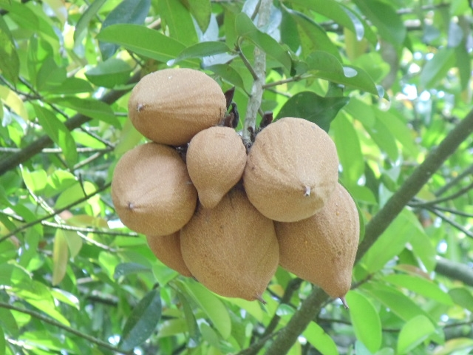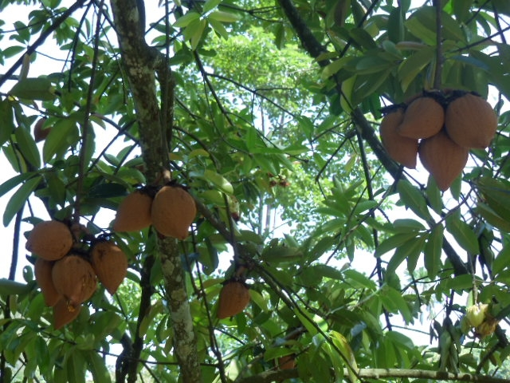

Fruits

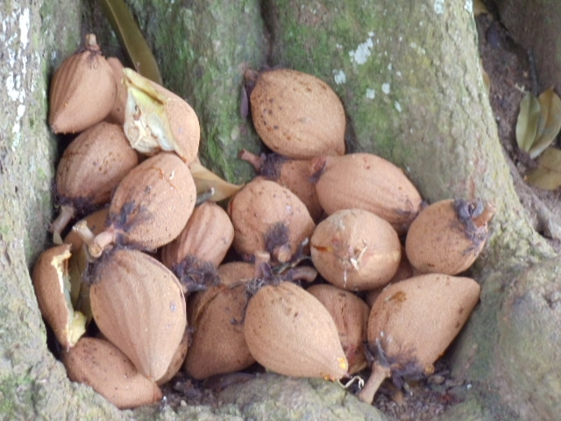

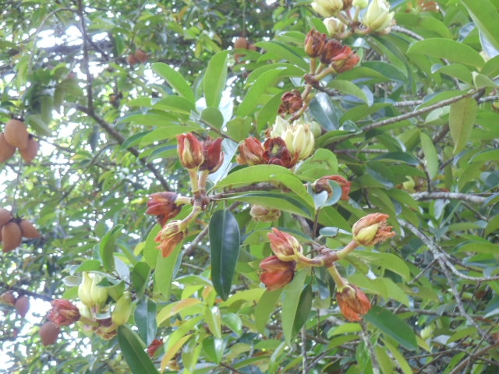

Fruits, opened, pollinated and unopened flowers

Nine month old seedlings, ten months after planting in the field
Sri Lanka
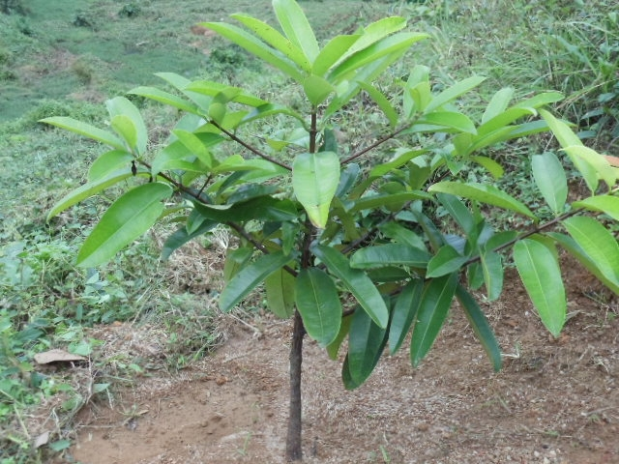

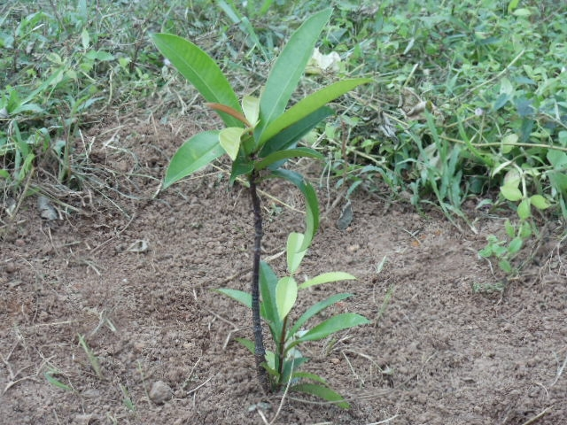

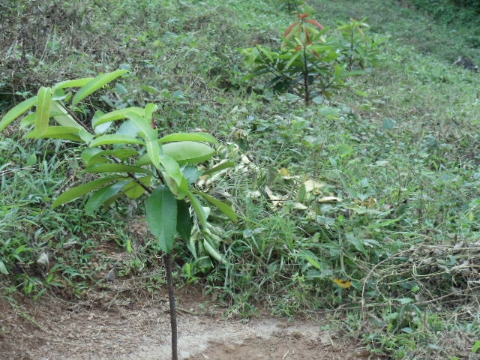

60 – 75 cm in height

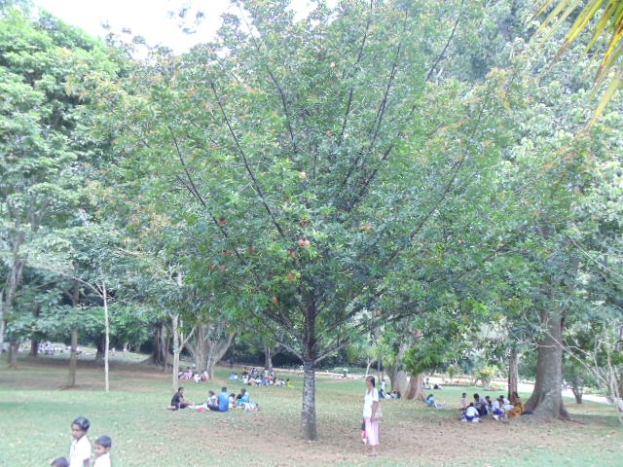

Young tree – app. 15 years - Sri Lanka

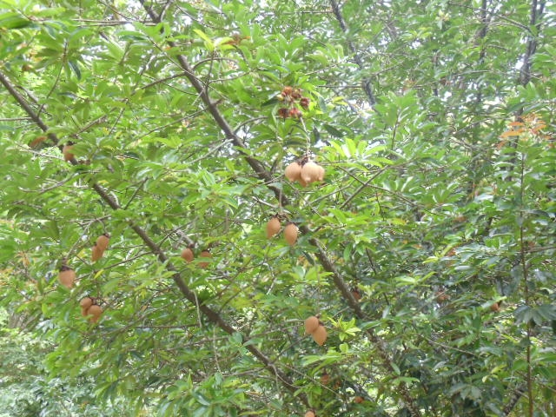

Fruits on young tree – app. 15 years - Sri Lanka

