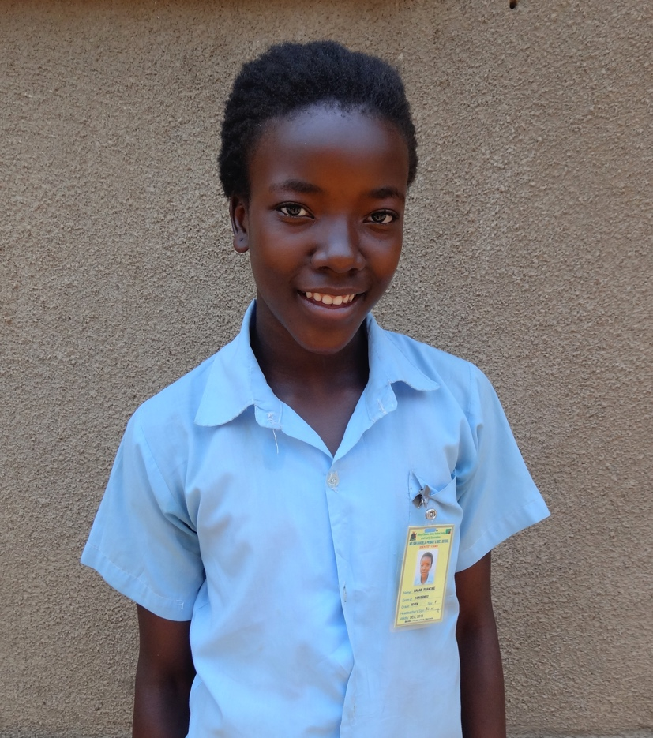
Meet Francine
Quick Facts
Name Francine
Birthday 22 December 2001
Birth Place Lusaka, Zambia
Mother’s Name Bridget Balasi Esineya
Mother’s Profession Marketeer
Father’s Name Unknown
Father’s Profession Unknown
Primary School Nelson Mandela
Secondary School Chalo Trust
2015 Grade Level Grade 8

Francine’s Family
Francine lives with her single mother and three siblings in Chuunga. Her parents were never legally married, and her father left for Botswana many years ago. He is uninvolved in her life. However, her uncle is active and supportive in her life, and was present at the home interview. For a while, this uncle took care of Francine to help support the family. However, when he divorced his wife he also began to struggle. Francine returned to her mother. When he can, her uncle contributes to the family financially, sometimes up to 300 kwacha ($50)/ month. Francine’s mother sells fritters (small baked goods) on the road, which makes about 450 kwacha ($70)/month. They own a home with seven rooms, however they divided the house to be able to make rental income. Their tenant pays the family 300 kwacha ($50)/month, which helps pay for electricity and food for the family. Her older brother and sister are both attending secondary school, and her younger sister is in Grade 6 at Diana Kaimba. They don’t have running water but pay their neighbors to be able to use their well.
Francine’s Educational Background
Francine attended Chakundula, a government school, when she was under the care of her uncle. However, most recently, Francine has been attending Nelson Mandela Primary School. She usually performs in the top three in her class. She is a class captain and helps clean the class and write down the noisemakers. She enjoys debating with the other students in her class and is a football captain at the Olympic Youth Development Center (OYDC). Math is her favorite subject and she would like to be an accountant when she grows up. Although all the students at Nelson Mandela were very impressive, Francine stood out as the top girl competition. She impressed us with her English skills and ability to teach us a variety of topics. On the KF exam, Francine placed in fourth position out of the 50 candidates.

