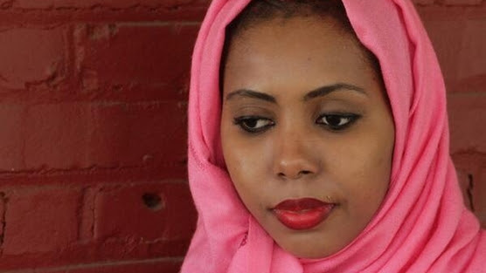

Thank you for being a champion for Equality Now’s Adolescent Girls’ Legal Defense Fund (AGLDF)!
Because of donors like you, Equality Now is supporting the efforts of courageous women like Jaha and 45 young girls from the Pokot and Narok district in Kenya that fled their homes to prevent being mutilated.
Jaha experienced female genital mutilation (FGM) as an infant in Gambia. FGM is a harmful cultural tradition performed in many countries, in some cultures to keep girls “marriageable.” However, no one told Jaha the reason she had been mutilated was to guarantee her virginity before marriage. She learned this in a Manhattan doctor’s office at age 15 when she was forced into a marriage to a 45-year-old man. Jaha then had to go through a re-opening process, which felt like undergoing FGM again.
There are millions of girls like Jaha, whose young bodies have been permanently altered without their permission and often against their will. The devastating effects can last a lifetime. Now 24 and living in Atlanta, Jaha with the support of Equality Now has launched a campaign with an online petition, asking Congress to fund the necessary studies to determine how many girls are at risk of FGM in the United States so that the 2013 law protecting girls and signed by President Obama can be enforced.

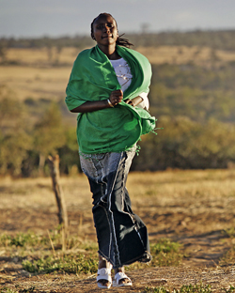
Though the United Nations has declared FGM a human rights violation -- the practice continues in the United States and around the world. In the US, the procedure is performed in secret, and many girls are taken out of the country during school holidays to be mutilated at vacation cutting ceremonies at home.

In Kenya, the month of December is a season of mass mutilation. But thanks to supporters like you, we were able to fund a local group that moved 45 girls at risk of FGM to a safe place and we are now looking into bringing a class action suit on behalf of these girls who had to flee their homes to escape FGM and child marriage. We hope that such a case would put pressure on the Kenyan government to enforce its law against FGM and discourage parents from subjecting their daughters to this practice. Because of caring people like you, Equality Now was able to put pressure on the Kenyan government and for the first time ever, they have created an anti-FGM Board to tackle the situation.

Thank you again for supporting of our AGLDF program which will continue to help young women like Jaha and the girls from the Pokot region.

Let Jaha know you care, sign her petition today.

