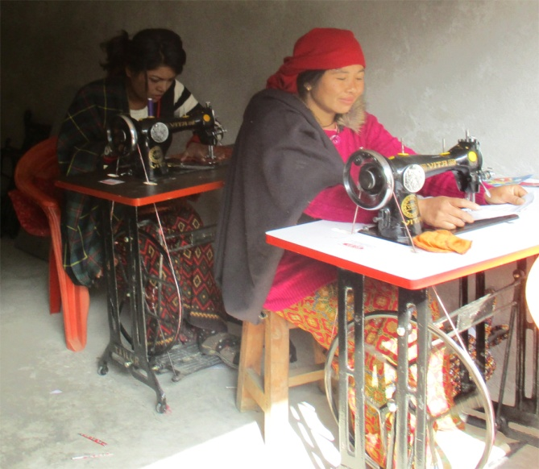
Radhika undergoing a sewing training

