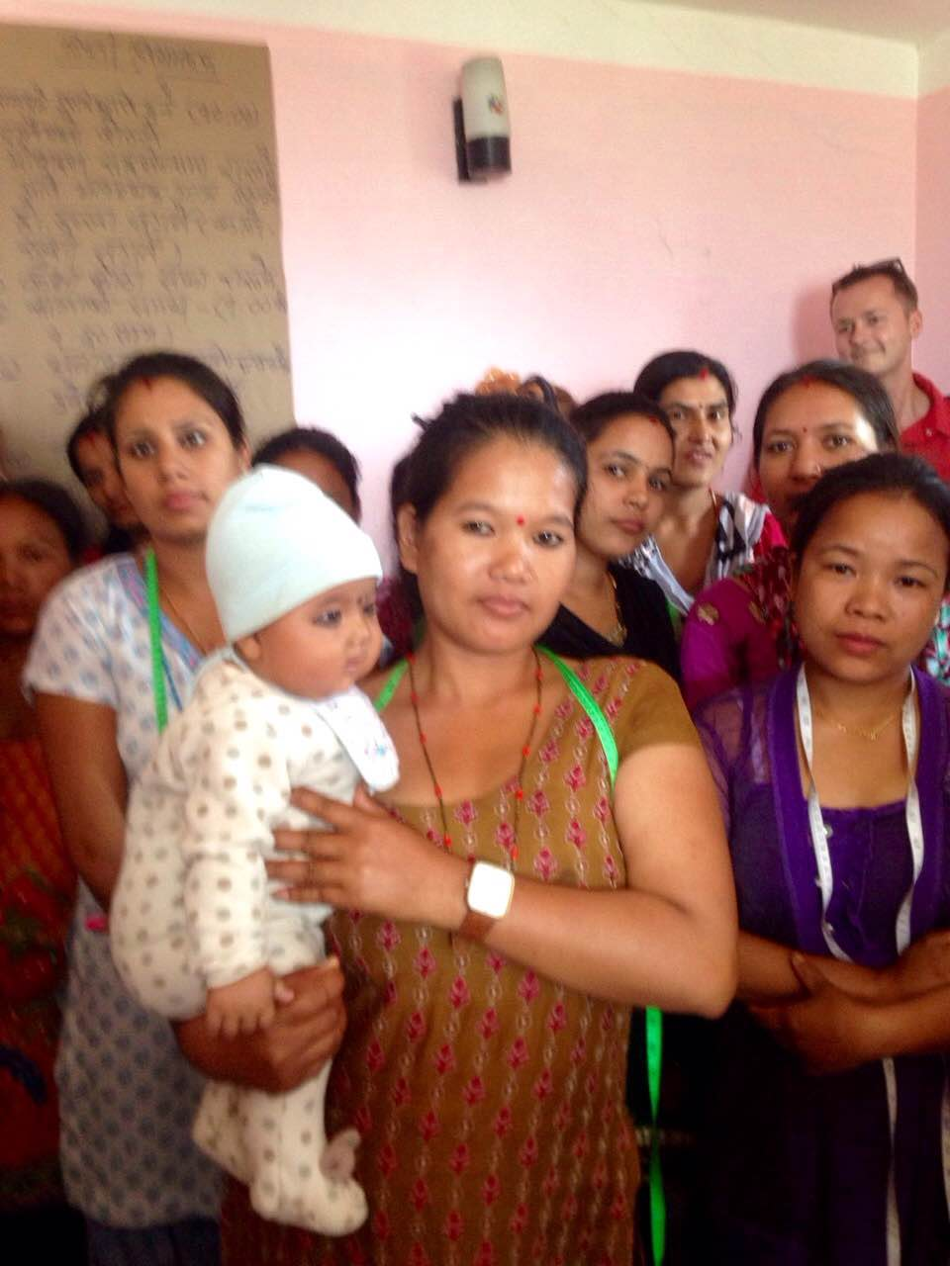
Prizaa, a young woman of 24 years was 8 months pregnant when the earthquake hit. She ran out of her home with her 4-year old daughter, but got caught in between two houses that collapsed. She was fully buried under the rubble with only four fingers showing. She could hear voices outside since she was conscious. Finally about half an hour later, the community saw her fingers and rescue her alive. But she lost her 4-year old daughter. In three weeks, she delivered a baby boy now 3 months old. When the HTG shadow barefoot volunteers met her she was still in trauma. She said that unless she goes out of the house for 3-4 hours and does something to occupy her, she couldn't survive. That is when the HTG volunteers in Dharmasthali organized the sewing training by reaching out to local donors for support. They have started a 3 month-long training for 28 participants. Prizaa is one of them. She brings her 3-month old baby to the class. An earlier Tewa staff/donor contributed enabling to buy a bamboo crib for the baby while she trains. Prizza is now hopeful. She has self-confidence and is striving to live her life anew. (Courtesy – Sadhana, ED Tewa)

